- Create user with name Techie and provide sudo access to user.
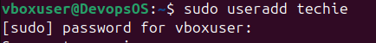
Using cat /etc/passwd show all user. 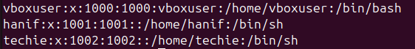
Set password to techie user 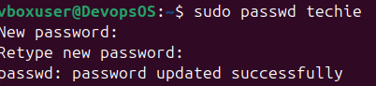
How to find sudoers file. 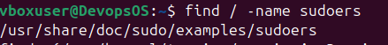
How to open sudoers file? 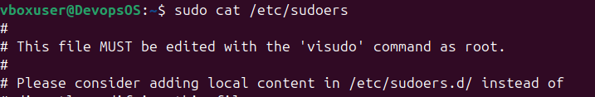
Assignee Sudoers permission. 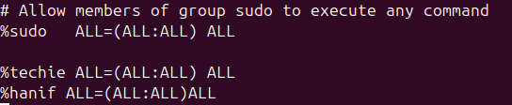

- Navigate to the home directory.
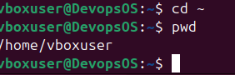
- Create a new directory.
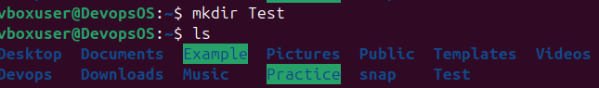
- List the contents of a directory.

- Change the current directory.
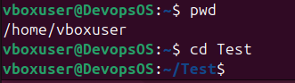
- Create a new empty file.
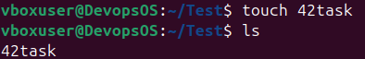
- View the contents of a file.
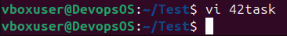
- Copy a file to another location.
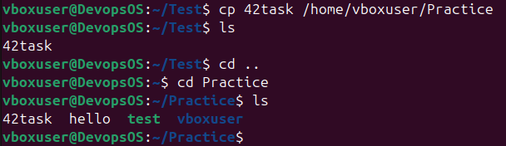
- Move a file to another location.
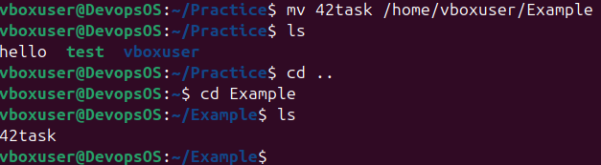

- Rename a file.
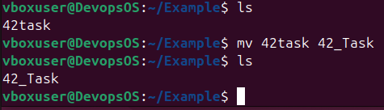
- Delete a file.
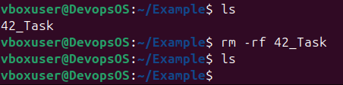
- Grant or revoke permissions on a file or directory.
Grant permission to 42task file
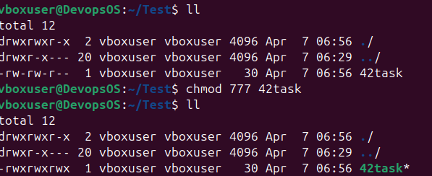

Revoke permission to 42task file.
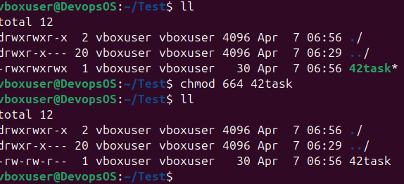
- View the current date and time.
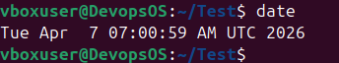
- Check the system uptime.
Using uptime command

Also use top command
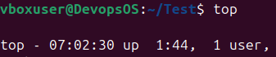
- View the running processes.
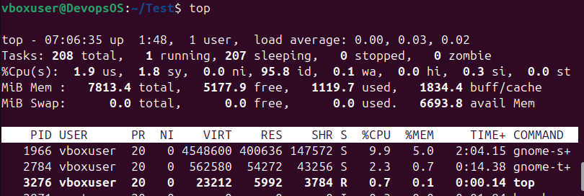

- Kill a running process.(below is running process)
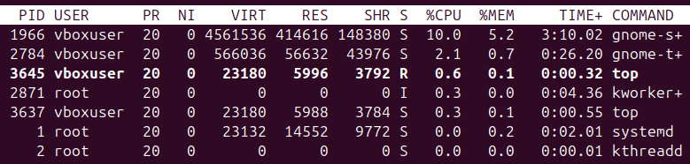
Process id 3645 is killed below screen
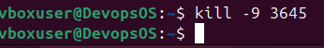
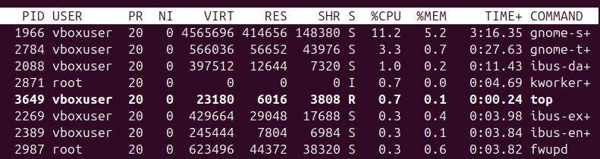
- Install a package using the package manager (e.g., apt or yum).
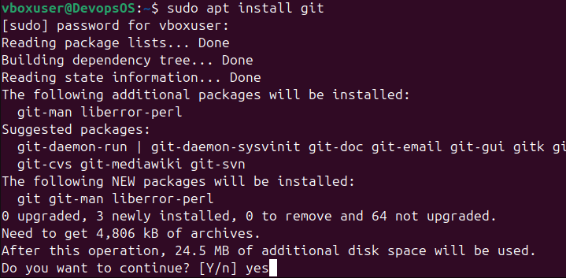
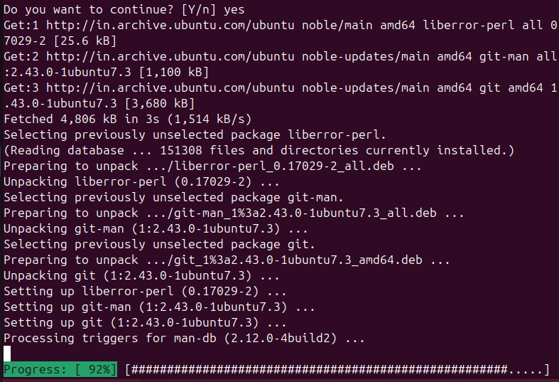
- Update the system packages.
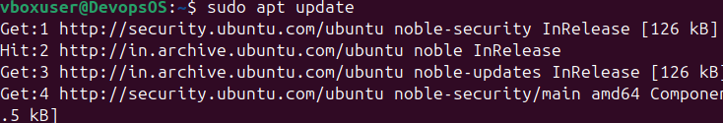
- Create a symbolic link.
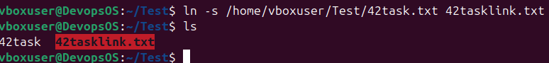
- Search for files using the find command.
- Compress and decompress files using tar.
Compress
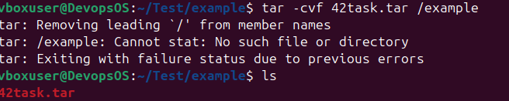

Decompress
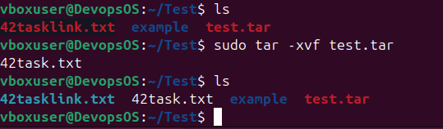

- Monitor system resources with top or htop.
Using top command
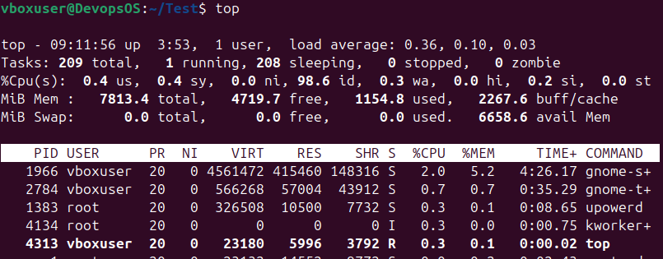

If htop is not install then install first
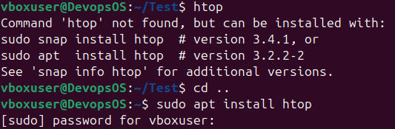
After install then run below command
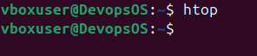
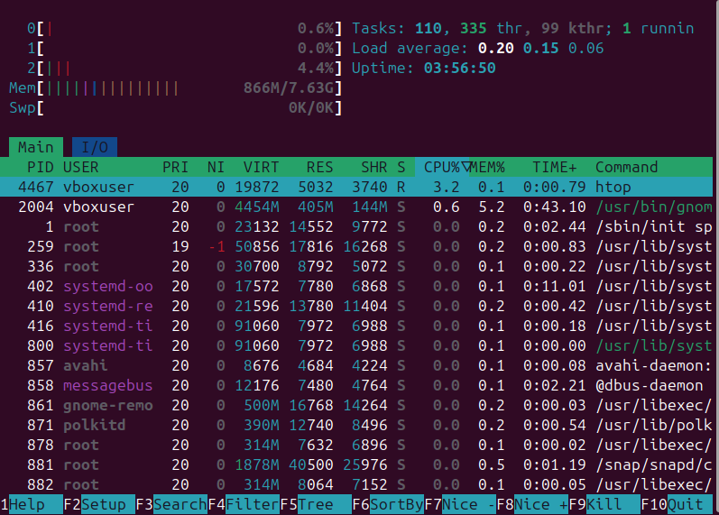
- Create and manage user groups.
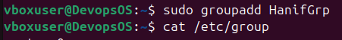
Group Created HanifGrp
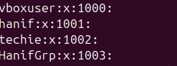
Add techie user in HanifGrp Group
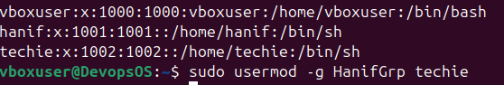
User techie group is change now


- Set up SSH password less authentication.
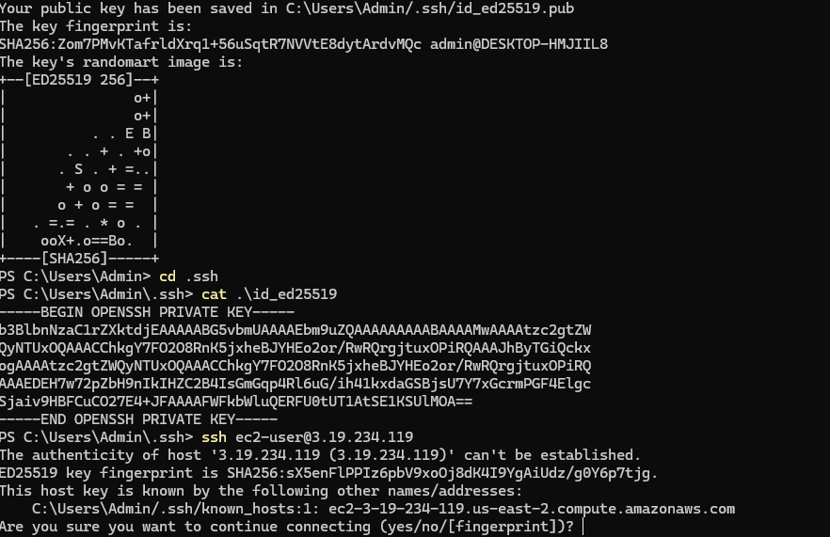
- Monitor log files using tail or grep.
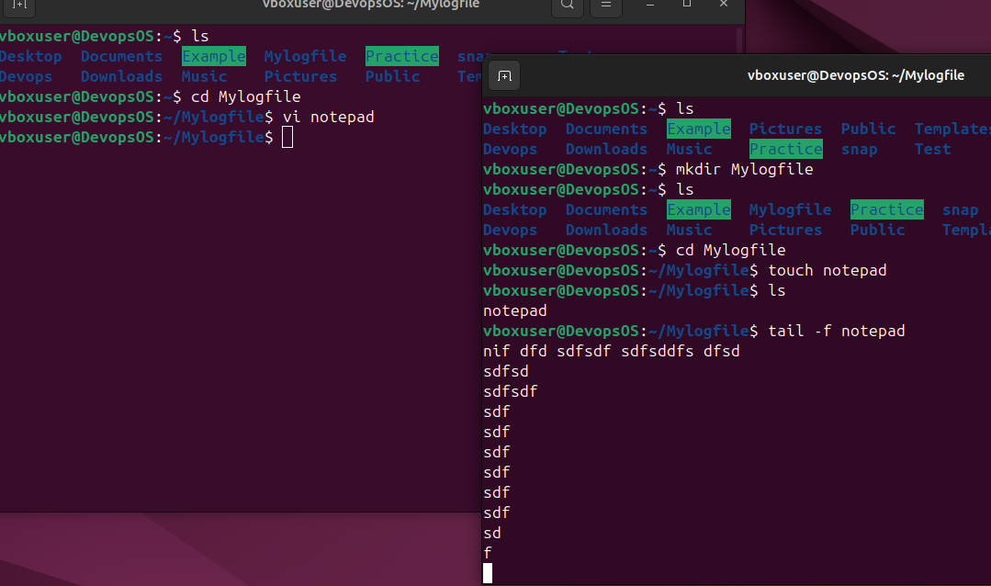
- Set up a web server (e.g., Apache or Nginx).
Apache 2
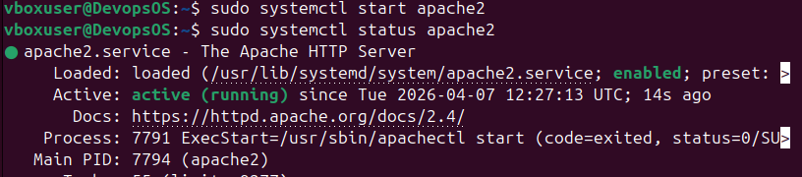

Nginx

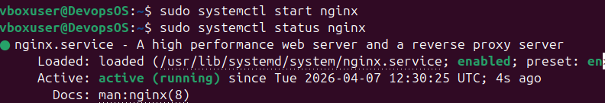
- Configure and secure a MySQL Database.
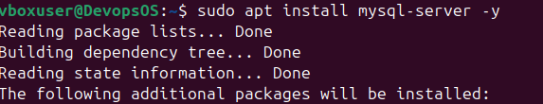
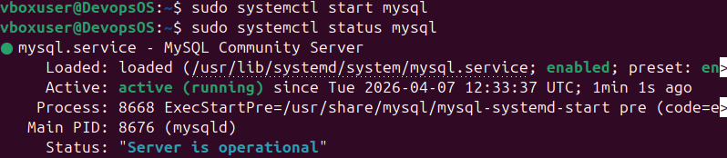

- Set up a Application Server (e.g.,Apache Tomcat)
Install jdk
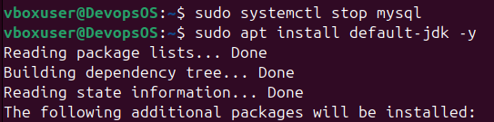
To check jdk install or not
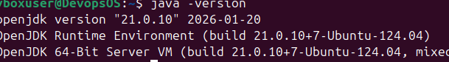
Need to download and install Apache Tomcat
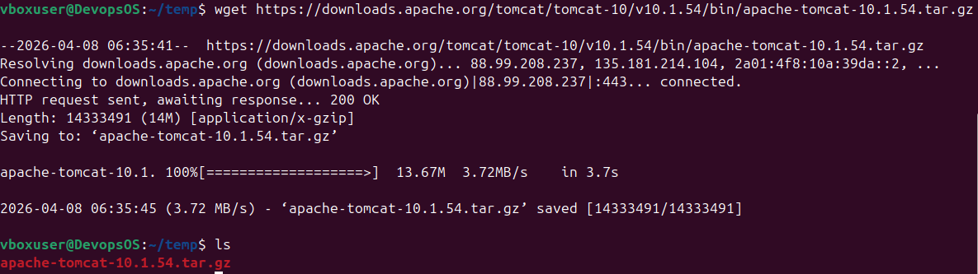
Tomcat file is downloaded, Now decompress the tar file.
We are moving the apache tomcat package to /opt/tomcat directory which we created just now.
we need to go bin folder and execute the startup script which start our tomcat server.
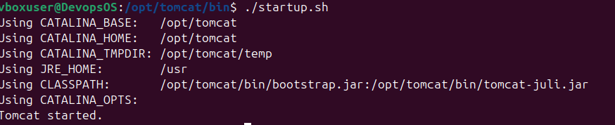
Tomcat is started now. 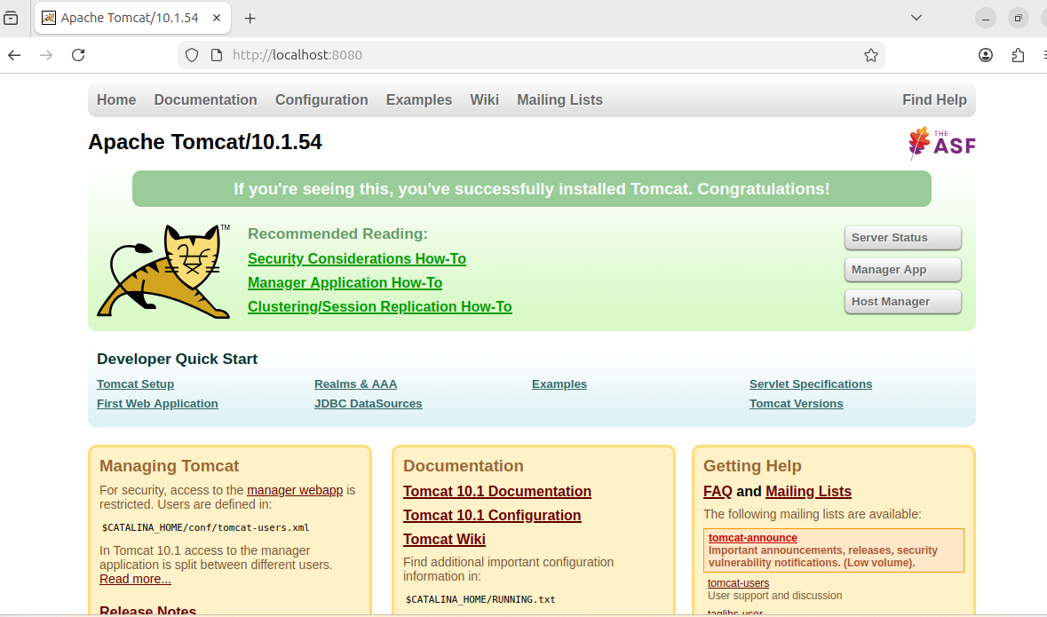

- create a service file for Apache Tomcat.(Should execute by using systemtctl command)
Creating a system service file
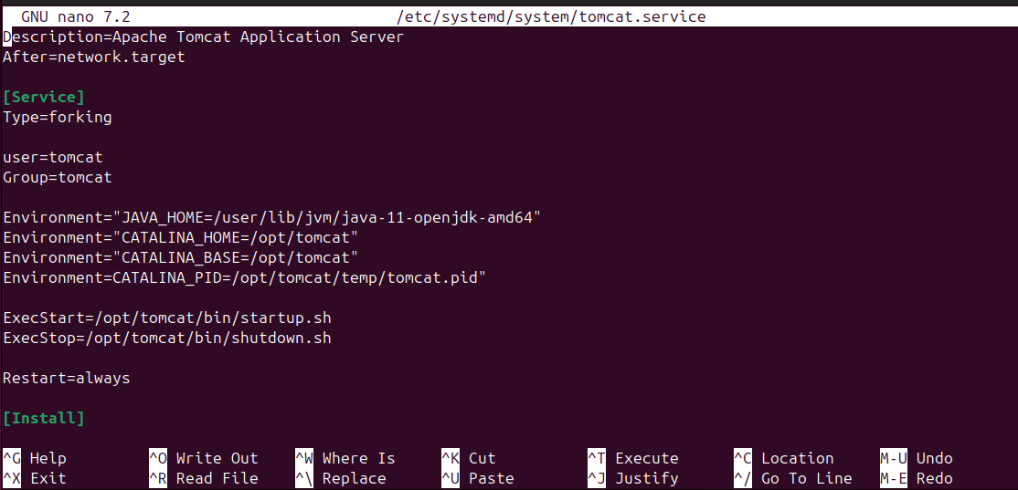
Reload daemon
ensure scripts are executable by giving proper permissions
now go to the /opt/tomcat/bin directory from there we can execute our startup script service ile

- Print specific columns from a delimited file.
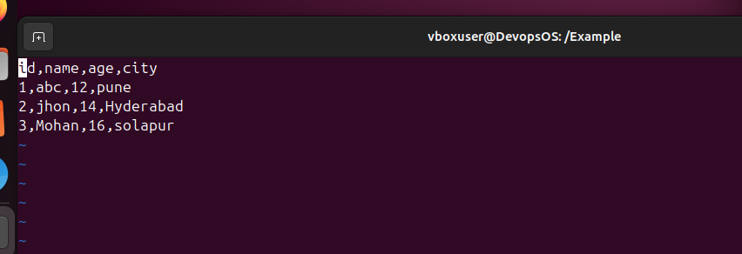
we can print out the specific columns using the cut command.
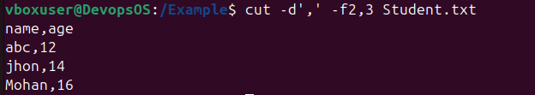
- Filter and print lines based on a specific pattern or condition.
We can achieve this by using grep command Here we have a alternatives log file from which we can filter our output.
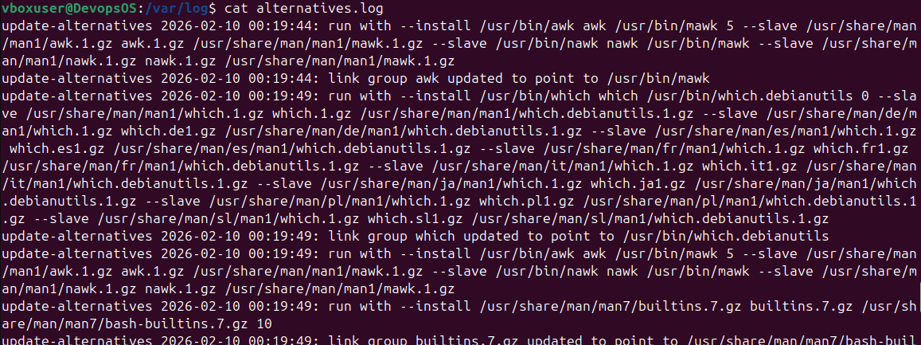

Here we have filtered out only ‘2026-04-07’ logs
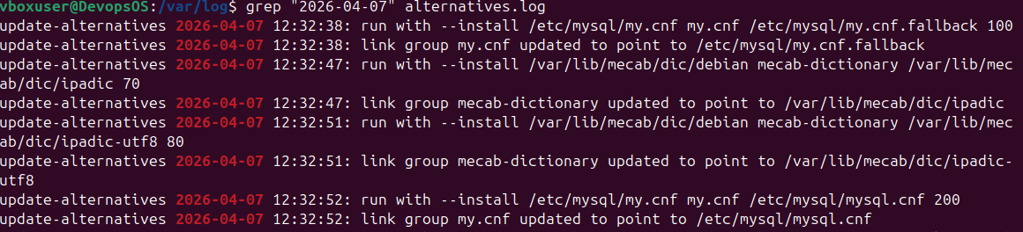
- Calculate and print the average, sum, or other statistics of a column.
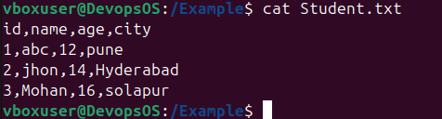
Calculate sum
Find the average
Find minimum and Maximum
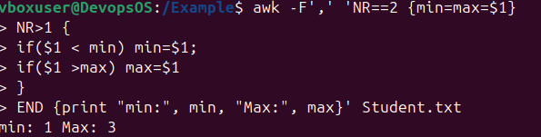

- Perform string manipulation, such as extracting substrings or changing case.
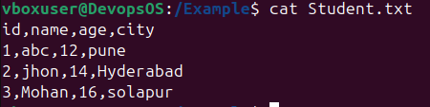
we are printing the first 3 letters of the name column
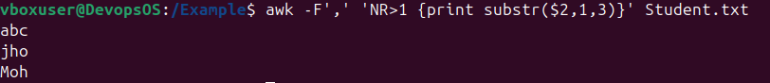
Converted name column in to upper case
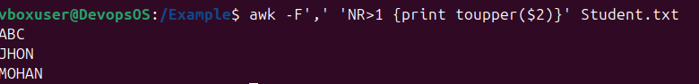

- Count the occurrences of a specific pattern in a file.
- Sort lines based on a specific field or column.
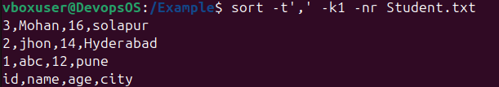
Data is show in descending order. Using id column
- Merge multiple files based on a common field or column.

- Substitute text in a file using search and replace.
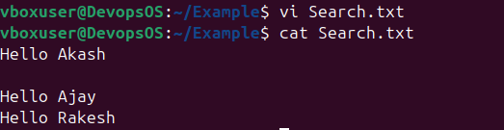
We search and replaced Hello to Hi
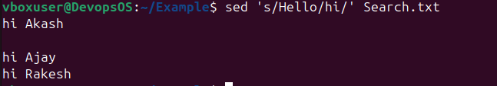
- Delete specific lines based on a pattern or line number.

Second line is deleted here.
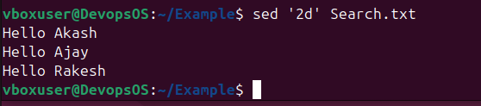
Based on Pattern
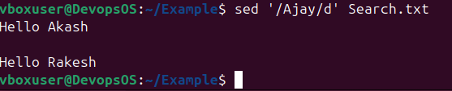

- Append or insert text before or after a specific pattern or line.

Append Text Before “Hello Rakesh”
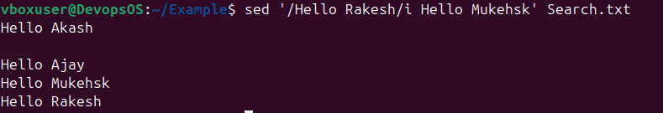
Append Text After “Hello”
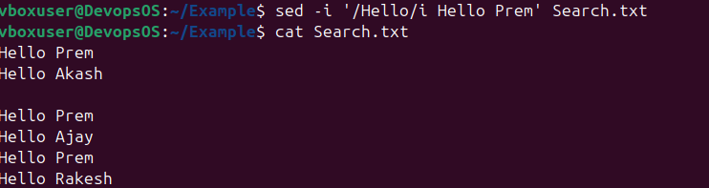

- Print only specific lines from a file.
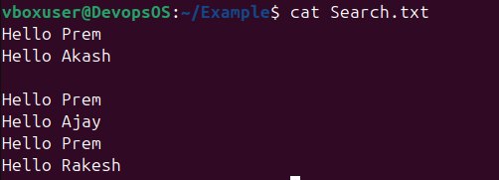
By using sed we have printed only the second line
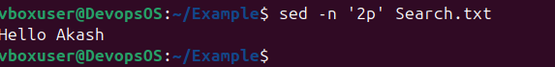
- Copy file from linux to windows machine
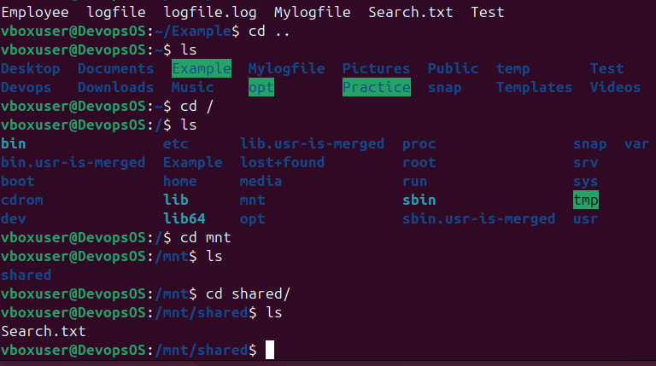
- 5 use cases for AWK and 5 use cases for sed
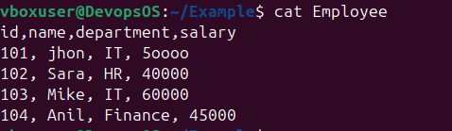
Print column 1 and 3
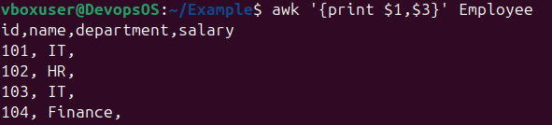
Apply multiple condition
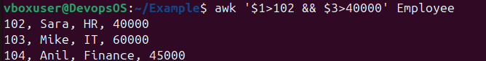

Add Computed Column
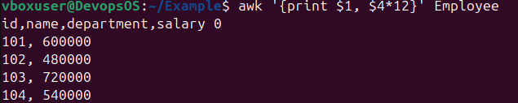
Count Matching row
Filter row base condition.
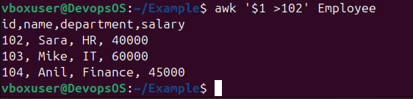

Using Sed command. This is my test file.
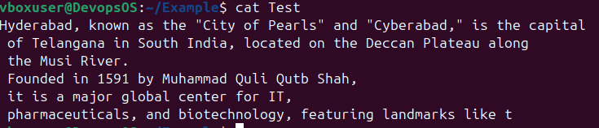
Hello word add in before Hyderabad word.
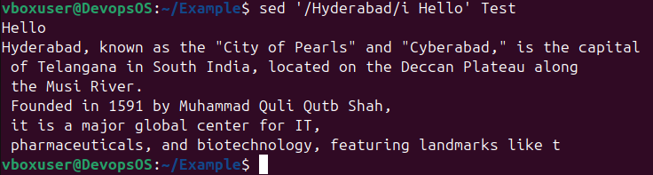
Change Specific word “Cyberabad” To “Pune” in line 1
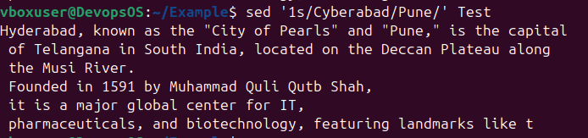
Print only matching line the 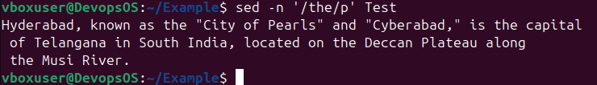
Delete particular line.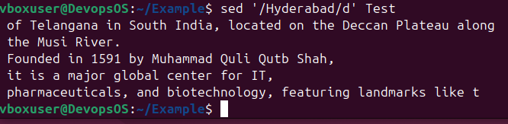
Change “is” to “that “, In whole file.
