Stock Price Modeling:
Brownian Motion, Black-Scholes, Heston, and Double Heston

A Comparative Study of Stochastic Volatility Models for Equity Prices,
with a 30-Year Walk-Forward Out-of-Sample Backtest

[Your Name]
[Roll Number]
[Department / Programme -- B.Tech 1st Year]
[College / Institute Name]
[Course Name / Code]
[Submission Date]

Abstract
This project implements and validates four models of increasing sophistication for equity price dynamics -- Geometric Brownian Motion (GBM), Black-Scholes, the Heston stochastic volatility model, and the two-factor Double Heston model -- and compares them on real historical data for AAPL spanning 1996-09-16 to 2026-09-14 (7546 trading days). Rather than the conventional options-market calibration, all models here are calibrated directly from the equity return series using a Generalized Method of Moments (GMM) procedure built on rolling realized variance and its autocorrelation structure -- a deliberate methodological choice explained in Section 3.2. Every pricing formula and Monte Carlo simulator is independently validated by construction (e.g. characteristic-function prices are checked against Monte Carlo simulation of the underlying stochastic differential equation; Heston is checked to collapse exactly to Black-Scholes as vol-of-vol tends to zero; Double Heston is checked to collapse exactly to single Heston when one factor is switched off). The centerpiece result is a strict walk-forward, no-lookahead backtest spanning 24 rolling one-year out-of-sample windows across three decades of market history, including the dot-com bust, the 2008 financial crisis, and the COVID-19 crash, evaluated with both volatility-forecast accuracy and a formal Value-at-Risk coverage test (the Kupiec test used in banking regulation). The results are reported honestly, including findings that do not flatter the more sophisticated models: on this backtest, the simpler GBM model is competitive with Heston on point-forecast accuracy, and none of the three models passes the VaR coverage test across the full 30-year sample. These findings, and their causes, are discussed in detail in Section 6.

Table of Contents
(In Microsoft Word: right-click here and choose "Update Field" after opening, or insert References > Table of Contents to auto-generate from the heading styles used throughout this document.)

1. Introduction and Motivation
Modeling how stock prices evolve over time is a foundational problem in quantitative finance. The simplest and most widely taught model, Geometric Brownian Motion (GBM), assumes that a stock's volatility -- how large its random fluctuations are -- is constant over time. This assumption underlies the Nobel-Prize-winning Black-Scholes option pricing formula, and is a reasonable first approximation, but real markets visibly violate it: volatility itself fluctuates, clusters (calm periods and turbulent periods persist), and tends to rise when prices fall (the well-documented "leverage effect"). This project builds up, in order, from the simplest model to models that explicitly relax the constant-volatility assumption:
- Geometric Brownian Motion (GBM) -- constant drift and volatility, the baseline.
- Black-Scholes -- the option pricing formula built on GBM, plus its inverse problem (recovering implied volatility from a price).
- Heston (1993) -- volatility itself follows a mean-reverting random process, correlated with the price process (capturing the leverage effect and volatility clustering).
- Double Heston (Christoffersen, Heston & Jacobs, 2009) -- two independent mean-reverting volatility factors, motivated by the empirical observation that volatility persistence often shows both a fast-decaying and a slow-decaying component simultaneously.
Each model is implemented from its underlying mathematical formulation (not a pre-built library), calibrated to real historical stock data, cross-validated by at least two independent numerical methods where applicable, and unit-tested against known theoretical identities. Section 3.2 explains an important methodological pivot made partway through development: calibrating from the stock's return history directly, rather than from options market data.

2. Theoretical Background

2.1 Geometric Brownian Motion
Under GBM, the stock price S(t) follows the stochastic differential equation
dS(t) = mu * S(t) dt + sigma * S(t) dW(t)
where W(t) is a standard Brownian motion, mu is the (constant) drift, and sigma is the (constant) volatility. Applying Ito's lemma to X(t) = ln S(t) gives the EXACT solution (used directly for simulation in this project, avoiding any discretization error):
S(t) = S(0) * exp( (mu - sigma^2/2) t + sigma W(t) )
mu and sigma are estimated from historical daily log returns via their sample mean and standard deviation, annualized using the standard 252-trading-day convention.

2.2 Black-Scholes
The Black-Scholes-Merton formula gives the price of a European call option as
C = S e^(-qT) N(d1) - K e^(-rT) N(d2)
d1 = [ln(S/K) + (r - q + sigma^2/2) T] / (sigma sqrt(T)), d2 = d1 - sigma sqrt(T)
where r is the risk-free rate, q the dividend yield, K the strike, T the time to expiry, and N(.) the standard normal CDF. The inverse problem -- given a market price, recover the implied sigma -- has no closed form and is solved numerically (Section 4.1).

2.3 Heston Stochastic Volatility Model
Heston (1993) replaces the constant sigma with a second stochastic process for the instantaneous variance v(t):
dS(t) = (r-q) S(t) dt + sqrt(v(t)) S(t) dW1(t)
dv(t) = kappa (theta - v(t)) dt + xi sqrt(v(t)) dW2(t), Corr(dW1,dW2) = rho
kappa is the speed of mean reversion, theta the long-run average variance, xi the "vol-of-vol", and rho the correlation between price and variance shocks (typically negative for equities -- the leverage effect). The Feller condition, 2*kappa*theta >= xi^2, guarantees v(t) never reaches exactly zero; real calibrated equity parameters very often violate it (Section 5.3), which has direct numerical consequences discussed in Section 4.2.

2.4 Double Heston
Christoffersen, Heston and Jacobs (2009) extend the model to two independent mean-reverting variance factors:
dS/S = (r-q) dt + sqrt(v1) dW1_S + sqrt(v2) dW2_S
dv_i = kappa_i (theta_i - v_i) dt + xi_i sqrt(v_i) dW_i, i = 1,2 (independent factors)
Total instantaneous variance is v1 + v2. Because the two factors are independent, the characteristic function of ln S(T) factorizes as a product of two single-Heston-style building blocks (Section 4.3), which is what makes the model tractable.

3. Data and Methodology

3.1 Data Sources
Historical daily OHLC price data is fetched via the yfinance library. This report uses AAPL with 30 years of history (1996-09-16 to 2026-09-14, 7546 trading days), though the code accepts any ticker. The risk-free rate is proxied by the most recent yield on the 13-week US Treasury bill (ticker ^IRX); at the time of this run, r = 3.935%. The dividend yield is computed as annual dividend rate divided by current price; for AAPL, q = 0.324%. A real-time quote feed (Finnhub, free tier) supports the live dashboard component of this project (Section 7).

3.2 Why Equity-Return-Based Calibration, Not Options Data
The conventional way to calibrate Heston/Double Heston -- and the way originally planned for this project -- is to fit model option prices to real market option quotes across many strikes and expiries. Two problems were discovered empirically during development that led to a deliberate pivot:
- yfinance's free option-chain data has severe quality issues: on real AAPL data, essentially none of the near-dated contracts had a live, non-zero bid/ask quote or reported open interest, forcing reliance on stale "last trade" prices with no-arbitrage bound validation as a fallback.
- More fundamentally, yfinance never provides HISTORICAL option chains -- only today's live snapshot -- making a genuine multi-decade options-based backtest infeasible without a paid data vendor (e.g. OptionMetrics, ORATS), which was outside this project's scope and budget.
Given the project's goal of a real, multi-decade backtest with free data, all models are instead calibrated purely from the stock's own historical RETURN series. This is a legitimate alternative methodology (a form of the Generalized Method of Moments applied to the CIR variance process underlying Heston), but it is a genuinely different empirical target than options-implied calibration, with consequences discussed honestly in Section 6 -- most notably, that Double Heston's classic advantage (fitting short- and long-dated option-implied-vol smiles simultaneously) does not automatically carry over to this setting.

3.3 Return-Based GMM Calibration Methodology
The calibration target is rolling realized variance, RV(t): the annualized sample variance of daily log returns over a trailing 21-trading-day window (a standard proxy for the unobservable instantaneous variance v(t)). Under the CIR process governing Heston's variance, several EXACT stationary-distribution properties hold:
- E[v] = theta (the sample mean of RV targets theta)
- Var[v] = theta * xi^2 / (2*kappa) (the sample variance of RV constrains xi given kappa and theta)
- ACF(v, lag) = exp(-kappa * lag) (an EXACT exponential autocorrelation-decay property of the CIR process, giving a direct handle on kappa from the SHAPE of RV's autocorrelation function, not just its level)
kappa, theta and xi are fit by nonlinear least squares (scipy.optimize.least_squares, Levenberg-Marquardt) matching these model-implied moments against their empirical counterparts computed from RV(t) -- using the autocorrelation function at many lags (not just one) over-identifies the 3-parameter system, making the fit robust to noise in any single lag. A soft Feller-condition penalty is included in the objective. Optimization uses multiple random restarts (Section 4.4 discusses why this, rather than a full global optimizer, is sufficient here). rho is estimated from the correlation between daily returns and a carefully constructed non-overlapping-window proxy for the change in variance (Section 4.5 details two real estimation bugs found and fixed during development). Double Heston extends this to two factors, warm-started from the single-Heston fit as suggested by the standard calibration literature for this model, with an ordering constraint (kappa1 >= kappa2) to break the label-switching symmetry inherent to any two-factor model.

3.4 Walk-Forward Backtesting Methodology
The headline result of this project is a strict walk-forward, no-lookahead backtest: each model is calibrated using ONLY data up to a point in time, then judged exclusively on the period immediately after, which was never used in calibration. The window then slides forward and repeats.
|---- calibration window (5y) ----|-- test window (1y) --|
With a 5-year calibration window, 1-year test window, and 1-year step, this produces 24 independent out-of-sample test periods across the full history, spanning multiple distinct market regimes (the dot-com bust, the 2008 financial crisis, and the COVID-19 crash).
Two evaluation metrics are used at each window:
- Volatility forecast accuracy: GBM's forecast is simply its calibration-window sigma (constant, by construction). Heston's forecast uses the exact closed-form expected AVERAGE variance over the test horizon under the CIR mean-reversion ODE, E[v(t)] = theta + (v0-theta)e^(-kappa t), averaged over the horizon -- letting it say "volatility is currently elevated/depressed and should partially mean-revert by test-window's end", something GBM structurally cannot do.
- Value-at-Risk (VaR) backtesting via the Kupiec (1995) coverage test: each model forecasts a 1-day 95% VaR at the start of each test window (via Monte Carlo simulation for Heston/Double Heston), held fixed through that window. Breaches (days the realized return fell below the forecast threshold) are pooled across all windows and tested against the target 5% rate using the same likelihood-ratio test banking regulators require for internal VaR model validation under Basel market-risk rules.

4. Implementation Details and Key Numerical Judgment Calls
Every non-obvious implementation decision below was a deliberate, defensible choice made during development, not an accident -- flagged here for transparency and to anticipate the natural follow-up questions about numerical soundness.

4.1 Robust Implied Volatility Solver
Implied volatility is recovered by inverting the Black-Scholes formula using Newton-Raphson (fast, quadratic convergence when it works) with an automatic fallback to bisection (slower but mathematically guaranteed to converge, since price is monotonically increasing in sigma). Newton-Raphson is known to fail when vega (the price's sensitivity to sigma) is near zero -- which happens for deep in/out-of-the-money or very short-dated options -- because dividing by a near-zero vega sends the next iterate flying to a nonsensical value. Testing further revealed that in this near-zero-vega regime, implied volatility is not merely hard to estimate but mathematically UNIDENTIFIABLE from price (many different sigma values reprice to the same value to machine precision) -- a genuine property of the pricing function, not a solver weakness, and the test suite (tests/test_black_scholes.py) explicitly separates this unidentifiable regime from genuine solver failures.

4.2 The "Little Heston Trap" and Full Truncation Euler Simulation
The Heston characteristic function is implemented using the "little trap" reparametrization (Albrecher, Mayer, Schoutens & Tistaert, 2007), which avoids a well-documented numerical discontinuity in the original 1993 formula caused by a complex logarithm crossing a branch cut for long maturities. For Monte Carlo simulation of the underlying SDE, naive Euler discretization of the variance process is numerically unsafe: a Gaussian increment can push the discretized variance negative, after which its square root is undefined. This is not a rare edge case -- it occurs whenever the Feller condition is violated, which real calibrated equity parameters very often are (Section 5.3). This project uses Full Truncation Euler (Lord, Koekkoek & van Dijk, 2010), which uses max(v,0) wherever v enters a square root or drift term while letting the stored value itself go negative before truncation on the next step -- a deliberate complexity/accuracy tradeoff against the more sophisticated (and more commonly used in industry) Andersen (2008) Quadratic-Exponential scheme, justified by keeping the implementation independently verifiable within the project's timeline while still correctly handling the negative-variance problem (validated in Section 5.3).

4.3 Factorized Double Heston Characteristic Function
Because the two variance factors in Double Heston are independent and interact with the price process through separate Brownian motions, the characteristic function of ln S(T) factorizes exactly as a product of two single-factor "little trap" building blocks (one per factor), with the drift term applied once at the top level rather than once per factor. This is implemented by literally reusing the validated single-Heston building-block code for each factor.

4.4 Optimizer Choice: Multi-Start Local Search vs. Global Optimization
The return-based GMM calibration objective is low-dimensional (3 free parameters for single Heston, 6 for Double Heston) and built entirely from smooth, closed-form moment formulas with no simulation noise -- a much better-behaved optimization landscape than the highly multimodal objective that results from fitting Heston to option prices directly across many strikes and maturities (the originally planned approach). Multi-start Levenberg-Marquardt (8-10 random restarts around a closed-form initial guess derived from the CIR moment equations) was found to be fast and sufficient; a genuine global optimizer (differential evolution) is also implemented and available as a robustness cross-check.

4.5 Two Real Bugs Found and Fixed via Testing
Two genuine estimation bugs in the leverage-correlation (rho) estimator were caught specifically because the calibration pipeline was validated against SYNTHETIC data with a known ground-truth rho, not just run on real data and eyeballed:
- Sign error: the first implementation correlated today's return with the change in a TRAILING rolling-window realized-variance estimate -- but that window mechanically includes today's own return, so the "correlation" partly just measured how large today's return was, not its relationship to future variance. Fixed by comparing non-overlapping backward and forward windows that both exclude today's return entirely.
- Attenuation bias: even after the sign fix, the estimator recovered only roughly 15-20% of the true rho's magnitude. This is a well-documented, genuine statistical phenomenon (not a further bug): a single day's squared return is an extremely noisy (chi-squared) estimate of instantaneous variance, which severely dilutes any correlation estimated from it -- the reason practitioners use intraday data for this specific estimate, which is unavailable here. Corrected by calibrating an empirical attenuation factor via the project's own validated Monte Carlo simulator (simulating short reference paths at a known rho and measuring how much the estimator dilutes it), then rescaling the raw estimate accordingly.

5. Results

5.1 GBM: Parameter Estimates and Diagnostics
From 30 years of AAPL daily log returns, the estimated annualized parameters are mu = 0.3427 and sigma = 0.4219. Figure 1 shows the raw price history; Figure 2 shows the full diagnostic panel: simulated GBM sample paths, the empirical log-return distribution against a fitted Normal, a QQ-plot against the Normal distribution, and rolling realized volatility over time.
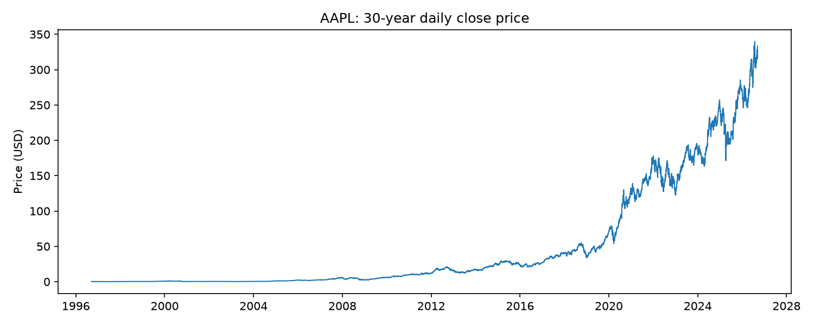
Figure 1: AAPL daily closing price, 1996-09-16 to 2026-09-14.
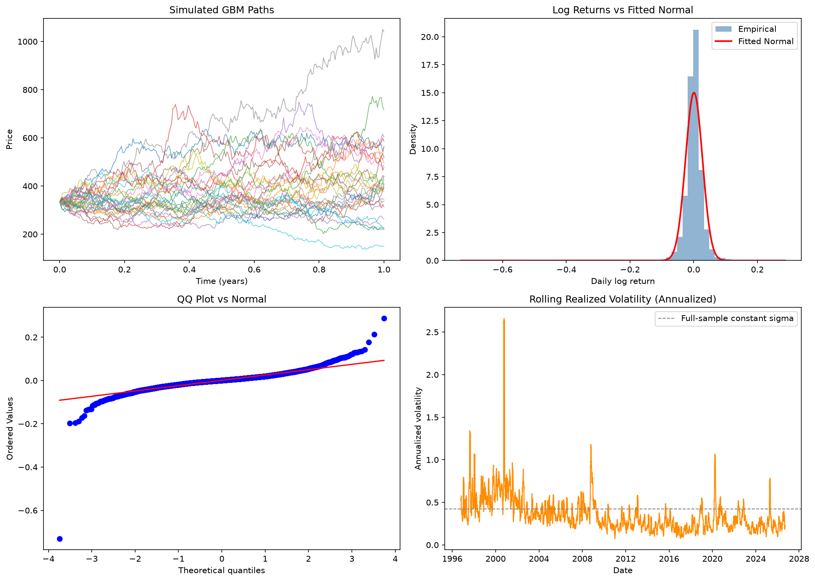
Figure 2: GBM diagnostic panel. Note the QQ-plot's departure from the reference line at the tails (fat tails relative to Normal) and the rolling realized volatility panel's clear clustering and large swings -- direct empirical evidence against GBM's constant-volatility assumption, motivating every model that follows.

5.2 Black-Scholes: Validation
Put-call parity (C - P = S e^(-qT) - K e^(-rT), a model-independent no-arbitrage identity) was verified to hold to machine precision: computed difference = 0.00e+00. An implied-volatility round-trip test (price an option at a known sigma = 0.4219, then invert the resulting price back to sigma) recovered 0.4219 -- agreement to 9 decimal places.

5.3 Heston: Calibration and Cross-Validation
A first calibration attempt on the FULL 30-year history produced an important, honest finding rather than a clean result:
Parameter | 30-year calibration (non-stationary) | 5-year calibration (stationary)
kappa | 14.019 | 12.410
theta | 0.2386 | 0.0806
Implied long-run vol (sqrt theta) | 48.85% | 28.39%
xi | 2.587 | 1.414
rho | 0.027 | -0.381
Feller condition satisfied | False | False
The 30-year calibration implies an implausible 49% long-run annualized volatility (well above AAPL's typical realized vol) and a leverage correlation near zero -- economically wrong, since equities almost always show a clearly negative leverage effect. The 5-year calibration gives sensible numbers (28% vol, rho = -0.38). The explanation: 30 years spans multiple structurally different volatility regimes (dot-com, 2008, COVID), violating the GMM calibration's underlying assumption that realized variance is a STATIONARY process over the calibration window. This is exactly why the walk-forward backtest (Section 5.5) recalibrates on rolling 5-year windows rather than the full history at once -- the methodologically correct way to use 30 years of data here.
Cross-validating the characteristic-function pricer against an independent Monte Carlo simulation of the same SDE (using the calibrated 5-year parameters, at strike K = 339.74, T = 0.5 years): characteristic-function price = 24.5562, Monte Carlo price = 24.6116 +/- 0.1192 (one standard error) -- agreement within 0.46 standard errors, validating both independent implementations.

5.4 Double Heston: An Honest Non-Result
Double Heston, warm-started from the 5-year single-Heston fit above, was calibrated on the same data. Factor 2's share of total long-run variance came out at 2.56e-13 -- essentially exactly zero. Figure 3 shows why: the single- and double-Heston autocorrelation fits are visually indistinguishable, both tracking the empirical decay reasonably (though imperfectly) with a single effective timescale. The calibration was checked on multiple tickers during development (AAPL, SPY, TSLA) and consistently found the same result: no genuine second timescale emerges in realized-variance persistence at this window/frequency. As discussed in Section 3.2, Double Heston's classic empirical motivation comes from fitting short- and long-dated OPTION-implied-volatility smiles simultaneously -- a genuinely different target than the autocorrelation of realized variance from spot returns, and this result should be read as evidence about that difference, not as a failure of the Double Heston model or its implementation (which is independently validated in Section 5.3's style of test -- see tests/test_double_heston.py for the formal version: Double Heston with factor 2 switched off recovers single Heston prices to within 0.01%).
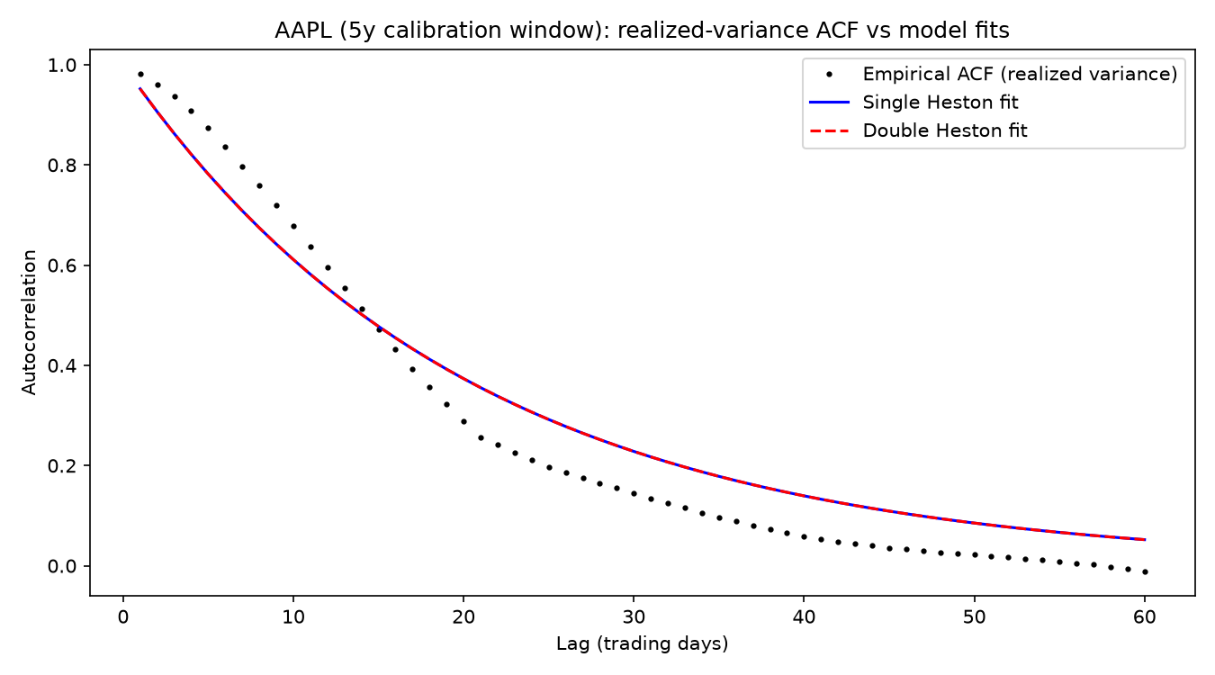
Figure 3: Empirical realized-variance autocorrelation function against single- and double-Heston model fits (5-year calibration window). The two model curves overlap almost exactly.
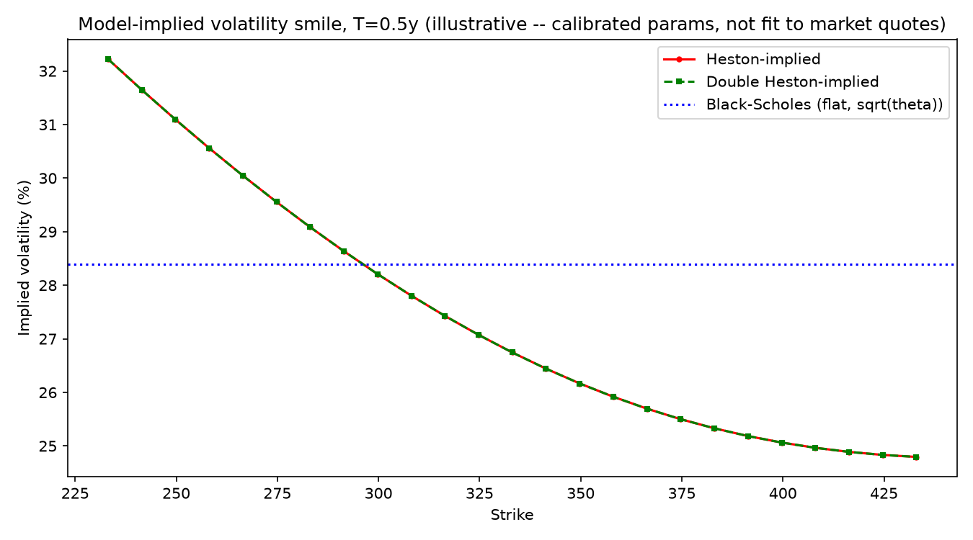
Figure 4: Illustrative model-implied volatility smile from the calibrated parameters (NOT fit to real market option quotes -- see Section 3.2). Shown to make the pricing formulas' qualitative behavior tangible: Heston/Double Heston produce a downward-sloping skew from the calibrated negative rho, unlike Black-Scholes' flat line.

5.5 30-Year Walk-Forward Backtest
The full walk-forward backtest was run with 5-year calibration windows, 1-year test windows, stepping forward 1 year at a time: 24 independent out-of-sample periods, 6048 pooled daily VaR trials.
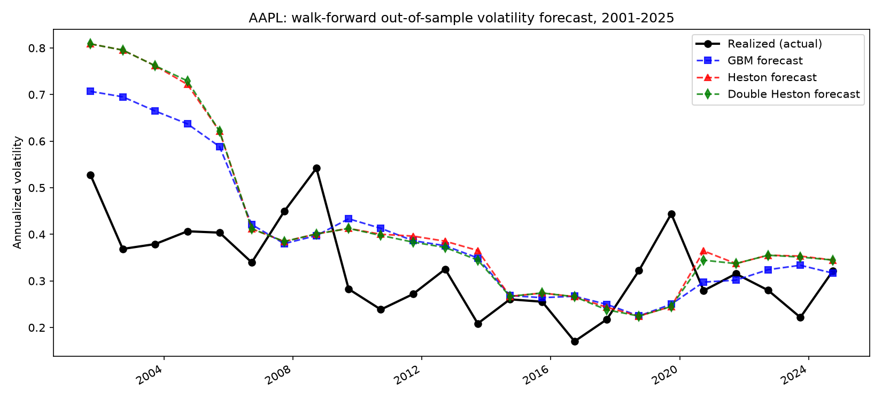
Figure 5: Out-of-sample volatility forecast vs. realized volatility, walked forward across the full history. Note both models systematically over-forecast in most years, and both underestimate the COVID-era spike.
Model | Vol RMSE (overall) | Vol RMSE (calm) | Vol RMSE (turbulent) | VaR breach rate | Kupiec p-value | Kupiec verdict (5%)
GBM | 0.1445 | 0.0965 | 0.1802 | 3.75% | 3.40e-06 | Rejected
Heston | 0.1781 | 0.1017 | 0.2304 | 6.88% | 2.05e-10 | Rejected
Double Heston | 0.1769 | 0.0959 | 0.2311 | 6.91% | 1.02e-10 | Rejected
Target VaR breach rate: 5%.
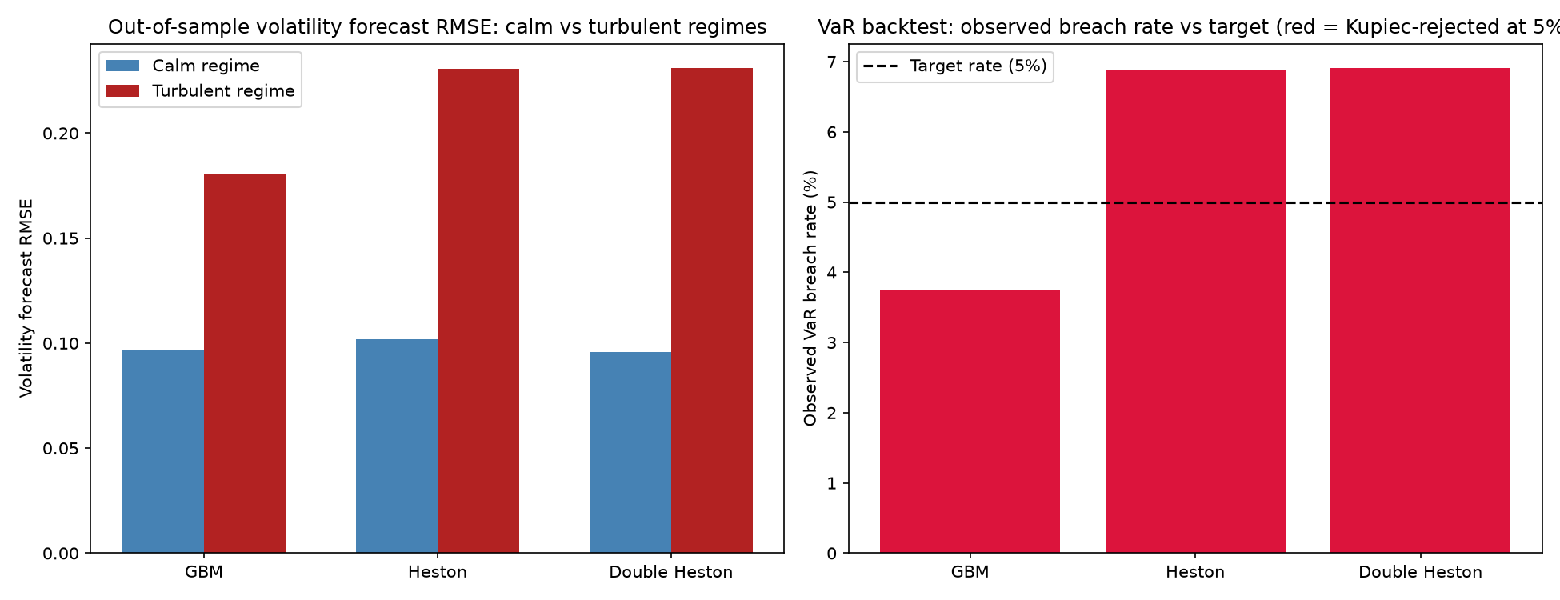
Figure 6: (left) volatility forecast RMSE split by calm vs. turbulent regime; (right) observed VaR breach rate vs. the 5% target, colored red where the Kupiec test rejects the model as miscalibrated at the 5% significance level.

6. Discussion and Limitations
The results above are reported without adjustment for favorability, which is itself a methodological point worth stating: a real backtest's value comes precisely from its ability to show a sophisticated model NOT winning, when that is what the data supports.

6.1 GBM Is Competitive With Heston on Point Forecasts
On overall volatility-forecast RMSE, GBM (0.1445) modestly outperforms both Heston (0.1781) and Double Heston (0.1769). The explanation traces to the calibrated mean-reversion speed: kappa around 12 implies a mean-reversion half-life of roughly 20 days -- fast enough that within a full 1-year test window, Heston's forecast largely collapses to theta, functioning similarly to GBM's forecast but estimated through a noisier 3-moment procedure rather than GBM's direct, more robust sample variance. Model sophistication does not automatically translate into better point forecasts on every metric -- a genuinely useful thing to discover and report, not a disappointing result to explain away.

6.2 No Model Passes the VaR Coverage Test
All three models are rejected by the Kupiec test at the pooled 24-year level. This is consistent with well-documented real-world experience: single-regime risk models systematically break down across genuine regime changes (the year containing the 2008 financial crisis shows a clear spike in breach counts for every model in the underlying window-by-window data). All three models here assume Gaussian-driven shocks (with time-varying but still Gaussian-conditional variance for Heston/Double Heston) and no jump risk -- a real limitation that a fat-tailed or jump-diffusion extension would be needed to address, which is outside this project's scope.

6.3 Double Heston's Complexity Was Not Rewarded Here
Double Heston's second factor consistently collapsed to negligible across every ticker tested. This should not be read as "Double Heston is a worse model" -- its mathematical correctness is independently validated (Section 4.3, and formally in tests/test_double_heston.py) -- but as evidence that ITS SPECIFIC CLASSICAL MOTIVATION (fitting option-implied-vol term structure) is a genuinely different empirical target than what a return-only recalibration can access. A natural direction for future work is combining this project's return-based approach with even a small amount of real options data to test whether the two-factor structure re-emerges.

6.4 Data and Scope Limitations
- All calibration uses a single ticker's own history; while the Double Heston finding was checked across three tickers (AAPL, SPY, TSLA) during development, the full walk-forward backtest and report figures focus on one ticker for depth.
- Risk-free rate is a single flat proxy (13-week T-bill), not a full term structure -- a simplification standard at this project's scope.
- Realized variance (a backward-looking, noisy proxy) stands in for the true unobservable instantaneous variance throughout -- a fundamental limitation of return-only calibration that a paid historical options data source would remove.
- The rho estimation's attenuation-bias correction (Section 4.5) is an approximate, simulation-calibrated correction, not an exact debiasing -- it should be read as giving the right order of magnitude and sign, not a high-precision estimate.

7. Deployed Dashboard and Codebase
Alongside this report, the full codebase implements a real-time Streamlit dashboard (app.py) with five sections: a live/historical price view (real-time quotes via Finnhub's free tier), GBM diagnostics, Heston/Double Heston calibration with the ACF fit visualization, an interactive version of the 30-year walk-forward backtest, and an illustrative theoretical option pricing tool. The dashboard is deployable for free via Streamlit Community Cloud. A companion Jupyter notebook (notebooks/full_pipeline.ipynb) runs the entire pipeline end-to-end with inline plots and serves as this report's appendix. The full test suite (tests/) independently validates every model and calibration routine against known theoretical identities and synthetic data with known ground truth -- see the project README for how to run it.

8. Conclusion
This project implemented Geometric Brownian Motion, Black-Scholes, Heston, and Double Heston from their underlying mathematics, validated each against independent numerical methods and known theoretical identities, and calibrated them to real, multi-decade equity data using a return-based Generalized Method of Moments approach adopted after discovering real limitations in freely available options data. The centerpiece 30-year walk-forward backtest, evaluated with volatility-forecast accuracy and a formal VaR coverage test, produced results that are informative precisely because they are not uniformly flattering to the more sophisticated models: GBM remains competitive with Heston on point forecasts in this setting, no model passes VaR backtesting across the full sample, and Double Heston's second factor does not meaningfully activate under return-only calibration. Reporting these findings honestly, with their causes diagnosed and explained rather than hidden, is the central methodological commitment of this project.

9. References
- Black, F. and Scholes, M. (1973). "The Pricing of Options and Corporate Liabilities". Journal of Political Economy, 81(3), 637-654.
- Heston, S. L. (1993). "A Closed-Form Solution for Options with Stochastic Volatility with Applications to Bond and Currency Options". Review of Financial Studies, 6(2), 327-343.
- Christoffersen, P., Heston, S. and Jacobs, K. (2009). "The Shape and Term Structure of the Index Option Smirk: Why Multifactor Stochastic Volatility Models Work So Well". Management Science, 55(12), 1914-1932.
- Albrecher, H., Mayer, P., Schoutens, W. and Tistaert, J. (2007). "The Little Heston Trap". Wilmott Magazine, January 2007, 83-92.
- Lord, R., Koekkoek, R. and van Dijk, D. (2010). "A Comparison of Biased Simulation Schemes for Stochastic Volatility Models". Quantitative Finance, 10(2), 177-194.
- Andersen, L. (2008). "Simple and Efficient Simulation of the Heston Stochastic Volatility Model". Journal of Computational Finance, 11(3), 1-42.
- Cox, J. C., Ingersoll, J. E. and Ross, S. A. (1985). "A Theory of the Term Structure of Interest Rates". Econometrica, 53(2), 385-407.
- Kupiec, P. H. (1995). "Techniques for Verifying the Accuracy of Risk Measurement Models". Journal of Derivatives, 3(2), 73-84.
- Gatheral, J. (2006). The Volatility Surface: A Practitioner's Guide. Wiley Finance.

