AI CAPITAL GROUP
Sharpened Project Plan — v2
CEO Operating Model: goal · plan · approve · execute · report · judge
Issued: 13 April 2026 | Owner: J (CEO)
From: Phases 1-3 live, Telegram partial, company status RED.
To: 5 divisions live, CEO decides only, silence by default, time saved proven.

1. Executive Summary
This is v2 of the project plan. v1 described how to build the system. v2 describes how the CEO operates it. The change is not cosmetic: the CEO's stated goal is to make decisions while delegating monitoring, retain productivity, and save time. v1 was 75% aligned to that goal; v2 closes the gap.
Three operating-model concepts are now baked in: (1) the six-stage Loop — Goal → Plan → Approve → Execute → Report → Judge; (2) a Decision Queue capped at five open items; and (3) a Silence Policy under which the system speaks only when something is actually waiting on the CEO. Two stages from v1 have been descoped: Research is now on-demand by default rather than weekly, and Idea Generation is fully optional and capped at one idea per week. Treasury has been promoted ahead of Research because it removes the most CEO time per hour invested. Time-Saved is now a tracked metric, not an aspiration.

2. The Operating Model
This is the contract between you and the system. Every stage of the build serves it.

# | Stage | Who does what
01 | GOAL | CEO issues a goal in chat or in the Tracker. The system writes it to the Goals sheet and routes it to the relevant division.
02 | PLAN | Division drafts a plan: scope, success criteria, effort estimate. Plan is written to the Plans sheet with status = awaiting_approval.
03 | APPROVE | CEO sees the plan in Decisions Pending and replies in chat: /approve <id>, /reject <id>, or /amend <id> <note>. One tap, low friction.
04 | EXECUTE | Approved plan is executed by the division. Every action lands in the Execution Log automatically.
05 | REPORT | Division files a report on completion (or on weekly cadence). Report shows up on the Reports sheet.
06 | JUDGE | CEO marks the report Accepted (loop closes) or Re-tasked (a new goal spawns). Verdict is logged.

Three rules govern the model:
- The Decision Queue holds at most five open items. A sixth waits for one to clear.
- The system is silent by default. It speaks only when (a) a decision is pending, (b) status colour changed, or (c) seven days have passed.
- Time saved is logged weekly. Two consecutive weeks of net-negative time means the operating model has failed and must be revised before any new work.

Visual reference
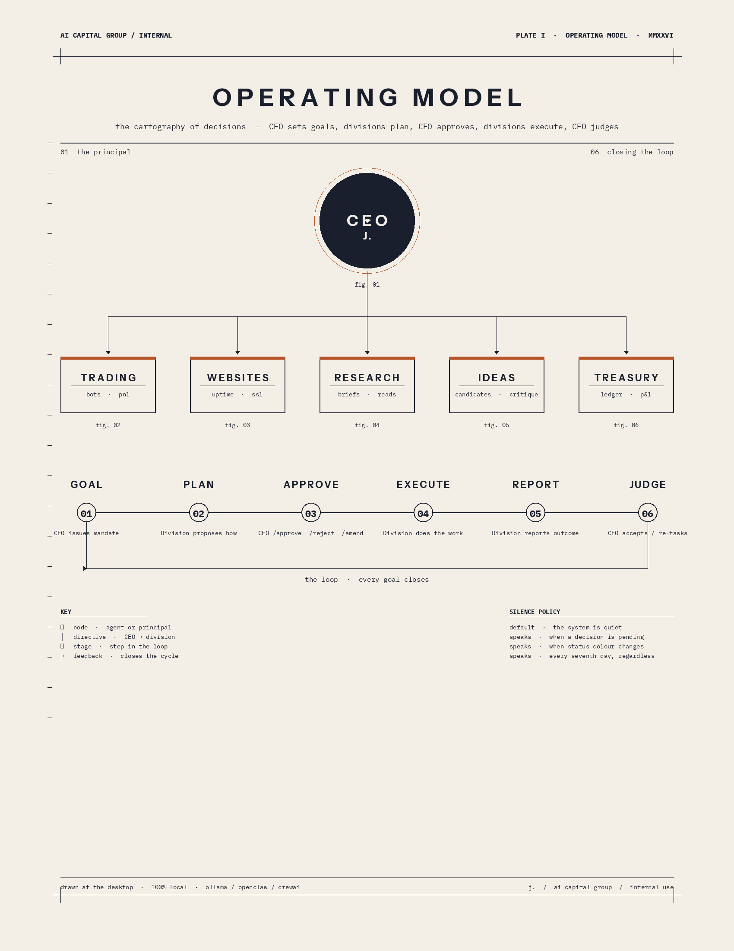
fig. 01 · Operating Model

3. Companion Artifacts
This plan is one of three artifacts. They are designed to work together.
Artifact | What it does
AI-Capital-Group_Operating-Model.png | Single-page visual reference. CEO at top, divisions below, 6-stage loop with silence policy. Print it.
AI-Capital-Group_Goals-Decisions-Tracker.xlsx | Source of truth. Sheets: README, Goals, Plans, Decisions Pending, Execution Log, Reports, Time Saved. Color-coded statuses, dropdowns, formulas.
AI-Capital-Group_Sharpened-Project-Plan-v2.docx | This document. The contract between CEO and the system. Re-issued at end of every stage.

How to use them together: the Tracker is where work lives day-to-day. The Diagram is the one-page mental model. This Plan is the contract for what gets built and in what order.

4. Current State Snapshot
Component | Status | Evidence (as of 2026-04-13)
Phase 1 — Telemetry / Daily Brief | LIVE | daily_brief_latest.json @ 17:18:03Z. bots=2, websites_up=2/2, alerts=3.
Phase 2 — Division Crews | LIVE | phase2_divisions_latest @ 17:19:55Z. trading=AMBER, websites=RED.
Phase 3 — CEO / Holding Board | LIVE | phase3_holding_latest @ 17:20:35Z. company_status=RED.
Telegram Chat Ops | PARTIAL | /brief sim fails auth gate. allowlists empty in projects.yaml.
Scheduler | UNVERIFIED | heartbeat.yaml exists; not confirmed firing autonomously.
Operating-Model Loop | NEW | This document defines it. Tracker workbook implements it.
Operational Signals | RED | Polymarket recency stale; FreeTraderHub freshness stale; division green ratio failing.

Headline: the brain works, the mouth doesn't, the operating model wasn't formalised, and three signals are red. v2 fixes all of that in priority order before adding new capability.

5. What 'Fully Running' Looks Like
Before any more work happens, the destination must be unambiguous. The table below is the acceptance test for the entire programme. If all nine rows are true and have been true for 14 consecutive days, the holding company is in production.
Dimension | What 'fully running' looks like
CEO role | Decides only. Issues goals, approves plans, judges reports. Does no monitoring, no math, no chasing.
CEO time | Under 30 minutes per day on average. Tracked weekly in the Time Saved sheet. Net hours saved is positive every week.
Chat experience | Silence by default. System speaks only when (a) a decision is pending, (b) status colour changed, or (c) 7 days passed.
Divisions | Five live: Trading, Websites, Research, Idea Gen, Treasury. Each plans its own work, executes after approval, reports back.
Decision Queue | Always visible in the Tracker and accessible via /pending. Hard cap of 5 open decisions at any time. Older items expire and re-queue.
Holding Board | Weekly Board Pack with 1-3 specific CEO decisions, each with dissent and a deadline. Decision log is append-only.
Reliability | 14-day green streak. Daily backup to second local disk. Disaster recovery rehearsed once.
Locality | 100% Ollama. Network logs show zero outbound calls to cloud LLMs. Model updates A/B-gated.
Cost | $0 in API costs. Marginal electricity only.

6. Timeline (8-Week View)
Weeks are wall-clock, assuming part-time CEO availability and CPU-only inference. Critical path: A → B → D → G → H → I. Stages C, E, F are parallel or optional.
Stage | Wk1 | Wk2 | Wk3 | Wk4 | Wk5 | Wk6 | Wk7 | Wk8
A — Telegram + Silence
B — Scheduler
C — Sanitizer
D — Signals → GREEN
G — Treasury (moved up)
E — Research (on-demand)
F — Ideas (optional)
H — Board v2 + Queue
I — Steady State + Proof

Note the reorder vs. v1: Treasury (G) is now ahead of Research (E) because it removes the most CEO time. Idea Gen (F) is now flagged optional.

7. Detailed Stage Plan
Each stage below is independently scoped with its own goal, deliverables, success criteria, and definition of done. Do not begin a stage until its dependencies are GREEN. Each stage names its role in the operating-model Loop.

STAGE A Telegram Bridge + One-Tap Approvals + Silence Policy

Owner | CEO populates secrets; system applies
Effort | 1 hr
Depends on | Existing OpenClaw gateway; Telegram bot already paired
Priority | P0 — without this, the whole operating model is theoretical
Loop role | Powers stages 03 (APPROVE) and 06 (JUDGE) end-to-end

Goal
Make Telegram the CEO's single control surface. Plans surface as one-tap approve/reject. The system stays silent unless a decision is pending, status changed colour, or 7 days passed.

Deliverables
- TELEGRAM_OWNER_CHAT_ID / TELEGRAM_OWNER_USER_ID populated; allowlists in projects.yaml filled
- Commands: /pending (decision queue), /approve <id>, /reject <id>, /amend <id> <note>, /accept <id>, /retask <id>, /brief, /trading, /websites, /ceo, /status, /time, /help
- Silence policy implemented: default = no message; speaks only on pending-decision / colour-change / 7-day-quiet
- Inbound rate limit (30 cmds/hr) and unauthorised-sender refusal + log

Success criteria (binary, measurable)
- /pending returns the current decision queue in <10s
- /approve and /reject mutate the Tracker correctly and confirm in <5s
- Over a 7-day window: zero unsolicited messages on days with no pending decisions and no colour change
- Zero auth-gate failures in a 24h rolling window

Done means
You can run the entire CEO loop from your phone, and on a quiet day you hear nothing.

Top risks / watch-outs
- Silence policy hides genuine problems — set the 7-day floor as a hard maximum, never longer
- Allowlist drift across projects.yaml and .env — pick ONE primary; the other reads from it

STAGE B Scheduler Verification & Self-Heal

Owner | System (with CEO sign-off on times)
Effort | 45 min
Depends on | Stage A complete (so missed-fire alerts can reach you)
Priority | P0 — without this, scheduled reporting is fictional
Loop role | Powers stage 05 (REPORT) cadence and the silence-policy 7-day floor

Goal
Prove the heartbeat fires autonomously and produces a posted Telegram message every time. Add self-heal: missed fires are detected and reported.

Deliverables
- heartbeat.yaml validated and loaded by the running gateway container
- scheduler_audit.log: one line per fire (timestamp, task, status, duration_ms)
- Missed-fire detector pings CEO if last_fire age > expected + 15 min
- Manual trigger /run brief now uses the same code path as scheduled fire

Success criteria (binary, measurable)
- Three consecutive scheduled fires post to Telegram unprompted (subject to silence policy — i.e. only if a decision/change exists)
- Manual /run brief now and scheduled fire produce byte-identical artifact shape
- Missed-fire ping demonstrably reaches Telegram when scheduler is paused

Done means
You wake up to briefs only when needed for 3 consecutive days, with no manual intervention.

Top risks / watch-outs
- Windows sleep / Docker Desktop stop — pick and document the wake/keepalive choice (no cloud)
- Time-zone drift — pin TZ explicitly in compose file

STAGE C Sanitizer & Allowlist Remediation

Owner | System (prompt + allowlist work)
Effort | 1-2 hrs
Depends on | None (parallel with A/B)
Priority | P1 — quality; not a blocker but visible in every report
Loop role | Cleans stage 05 (REPORT) outputs

Goal
Eliminate 'blocked non-allowlisted command lines' warnings on trading and CEO outputs by tightening prompts AND surgically expanding the allowlist. Reports should read like reports, not shell scripts.

Deliverables
- Audit report of every blocked command in last 7 runs
- Prompt revisions for trading_division and ceo agents: 'never propose shell commands; use tool calls only'
- Allowlist v2 with rationale per entry, version-controlled
- Unit test: assert sanitized output contains zero `$` / `>` / fenced bash blocks

Success criteria (binary, measurable)
- Zero sanitizer-blocked lines across 5 consecutive Phase 2 + Phase 3 runs
- Allowlist file under version control with a rationale comment per entry
- Test suite passes locally

Done means
Reports read clean and the CEO never sees a 'sanitised' warning again.

Top risks / watch-outs
- Over-tightening prompts kills useful detail — keep one 'recommendations' section explicitly allowed

STAGE D Operational Signal Remediation (Get to GREEN)

Owner | System fixes pipelines; CEO approves new SLAs
Effort | 2-4 hrs over 1-2 days
Depends on | A (so CEO can monitor remediation from chat)
Priority | P1 — the reason company status is RED today
Loop role | Goal G-001 / G-002 in Tracker; full loop runs once for each

Goal
Move company_status from RED to GREEN by closing the three known gaps: Polymarket resolved-trade recency, FreeTraderHub research brief freshness, division green ratio.

Deliverables
- Polymarket: cached fetcher with 6h max staleness, fall back to 'no data' (not stale data)
- FreeTraderHub: research_brief generator with weekly cadence + last_generated_at
- SLA config per signal: { fresh_threshold, warn_threshold, stale_threshold }
- Division green-ratio calculator publishes to Phase 3 input

Success criteria (binary, measurable)
- trading division GREEN for 7 consecutive daily briefs
- websites division GREEN for 7 consecutive daily briefs
- company_status = GREEN on Phase 3 board for 7 consecutive days
- No 'stale_data' flags in any signal for 7 consecutive days

Done means
You see a green Phase 3 board for one full calendar week.

Top risks / watch-outs
- Polymarket API rate limits — cached fetch with backoff
- Defining 'fresh' too aggressively makes everything red — start lenient, tighten

STAGE G Treasury / Finance Division (promoted ahead of E and F)

Owner | System builds; CEO approves accounting model
Effort | 1.5 days
Depends on | D (clean trading signals) and A (Telegram)
Priority | P1 — biggest CEO time-saver of any new division
Loop role | Stage 02 PLAN comes from Treasury; CEO approves once, then weekly reports for life

Goal
Stand up Treasury (CFO + Bookkeeper + Risk Officer + Reporter) that produces a daily PNL roll-up and weekly P&L. Read-only at first; no auto-trading or fund movement.

Deliverables
- treasury_division/ with a chart of accounts (simple JSON, no double-entry yet)
- daily_treasury_latest.json: cash, bot-equity, hosting cost burn, net change
- weekly_pnl_latest.md: P&L statement formatted for human review
- Risk Officer agent: flags drawdown >X%, hosting cost spike >Y%
- Telegram /pnl today and /pnl week

Success criteria (binary, measurable)
- Daily roll-up matches manual reconciliation within ±$0.50 for 7 consecutive days
- Weekly P&L delivered every Monday 09:00 unprompted for 4 weeks
- Risk alerts trigger at least one CEO acknowledgement test (manual injection)
- Phase 3 board lists Treasury as a division row

Done means
You have a daily and weekly money picture you trust, delivered in chat, with no spreadsheet labour.

Top risks / watch-outs
- Numerical hallucination — Treasury must use deterministic Python tools for arithmetic, not the LLM
- Scope creep into auto-trading — explicitly out of scope; gated to a future Phase 5

STAGE E Research Division (on-demand first, weekly second)

Owner | System builds; CEO approves charter
Effort | 1 day
Depends on | C and D substantially complete
Priority | P2 — only valuable if CEO actually wants more reading
Loop role | Stage 02 PLAN comes from Research; CEO approves topic scope, division delivers

Goal
Promote the existing FreeTraderHub research function into a first-class CrewAI hierarchical division. Default mode is on-demand: /research <topic> returns a brief. Weekly cadence is OPT-IN, not default.

Deliverables
- research_division/ folder: charter.md, crew.py, agents.py, tasks.py
- research_brief_latest.md/.json artifacts (matching Phase 2/3 schema)
- Hooks into Phase 3 board so research appears as a division row
- Telegram /research <topic> for ad-hoc briefs
- Weekly cadence DISABLED by default; CEO must /enable research-weekly to turn on

Success criteria (binary, measurable)
- /research <topic> returns a briefing in chat in <5 min (CPU-only acceptable)
- If weekly cadence enabled: brief generated automatically without CEO prompt for 2 weeks running
- Phase 3 board lists Research as a division row
- All Research outputs stay 100% local — verified by network log

Done means
You can ask 'what should I read this week on X' in Telegram and get a usable briefing without lifting a finger — and you don't get unwanted briefs you didn't ask for.

Top risks / watch-outs
- Local web fetching tool is the new attack surface — restrict to allowlisted domains
- Synthesis quality on CPU-only Mistral 7B may be thin — keep brief format short and structured

STAGE F Idea Generation Division (descoped, opt-in)

Owner | System builds; CEO defines mandate themes
Effort | 1 day
Depends on | E
Priority | P3 — explicitly optional; this stage may be skipped
Loop role | Stage 02 PLAN proposes ideas; stage 06 JUDGE marks each shipped/rejected

Goal
If — and only if — CEO wants new decision-load, stand up an Idea Generation crew that produces ONE idea per week (hard cap, not five) plus on-demand ideation. Critic agent must always file a counter-argument. Default cadence is OFF.

Deliverables
- idea_division/ folder mirroring research division structure
- ideas_digest_latest.md scored on (impact, effort, fit, risk) 1-5 each
- Hard cap: 1 idea / week, never more
- Critic must produce 'why this might be wrong' for every idea
- Telegram /ideas command; weekly cadence OFF by default

Success criteria (binary, measurable)
- Each idea has all 4 scores AND a critic counter-argument
- If enabled: weekly digest fires with EXACTLY 1 idea (not 5)
- At least 1 idea per quarter is shipped or rejected with a one-line CEO reason

Done means
If you want a credible idea pipeline, you have one. If you don't, the system never bothers you about ideas.

Top risks / watch-outs
- Idea slop — enforced hard cap of 1 + critic gate
- If this stage adds CEO decision-load without commensurate value, descope it

STAGE H Holding Board v2 — Decision Queue & Weekly Board Pack

Owner | System
Effort | 1 day
Depends on | E + G (and F if enabled)
Priority | P2
Loop role | The Holding Board IS the loop, surfaced weekly

Goal
Upgrade Phase 3 from a status reporter into a decision proposer. The Board synthesises across divisions, surfaces 1-3 specific decisions for the CEO each week, and tracks acceptance/rejection. Decision Queue is hard-capped at 5 open items.

Deliverables
- phase3_holding_v2: adds proposed_decisions array with {decision, rationale, dissent, deadline}
- decision_log.json append-only record of every proposal and CEO disposition
- Weekly Sunday-evening Board Pack via Telegram with the week ahead
- Dissent agent (devil's advocate) files an objection on every decision proposed
- Hard cap: 5 open decisions in queue; 6th waits for one to clear

Success criteria (binary, measurable)
- Board Pack delivered for 4 consecutive Sundays without prompt
- Every proposed decision has dissent + deadline + clear ask
- /accept <id> and /reject <id> close the loop in <5s
- Decision-queue size never exceeds 5 for >24h

Done means
The system stops just reporting status and starts asking you to make specific calls — but never overwhelms you.

Top risks / watch-outs
- Decision fatigue — the 5-item cap is the safety valve, do not remove it
- Rubber-stamp risk if dissent is weak — measure dissent quality not just presence

STAGE I Operational Steady State + Time-Saved Proof

Owner | System + CEO
Effort | Ongoing; ~1 day to set up
Depends on | H complete
Priority | P3 — promotion to 'real' system
Loop role | Whole loop runs autonomously; CEO judges quality weekly

Goal
Lock the system into stable, recoverable, observable production posture. Prove time saved. Backups, model update cadence, runbook, 14-day green streak.

Deliverables
- RUNBOOK.md: start, stop, recover, rotate token, restore from backup
- Daily backup of artifacts/, config/, logs/ to a second local disk (no cloud)
- Model update cadence: monthly check, A/B test before swap
- Disaster drill: container loss, restore in <30 min
- Local observability dashboard (HTML or terminal)
- Time-Saved Tracker reviewed and signed off weekly

Success criteria (binary, measurable)
- company_status = GREEN for 14 consecutive days
- Successful disaster drill once
- RUNBOOK.md walked end-to-end by CEO with no questions
- Zero unscheduled outages > 1 hour in trailing 30 days
- Time Saved sheet shows positive net hours saved every week for 4 consecutive weeks
- CEO time on system <30 min/day average for 4 consecutive weeks

Done means
You can leave for two weeks and the holding company runs itself, alerts you only when needed, and is fully recoverable. The time-saved log proves it.

Top risks / watch-outs
- Complacency — schedule a quarterly chaos test on the calendar
- Time-saved drift — if any week shows net-negative for 2 consecutive weeks, halt new work and revise the operating model

8. How To Use This Plan
- Work one stage at a time. Do not start the next until success criteria for the current stage are all true.
- At the end of each stage, re-issue this document with status updated and the next stage's plan refreshed if scope shifted.
- Anything that violates the locality rule is automatically out of scope and must be flagged immediately.
- If a stage takes >2x its estimate, stop and re-plan rather than push through.
- Review the Time Saved sheet weekly. Two consecutive net-negative weeks halts new work.

9. Out of Scope (Explicitly)
- Auto-trading or auto-fund-movement (Treasury is read-only; possible future Phase 5)
- Any cloud-hosted LLM, embedding service, or vector DB
- Multi-CEO / multi-tenant access
- Web UI beyond the local observability dashboard
- Cross-machine deployment (single Windows desktop is the target)

End of plan. Reply in chat with the stage you want to execute next.

