KATON
Technical Architecture
Base tokenized-stock credit desk
A public liquidation request-for-quote, curated native-USDC facilities, and typed adapters over Aave, Morpho, and Euler. Ranking is off-chain. Settlement is one Base transaction. The coordination API is keyless.

Field | Value
Document | Katon Technical Architecture
Version | 1.0
Date | 8 September 2026
Status | Design reviewed · D1–D15 locked
Audience | Engineering, security, operations, stakeholders
Network | Base Sepolia 84532 first; gated Base mainnet 8453
Classification | Internal

Product copy names Katon and Base only. Editable UML sources live in docs/architecture/diagrams/. This file is the stakeholder rendering.

Document control
This is the stakeholder architecture for Katon on Base. It describes the protocol shape, contracts, flows, stack, storage, settlement math, events, keepers, and threat model. Implementation research that is still open is listed in Appendix B and is not invented here.

Related documents
Document | Role
Technical architecture (markdown) | Canonical source for this file
Feature design, 8 September 2026 | Reviewed design, locked D1–D15
Requirements, 8 September 2026 | Requirements and SC mapping
Architecture diagrams | Editable draw.io UML and PNG exports

How to read this document
- Sections 1–2 state the product and the six-part protocol shape.
- Section 3 describes each on-chain component. Typed signatures are in section 7.
- Section 4 is the operating model: LP-won, facility-won, FIFO withdraw, and the ranker.
- Sections 5–6 cover the stack and pinned integrations.
- Sections 8–11 cover storage, math, events, and keepers.
- Section 12 is the STRIDE model. Section 13 restates what v1 ships and what it does not.
v1 is a credit desk. It is not a neobroker, not a stock-index product, and not a spot swap page. Aerodrome is a read-only max-seize floor, not a dump venue. Confidential compute is out of scope.

Contents
1. Introduction
1.1 High-level overview
1.2 Key terms
1.3 User roles
2. Architecture overview
2.1 The protocol at a glance
2.2 System overview
2.3 Detailed components
2.4 Architecture constraints
2.5 Functional scope
3. Smart contracts
4. Protocol flows
5. Technology stack
6. Integrations
7. Typed Solidity function signatures
8. Storage layout
9. Settlement math
10. Events
11. Keepers
12. STRIDE threat model
13. Component summary
Appendix A. Locked design decisions
Appendix B. Open implementation pins
Appendix C. List of figures

Figures in this document
Figure 1. System overview
Figure 2. Detailed components
Figure 3. LP-won liquidation sequence
Figure 4. Facility-won liquidation sequence
Figure 5. Facility deposit, withdraw, and FIFO queue
Figure 6. Deployment topology
Figure 7. Contract interfaces and structs

1. Introduction

1.1 High-level overview
Coinbase tokenized stocks trade on Base as B20 tokens with 1:1 Alpaca/ADGM custody. Eligible non-US wallets can hold and transfer them on the secondary market, subject to token policy. Lending markets that accept this collateral still need an atomic repay-and-seize path. DEX pools are thin relative to issuer, authorized-participant, and liquidation size. Dumping a full liquidation through an AMM leaks inventory and can gap the book.
Katon gives depositors a native Circle USDC facility that earns yield in approved Base lending venues, and gives keepers and LPs a public RFQ that funds unhealthy B20-collateral loans in one transaction.
The protocol comprises:
- A settlement contract — verifies EIP-712 LP orders and pulls USDC after the maker approves. Custody stays in the wallet.
- A keyless backend — coordinates the public RFQ, accepts TLS bids, ranks sources, and returns unsigned calldata. It holds no keys and no inventory.
- A liquidity facility — ERC-4626 vault. Depositors park USDC. Curators allocate into Aave, Morpho, and Euler. On a facility-won RFQ the vault funds repayment and books B20 inventory at acquisition cost.
- Adapter contracts — one yield adapter and one liquidation adapter per venue. Fixed interfaces. No user-supplied calldata.
- An RFQ router — executeLiquidationRoute binds one funding source to one allowlisted adapter and settles atomically. executeSwapRoute is reserved and unexposed in v1.
- A facility aggregator — registers facilities and exposes on-chain USDC capacity quotes.
A later milestone may add a public stock-for-USDC auction on the reserved seam. v1 does not ship that page.

1.2 Key terms
Term | Definition
RFQ | Request-for-quote. Public liquidation auction: pair, size, min_out, deadline.
Funder | Off-chain LP or liquidity facility that supplies USDC to repay a venue.
Maker / LP | Wallet that signs an EIP-712 funding order.
Facility | Curated, share-based ERC-4626 vault holding native USDC in yield adapters.
Curator | Facility manager: adapter allowlist, caps, haircut, pause.
Facility executor | Curator EOA or bound ERC-1271 that submits a facility-won route.
Keeper | Permissionless detector that publishes a typed unhealthy-position RFQ. Detection is not custody and not an exclusive execution right.
Venue | External lending market (Aave, Morpho, Euler) or the Aerodrome quote source.
Adapter | Thin contract with a fixed interface over one venue.
Haircut | Capacity discount on a facility quote: withdrawable × (WAD − haircutWad) / WAD. Not a purchase or seize price.
NAV | Idle USDC + adapter totalAssets + inventory at acquisition cost, minus losses and reserved queue assets.
B20 | Coinbase tokenized-stock token on Base. Policy via isAuthorized. Share-equivalent value via scaledBalanceOf / WAD. One token is not one share.
Funding auction | v1 ranking mode. The venue fixes seized collateral for a given repay. LP bids and facility quotes compete to fund that repay.
Max-seize floor | Aerodrome implied collateral-for-repay. Predicted gross seize must be ≤ this amount. Read-only. Not a dump venue.
Dual min_out | RFQ public minCollateralOut and the funder's minCollateralOut. Both apply after one protocol fee.
FOK | Fill-or-kill. A single RFQ fill is all-or-nothing at the published repayAssets.
Winner binding | msg.sender must be the bound winner. Keepers never submit.
Keyless backend | API that never holds a funded private key and never submits settlement.
Native USDC | Circle USDC on the active network. Bridged USDbC is rejected.

1.3 User roles
Role | What they do
Facility depositor | Deposits native USDC, holds vault shares, withdraws or queues.
Facility curator | Sets adapter allowlists, allocation caps, haircuts, pauses.
Liquidity provider | Posts standing or one-off EIP-712 bids. Signs executeLiquidationRoute on a win.
Keeper | Publishes typed unhealthy-position RFQs. Rate-limited, not exclusive.
Compliance operator | Reviews B20 policy evidence. Never holds keys or inventory.
Protocol guardian | Multisig / timelock for pause, venue pin, fee enablement, upgrades.

2. Architecture overview

2.1 The protocol at a glance
Katon runs off-chain ranking with on-chain atomic settlement. Two funding sources compete:
- Off-chain LPs: sign EIP-712 orders and POST /v1/bids over TLS.
- Curated facilities: quote live USDC capacity through the facility aggregator.
A third input, Aerodrome, is a read-only max-seize floor. It is not a bidder and not a settlement venue in v1.
The backend selects one eligible funder and notifies the bound winner. The winner signs executeLiquidationRoute in MetaMask (or ERC-1271). Solidity does not re-rank. It enforces signature, oracle, B20 policy, deadline, fee, adapter allowlist, both minimums, and maxDecisionBlockAge.

2.2 System overview
Figure 1 is the system context. Participants talk to a keyless NestJS coordination plane. The bound winner — never the keeper and never the API — submits the settlement transaction on Base. Venue adapters call official liquidate / allocate only. Aerodrome is dashed: the ranker reads it; settlement does not dump through it.

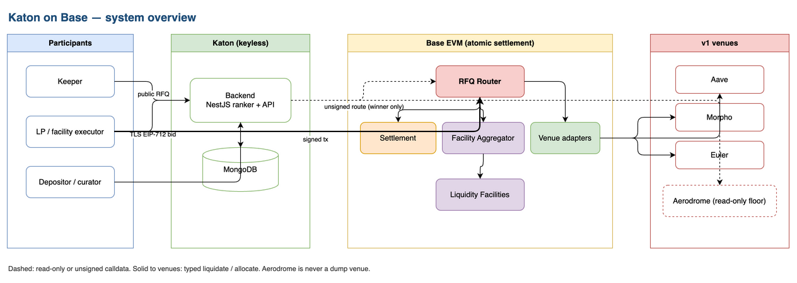
Figure 1. Katon on Base — system overview. Dashed edges are unsigned calldata or read-only floor quotes. Solid edges to venues are typed liquidate / allocate.

2.3 Detailed components
Figure 2 expands the same shape into packages and contracts. Ranking lives in packages/base-core (compareLiquidationBids). The API assembles an unsigned executeLiquidationRoute for the bound winner only. Non-winners receive UNAUTHORIZED and no calldata. OracleGuard and B20Guard are fail-closed reads at settlement, not a second ranking pass.
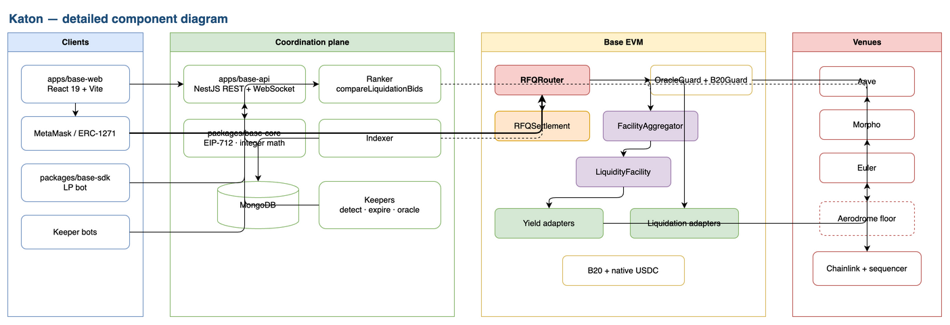
Figure 2. Detailed components. Clients, coordination plane, Base EVM, and v1 venues. Ranker → Aerodrome is read-only. Winner-signed settlement is the only path that moves funds.

2.4 Architecture constraints
# | Constraint | Description
1 | Non-custodial backend | Every fund movement is signed by a wallet or authorized by a contract. Boot fails if a settlement key is configured.
2 | Atomic settlement | Supply USDC, repay the venue, transfer B20, take at most one fee: one transaction or total revert.
3 | Funding-auction ranking | One winner. Venue-fixed seize. Dual min_out after one protocol fee.
4 | Unified auction channel | LP orders, facility quotes, and the Aerodrome floor share one comparator.
5 | Winner submits | msg.sender == winner. Keepers never submit.
6 | EIP-712 anti-replay | Domain binds name, version, chainId, and verifying contract. Order salt, usedRfqIds, cancelledSalt.
7 | B20 policy at settlement | isAuthorized plus TRANSFER/SEIZE pause. No extra desk KYC. approve is not policy-gated.
8 | Modular venues | Adding a protocol means adding an adapter with a pinned bytecode hash. No user calldata.
9 | Curated facilities | Facilities act only inside curator policy. No arbitrary external calls.
10 | Base-only v1 | Base Sepolia 84532 first. Gated Base mainnet 8453 later.
11 | Native USDC only | Circle USDC per network. Bridged USDbC is rejected.
12 | Integer units | Amounts at every trust boundary are integer base units. Convert with mulDiv.
13 | No v1 swap page | executeSwapRoute is reserved and unexposed. Aerodrome is not a dump venue.

2.5 Functional scope
In v1:
- Public liquidation RFQ (pair, size, min_out, deadline public; losing LP prices unpublished)
- Standing and one-off EIP-712 LP bids over TLS
- ERC-4626 facilities with FIFO queued withdraw
- Aave / Morpho / Euler yield allocation and typed liquidation
- Aerodrome as a read-only max-seize floor
- Chainlink total-return feeds, Coinbase oracle-registry pause, Base sequencer uptime
- B20 isAuthorized, TRANSFER/SEIZE pause, scaledBalanceOf / WAD
- Curator dashboard and depositor vault UI
- LP TypeScript SDK and example funding bot
- Headed MetaMask QA on Base Sepolia
Out of v1:
- Confidential or sealed-size auctions
- Live public losing-bid ladder
- Spot stock-for-USDC page
- Authorized-participant mint or redeem
- Extra desk KYC or a parallel OFAC list
- Rebate-style liquidation (LP names collateral kept)
- Bridged USDbC
- Mainnet funds before Sepolia evidence, venue-fork conformance, and audit gates

3. Smart contracts
Typed Solidity signatures are in section 7. Figure 7 is the interface map.

3.1 Settlement
EVM contract that fills maker-signed liquidation funding orders between native USDC and a B20 token.
Responsibilities:
- EIP-712 signature verification (EOA and ERC-1271)
- USDC pull via transferFrom after maker approve
- Fill accounting and cancel / salt invalidation
- Delegated signers

Function | Description
fillLiquidationOrder | Validates the order, verifies the signature, pulls USDC, records fill
registerOrderSigner / revokeOrderSigner | Authorizes a delegated key for the maker
cancelOrder | Cancels one order hash
cancelPairBelowSalt | Invalidates the maker's orders for a pair below a salt

Makers grant an ERC-20 allowance to the settlement contract before fill. Custody remains with the wallet. The backend holds no keys.

3.2 RFQ router
Contract that binds one funding source to one allowlisted liquidation adapter and settles atomically. There is no on-chain quote() that re-ranks LPs. Ranking is off-chain so losing prices never hit the ledger. The router still enforces every settlement invariant.
Function | Description
executeLiquidationRoute | Winner submits. Pulls or funds USDC, calls typed liquidate, checks both min_out after one fee, reverts on any failed leg
executeSwapRoute | Reserved. Unexposed in v1
Adapter allowlist / pause / fee | Guardian and timelock

Winner binding:
- LP win: winner is the order maker. msg.sender must be that maker (or an ERC-1271 validator the maker is). recipient is the maker unless the order names another isAuthorized wallet. Funding source is settlement.
- Facility win: winner is the facility executor. recipient is the facility. Funding source is LiquidityFacility.fundLiquidation. Keepers are not winner.

3.3 Facility aggregator
Contract that registers curated facilities and exposes USDC capacity quotes. A quote is capacity after haircut, not a purchase price.
Function | Description
registerFacility | Registers a facility with pause / revoke
quote | Returns each facility's quoteUsdc at the current block
fill | Forwards a fund request to the winning facility

3.4 Liquidity facility
Curated ERC-4626 vault. Base asset is native USDC. v1 does not redeem B20 with an issuer and does not run a spot auction to sell inventory. USDC exits may queue while inventory is illiquid.
Function | Description
deposit / withdraw | ERC-4626 mint and burn at current NAV
requestWithdraw / claimWithdraw | FIFO queue when idle plus maxWithdraw cannot cover the redeem (SC-19)
quoteUsdcCapacity | withdrawable × (WAD − haircutWad) / WAD
fundLiquidation | Called on win: pulls USDC, router/adapter repay the venue, facility receives B20
allocate / deallocate | Deploy or recall USDC on allowlisted yield adapters

NAV:
NAV = idle USDC
+ sum(adapter.totalAssets)
+ inventory at acquisition cost
- realized loss
- reserved queue assets
sharePrice = NAV / totalShares

3.5 Adapters
Thin contracts. Adding a protocol means adding an adapter and pinning its bytecode hash.
- Yield (IFacilityAdapter): asset, deposit, withdraw, totalAssets, maxWithdraw.
- Liquidation (ILiquidationAdapter): typed Request (market, borrower, debt, collateral, max repay, min collateral, recipient) and liquidate. Official venue liquidate only. No rebate of leftover collateral in v1. No arbitrary calldata.
v1 venues: Aave, Morpho, Euler. Aerodrome is not an adapter; the ranker reads it off-chain.

3.6 Oracle and B20 guards
Guard | Reads | Fail closed when
OracleGuard | Chainlink AggregatorV3 (8-decimal total-return), Coinbase onchain oracle-registry pause, Base sequencer uptime feed | Stale heartbeat, paused registry, sequencer answer 1, or inside the configured grace after sequencer recovery
B20Guard | isAuthorized, TRANSFER/SEIZE pause bits, WAD multiplier | Unauthorized account, TRANSFER or SEIZE paused

MINT/BURN pause does not by itself block liquidation. This desk never mints or burns. The router does not recompute venue health factor. A healthy position reverts at liquidate.

4. Protocol flows

4.1 An off-chain LP wins a liquidation
Figure 3 is the LP-won sequence. Ranking is an internal worker. The winner fetches unsigned calldata; keepers never submit.

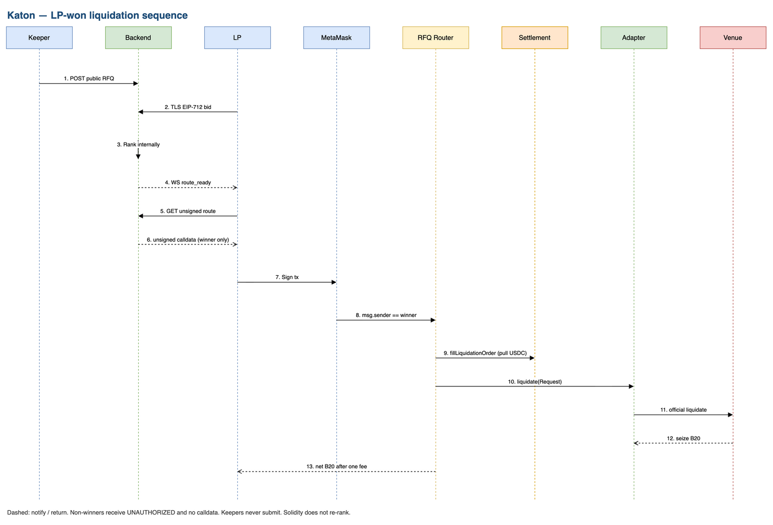
Figure 3. LP-won liquidation. Dashed: notify / return. Non-winners receive UNAUTHORIZED and no calldata. Solidity does not re-rank.

4.2 A curated facility wins
Same ranking channel as 4.1. Winner is the facility executor (curator EOA or bound ERC-1271). fundLiquidation supplies USDC from idle plus adapters. Recipient is the facility; B20 is booked as inventory at acquisition cost. Keepers do not sign.
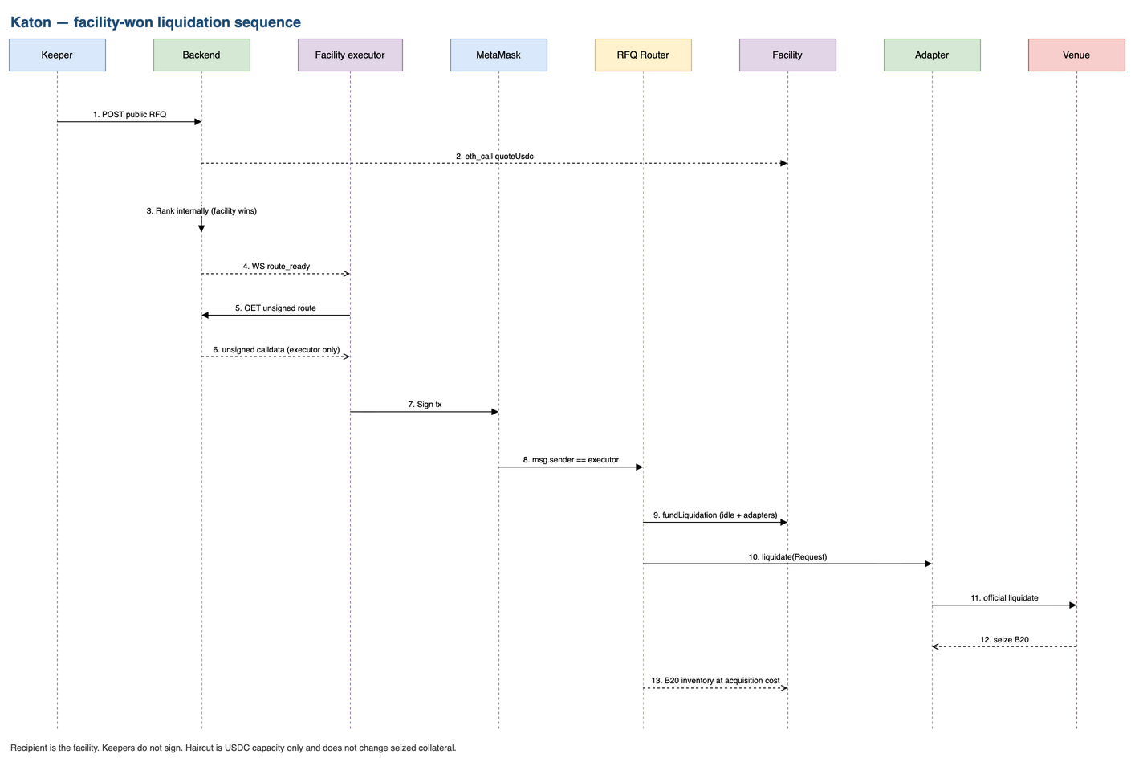
Figure 4. Facility-won liquidation. fundLiquidation supplies USDC from idle plus adapters. Recipient is the facility. B20 is booked as inventory at acquisition cost.

4.3 Facility deposit and withdrawal
Figure 5 is the depositor path. Haircut discounts quoteUsdc only; it does not change depositor NAV.
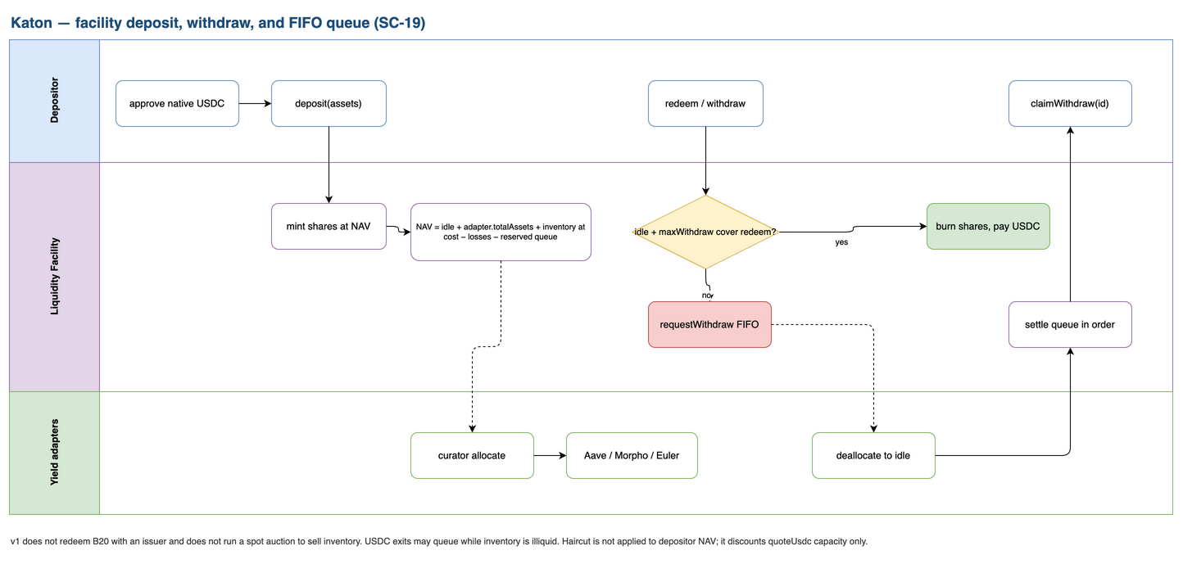
Figure 5. Facility deposit and FIFO withdraw. Synchronous redeem when idle plus maxWithdraw covers the request; otherwise requestWithdraw queues, deallocate settles in order, claimWithdraw pays USDC.

Deposit. Depositor approves USDC and calls deposit. Facility mints shares at current NAV. Curator may allocate to allowlisted yield adapters.
Synchronous withdraw. If idle USDC plus adapter maxWithdraw covers the redeem, burn shares and pay USDC at NAV.
Queued withdraw. Otherwise requestWithdraw locks shares in a FIFO queue. Later deallocate settles requests in order. The vault never pretends illiquid allocations are instantly redeemable.

4.4 Ranking rules (operating model)
A source is eligible only if all of the following hold:
- Unexpired, remaining capacity ≥ published repayAssets (FOK at that size)
- debtAsset is native USDC and collateralAsset is the RFQ B20 token
- Predicted net ≥ RFQ minCollateralOut and ≥ funder minCollateralOut
- Predicted gross ≤ Aerodrome-implied collateral for the same repay
- Aerodrome quote present and fresh; otherwise FLOOR_NOT_MET
- Oracle, sequencer, B20 TRANSFER/SEIZE, and recipient isAuthorized pass
Rank key among eligible sources:
- Lower predicted gross collateral
- Earlier bid timestamp (facility quotes use the quote-snapshot block timestamp)
- Lower order hash (facility quote id hashed with facility address)
Under venue-fixed seize the first key ties, so timestamp and hash decide. Solidity does not re-run this comparator. Haircut is USDC capacity only; it does not change seize.

5. Technology stack

5.1 Smart contracts (Base EVM)
Contract | Role | Notes
Settlement | EIP-712 LP orders, USDC pull | EOA + ERC-1271
RFQ Router | Atomic liquidation route, fee, winner binding | Reentrancy guard; no quote()
Facility Aggregator | Facility registry and capacity quotes | Pause / revoke
Liquidity Facility | ERC-4626, queue, allocate, fund | Isolated per vault
Yield adapters | Aave, Morpho, Euler | IFacilityAdapter
Liquidation adapters | Aave, Morpho, Euler | Typed Request
OracleGuard / B20Guard | Fail-closed reads | Called at settlement

Language: Solidity 0.8.x. Tooling: Foundry. Config: contracts/base/deployments/<network>.json with bytecode hashes.

5.2 Backend
Component | Technology
Framework | NestJS (TypeScript)
Database | MongoDB
Roles | RFQ intake, TLS bid intake, deterministic ranker, unsigned-route assembly, WebSocket notify, keepers
Auth | SIWE for interactive sessions; API keys or mTLS for bots
Chain reads | eth_call / logs via a Base RPC. Indexer projects events. Settlement does not depend on the indexer
Shared math | packages/base-core: EIP-712 hashing, compareLiquidationBids, oracle policy, B20 scaled units

5.3 Frontend
Component | Technology
Framework | React 19 + Vite (TypeScript)
Wallets | MetaMask via wagmi / viem. EOA and ERC-1271
Features | Depositor vault, curator dashboard, public RFQ table, LP bid form, facility-executor unsigned-tx review, oracle/B20 status strip
Not in v1 | Stock-for-USDC swap ticket

5.4 Repository shape
New packages sit beside the existing monorepo. This feature does not rewrite packages already in the tree.
apps/
base-web/
base-api/
packages/
base-core/
base-sdk/
base-contracts/
contracts/base/
services/
indexer/
keepers/

5.5 Infrastructure
Vendor is unpinned. Figure 6 is the topology, not a hosting commitment. No funded settlement key in any API environment.

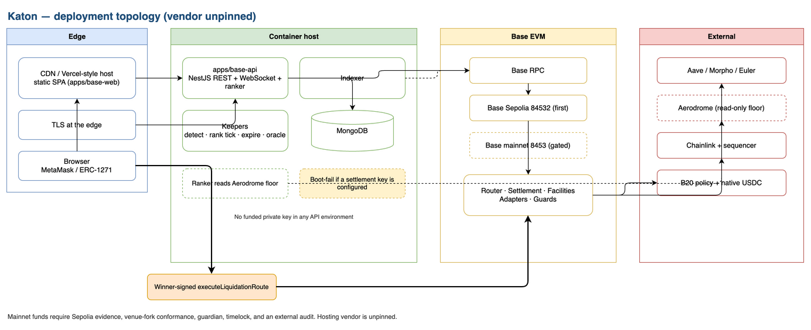
Figure 6. Deployment topology (vendor unpinned). Winner-signed executeLiquidationRoute is the only settlement path. Boot-fail if a settlement key is configured. Mainnet funds require Sepolia evidence, venue-fork conformance, guardian, timelock, and an external audit.

- Web: static SPA on a CDN or Vercel-style host
- API, indexer, keepers: container host with MongoDB and TLS at the edge
- No funded settlement key in any API environment

6. Integrations
Integration | Usage
MetaMask / wagmi / viem | Connect, chain gate (84532 / 8453), eth_signTypedData_v4, send tx
Base RPC | Simulate, submit, log tail
Circle native USDC | Facility asset and RFQ debt asset. Base 0x833589fCD6eDb6E08f4c7C32D4f71b54bdA02913. Sepolia 0x036CbD53842c5426634e7929541eC2318f3dCF7e. Reject USDbC 0xd9aAEc86B65D86f6A7B5B1b0c42FFA531710b6CA
B20 | Factory 0xB20f000000000000000000000000000000000000. PolicyRegistry 0x8453000000000000000000000000000000000002. ActivationRegistry 0x8453000000000000000000000000000000000001. Token registry 0x3f3E8cf41cdd3b1D118c16471aB0113DfDDd5CaD
Chainlink | 8-decimal total-return equity feeds. Sequencer uptime 0xBCF85224fc0756B9Fa45aA7892530B47e10b6433 (answer 0 up, 1 down)
Coinbase oracle registry | Onchain pause flag. Fail closed
Aave, Morpho, Euler | Yield allocate / deallocate and typed liquidate. Addresses pinned from official docs plus bytecode hash at implementation
Aerodrome | Read-only implied collateral-for-repay. Not a swap in the liquidation transaction

6.1 First-wave B20 tokens
Key by address, never by ticker alone. v1 markets are the intersection of this list, an official Chainlink feed, and at least one confirmed v1 lending market.
Symbol | Token
AAPLc | 0xb200000000000000000000C2e324d24d7eEcd1fb
AMZNc | 0xb200000000000000000000d9192b6B456483C2E8
COINc | 0xb200000000000000000000c85a31389D71F3ecfb
CRCLc | 0xB20000000000000000000019f6E7C675b73C2e4D
GOOGLc | 0xb2000000000000000000002D0BA3164cc74f58B7
INTCc | 0xB2000000000000000000004AFF16039bA04bdFBc
METAc | 0xb2000000000000000000008bC8786B856E61707C
MSFTc | 0xB200000000000000000000Ab99cFa739E253872B
MSTRc | 0xb2000000000000000000004884b426556b92883d
NVDAc | 0xb20000000000000000000078ee7ce2fE4908108C
SNDKc | 0xb200000000000000000000397293Cb8cda9a10c5
SPCXc | 0xb2000000000000000000007b9fcbd005511aCBd5
TSLAc | 0xb2000000000000000000001e800a7f5189430cD0

6.2 Chainlink total-return feeds
8 decimals. 0.5% deviation or 24h heartbeat, 24/5. Freeze on weekends, holidays, and corporate actions. Token price equals underlying equity market price times the B20 multiplier.
Underlying | Feed
AAPL | 0x787f13dEa48Db0897CbCDD985de77809D837F988
AMZN | 0x06A8E4b3aBB3B7543d8396FB2B763d22820cB295
COIN | 0x408e44f504A7371a345F03a73dDC96A4b48e8aa7
CRCL | 0x0231cF2635D1E17bB5c2462cc7504Ba1fBd61f33
GOOGL | 0x5bF49E0ffA937CE2FfF033c739aD7C634c4D34F2
INTC | 0xAB657C39bac0D5886250D70849e2E3E008F2EECB
META | 0x6526aE6797A76123638b863AeE4dD27Ba4E4b27D
MSFT | 0xeB10A6c9aa7E537aEd766C08c35Dae35B321b18c
MSTR | 0xB3cE282CD188b35DA0E38D8Bc7d58e33173D202a
NVDA | 0x04689a41629776563E6822F76f2e57D148d28513
SNDK | 0x388b0dC46C0Fb05A74BeE0994fa5b02c6Fcca2eA
SPCX | 0x6A634B235903C4ad6376892180d6fF8612e3Fa68
TSLA | 0xFaf869185383a24F8cb00e27BdA6b63B9905DCb4

7. Typed Solidity function signatures
Figure 7 is the interface map. The plan contains no arbitrary target and no user calldata. feeBps is 0 in pilot and cannot exceed 50.

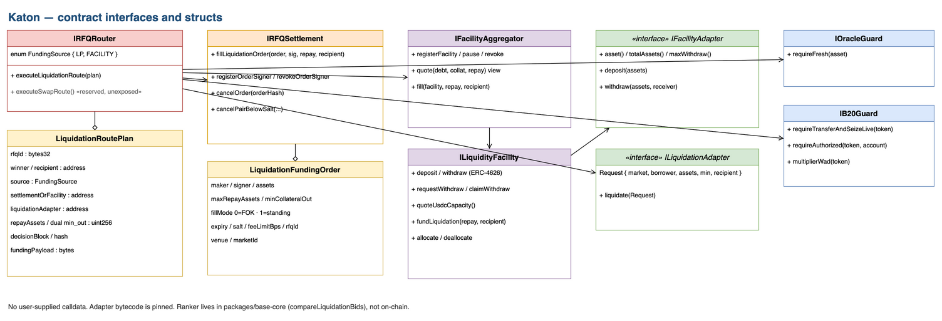
Figure 7. Contract interfaces and structs. executeSwapRoute is reserved and unexposed. Ranker lives in packages/base-core, not on-chain. Adapter bytecode is pinned.

7.1 Settlement
interface IRFQSettlement {
struct LiquidationFundingOrder {
address maker;
address signer;
address debtAsset;
address collateralAsset;
uint256 maxRepayAssets;
uint256 minCollateralOut;
uint8 fillMode;
uint256 expiry;
uint256 salt;
uint16 feeLimitBps;
bytes32 rfqId;
address venue;
bytes32 marketId;
}

function fillLiquidationOrder(
LiquidationFundingOrder calldata order,
bytes calldata signature,
uint256 repayAssets,
address recipient
) external returns (uint256 pulledUsdc);

function registerOrderSigner(address signer) external;
function revokeOrderSigner(address signer) external;
function cancelOrder(bytes32 orderHash) external;
function cancelPairBelowSalt(
address debtAsset,
address collateralAsset,
uint256 minSalt
) external;
}

EIP-712 domain: name KatonRFQSettlement, version 1, chainId, verifyingContract. fillMode 0 is fill-or-kill for a bound RFQ. fillMode 1 is a standing order that may fund later RFQs until capacity is zero. A standing order with remaining capacity below repayAssets is skipped.

7.2 RFQ router
interface IRFQRouter {
enum FundingSource { LP, FACILITY }

struct LiquidationRoutePlan {
bytes32 rfqId;
address winner;
address recipient;
uint256 deadline;
FundingSource source;
address settlementOrFacility;
address liquidationAdapter;
uint256 repayAssets;
uint256 minCollateralOutRfq;
uint256 minCollateralOutFunder;
uint256 decisionBlock;
bytes32 decisionBlockHash;
bytes fundingPayload;
}

function executeLiquidationRoute(LiquidationRoutePlan calldata plan)
external
returns (uint256 repaidAssets, uint256 collateralSeized, uint256 fee);
}

7.3 Facility aggregator
interface IFacilityAggregator {
struct FacilityQuote {
address facility;
uint256 quoteUsdc;
uint256 haircutWad;
uint256 snapshotBlock;
}

function registerFacility(
address curator,
address facility,
address[] calldata assets
) external;
function pauseFacility(address facility) external;
function revokeFacility(address facility) external;
function quote(
address debtAsset,
address collateralAsset,
uint256 repayAssets
) external view returns (FacilityQuote[] memory);
function fill(
address facility,
uint256 repayAssets,
address recipient
) external returns (uint256 fundedUsdc);
}

7.4 Liquidity facility
interface ILiquidityFacility {
function deposit(uint256 assets, address receiver)
external returns (uint256 shares);
function withdraw(uint256 assets, address receiver, address owner)
external returns (uint256 shares);
function requestWithdraw(uint256 assets)
external returns (uint256 requestId);
function claimWithdraw(uint256 requestId)
external returns (uint256 assets);
function quoteUsdcCapacity() external view returns (uint256);
function fundLiquidation(uint256 repayAssets, address recipient)
external returns (uint256 fundedUsdc);
function allocate(address adapter, uint256 assets) external;
function deallocate(address adapter, uint256 assets) external;
}

7.5 Adapters and guards
interface IFacilityAdapter {
function asset() external view returns (address);
function deposit(uint256 assets) external returns (uint256 deployed);
function withdraw(uint256 assets, address receiver)
external returns (uint256 returned);
function totalAssets() external view returns (uint256);
function maxWithdraw() external view returns (uint256);
}

interface ILiquidationAdapter {
struct Request {
bytes32 marketId;
address borrower;
address debtAsset;
address collateralAsset;
uint256 maxRepayAssets;
uint256 minCollateralOut;
address recipient;
}
function liquidate(Request calldata request)
external returns (uint256 repaidAssets, uint256 collateralSeized);
}

interface IOracleGuard {
function requireFresh(address asset) external view;
}

interface IB20Guard {
function requireTransferAndSeizeLive(address token) external view;
function requireAuthorized(address token, address account) external view;
function multiplierWad(address token) external view returns (uint256);
}

8. Storage layout
Critical mappings are not packed with frequently mutated counters. Chain state is authoritative for funds.

8.1 Settlement
Slot / mapping | Type | Data
admin | address | Owner
usdc | address | Native Circle USDC
filled | mapping(bytes32 => uint256) | Filled repay per order hash
orderSigners | mapping(address => mapping(address => bool)) | Delegated signers
cancelledSalt | mapping(bytes32 => uint256) | Pair-scoped min salt

8.2 RFQ router
Slot / mapping | Type | Data
admin / guardian | address | Upgrade and pause
feeRecipient | address | Fee sink
feeBps | uint16 | Active fee; immutable cap 50
maxDecisionBlockAge | uint64 | Stale rank snapshot bound
liquidationAdapters | mapping(address => bool) | Allowlisted adapters
usedRfqIds | mapping(bytes32 => bool) | Packaged RFQ replay
oracleGuard / b20Guard | address | Fail-closed guards
_status | uint256 | Reentrancy lock

8.3 Facility aggregator
Slot / mapping | Type | Data
admin | address | Register / pause / revoke
facilities | mapping(address => FacilityRecord) | Curator, assets, paused

8.4 Liquidity facility
Slot / mapping | Type | Data
curator / executor / guardian | address | Policy and submitter
asset | address | Native USDC
haircutWad | uint256 | Capacity haircut
adapters | allowlist | Yield adapters
inventoryLots | mapping(uint256 => Lot) | B20 at acquisition cost
withdrawQueue | FIFO | SC-19 queued redeem
ERC-4626 balances | inherited | Depositor shares

8.5 Mongo collections (off-chain)
Collection | Contents | Public GET
liquidations | Public RFQ fields, status, decision block | Yes, without losing prices or calldata
bids | Order hash, maker, remaining capacity, ranking fields, signature | No. Owner GET /v1/standing-bids/me only
routes | Winner, unsigned payload hash, fail-closed reason | Winner-only GET /v1/liquidations/:id/route
sessions | SIWE sessions, bot API key hashes | No
facilities | Cached quotes, caps, haircuts | Yes (already on-chain)
indexer_cursors | Per-contract log cursor | No
oracle_snapshots | Feed age, pause, sequencer | Yes

Forward-only migrations. Losing-price payloads are omitted from structured logs.

9. Settlement math
All amounts are integer base units. Convert with mulDiv and 256-bit intermediates. Protocol fee is taken from gross collateral, not from USDC repay. Pilot fee is 0.
repayAssets = RFQ.repayAssets
predictedGrossSeize = venueSeize(repayAssets, closeFactor, bonus,
chainlinkAnswer, b20MultiplierWad)
predictedFee = predictedGrossSeize * feeBps / 10_000
predictedNet = predictedGrossSeize - predictedFee
aerodromeImplied = aerodromeCollateralFor(repayAssets) // read-only
quoteUsdcCapacity = min(maxWithdraw, idle + adapterMaxWithdraw)
* (WAD - haircutWad) / WAD

On-chain:
grossSeized = collateral balance delta after adapter.liquidate
(do not trust return data)
fee = grossSeized * feeBps / 10_000 // 0 in pilot, cap 50
netToWinner = grossSeized - fee
require(netToWinner >= RFQ.minCollateralOut)
require(netToWinner >= funder.minCollateralOut)
require(msg.sender == winner)
require(block.number - decisionBlock <= maxDecisionBlockAge)

UI size labels show both token base units and scaled share-equivalent units from scaledBalanceOf / WAD. Storage and settlement stay in token base units.

10. Events
Every significant action emits an event for indexing and audit. Events do not include losing LP prices.

10.1 Settlement
event Fill(bytes32 indexed orderHash, address indexed maker, address indexed recipient,
address debtAsset, address collateralAsset, uint256 repayAssets,
uint256 collateralOut, uint256 fee);
event Cancel(address indexed maker, bytes32 indexed orderHash);
event SignerUpdated(address indexed maker, address indexed signer, bool authorized);

10.2 RFQ router
event RouteFilled(bytes32 indexed rfqId, address indexed winner, address indexed recipient,
address adapter, uint256 repayAssets, uint256 collateralSeized, uint256 fee);
event AdapterAllowlisted(address indexed adapter, bool allowed);
event FeeUpdated(uint16 feeBps);
event Paused(address account);
event Unpaused(address account);

10.3 Facility aggregator
event FacilityRegistered(address indexed curator, address indexed facility);
event FacilityPaused(address indexed facility);
event FacilityRevoked(address indexed facility);

10.4 Liquidity facility
event Deposit(address indexed sender, address indexed owner, uint256 assets, uint256 shares);
event Withdraw(address indexed sender, address indexed receiver, address indexed owner,
uint256 assets, uint256 shares);
event WithdrawQueued(address indexed owner, uint256 indexed requestId, uint256 assets, uint256 shares);
event WithdrawClaimed(address indexed owner, uint256 indexed requestId, uint256 assets);
event VenueAllocation(address indexed adapter, uint256 assets, bool allocating);
event InventoryAcquired(address indexed token, uint256 amount, uint256 usdcPaid);

Index B20 Announcement and MultiplierUpdated from the token contracts.

11. Keepers

11.1 Roles
Keeper | Trigger | Action | Cadence
Liquidation detector | Health factor below venue threshold on Aave, Morpho, or Euler with B20 collateral | POST /v1/liquidations (idempotent on venue, market, borrower, assets) | ~2s (Base block time). Overlapping workers allowed
Ranker tick | New bid, RFQ deadline, or idle open RFQ | Internal rank at a finalized block. WebSocket notify winner or fail-closed | On event, plus 1s idle tick
Expiry worker | RFQ deadline passed with no fill | Mark expired. Drop unsigned route | ~2s
Indexer | New logs | Project the read model | Real-time log tail
Oracle monitor | Heartbeat, pause, sequencer | Status strip only. Does not settle | ~2s read

11.2 Operating rules
- Runtime: Node.js TypeScript, Docker, same container host as the API
- Keepers authenticate for rate limits. They never hold a settlement key
- They never submit executeLiquidationRoute
- Detection is not an exclusive execution grant
- If detectors are down, venues remain liquidatable by other actors
- Ranking a single RFQ against 100 standing bids, 8 facility quotes, and one Aerodrome read completes in-process in under 200 ms excluding RPC

11.3 Coordination API (keyless)
Method | Auth | Behavior
POST /v1/liquidations | Keeper (rate limit) | Idempotent public RFQ
GET /v1/liquidations | Public | List: pair, size, min_out, deadline, status, optional bid count
GET /v1/liquidations/:id | Public | Detail without losing prices or calldata
POST /v1/bids | LP | TLS EIP-712 order
POST /v1/standing-bids | LP | Register or revoke
GET /v1/standing-bids/me | LP | Own orders only
GET /v1/liquidations/:id/route | Bound winner | Unsigned executeLiquidationRoute or fail-closed reason
GET /v1/facilities | Public | NAV, haircut, caps, allocations
GET /v1/oracles/:asset | Public | Freshness, pause, sequencer
GET /v1/ws | Authenticated | route_ready, rank_failed, rfq_expired

Fail-closed reasons: NO_ELIGIBLE_BID, FLOOR_NOT_MET, ORACLE_UNAVAILABLE, B20_PAUSED, SEQUENCER_DOWN, EXPIRED.
There is no caller-authenticated POST /v1/liquidations/:id/rank. Ranking is an internal worker. A circular “authenticate as the winner to rank” endpoint is not part of this design.

12. STRIDE threat model
Threat | Type | Scenario | Mitigation
Identity spoofing | S | Fake LP bid or stolen hot key | EIP-712 domain binds chainId and verifying contract. Delegated signers via registerOrderSigner, revocable. ERC-1271 for smart accounts. msg.sender == winner.
Seize tampering | T | Ranker or facility tries to extract extra collateral | Venue-fixed seize. Dual min_out after one fee. Aerodrome max-seize floor fail-closed. Solidity does not trust API ranking. Balance-delta accounting. Typed adapters, no user calldata.
Trade denial | R | LP denies a filled order | On-chain Fill / RouteFilled with order hash, amounts, addresses. Signature recoverable.
Information leak | I | Copy LP inventory policy from a public book | Losing LP prices unpublished. TLS bid intake. Structured logs omit losing prices. Winner-only unsigned calldata. Facility quotes are public by design.
Service disruption | D | RFQ flood, ranker stall, sequencer halt | Keeper POST rate limits. Idempotent opportunity keys. Oracle and sequencer fail closed, not fail open. Indexer is not on the settlement path.
Privilege escalation | E | Malicious adapter or API key drains a facility | Adapter allowlist, fixed interfaces, no delegatecall to arbitrary addresses. Keyless API. Curator cannot upgrade fund logic. Fee cap 50 bps. Guardian pause.

12.1 EVM protocol-level protections
Protection | Mechanism
Anti-replay | EIP-712 domain, order salt, usedRfqIds, cancelledSalt, maxDecisionBlockAge
Anti-reentrancy | Router reentrancy guard. Checks-effects-interactions. No untrusted delegatecall
Sequencer | Uptime feed. Answer 1 or inside grace: revert
Fund isolation | Non-custodial API. USDC pull after maker approve. Facility fund only for allowlisted liquidation
B20 policy | isAuthorized at every stock-token boundary. TRANSFER/SEIZE pause fail closed

12.2 Upgrade and admin
Role | Powers | Bound
Guardian (multisig) | Pause router and facilities, revoke adapters | Immediate pause
Timelock | Allowlist adapters, set fee (≤ 50 bps), upgrade proxies, pin oracle config | Mainnet gate
Curator | Haircut within bounds, allocate/deallocate, pause own quoting | Cannot upgrade deposited-fund logic
Facility executor | Submit facility-won route | Named EOA or ERC-1271
Default admin | Transfer roles | Guardian / timelock, not the API

Upgrade model: UUPS or Transparent proxy for router, settlement, aggregator, and facilities. Adapter bytecode is pinned. A venue upgrade is a new allowlisted adapter. Mainnet requires guardian, timelock, and an external audit.

13. Component summary
Off-chain: React 19 + Vite frontend, NestJS backend, MongoDB read model, indexer, keepers. On-chain: RFQ Router, Settlement, Facility Aggregator, Liquidity Facilities, yield and liquidation adapters, OracleGuard, B20Guard. External: MetaMask / ERC-1271, Chainlink + sequencer, B20 policy + oracle pause, Aerodrome floor.
The frontend signs typed data and sends the winner transaction. The backend eth_calls quotes and returns an unsigned route to the bound winner only. The ranker reads Aerodrome; it does not swap there.
v1 ships a credit desk: USDC facilities, typed liquidation, public RFQ, keyless coordination. It does not ship a swap page, confidential compute, or a second seize price. Losing LP prices stay unpublished. Only the bound winner settles.

Appendix A. Locked design decisions
These decisions are closed. Implementation follows them; it does not reopen them.
ID | Decision
D1 | Public unified channel, not confidential compute
D2 | Credit-first v1; spot auction later on the reserved executeSwapRoute seam
D3 | Aerodrome is a max-seize floor, not a venue dump
D4 | One ranking channel for LP bids, facility quotes, and the floor
D5 | Typed liquidation, not generic calls or user calldata
D6 | B20 policy at settlement; no extra desk KYC
D7 | Parallel packages (apps/base-*, packages/base-*, contracts/base)
D8 | Native Circle USDC only; reject USDbC
D9 | Ranking off-chain; enforcement on-chain
D10 | Integer ranking in packages/base-core (compareLiquidationBids)
D11 | Funding auction at venue-fixed seize, not a rebate auction
D12 | Winner submits; keepers do not
D13 | Dual minimum collateral after one protocol fee
D14 | Eligibility is B20 policy, not a desk list
D15 | Internal ranker worker; winner-only GET /v1/liquidations/:id/route

Appendix B. Open implementation pins
These items are required before mainnet funds. They are research and configuration, not design reopeners. This document does not invent addresses, grace periods, or bytecode hashes for them.
Item | Needed for
Aave / Morpho / Euler market addresses and bytecode hashes | Adapter pin at implementation
Aerodrome pool / quoter addresses used for the max-seize floor | Ranker floor read
Sepolia B20 token and feed availability | Testnet markets
Coinbase onchain oracle-registry pause-flag interface | OracleGuard
Sequencer grace window after recovery | OracleGuard fail-closed
maxDecisionBlockAge | Stale rank snapshot bound
Guardian, timelock, external audit | Mainnet gate

Appendix C. List of figures
Figure | Title | Source
1 | System overview | 01-system-overview
2 | Detailed components | 02-detailed-components
3 | LP-won liquidation sequence | 03-sequence-lp-won
4 | Facility-won liquidation sequence | 04-sequence-facility-won
5 | Facility deposit, withdraw, and FIFO queue | 05-facility-deposit-withdraw
6 | Deployment topology | 07-deployment
7 | Contract interfaces and structs | 06-class-interfaces

