ElintPOS Android - Setup & Login Guide
Official Step-by-Step User Configuration Guide
Step 1: App Boot & Initial Printer Setup Screen
Upon first launching the app after installation or storage reset, the system automatically opens the Printer Setup screen.
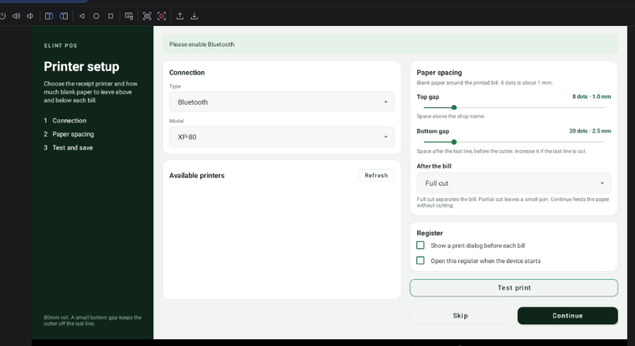
• Connection Box: Choose printer interface type (Bluetooth, USB, LAN, TecMI K8) and printer model.
• Paper Spacing: Configure blank margins (Top gap & Bottom gap) around each bill.
• After the bill: Select paper cutter action (Full cut, Partial cut, or Continue).
• Register Options: Enable automated startup on device boot and receipt print dialog.
Step 2: Select Connection Type & Printer Model
Tap the Type dropdown inside the Connection card to select your printer's connection interface.
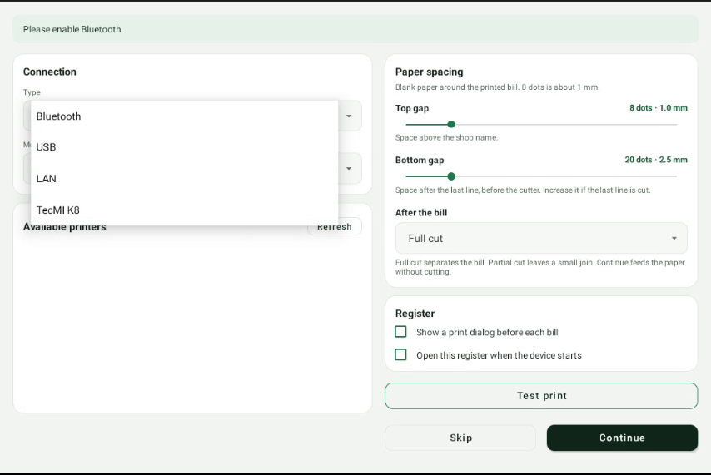
• Bluetooth: Wireless external thermal receipt printers (58mm / 80mm). Bluetooth must be ON.
• USB: Direct USB or OTG connection to thermal receipt printers.
• LAN: Network thermal printers connected over Wi-Fi / Ethernet (Port 9100).
• TecMI K8: For all-in-one POS terminals with built-in thermal printers.
• Model: Select paper roll model (e.g., XP-80 for standard 80mm roll).
Step 3: Select Printer, Test Print & Continue
The selected interface displays active printers in the Available printers list.
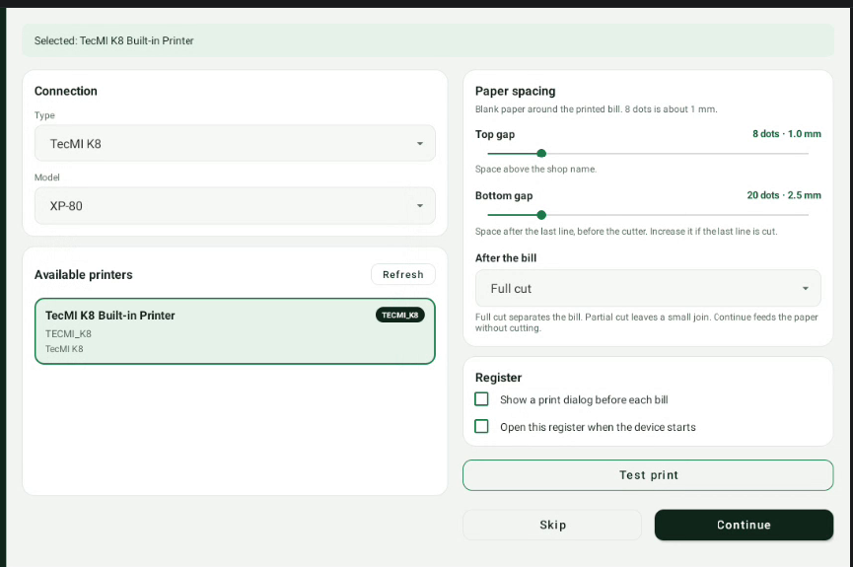
• Select Printer: Tap your printer in the list (e.g. TecMI K8 Built-in Printer). Border turns green.
• Test print: Tap Test print to verify paper feed, alignment, and print output.
• Continue: Tap Continue button to save configuration permanently and proceed.
Step 4: POS Sign In & Start Billing
After setup confirmation, the app immediately transitions to the ElintPOS Sign In page.
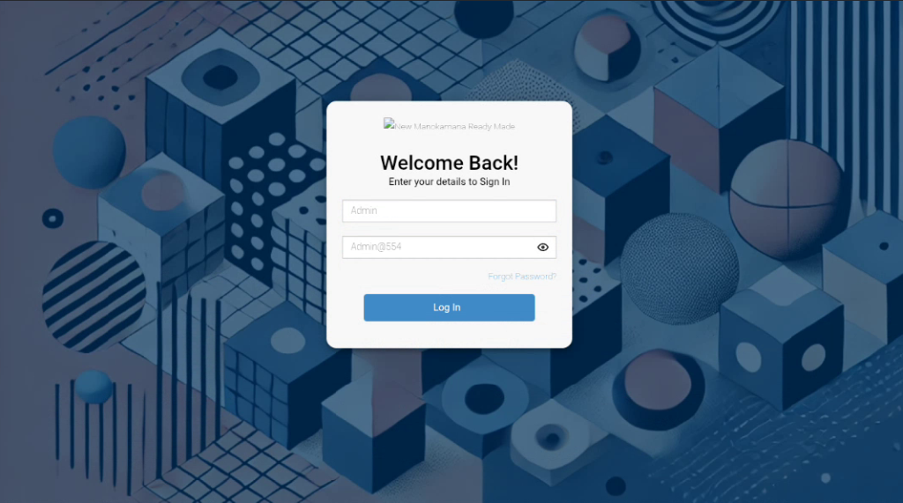
• Username: Enter your credentials (e.g., Admin).
• Password: Enter password (e.g., Admin@554).
• Log In: Click Log In button to open the active POS billing dashboard!

