**Computer Architecture CS322 Lab 10 Report**

**Name : Chandrawanshi Mangesh Shivaji**

**Roll Number : 1801CS16**

**Date : 19/11/2020**

**Task 1:** Study the given ***piplelined‐mips*** implementation of the processor and test using the following test program (create a new mem.dat)

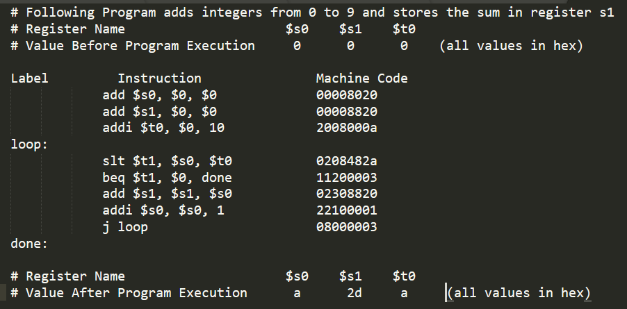

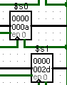 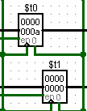

**Before Execution After Execution**

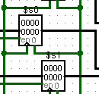

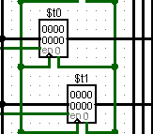

**Task 2**: Compare given single‐cycle, multi‐cycle and pipe‐line implementation. Run the above program and compute the number of cycles required in each of the case. Compute the CPI

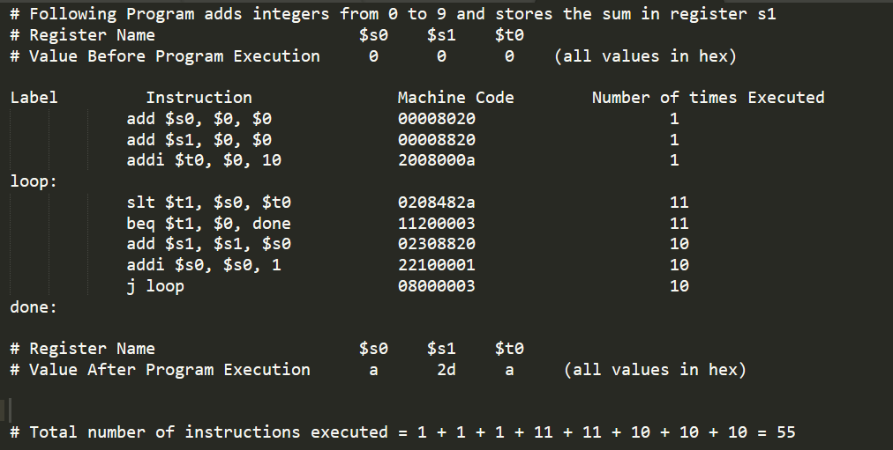

# **Total number of instructions executed** = 1 + 1 + 1 + 11 + 11 + 10 + 10 + 10 = **55**

# **Cycles Per Instruction (CPI)** = $\frac{Total Number of Execution Cycles}{Total Number of Instructions Executed}$

# **Single-Cycle Architecture**

Number of Cycles in Single Cycle Architecture = Total number of instructions executed = 55

For Single-Cycle Architecture, **CPI = $\frac{55}{55}$ = 1**

**# Multi-Cycle Architecture**

Number of Cycles in Multi Cycle Architecture = 1*4 + 1*4 +1*4 + 11*4 + 11*3 + 10*4 + 10*4 + 10*3 = 199

For Multi-Cycle Architecture, **CPI = $\frac{199}{55}$ = 3.6181**

# **Pipelined Architecture**

Number of Cycles in Pipelined Architecture = 128 (Calculated using Logisim)

For Pipelined Architecture, **CPI = $\frac{128}{55}$ = 2.3272**

**Submission Files:**

**Task 1:**

**Logisim: 1801CS16_Lab10_task1.circ**

**Code: code_task1.txt**

**Load Image File: loadfile_task1_and_task2**

**Task 2:**

**Logisim: 1801CS16_Lab10_task2_MIPS_MultiCycle.circ**

**Logisim: 1801CS16_Lab10_task2_MIPS_Pipelined.circ**

**Logisim: 1801CS16_Lab10_task2_MIPS_SingleCycle.circ**

**Code: code_task2.txt**

**Load Image File: loadfile_task1_and_task2**