CS322 – Computer Arcitechture Lab 5 Report

Name : Chandrawanshi Mangesh Shivaji
Roll No. : 1801CS16
Date : 14/10/2020

Introduction : I have created an interactive program using 32-bit nasm assembly which will sort the given non-zero input integers in non-decreasing order using the GNOME SORT ALGORITHM.

GNOME SORT ALGORITHM ?

Input – Array- arr[], Total elements - n
Algorithm Steps
- If you are at the start of the array then go to the right element (from arr[0] to arr[1]).

- If the current array element is larger or equal to the previous array element then go one step right
if (arr[i] >= arr[i-1])
i++;
- If the current array element is smaller than the previous array element then swap these two elements and go one step backwards
if (arr[i] < arr[i-1])
{
swap(arr[i], arr[i-1]);
i--;
}
- Repeat steps 2 and 3 till ‘i’ reaches the end of the array (i.e i = ‘n-1’)

- If the end of the array is reached then stop and the array is sorted.

Output - Sorted Array of n elements

Corresponding C++ Code for gnome sort algorithm :
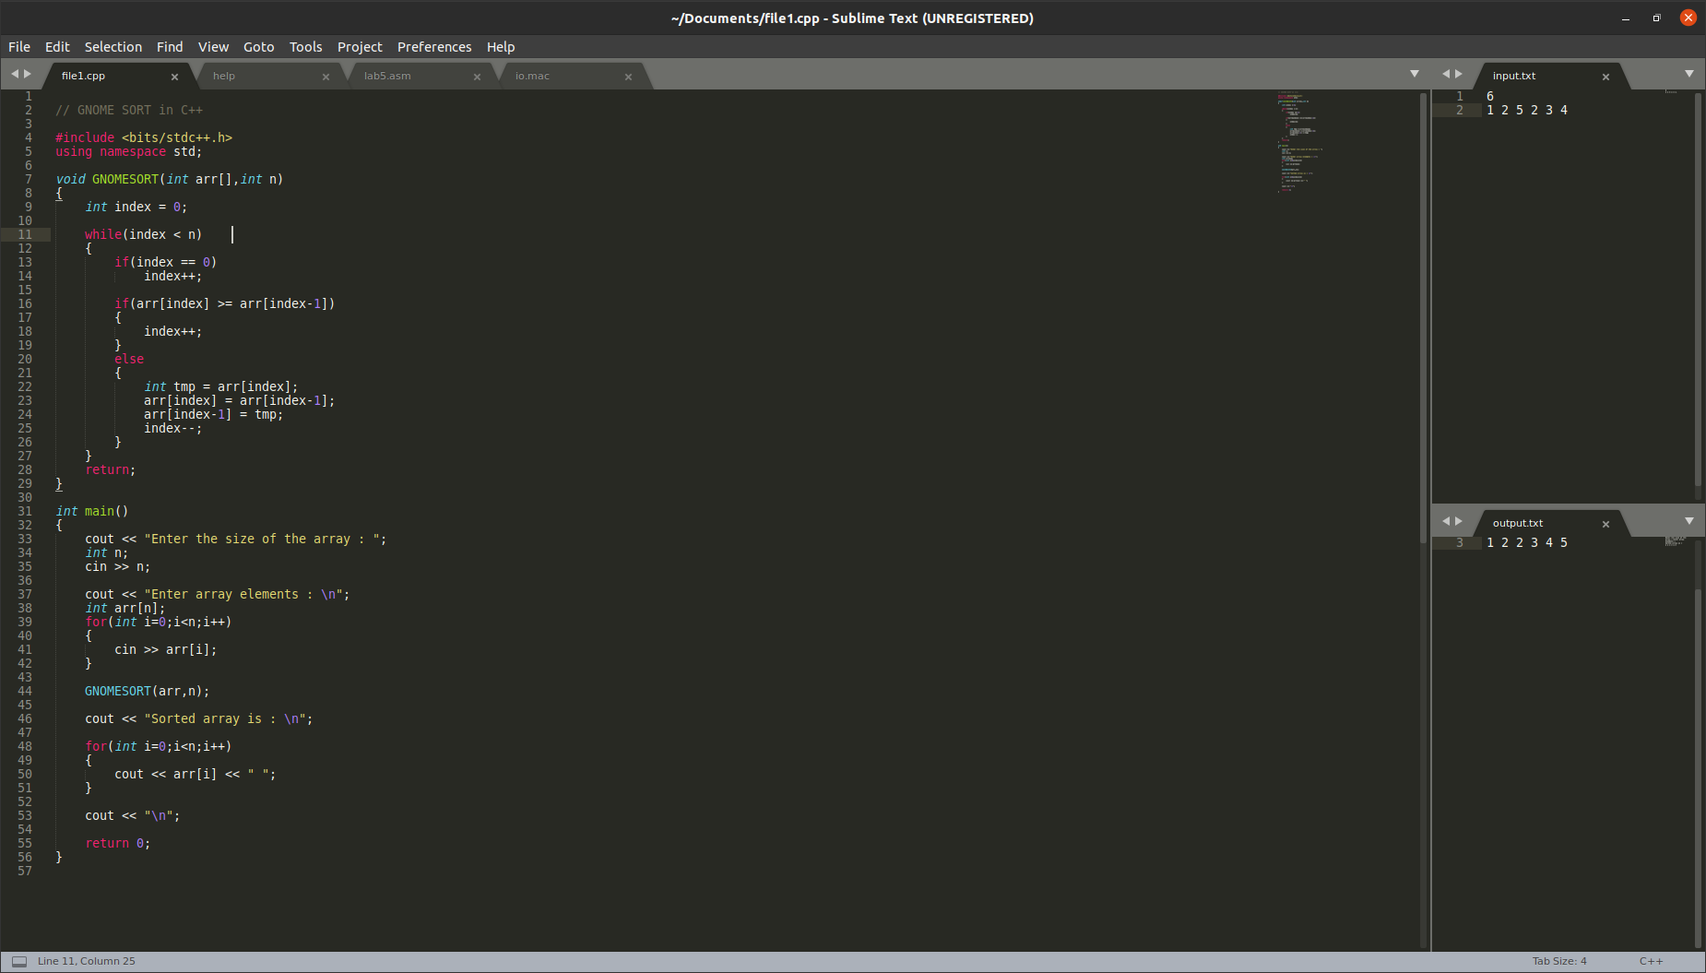
32-bit Assembly Code for nasm :
1. Initialization of variables and including necessary files
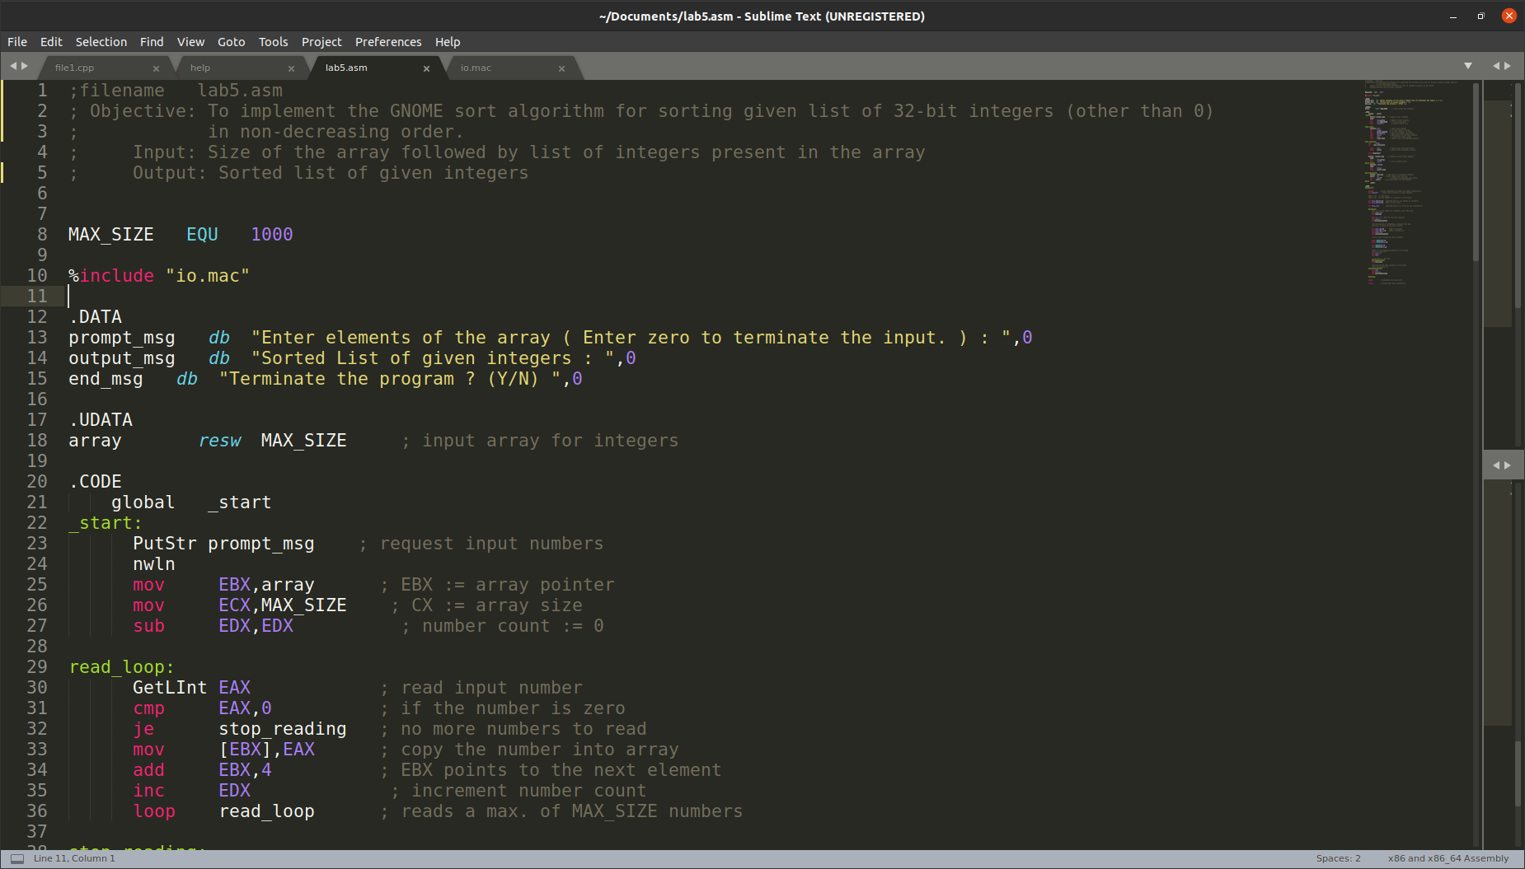
In this part, strings which are used for printing various messages during program execution are declared in data segment. ‘io.mac’ file is included to facilitate input and output of integers,strings and characters. It also contains some macro declarations in it. Max possible size for the array is also declared.

2. Prompt User for Input and Call Gnomesort Function
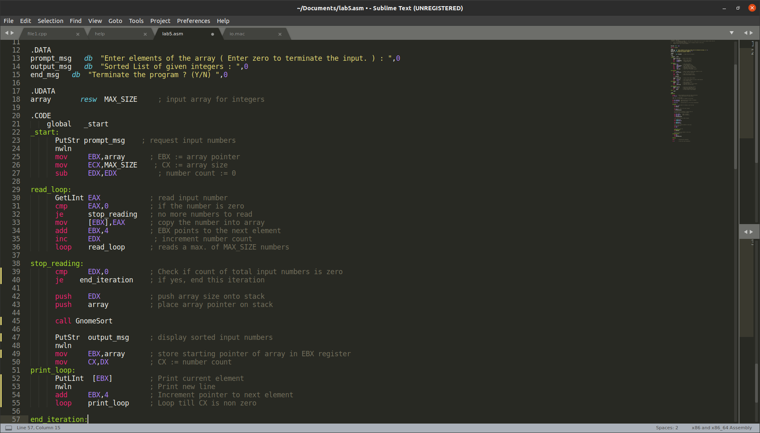

This part of the code first outputs a string msg prompting user for input of numbers in the array. It counts the size of array and stops taking input if 0 is given as input. It pushes size of array and array pointer on the stack and then calls the sorting function.

3.Gnomesort Function
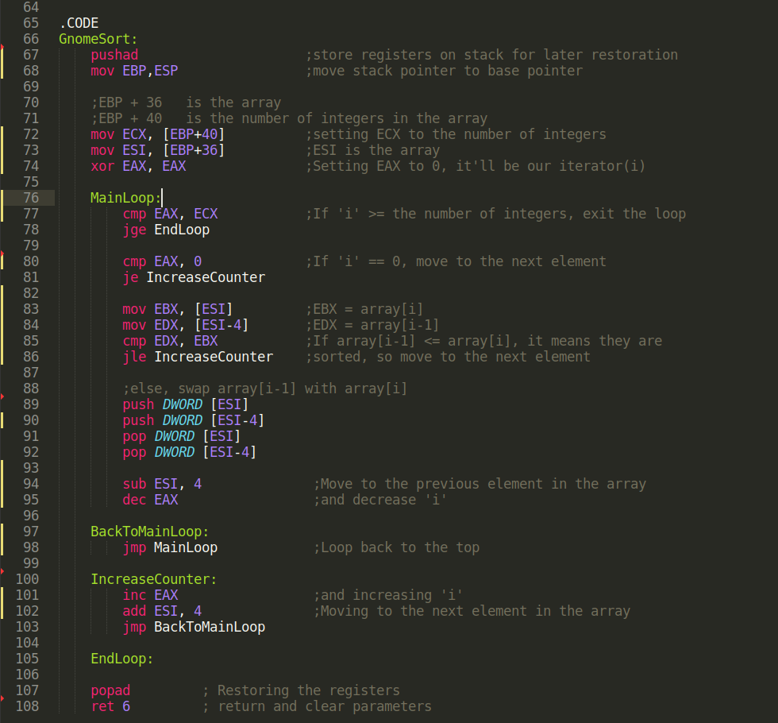
This function sorts the input using the earlier mentioned algorithm. It preservers the registers also and returns back to _start.

4. Print the sorted array and Termination of program
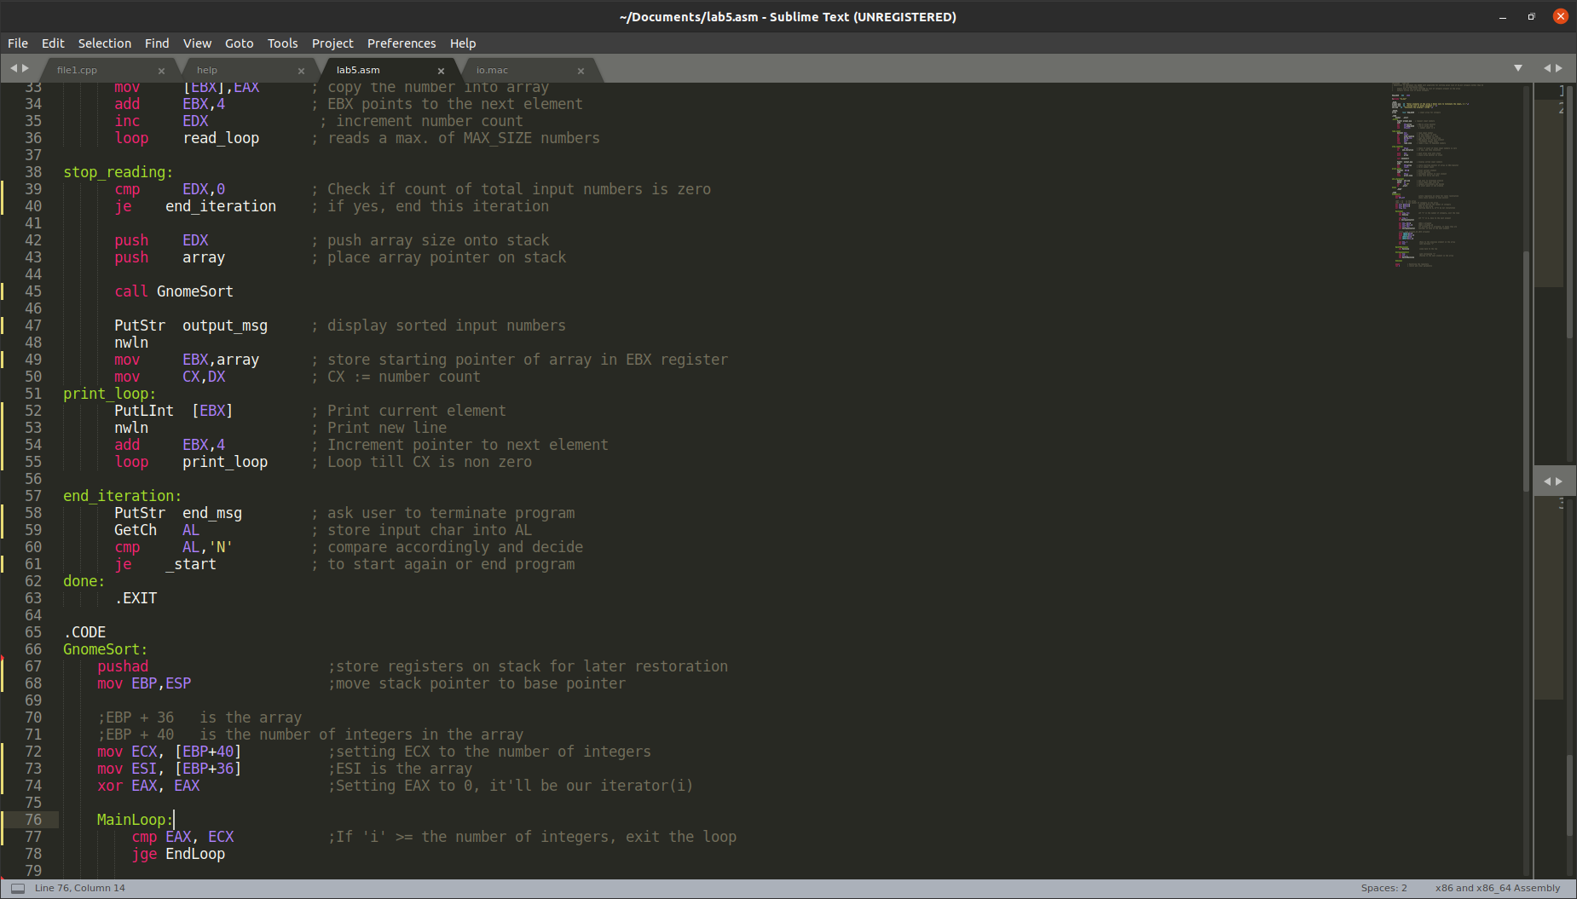
This part prints the sorted array first and then asks user to terminate the program or
not . If user wants to again sort some different list of integers, he can give input ‘N’.

Running Lab5.asm on Linux using nasm (instructions also inlcuded in help file)
