Computer Architecture Lab6 CS322 Report

Name : Chandrawanshi Mangesh Shivaji
Roll No : 1801CS16
Date : 23/10/2020

Task 1a : Comparison of C and Assembly version of Multiplication Functions

gcc -m32 -o2 -o c.out mult16m.c mult16c.c
./c.out
C version
Number of Calls (in millions) Time (in seconds)
1 0.054495
2 0.106635
5 0.262313
10 0.524121
20 1.042403
40 2.088936
60 3.122334
80 4.164502
100 5.206474

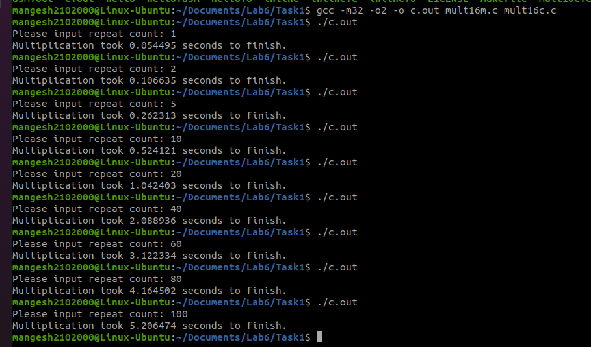
gcc -m32 -o2 -o asm.out mult16m.c mult16inline.c
./asm.out
AL version
Number of Calls (in millions) Time (in seconds)
1 0.008755
2 0.015339
5 0.034289
10 0.066551
20 0.131650
40 0.258591
60 0.388649
80 0.513768
100 0.642853

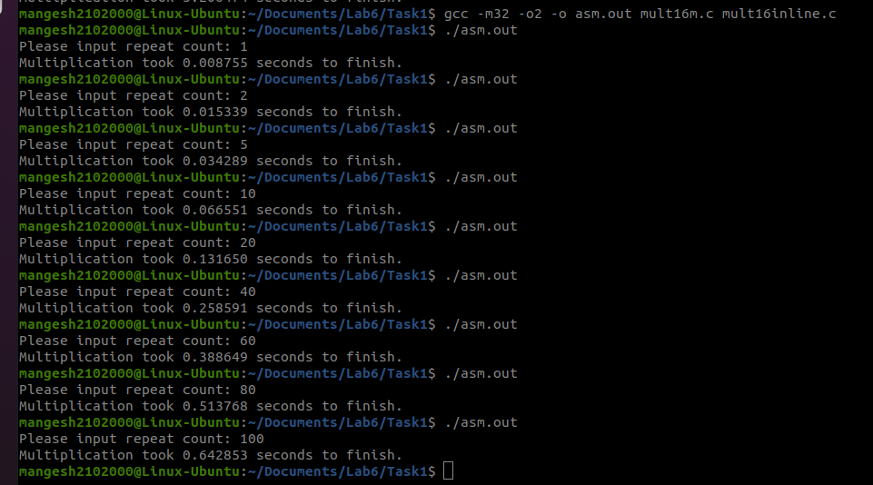
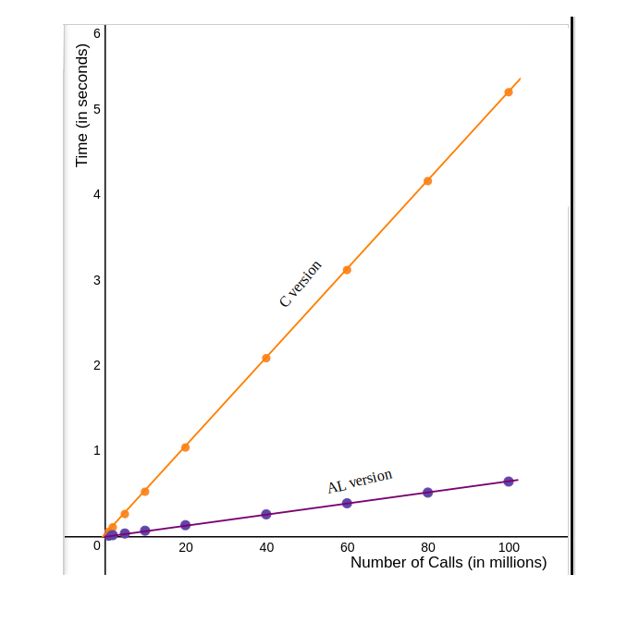
Graph 1 a

Fig. Comparision_Graph_C_and_AL_mult

So, from above graph we can conclude that assembly works faster than its equivalent C implementation. Here, both curves are linear in nature. But slope for C is greater is than corresponding Assembly implementation.

Task 1 b : Comparison of C and Assembly version of Factorial Functions

gcc -std=c99 L6_factorial.o L6_factorial_main_t_c.c
./a.out

C version

Number(upto which factorials are calculated) Time (in seconds)

1 0.000003
2 0.000004
5 0.000005
10 0.000005
25 0.000010
50 0.000023
100 0.000091
500 0.001515
1000 0.005546
5000 0.063451
10000 0.235433
20000 0.954791
30000 2.083967
40000 3.731651
50000 5.835595
60000 8.288919
70000 11.385861
80000 14.715557
90000 18.967658
10000 0 23.573817

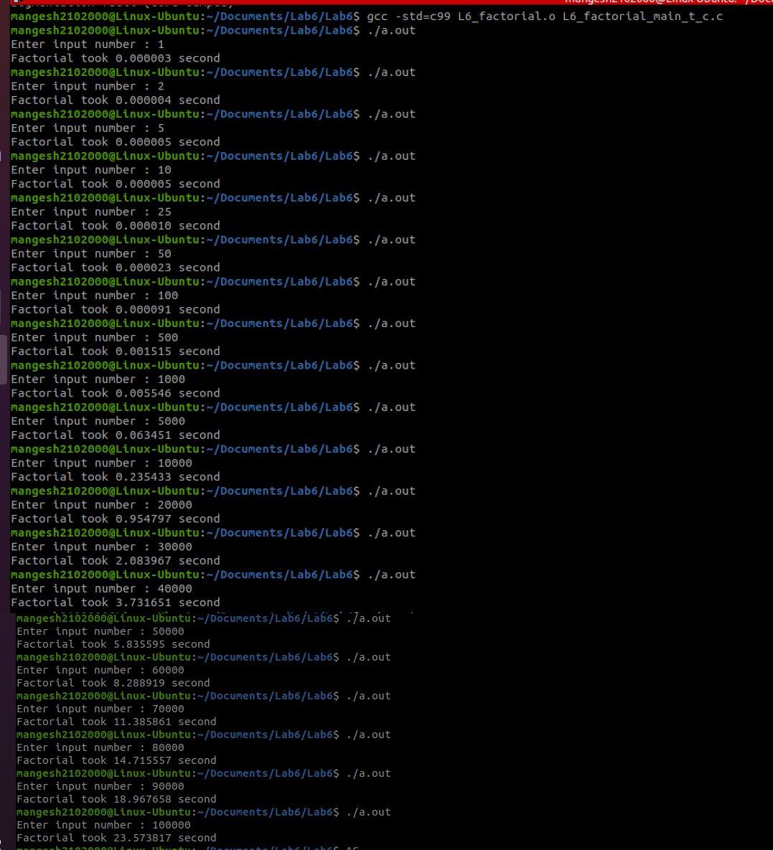
nasm -f elf64 L6_factorial.asm
gcc -std=c99 L6_factorial.o L6_factorial_main_t.c
./a.out

AL version

Number(upto which factorials are calculated) Time (in seconds)

1 0.000004
2 0.000005
5 0.000005
10 0.000005
25 0.000007
50 0.000013
100 0.000039
500 0.000999
1000 0.003493
5000 0.036828
10000 0.135437
20000 0.533520
30000 1.190139
40000 2.114971
50000 3.303128
60000 4.762004
70000 6.501823
80000 8.520762
90000 10.740420
10000 0 13.278020

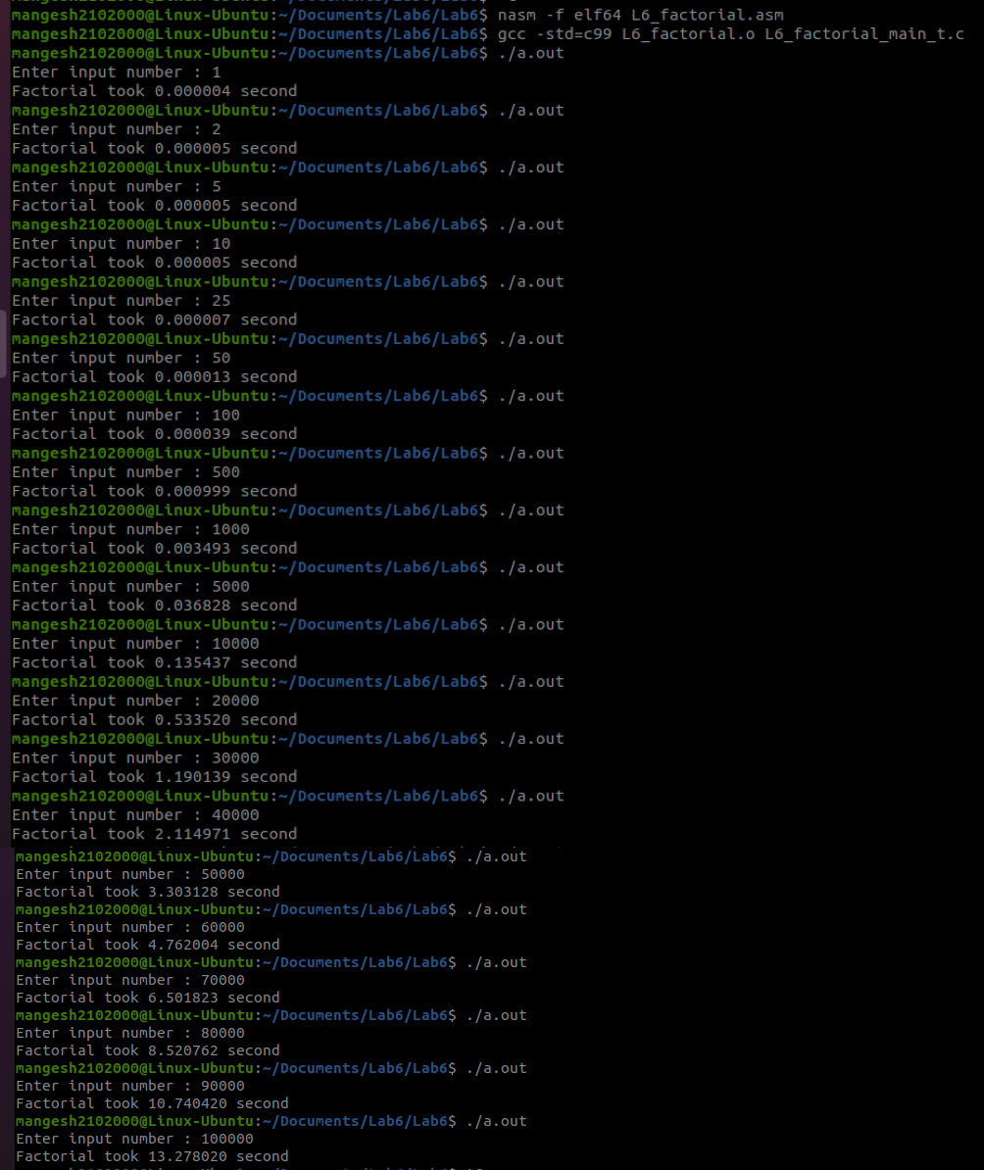

Graph 1 b

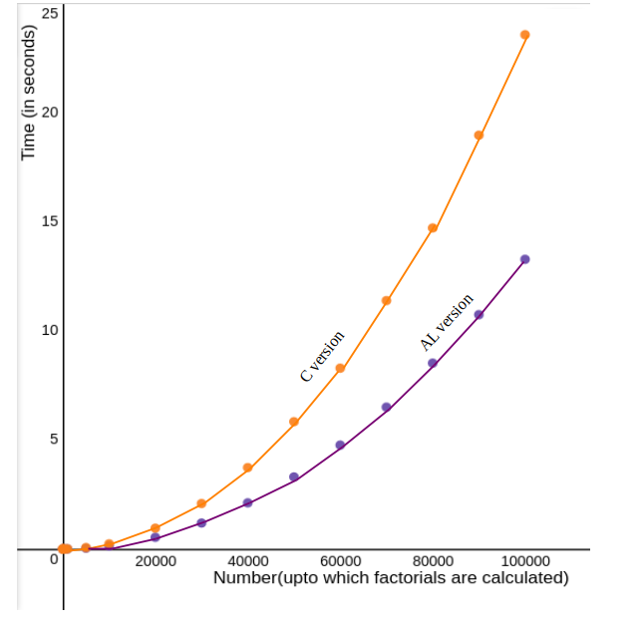
Fig. Comparision_Graph_C_and_AL_fact

So, from above graph we can conclude that assembly works faster than its equivalent C implementation for factorial function. Here, both curves are exponential in nature, But the constant factor for Assembly is lesser than its C counterpart.

From 1a and 1b, we can infer that for speed optimization it will be better if we write important functions in Assembly than any other high level language like C. Though it comes with a difficult implementation and also reduces code readability.

Task 2 : A 64-bit NASM program and a C program for implementing x^y functionality

Algorithm :
if y < 0, tell user that negative exponent is not allowed
if y == 0, ans is always 1
if y > 0, First store x in some variable (let us say in ans)
Then loop (y-1) times, in each iteration multiply ans by x
Now, we have x^y stored in ans

Command for running 64-bit NASM Program :
$ nasm -felf64 lab6.asm && gcc -o lab6 lab6.o –static
$ ./lab6 num1 num2
where num1 is base and num2 is exponent
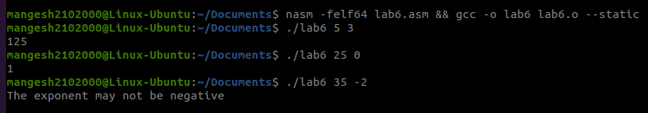

Command for running C Program :
$ gcc lab6.c
$ ./a.out
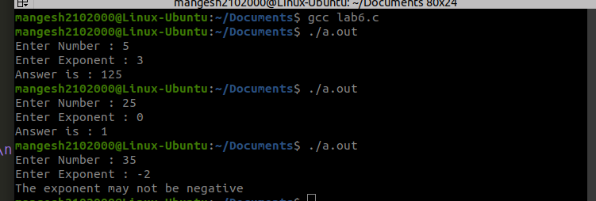
after this user will be prompted for input accordingly

