**Q1**

**Sample input:**

Number of Cylinders

Head position

Disk request

**Output:**

Algorithm name

Total head movement

Seek time

Graph

Sorted order of algorithms

**Q2**

**Sample input:**

Number of Cylinders

Head position

Disk request

**Output:**

THM (Total head movement)

Seek time

**Q2 S - LOOK**

Consider the following the following scenario :

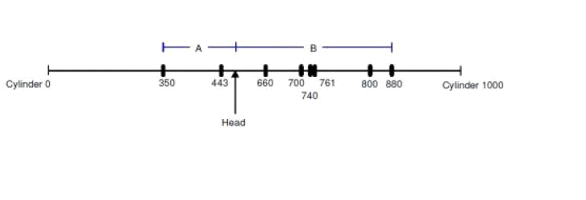

Where the horizontal line represents the disk cylinders in incrementing order from 0 to 1000 (left to right), the arrow shows the current disk head position, and A and B are the distances from the head to the far-end requests at the left and right respectively. The head has two options to serve Requests:

**Option 1:** to start serving the requests at the right first till the far-end request at cylinder 880 is reached, and then switch to travel left till cylinder 350.

**Option 2:** to go left first till cylinder 350 and then switch to travel right till cylinder 880.

Option 1 results in a total seek distance of 2B+A whereas the total seek distance for option 2 is 2A+B. Given that A<B, it is clear that

**option 2 has shorter total seek distance.**

The minimum seek distance to cover the total distance is, therefore, reached **when the disk head seeks towards its closer far-end request first, then switches to serve the other direction** .This modified version of LOOK algorithm is called **S -LOOK(Shortest LOOK)** . The algorithm is designed to make a decision of which direction should be served first instead of only continuing to seek in the same direction before the new requests have arrived.