**Switching Theory Lab (CS226) - 12**

Name : Chandrawanshi Mangesh Shivaji

Roll No. : 1801cs16

Date : 09/05/2020

(Q1) Model the following logic function using Verilog gate level description and design appropriate test bench.

Sol : -

// Verilog Code

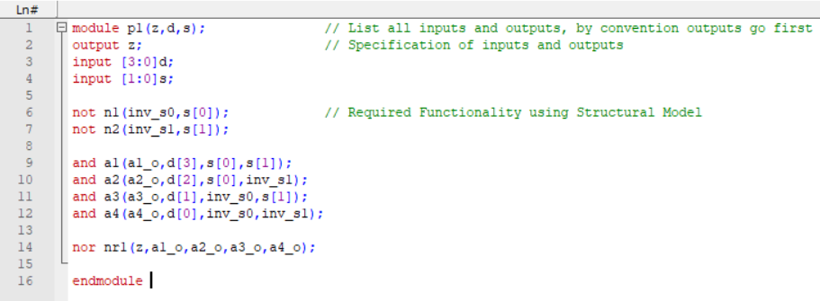

// Test Bench

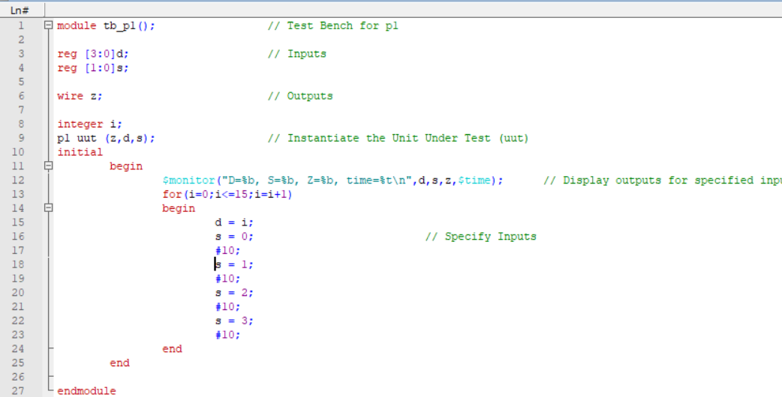

// wave_p1

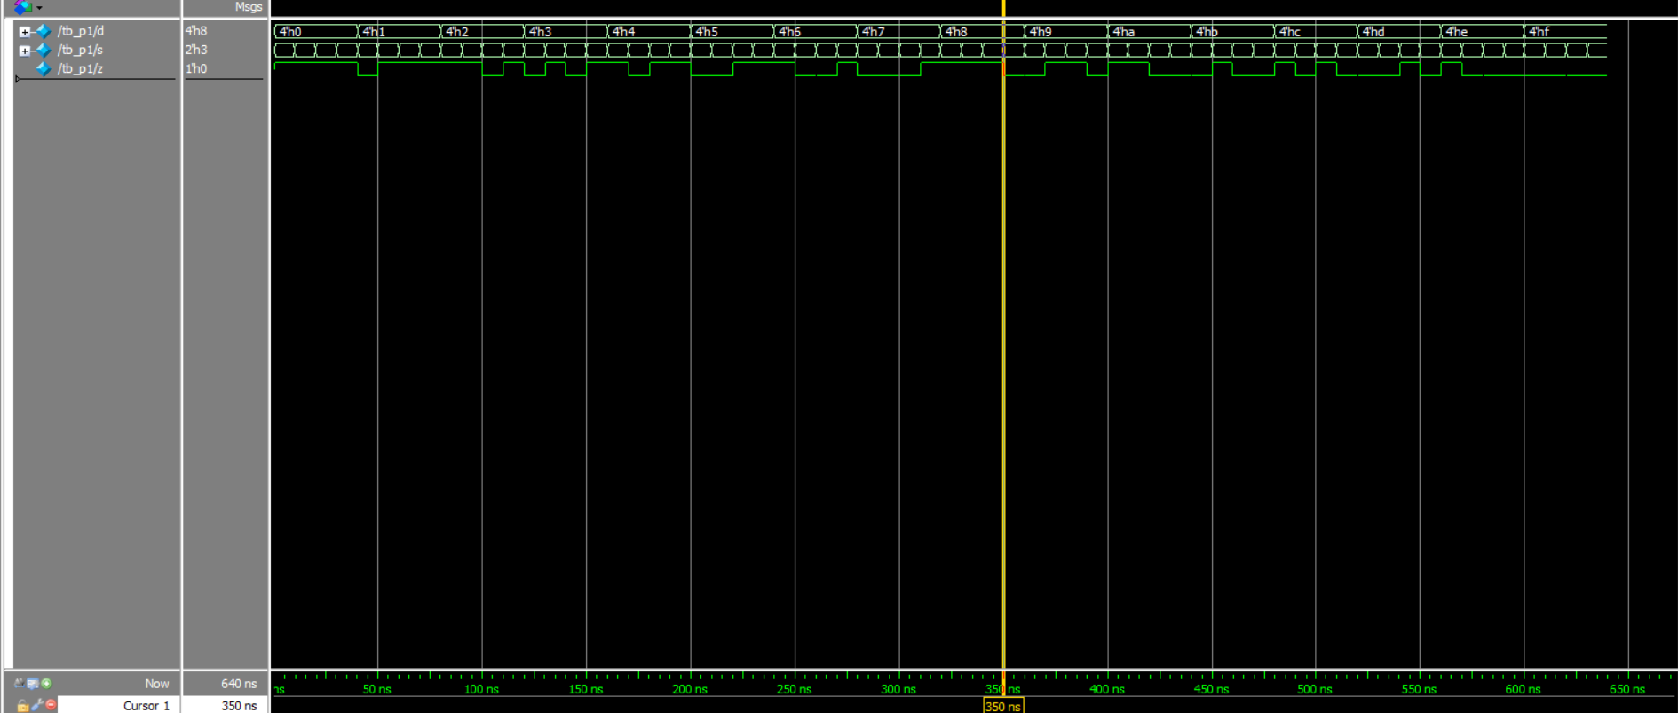

(Q2) A car has a fuel level detector that outputs the current fuel level as a 3-bit binary number, with 000 meaning empty and 111 meaning full. Create a simplified logic circuit (use Boolean algebra for simplification) that illuminates a “low fuel” indicator light (by setting an output L to 1) when the fuel level drops below level 3. Develop a Verilog model for the logic and test bench to verify the model.

Sol :-

// Verilog Code

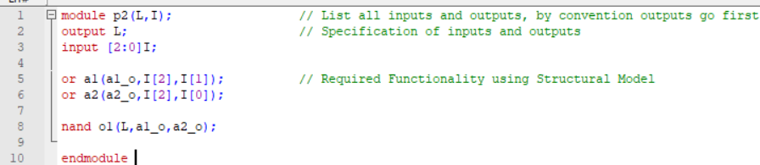

// Test Bench

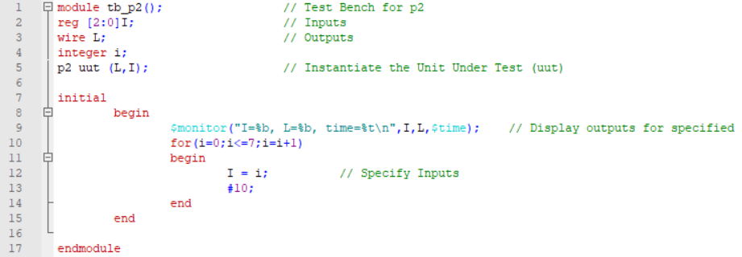

// wave_p2

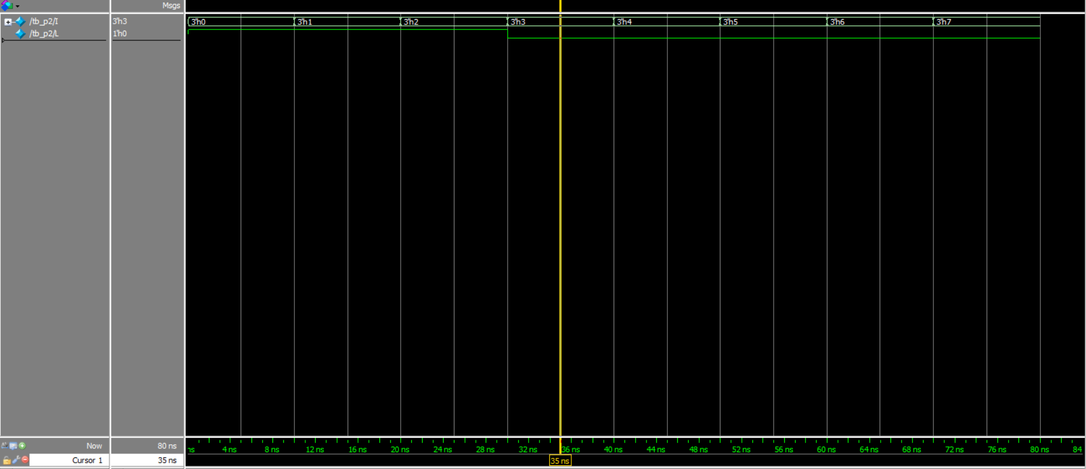

(Q3) Use a simulation to demonstrate whether or not the following functions are equal. (Be sure to state which, if any, are equal.) and verify using truth table

f = a b' + b' c' + a c

g = (b' + c) (a + b + c')

h = b' c' + b c + a c

Sol:-

// Verilog code

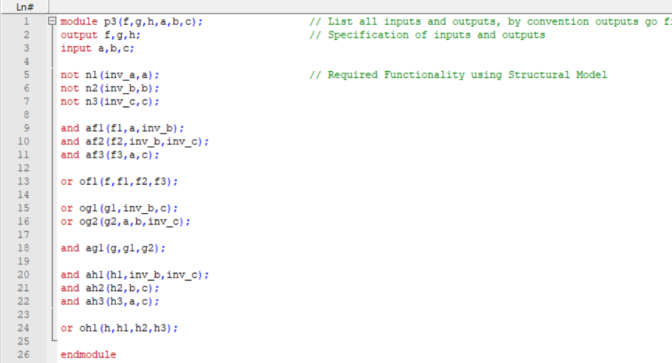

// Test Bench

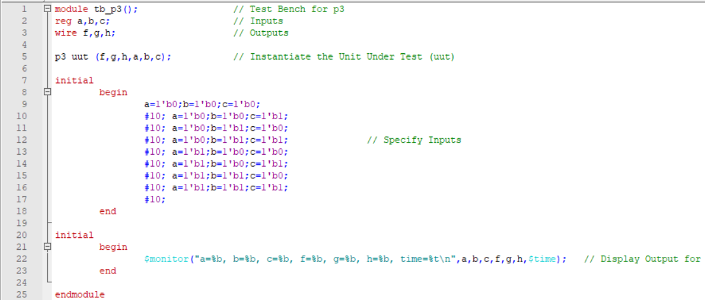

// wave_p3

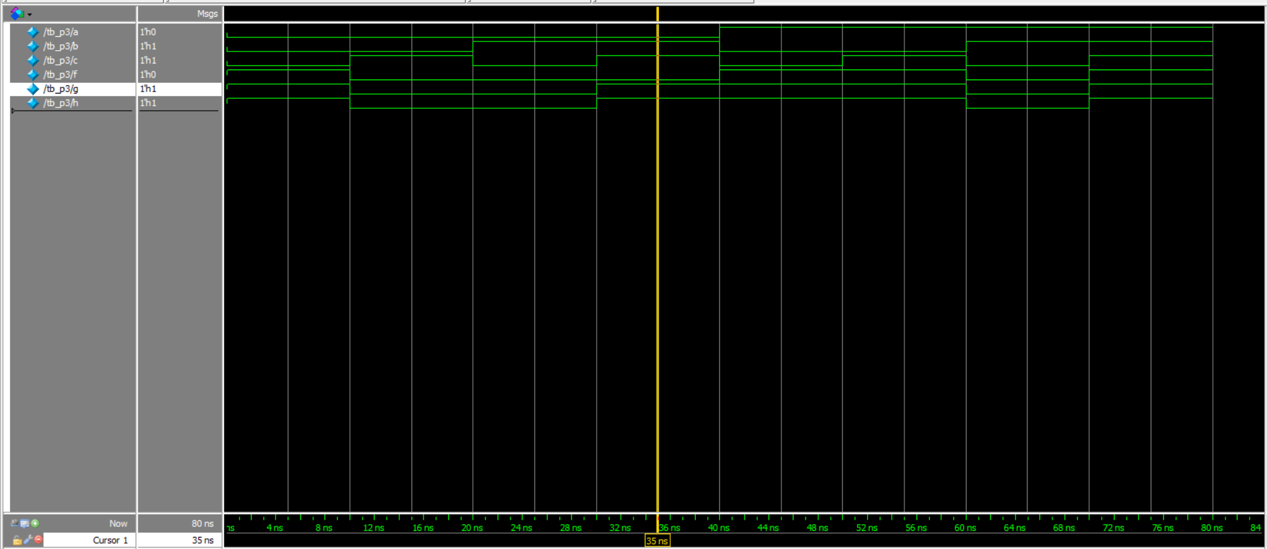

Functions g and h are equal. While f is different to both of them.

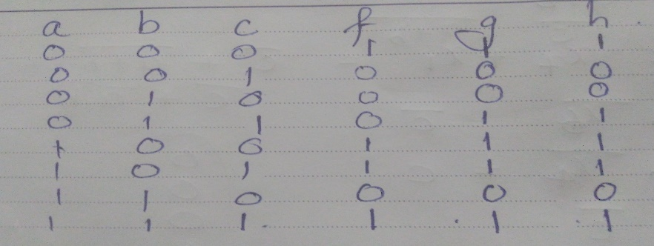

(Q4) Simulate the following function using appropriate test bench

Sol:-

// Verilog code

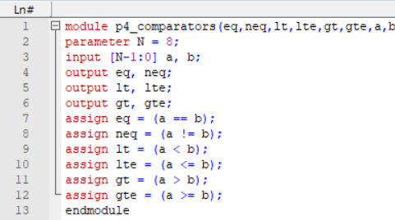

// Test Bench

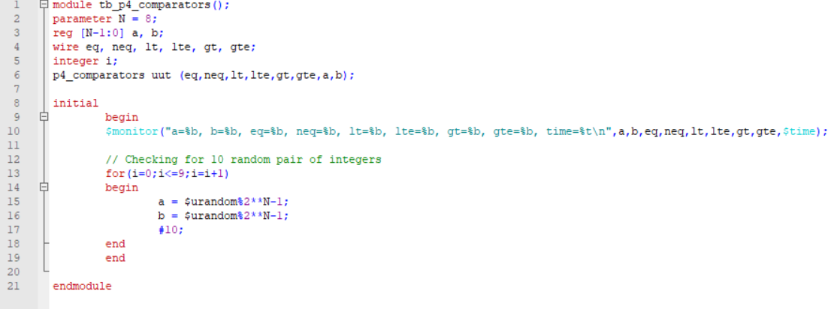

// wave_p4

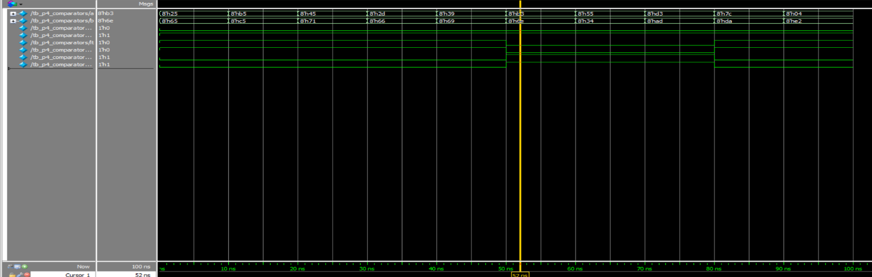

(5) A museum has three rooms, each with a motion sensor (m0, m1, m2) that outputs 1 when motion is detected. At night, the only person in the museum is one security guard who walks from room to room. Create a circuit that sounds an alarm (by setting an output A to 1) if motion is ever detected in more than one room at a time (i.e., in two or three rooms), meaning there must be an intruder or intruders in the museum. Develop a Verilog model for the above and write a test bench to verify the model.

Sol:-

// Verilog Code

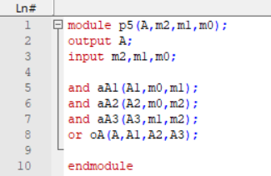

// Test Bench

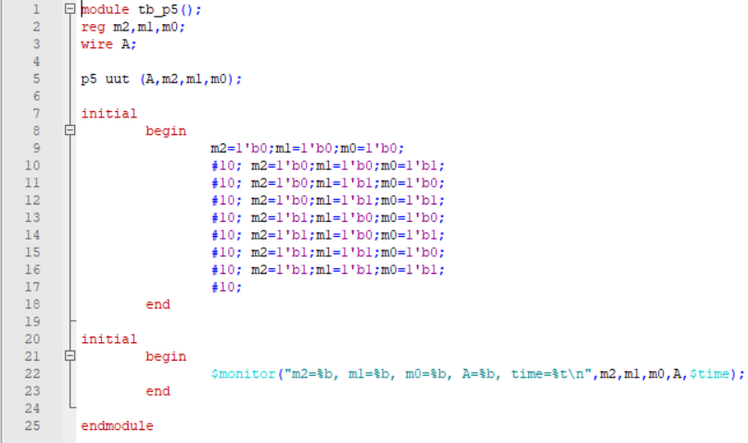

// wave_p5

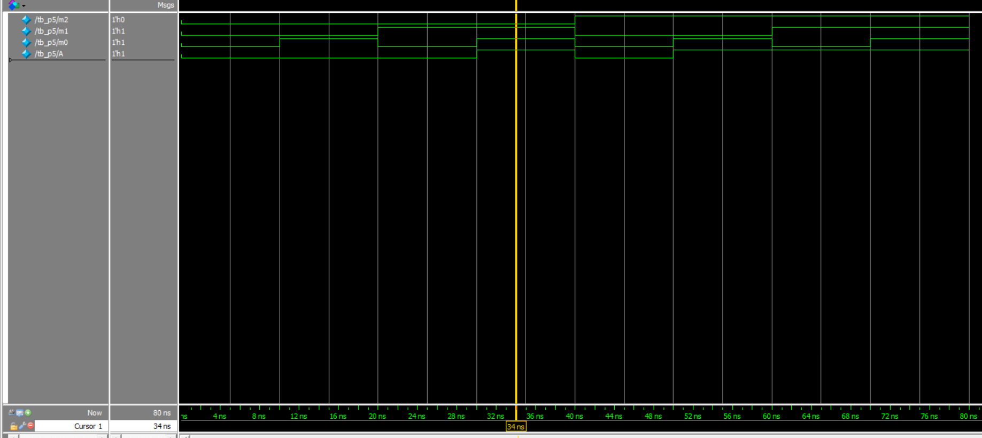

**(6**) Write a structural description of the following schematic. Check the functionality of the circuit by writing appropriate test bench.

Sol:-

// Verilog Code

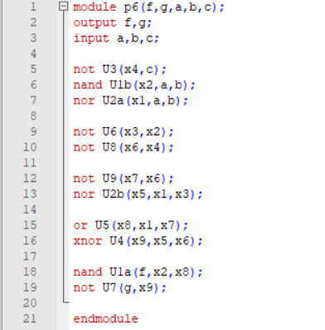

// Test Bench

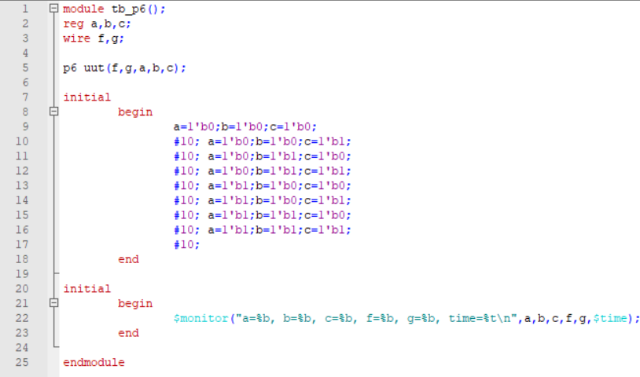

// wave_p6

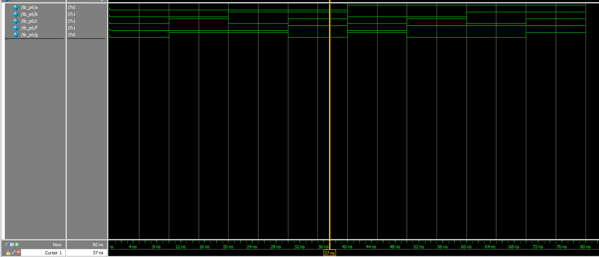

(Q7) Design 4 to 1 multiplexer with different coding styles ( at least 5) and test using appropriate test bench. Include all the designs in a single file (p7.v and tb_p7.v) and submit.

Sol:-

// Verilog Code

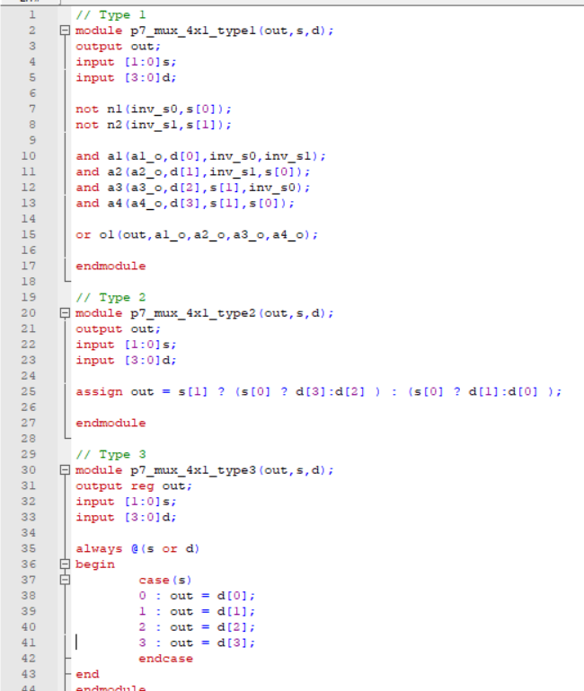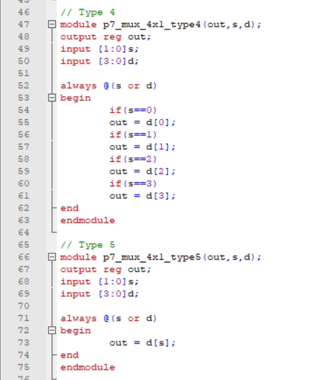

// For all other similar test bench is required just we have to change type in the implementation (Test Bench)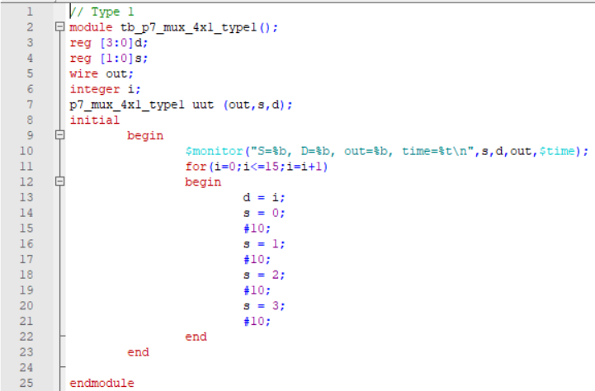

// wave_p7

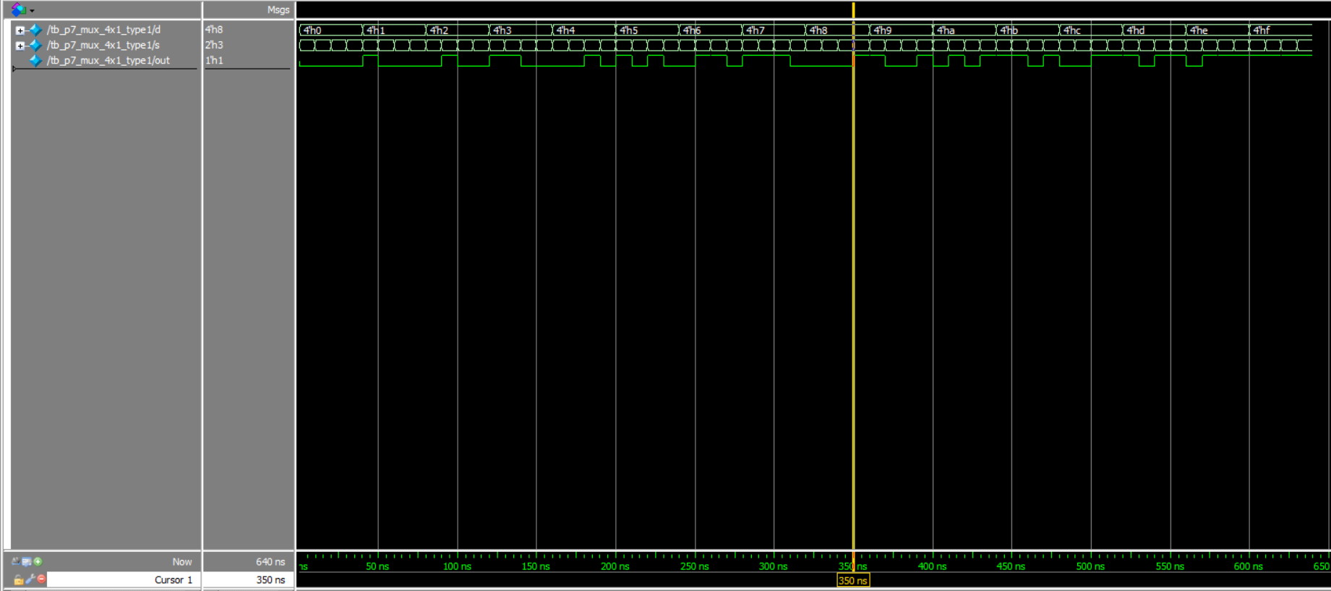

(Q8) Design 16 to 1 multiplexer using 4 to 1 MUXs and test using appropriate test bench. Include all the designs in a single file (p8.v and tb_p8.v) and submit

Sol:-

// Verilog Code

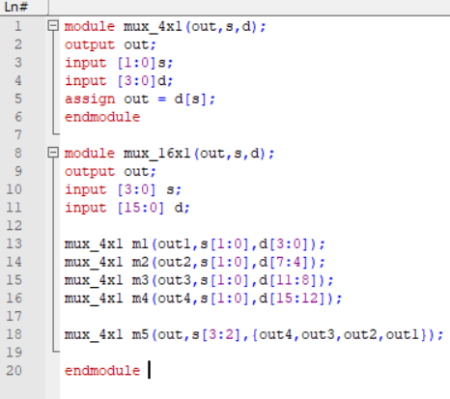

// Test Bench

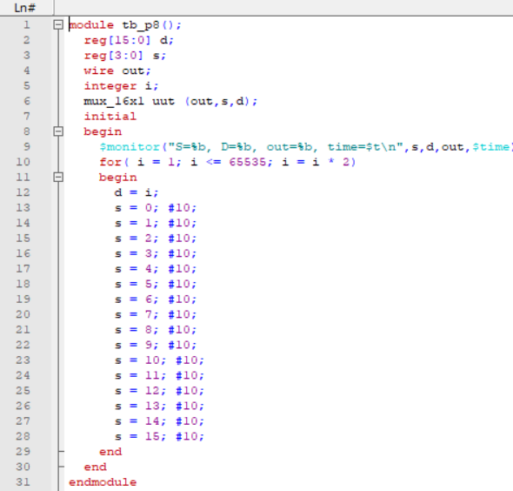

// wave_p8

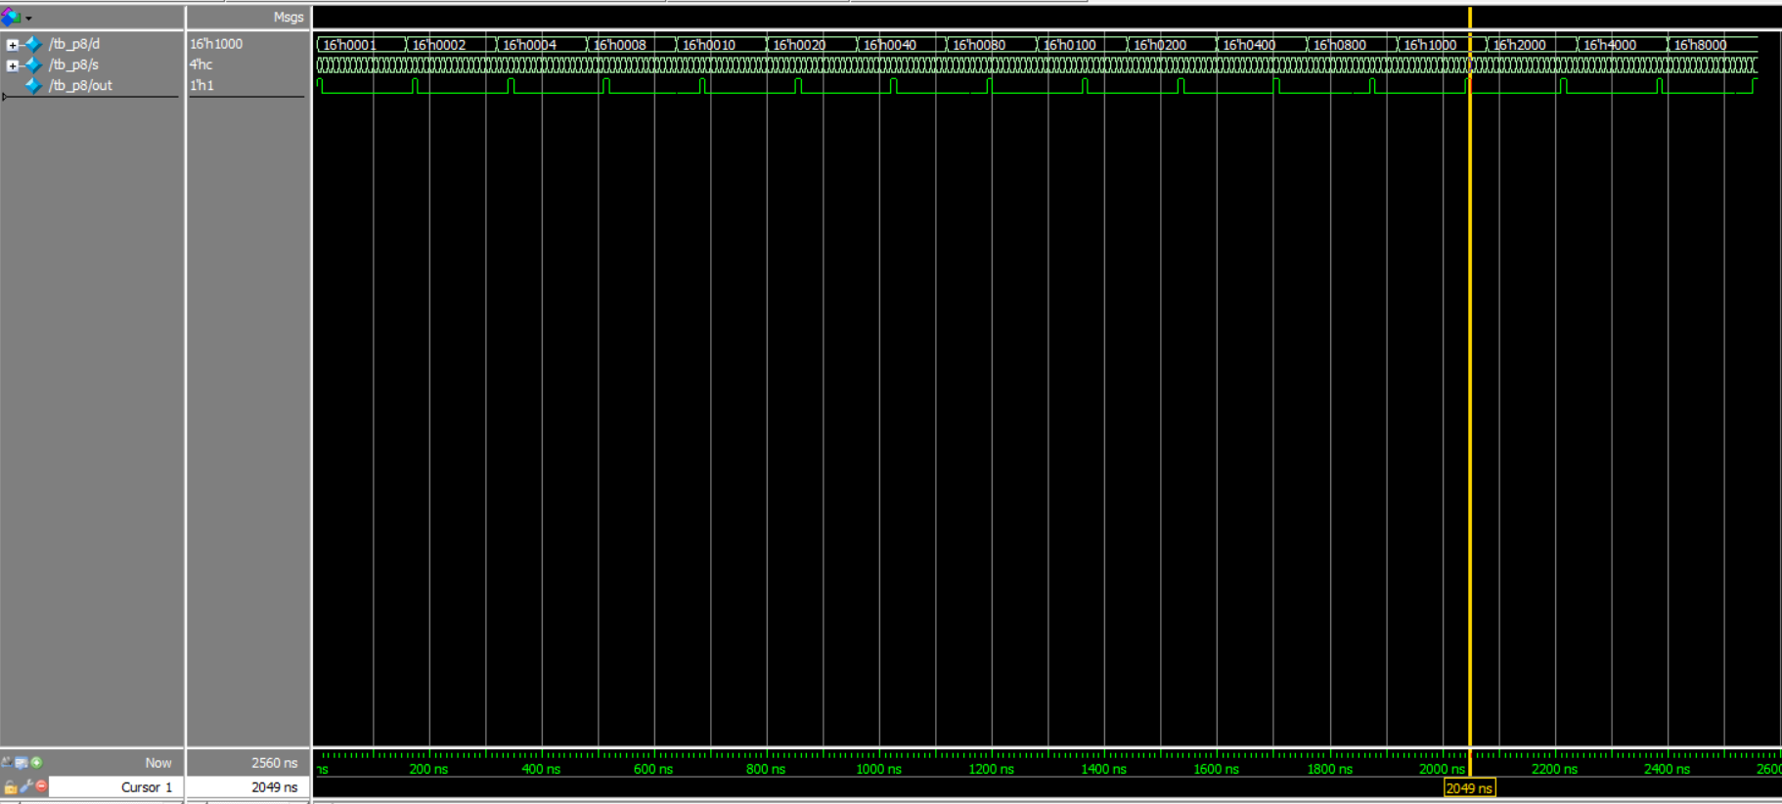

// End of Document