**Switching Theory Lab (CS226) - 13**

Name : Chandrawanshi Mangesh Shivaji

Roll No. : 1801cs16

Date : 16/05/2020

Note :- Waveforms along with screenshots of code,test benches are placed in another folder named screenshots also if not properly visible please refer there.For each ques. ( Code, Test Bench, Waveform ) is the order for screenshots.

**Q1) =>**

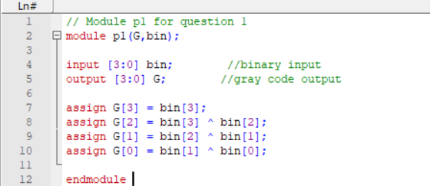

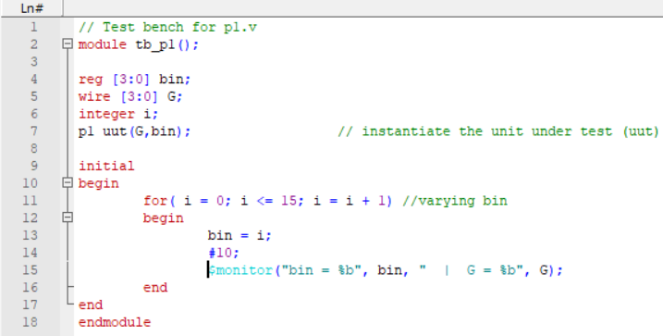



**Q2) =>**

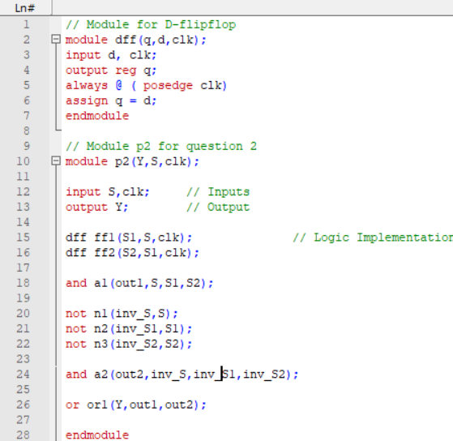

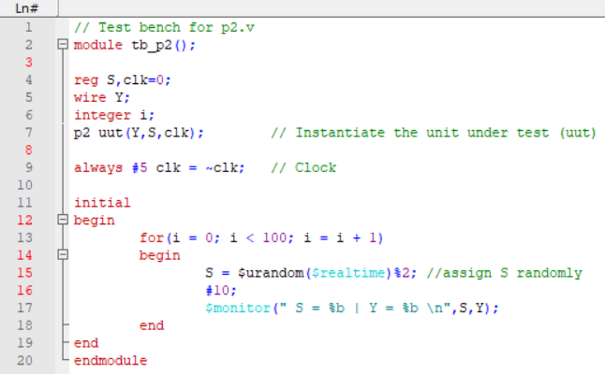

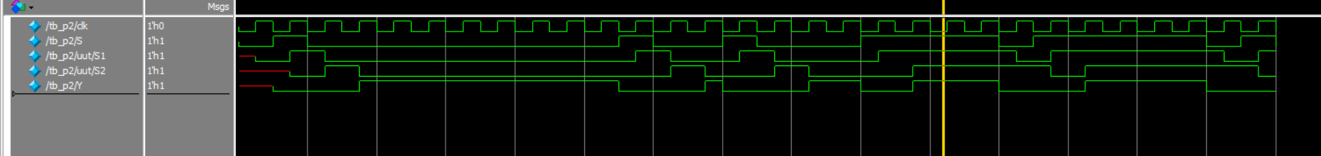

**Q3) =>**

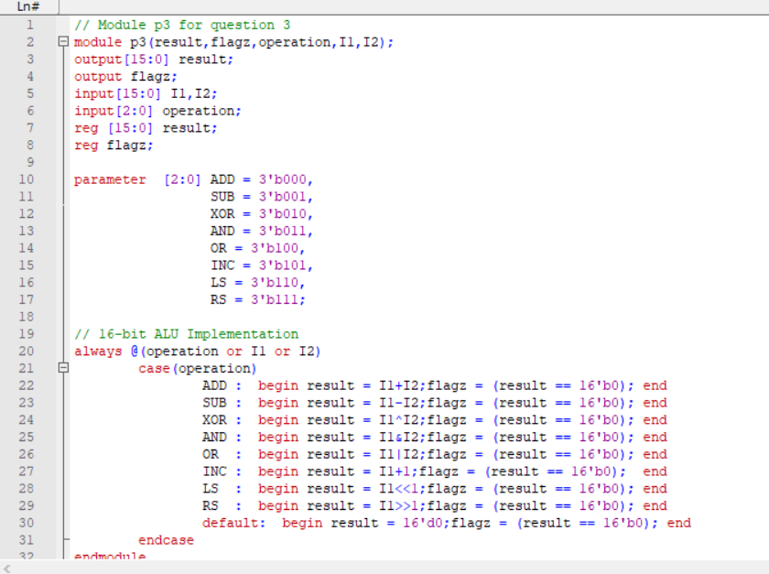

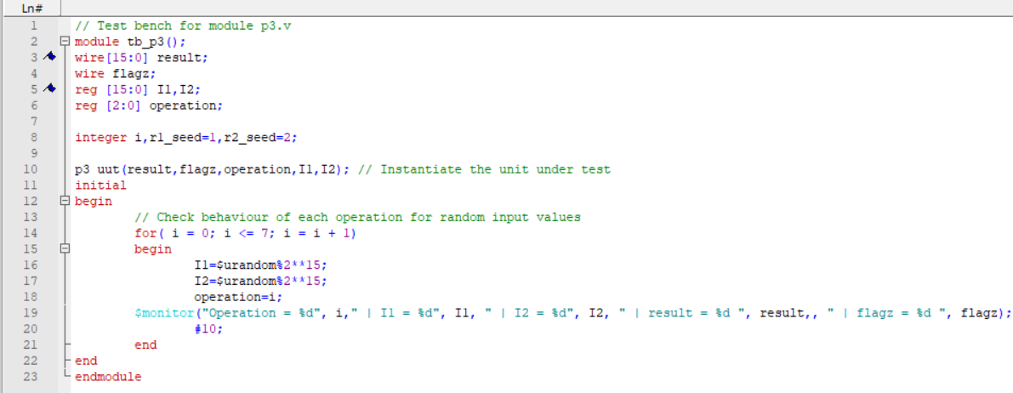



**Q4) =>**

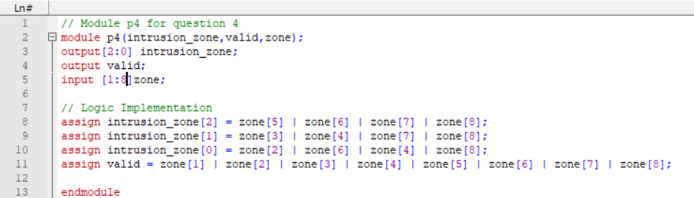

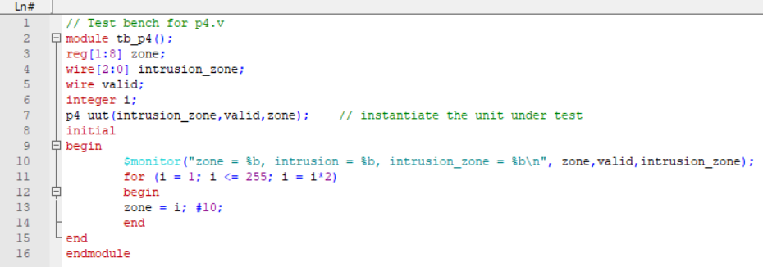 

**Q5) =>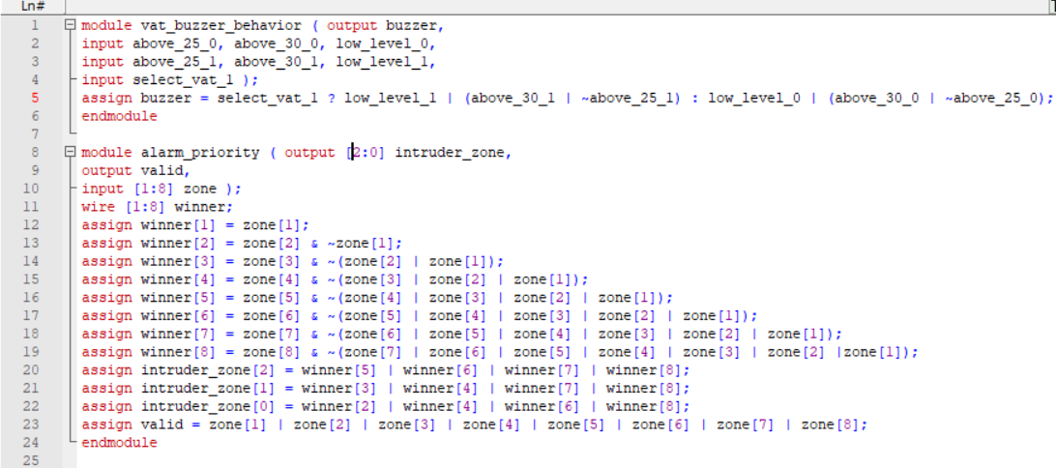 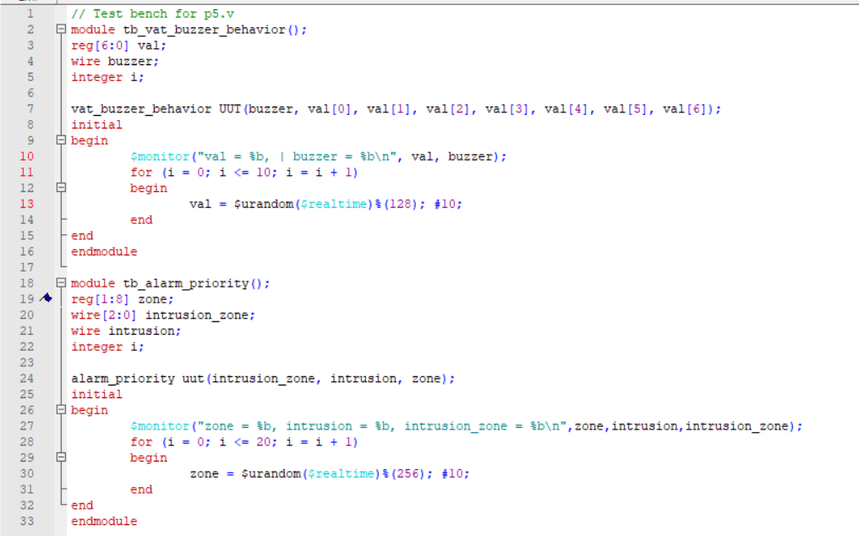 Wave alarm_ priority**



**Wave vat_buzzer_behaviour**



**Q6) =>**

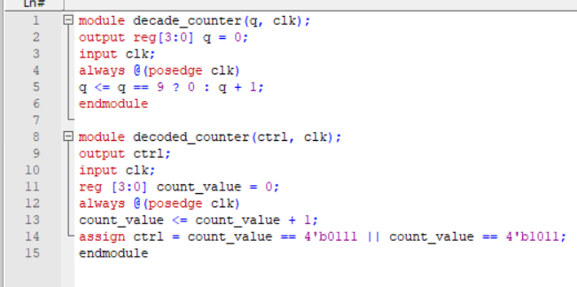

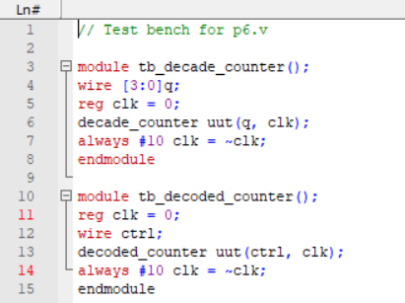

**Wave decade counter**



**Wave decoded counter**



**Q7) =>**

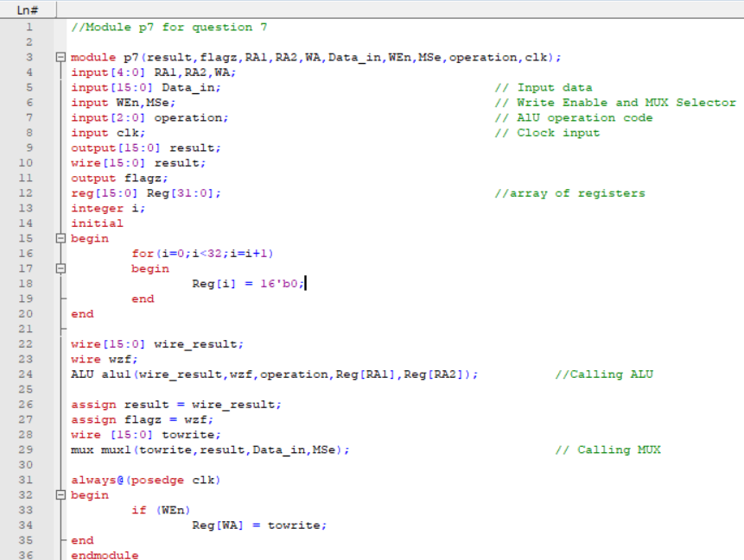

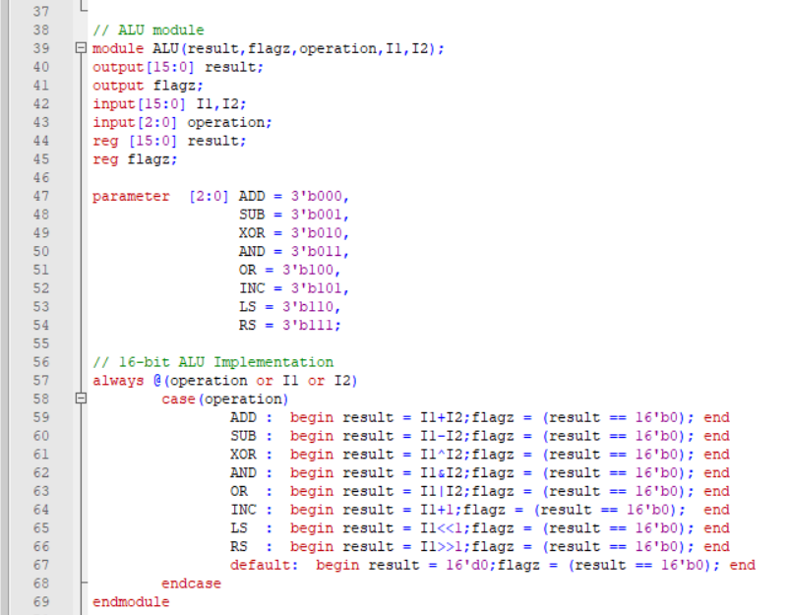

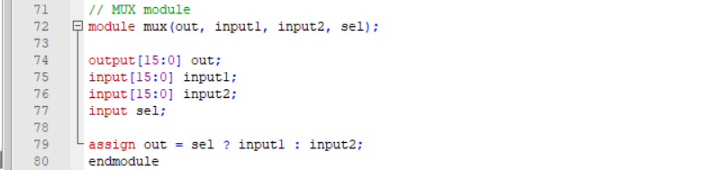

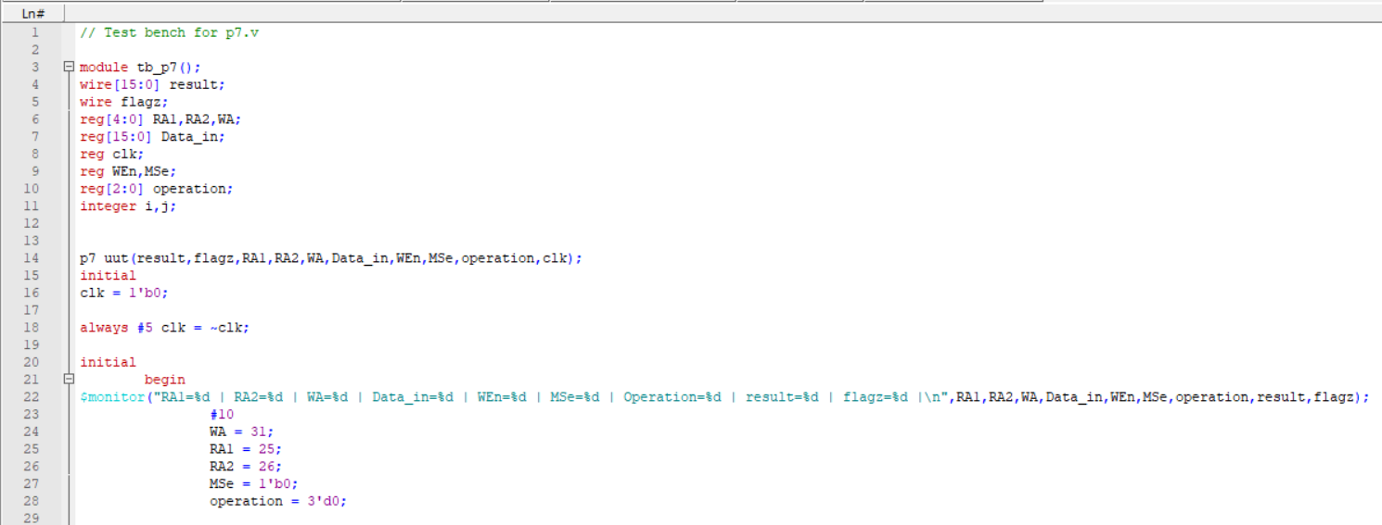

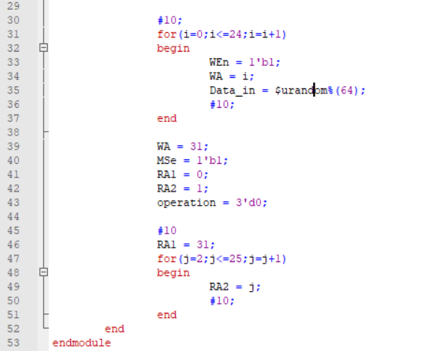

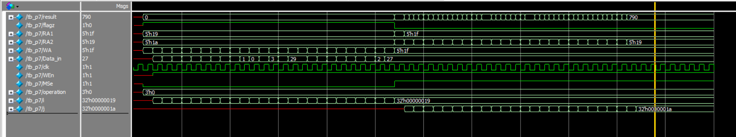

// End of Document