**Switching Theory Lab (CS226) - 14**

Name: Chandrawanshi Mangesh Shivaji

Roll No. : 1801cs16

Date: 21/05/2020

Note:- Waveforms along with screenshots of code, test benches,logisim circuits are placed in another folder named screenshots also. If not correctly visible, please refer there. For each ques. Code, Test Bench, Waveform is the order for screenshots.

**Q1) =>** **FSM:**

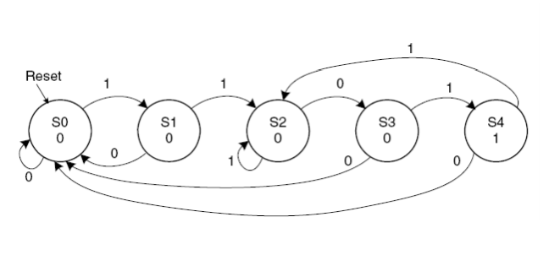

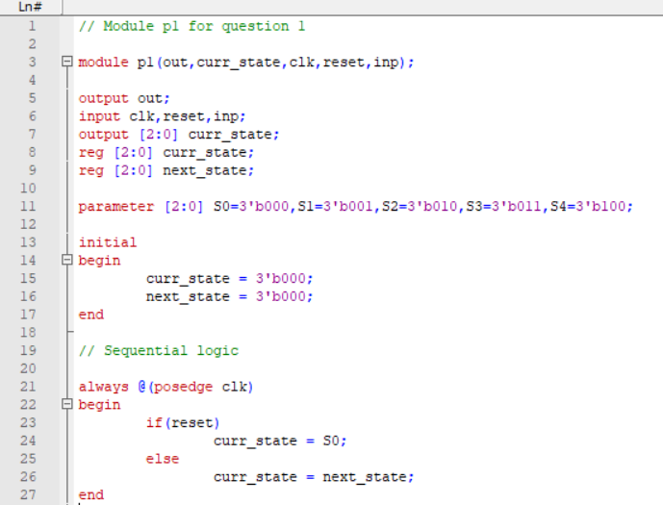

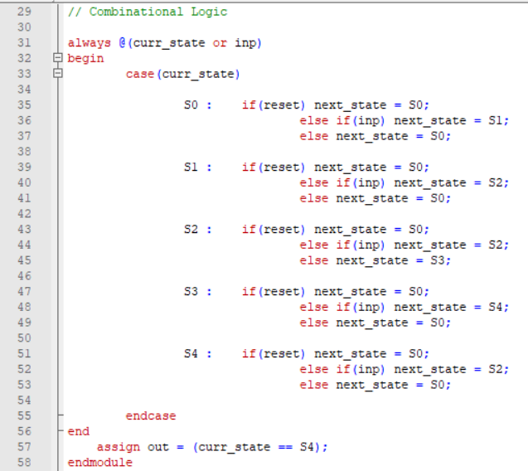

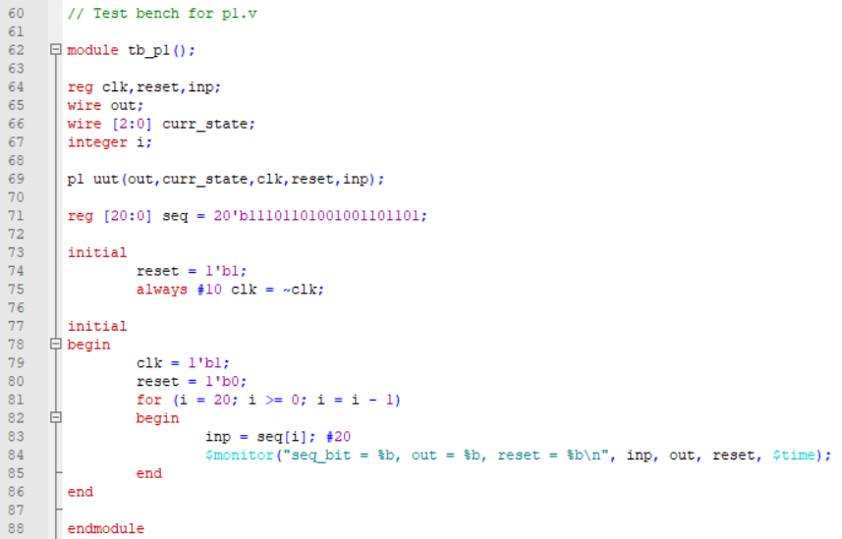

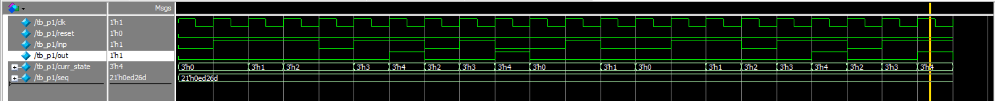

In the above waveform,

* seq is the input sequence (11101101001001101101)
* curr_state shows the current state w.r.t to the FSM
* inp is the sequential input from seq
* out is the output signal, which indicates the presence of an 1101 sequence.

We can see that in the sequence, there are four 1101 sequences, and correspondingly 4 out highs are there.

**Q2)=>**

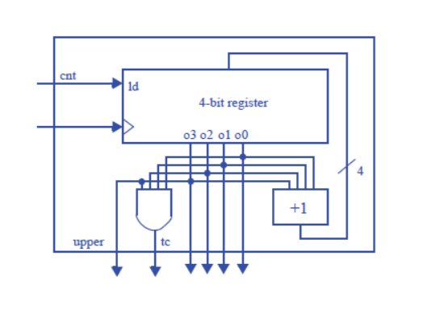

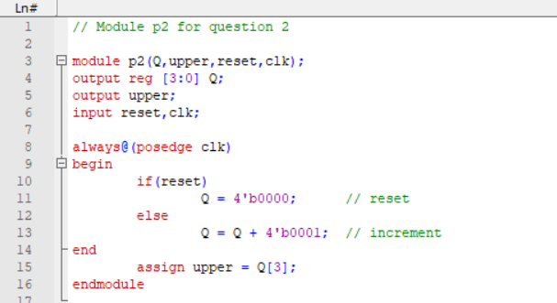

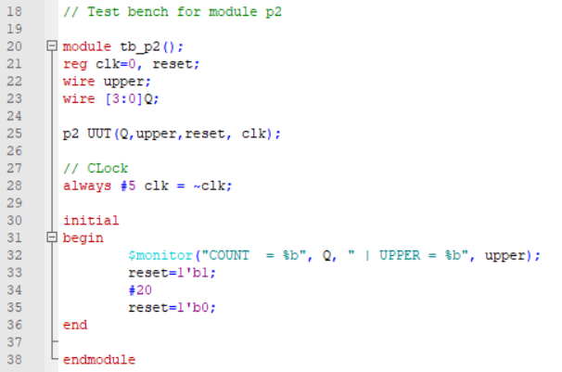

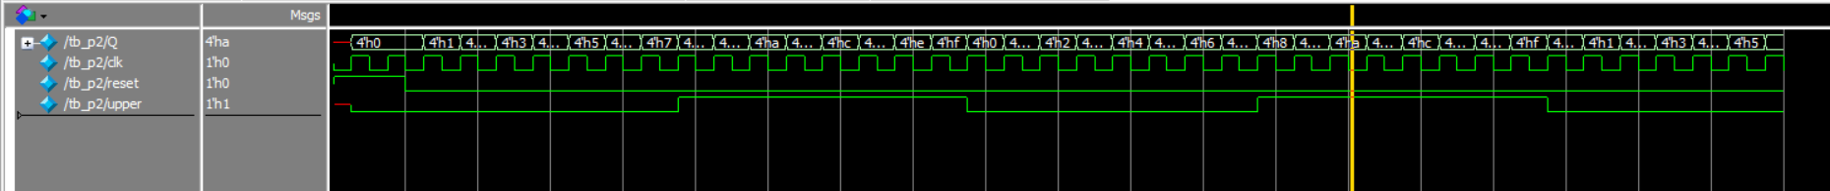

* We can see that the counter counts from 0 to 15.
* Reset and upper are also functioning correctly.

**Q3)=>** 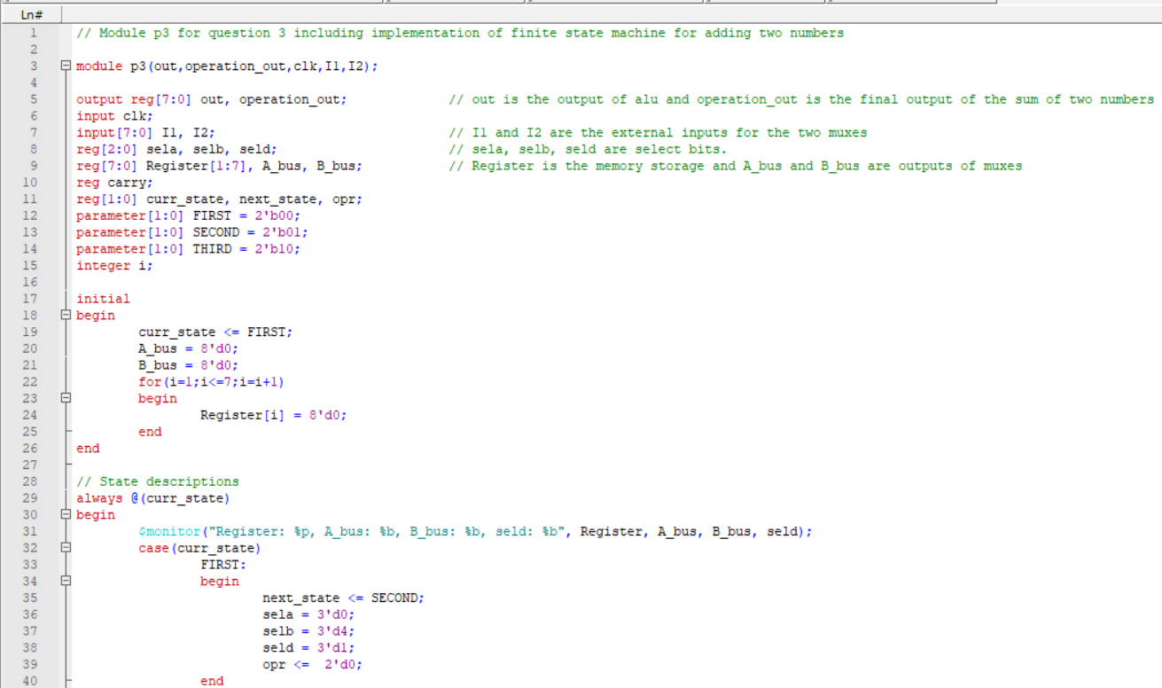

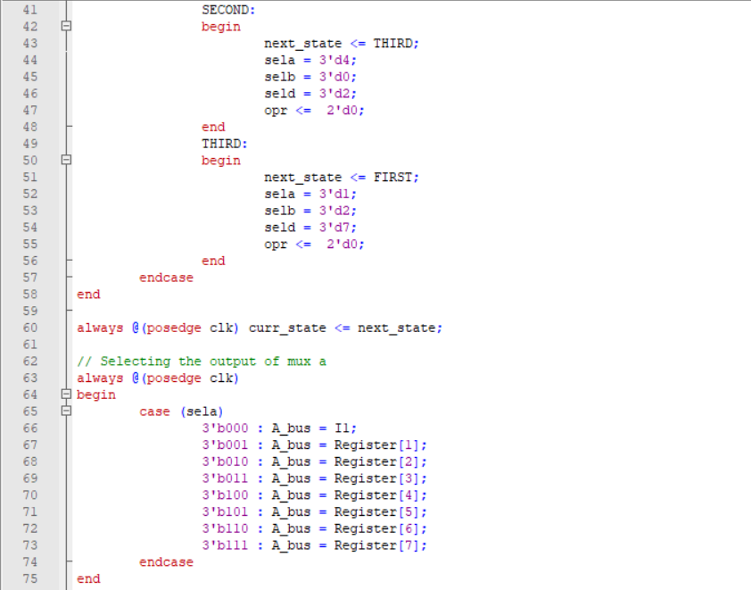

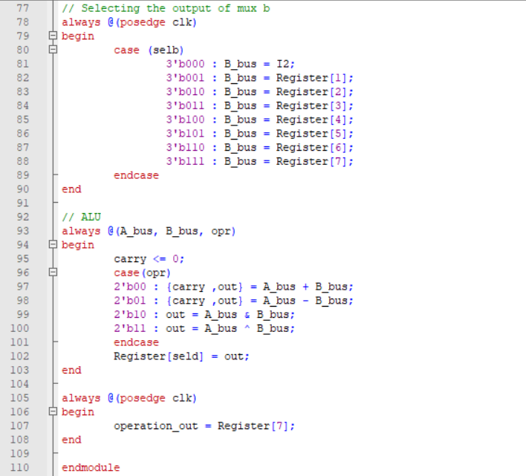

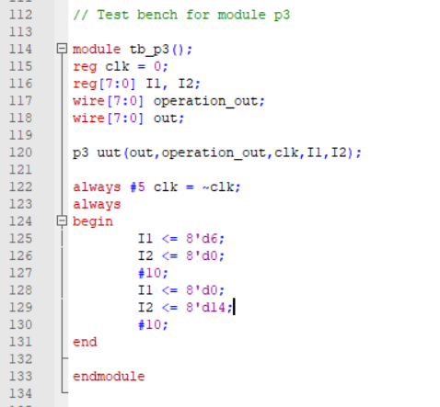

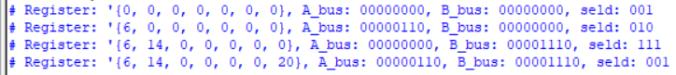



* We use an FSM to give input to the sequential circuit. SELA, SELB, SELD are chosen through the state diagram.
* First, from I1(external input to mux a), we add it to 0 in the ALU and store the result in Register[1].
* Second, from I2(external input to mux b), we add it to 0 in the ALU and store the result in Register[2].
* Now, we take the values from Register 1, 2, and pass it into the ALU for addition.
* The sum is finally stored in Register[7] (represented by operation_out in the waveform)
* We take inp1 as 6 and inp2 as 14. The sum is 20, which is stored in Register[1].

**Logisim Model including FSM**

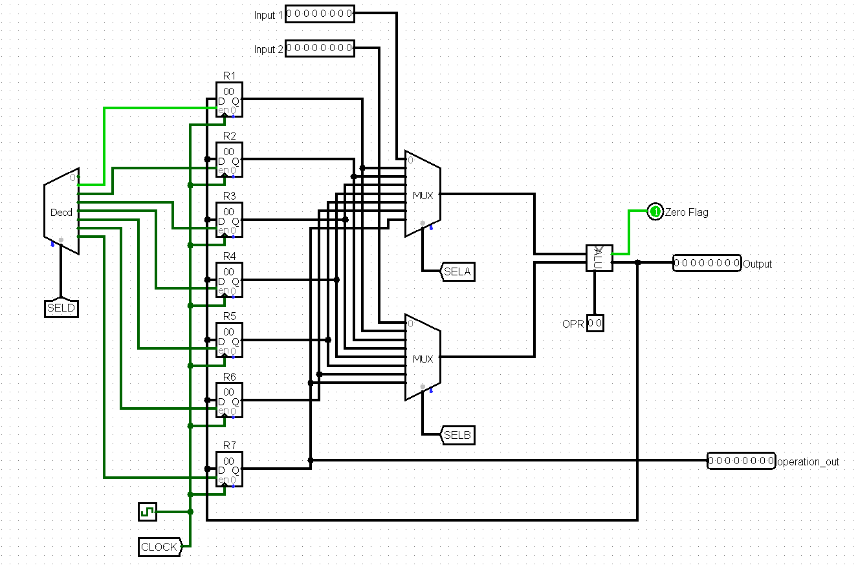

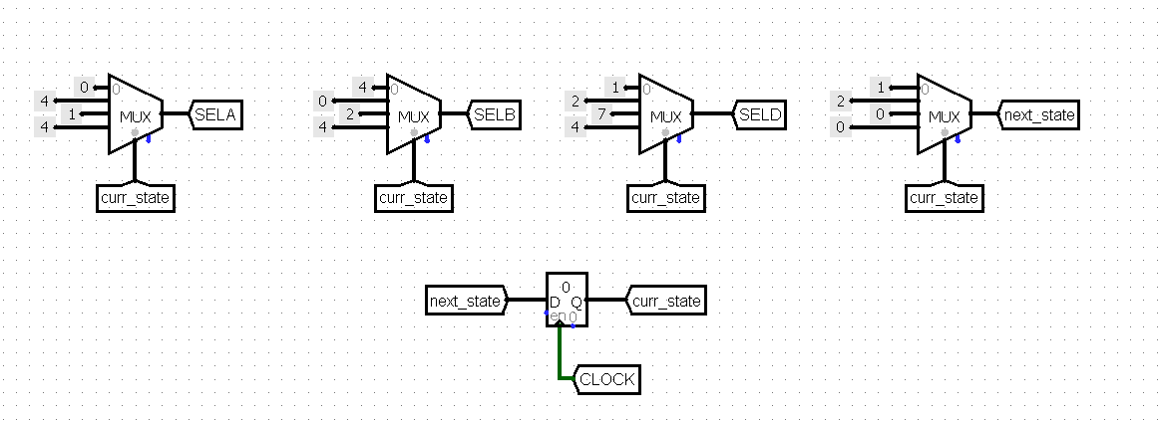

// End of Document