PROJECT REPORT

TO-DO LIST MANAGEMENT SYSTEM
DETAILED PROJECT REPORT

Submitted in partial fulfillment of the requirements for the course
Python Programming / Programming Fundamentals

SUBMITTED BY
Name - MANGESH
Reg no – 26BCE11583
Branch - CSE(CORE)
Semester - 1st Sem
Academic Year - 2026-27
VIT BHOPAL UNIVERSITY



CERTIFICATE
This is to certify that the project entitled “To-Do List Management System” is a Python-based console application developed for learning and demonstrating fundamental programming concepts. The project implements a menu-driven task management system using lists, loops, conditional statements, user input, string operations, and Boolean values.
This report presents the project objectives, requirements, design, implementation, features, testing, limitations, and possible future enhancements.

ACKNOWLEDGEMENT
I would like to express my gratitude to my faculty and institution for providing the opportunity to develop this Python project. Working on the To-Do List Management System helped me understand how basic programming concepts can be combined to create a practical application.
I also acknowledge the role of practice, debugging, and experimentation in developing the project and preparing this documentation.

ABSTRACT
The To-Do List Management System is a simple console-based Python application designed to help users organize and manage tasks. The application provides a menu through which users can add new tasks, view existing tasks, mark tasks as completed, delete tasks, edit task descriptions, search for tasks, view a task summary, clear all tasks, and exit the program.
The project is intentionally based on fundamental Python programming concepts. Tasks are stored in a list, and each task contains a description and a Boolean completion status. The application uses a continuous while loop to display the menu and process user choices until the Exit option is selected.
Input validation is included for empty task descriptions, task numbers, numeric input, and invalid menu choices. The project therefore provides a practical example of applying basic Python syntax and control structures to a real-world style problem.

TABLE OF CONTENTS
- 1. Introduction
- 2. Problem Statement
- 3. Project Objectives
- 4. Scope of the Project
- 5. Existing System and Proposed System
- 6. Requirements
- 7. System Design
- 8. Data Structure
- 9. Functional Modules
- 10. Algorithm and Program Flow
- 11. Implementation Details
- 12. Input Validation and Error Handling
- 13. Testing and Test Cases
- 14. Sample Output
- 15. Advantages
- 16. Limitations
- 17. Future Enhancements
- 18. Conclusion
- 19. References / Project Source

1. INTRODUCTION
Task management is a common requirement for students and individuals who need to keep track of activities. A To-Do List provides a simple way to record tasks and monitor whether they have been completed.
This project implements a To-Do List Management System using Python. It is designed as a console application, so all interaction takes place through text displayed in the terminal. The program repeatedly presents a menu and performs the operation selected by the user.
The uploaded program begins with an empty tasks list and provides nine menu choices. These choices cover the complete task-management workflow implemented by the project. fileciteturn0file0L1-L15

2. PROBLEM STATEMENT
Managing several daily tasks manually can make it difficult to remember which activities are pending and which have already been completed. A simple computerized system can make this process more organized by providing a single place to record, update, search, and monitor tasks.
The problem addressed by this project is therefore to create a simple Python application that allows a user to maintain a temporary list of tasks and their completion status through an easy menu-driven interface.

3. PROJECT OBJECTIVES
- Create a simple task-management application using Python.
- Allow users to add multiple tasks.
- Display all available tasks with their current status.
- Allow users to mark individual tasks as completed.
- Allow users to delete individual tasks.
- Allow users to edit task descriptions.
- Provide case-insensitive task searching.
- Display total, completed, and pending task counts.
- Allow the user to clear all tasks after confirmation.
- Provide input validation for common invalid inputs.
- Practice Python lists, loops, conditions, strings, Boolean values, and user input.

4. SCOPE OF THE PROJECT
The scope of the current project is limited to a single-user, console-based task-management session. The application can manage multiple tasks while the program is running.
- Task creation and display
- Task completion tracking
- Task editing and deletion
- Task searching
- Task-count summary
- Clearing all tasks
- Basic input validation
- Console-based interaction
The current implementation does not include permanent file/database storage, authentication, a graphical user interface, or network-based synchronization.

5. EXISTING SYSTEM AND PROPOSED SYSTEM

5.1 Existing / Manual Approach
In a manual approach, users may write tasks on paper or keep them in an unstructured note. Such an approach does not automatically maintain completion status, search tasks, or calculate a task summary.

5.2 Proposed System
The proposed system provides a menu-driven Python application where tasks can be created and managed from one interface. The program stores each task together with a Boolean status and provides operations for updating and reviewing the task list.
Aspect | Proposed Project
Interface | Console / command line
Task storage | Python list
Status | Pending / Completed
Search | Case-insensitive partial text search
Summary | Total, completed and pending counts
Data persistence | Not provided in current version

6. REQUIREMENTS

6.1 Software Requirements
- Python interpreter
- Any Python-compatible IDE or code editor
- Command Prompt, PowerShell, Terminal, or IDE console

6.2 Hardware Requirements
- A computer capable of running Python
- Keyboard for entering task information and menu choices
- Basic system memory and storage sufficient for Python and the project file

6.3 Functional Requirements
- The system shall allow a user to add a task.
- The system shall display stored tasks.
- The system shall mark a selected task as completed.
- The system shall delete a selected task.
- The system shall edit a selected task.
- The system shall search for matching tasks.
- The system shall calculate task totals.
- The system shall clear all tasks after confirmation.
- The system shall exit when the user selects option 9.

6.4 Non-Functional Requirements
- Simple and understandable console interface
- Fast response for the small in-memory task list
- Basic input validation
- Readable output and confirmation messages

7. SYSTEM DESIGN
The system follows a simple menu-driven architecture. The main loop displays the menu, receives a user choice, executes the corresponding operation, and then returns to the menu. The loop continues until the user selects Exit.
Start
|
v
Initialize tasks = []
|
v
Display Menu
|
v
Read User Choice
|
+--> 1 Add Task --------+
+--> 2 View Tasks |
+--> 3 Complete Task |
+--> 4 Delete Task |
+--> 5 Edit Task |
+--> 6 Search Task |
+--> 7 Task Summary |
+--> 8 Clear All |
+--> 9 Exit |
+--> Invalid Choice -----+
|
v
Return to Menu

7.1 Menu Structure
Option | Module | Purpose
1 | Add New Task | Adds a new pending task
2 | View My Tasks | Displays tasks and status
3 | Complete My Task | Marks a selected task completed
4 | Delete The Task | Deletes a selected task
5 | Edit The Task | Updates a task description
6 | Search My Task | Finds matching task text
7 | See Task Summary | Counts total/completed/pending tasks
8 | Clear All The Tasks | Deletes all tasks after confirmation
9 | Exit | Terminates the program

8. DATA STRUCTURE
The program initializes an empty Python list named tasks. fileciteturn0file0L1-L1
tasks = []
Each task is represented as a two-element list: the first element contains the task description and the second element contains its completion status.
["Complete Python assignment", False]
["Submit project report", True]
The Boolean value False represents a pending task, while True represents a completed task. The program checks this value when displaying tasks and calculating the summary. fileciteturn0file0L27-L33

9. FUNCTIONAL MODULES
Module | Description | Implementation Note | Source
9.1 Add Task | Takes a task description, rejects empty input, and appends the task with False completion status. | The code checks strip() before append(). | turn0file0 L16-L22
9.2 View Tasks | Displays every stored task with its number and status. | The status is selected from the Boolean value stored at index 1. | turn0file0 L23-L33
9.3 Complete Task | Displays tasks, validates a task number, and changes the selected status to True. | Already-completed tasks are detected and reported. | turn0file0 L34-L52
9.4 Delete Task | Displays tasks, validates the task number, and removes the selected task. | Uses list pop(). | turn0file0 L53-L68
9.5 Edit Task | Accepts a task number and replaces the task description. | Empty replacement text is rejected. | turn0file0 L69-L88
9.6 Search Task | Searches for text within task descriptions without case sensitivity. | Uses lower() on both search input and stored task text. | turn0file0 L90-L105
9.7 Task Summary | Counts total, completed, and pending tasks. | Uses a loop and Boolean status. | turn0file0 L106-L117
9.8 Clear All | Asks for yes/no confirmation and clears the list if the answer is yes. | Uses clear(). | turn0file0 L118-L127
9.9 Exit | Displays a closing message and leaves the loop. | Uses break. | turn0file0 L128-L129

10. ALGORITHM AND PROGRAM FLOW

10.1 Main Algorithm
- Start the program.
- Create an empty tasks list.
- Display the To-Do List menu.
- Read the user's choice.
- If the choice is 1, add a new task.
- If the choice is 2, display all tasks.
- If the choice is 3, mark a selected task as completed.
- If the choice is 4, delete a selected task.
- If the choice is 5, edit a selected task.
- If the choice is 6, search for a task.
- If the choice is 7, display the task summary.
- If the choice is 8, ask for confirmation and clear all tasks if confirmed.
- If the choice is 9, display the exit message and terminate.
- For any other choice, display an invalid-choice message.
- Repeat the menu until Exit is selected.

10.2 Add Task Algorithm
- Ask the user for the task description.
- Remove leading/trailing whitespace for the empty check.
- If the task is empty, display an error.
- Otherwise append [task, False] to the task list.
- Display a success message.

10.3 Complete Task Algorithm
- Check whether any tasks exist.
- Display task numbers and descriptions.
- Ask for a task number.
- Check whether the input contains digits.
- Convert the number to an integer.
- Check whether the number is within the task-list range.
- If already completed, display a message.
- Otherwise change the selected status to True.

11. IMPLEMENTATION DETAILS

11.1 Main Loop
The project uses a while True loop so that the menu remains available until the user chooses Exit. The uploaded code displays the nine options before taking the user's choice. fileciteturn0file0L3-L15
while True:
print("\n========== TO DO LIST ==========")
...
choice = input("Enter your choice: ")

11.2 Adding Data
A new task is appended as a two-item list. The second item is initialized to False, indicating that the task is pending. fileciteturn0file0L16-L22

11.3 Updating Completion Status
When a task is completed, the program updates the second element of the selected task to True. fileciteturn0file0L40-L48

11.4 Searching
Search is implemented by checking whether the lower-case search string occurs inside the lower-case task description. This allows partial and case-insensitive matching. fileciteturn0file0L94-L104

11.5 Summary Calculation
The summary starts completed and pending counters at zero and then loops through the task list, increasing the appropriate counter according to the Boolean status. fileciteturn0file0L106-L117

12. INPUT VALIDATION AND ERROR HANDLING
Situation | Validation / Response
Empty new task | Displays 'Task cannot be empty.'
No tasks available | Displays 'No tasks available.' for relevant operations
Non-numeric task number | Displays 'Please enter a number.'
Out-of-range task number | Displays 'Invalid task number.'
Already completed task | Displays 'This task is already completed.'
No search match | Displays 'Task not found.'
Clear-all not confirmed | Keeps existing tasks
Invalid menu choice | Displays a message asking for a number from 1 to 9

These checks are implemented directly in the uploaded program. For example, task-number input is checked with isdigit() before conversion to int, and task ranges are checked against len(tasks). fileciteturn0file0L40-L52

13. TESTING AND TEST CASES
The following test cases are derived from the implemented menu operations and validation behavior in the uploaded program.
Test ID | Action | Input Example | Expected Result
TC-01 | Add valid task | Study Python | Task added successfully; task is Pending
TC-02 | Add empty task | Blank input | Task cannot be empty
TC-03 | View tasks | Choice 2 | All stored tasks and statuses displayed
TC-04 | Complete task | Valid task number | Selected task becomes Completed
TC-05 | Complete completed task | Already completed number | Already-completed message displayed
TC-06 | Complete invalid number | 99 | Invalid task number
TC-07 | Complete with text | abc | Please enter a number
TC-08 | Delete task | Valid task number | Selected task is removed
TC-09 | Edit task | Valid number + new text | Task description updated
TC-10 | Search task | python | Matching tasks displayed
TC-11 | Search missing task | xyz | Task not found
TC-12 | View summary | Choice 7 | Total/completed/pending counts displayed
TC-13 | Clear all | yes | All tasks deleted
TC-14 | Clear all | no | Tasks remain
TC-15 | Invalid menu | 10 | Invalid choice message
TC-16 | Exit | 9 | Closing message and program termination

The code explicitly implements the menu, task validation, task-number validation, search behavior, summary, clear-all confirmation, and exit behavior. fileciteturn0file0L16-L22 fileciteturn0file0L34-L52 fileciteturn0file0L90-L105

14. SAMPLE OUTPUT

TO DO LIST
1. Add new Task

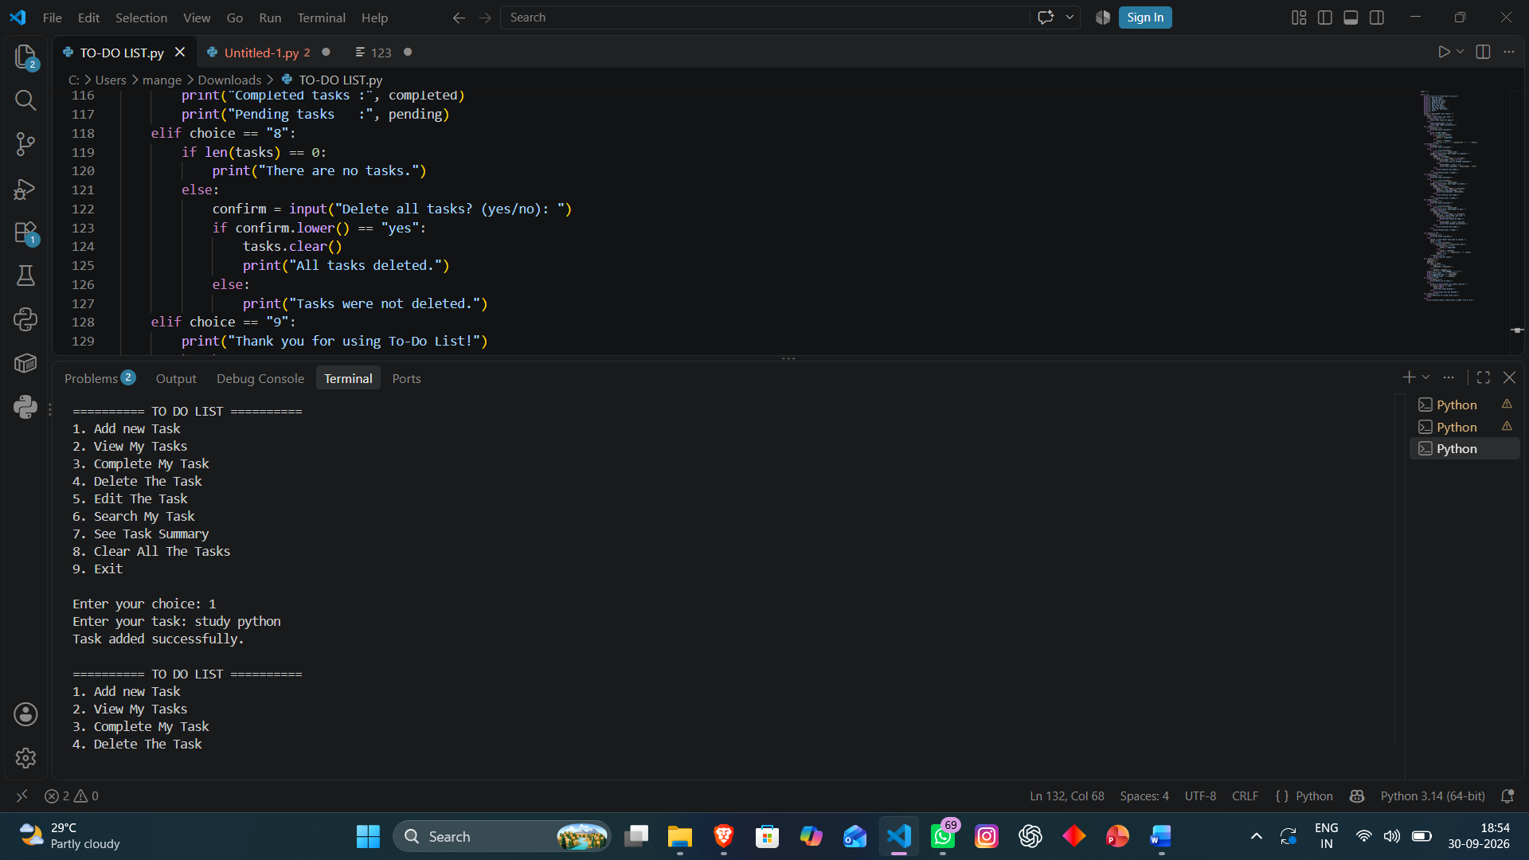

2. view my task
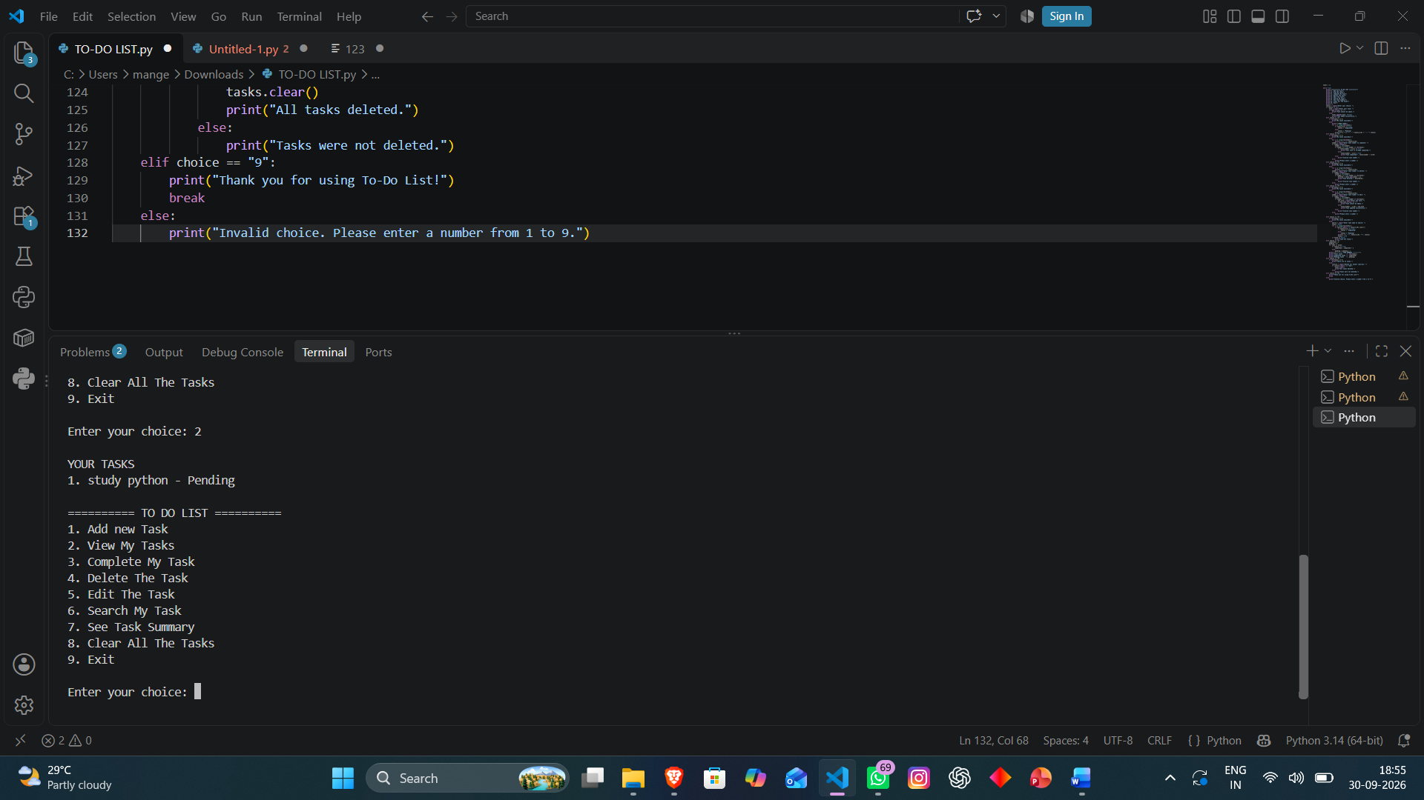
3. complete my tasks

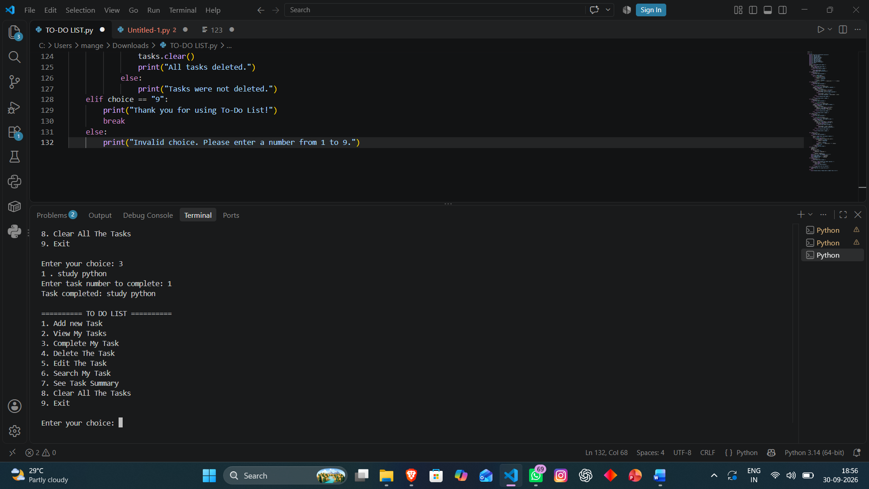

4. Delete the task

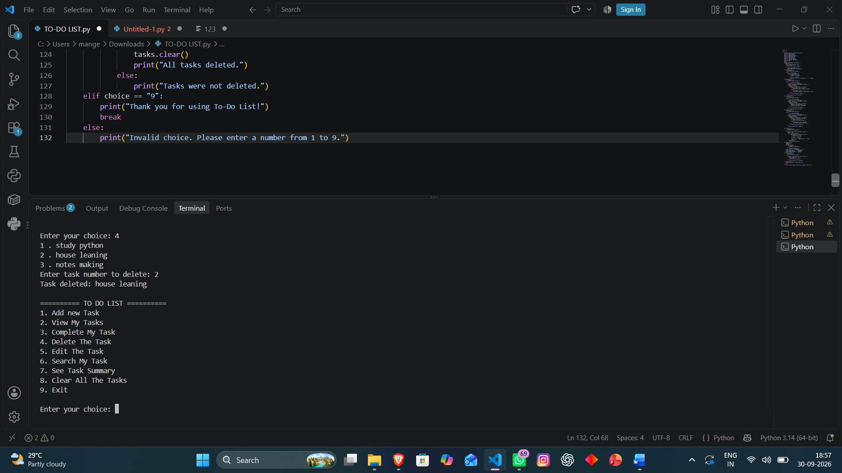

5. edit the task

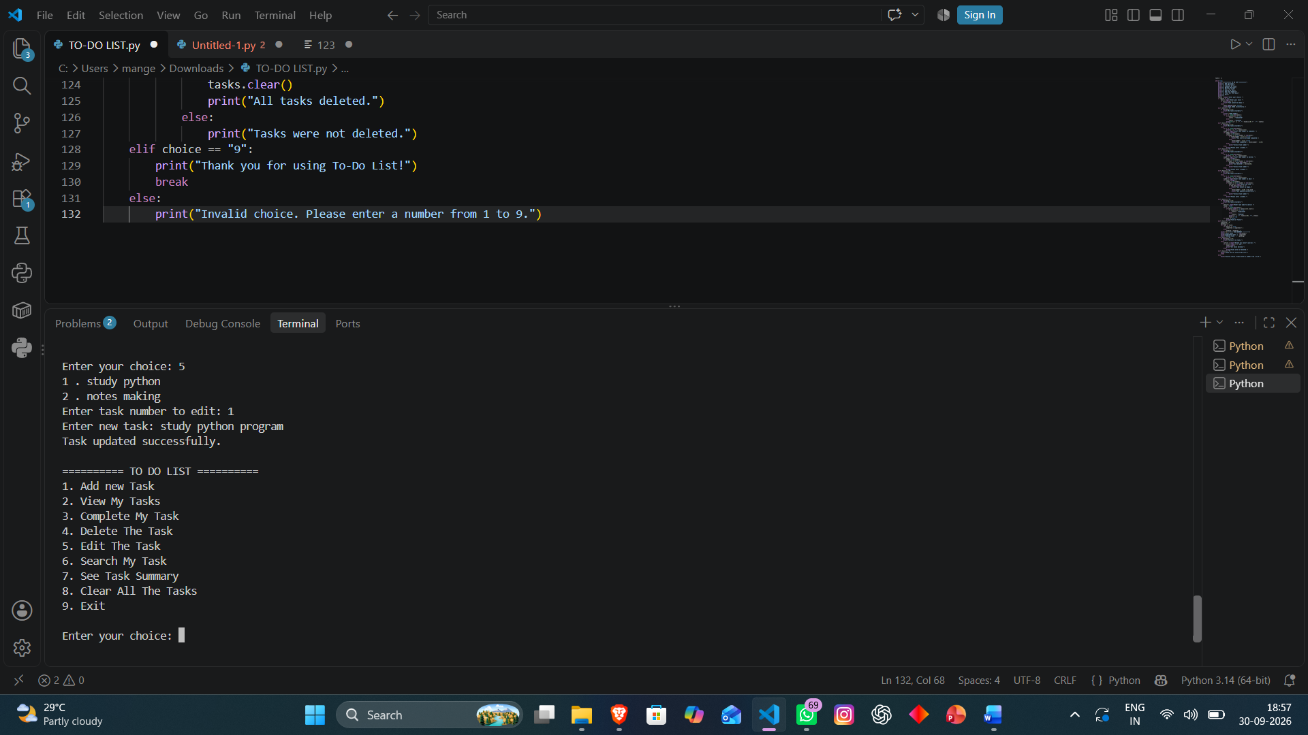

6. search my task

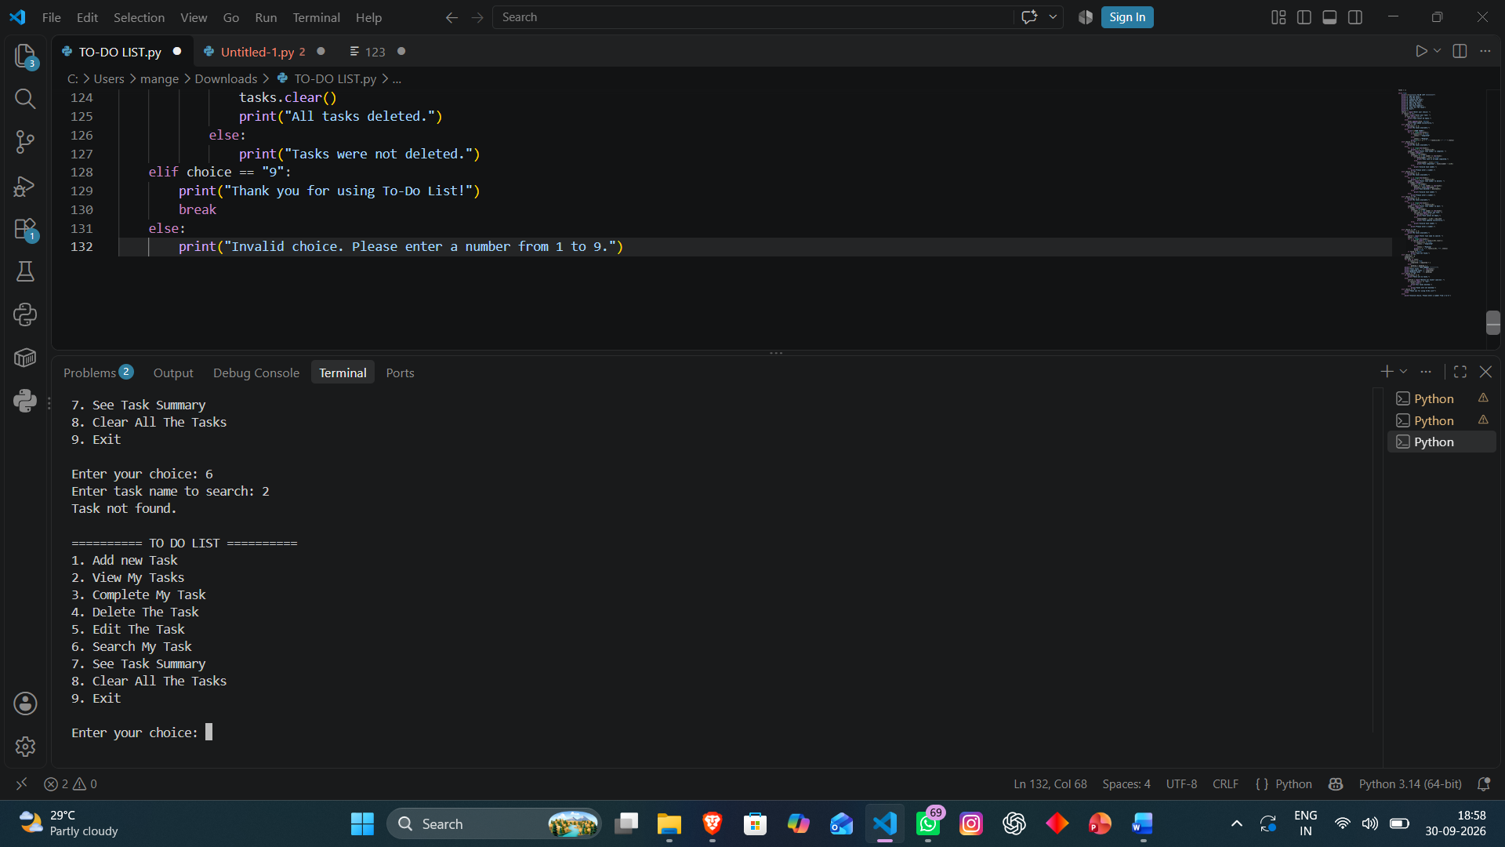

7.See Task summary

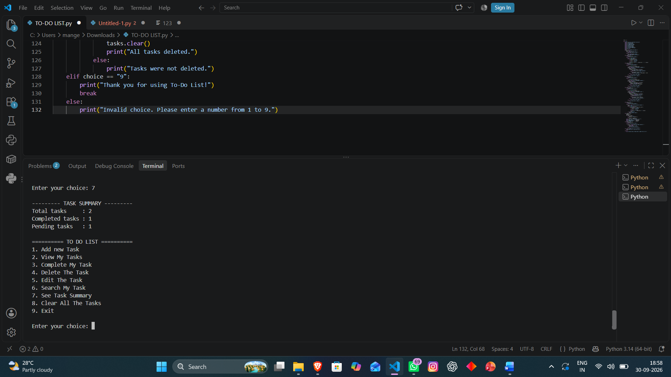

8. Clear All The Tasks

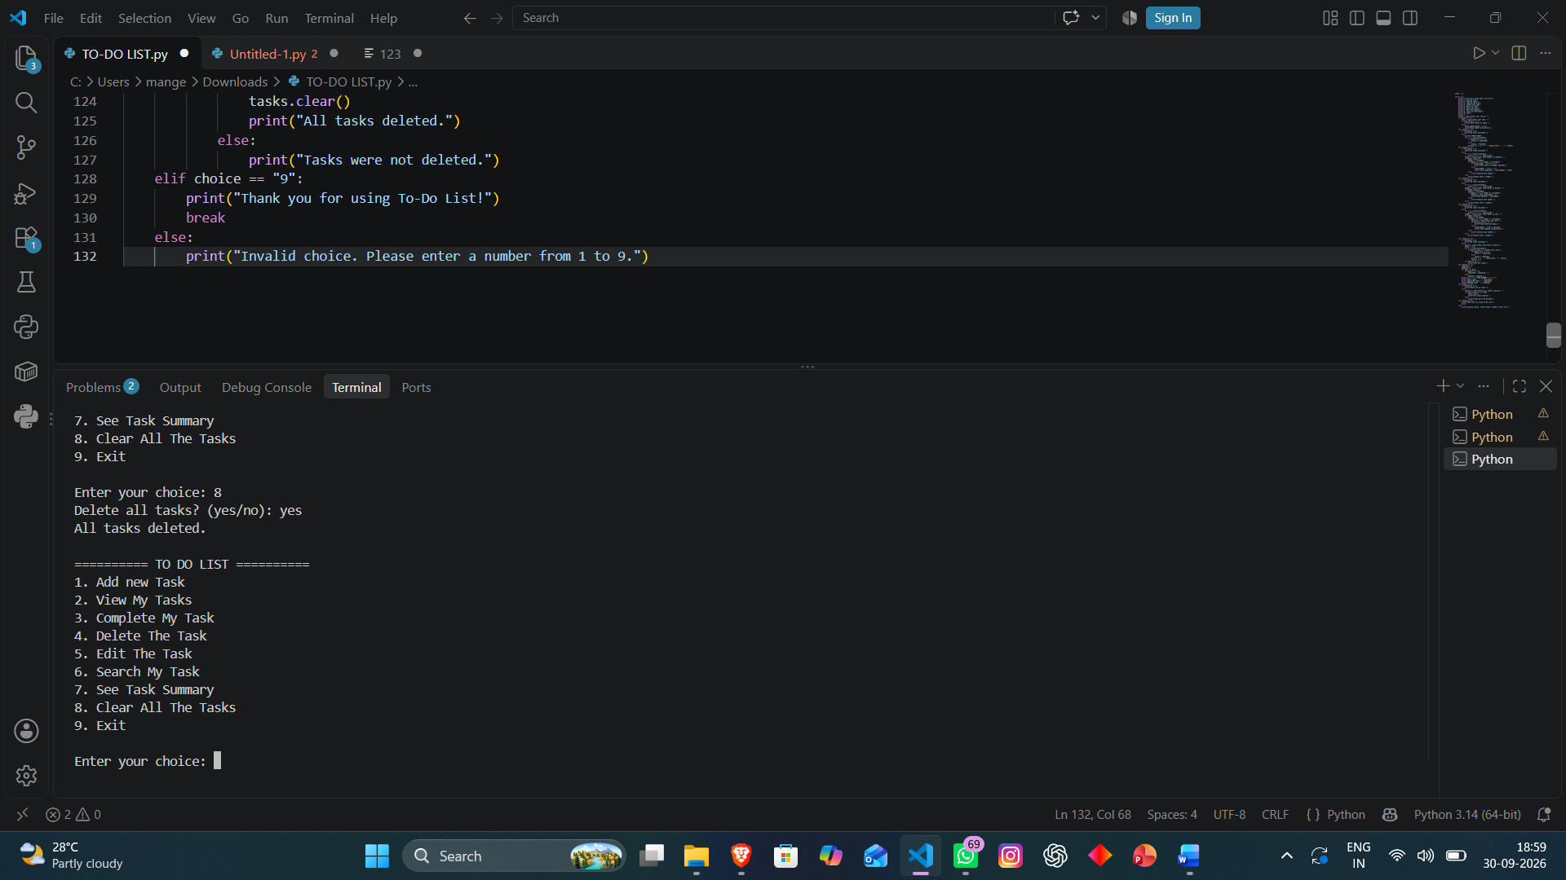
9. Exit

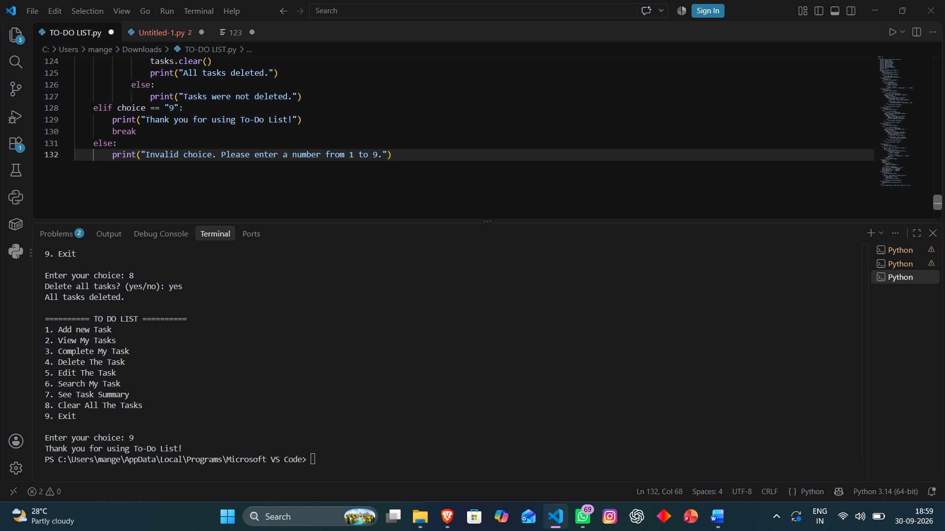

15. ADVANTAGES
- Simple and easy-to-understand interface.
- Supports multiple tasks during a program session.
- Provides both task and status information.
- Includes edit, delete, search, and completion operations.
- Provides a task summary.
- Includes basic input validation.
- Demonstrates several important Python fundamentals in one project.
- No external Python libraries are required by the program.

16. LIMITATIONS
- Tasks are stored only in memory while the program is running.
- Closing the program removes the current task data.
- The current application is console-based.

There is no user login or multi-user support.
- There are no due dates or reminders.
- There are no task priorities or categories.
- There is no database integration.
- There is no graphical user interface.
These limitations describe capabilities that are not present in the uploaded implementation; they are not defects inferred from hidden functionality.

17. FUTURE ENHANCEMENTS
- Add file-based storage so tasks remain available after restarting the program.
- Use a database such as SQLite for persistent task management.
- Add due dates and deadlines.
- Add priority levels such as Low, Medium, and High.
- Add task categories.
- Add sorting and filtering.
- Add a graphical user interface.
- Add user accounts and authentication.
- Add reminders or notifications.
- Add export/import functionality.
These are proposed enhancements and are not part of the current implementation.

18. CONCLUSION
The To-Do List Management System successfully demonstrates how basic Python programming concepts can be combined to create a practical console application. The project maintains tasks in a list and provides operations for adding, viewing, completing, deleting, editing, searching, summarizing, and clearing tasks.
The application also demonstrates basic input validation and control flow. Because the project is built using fundamental Python features, it is suitable for learning and practicing lists, loops, conditional statements, Boolean values, strings, and user input.
The current project provides a foundation that can later be extended with persistent storage, a graphical interface, additional task properties, and database functionality.

19. REFERENCES / PROJECT SOURCE
Primary source used for this report: the uploaded Python source file “TO-DO LIST(1).py”. The program contains 132 lines and implements the menu-driven To-Do List Management System described in this report. fileciteturn0file0L1-L132
The report is based on the actual functionality visible in the uploaded source. Suggested future enhancements are clearly identified as proposed features rather than current capabilities.

