Reference - https://www.educative.io/courses/grokking-coding-interview-patterns-java/B1Y0jWNAvpY

Sliding window.
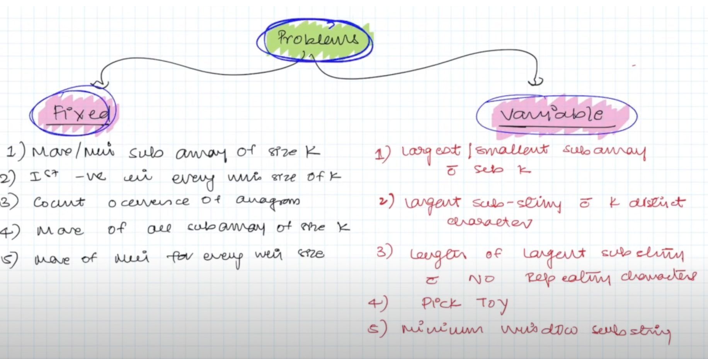

Reference - https://www.youtube.com/watch?v=KtpqeN0Goro&list=PL_z_8CaSLPWeM8BDJmIYDaoQ5zuwyxnfj&index=3

Aditya varma

