**NAME : MANGESH A. GHADWAJE**

**ROLL NO:24**

**BATCH : B2**

**COURSE: AR/VR PRACTICAL**

**Assginment No. 2**

**Problem Statement**: - Demonstration of the working of HTC Vive, Google Cardboard, Google Daydream and Samsung gear VR

**Objective**: - To learn about the working of HTC Vive, Google Cardboard, Google Daydream and Samsung gear VR

**Theory:-**

**Virtual Reality (VR)**:- is a technology that allows users to experience immersive and interactive computer-generated environments. VR headsets are the primary device used to experience virtual reality. In this write-up, we will discuss the working of four popular VR headsets, namely HTC Vive, Google Cardboard, Google Daydream, and Samsung Gear VR.

1. **HTC Vive: -** The HTC Vive is a high-end VR headset that requires a powerful gaming PC tooperate. It features two high-resolution displays with a refresh rate of 90Hz, and it utilizes motion sensors and controllers to track the user's movements and actions. The Vive's room- scale tracking allows users to move around and interact with their virtual environment. The headset provides an incredibly immersive experience and is widely regarded as one of the best VR devices on the market.

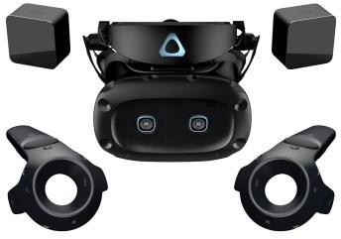

1. **Google Cardboard: -** Google Cardboard is a low-cost VR headset that is designed to be usedwith a smartphone. It consists of a cardboard frame and two lenses that allow users to view 3D content on their phone. The frame can be assembled in a few minutes and is compatible with a wide range of smartphones.

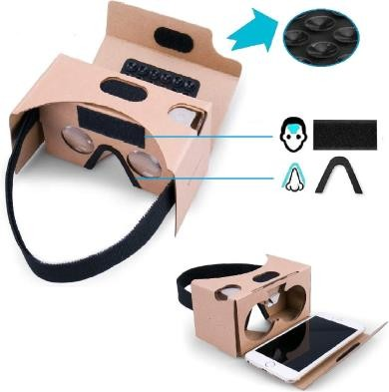

1. **Google Daydream:-**Google Daydream is a more advanced VR headset than Cardboard, designed to work with a range of high-end smartphones. It features a fabric-covered headset with a controller that allows users to interact with their virtual environment.The Daydream headset uses sensors to track the user's head movements, and the controller has sensors that track hand movements. The controller also features a touchpad and motion sensors that allowusers to interact with virtual objects.

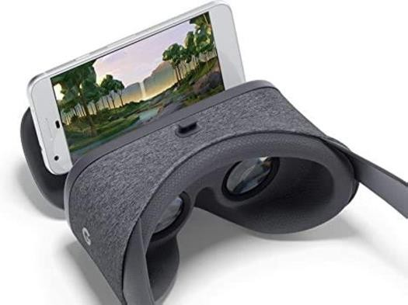

1. **Samsung Gear VR:-**The Samsung Gear VR is a high-end VR headset designed specificallyfor Samsung smartphones. It features a lightweight design with a touchpad and a built-in sensor that tracks the user's head movements. The Gear VR uses Oculus software to managethe VR experience, and it features a range of games, videos, and other VR content. The headset also has a focus wheel that allows users to adjust the image for their eyesight.

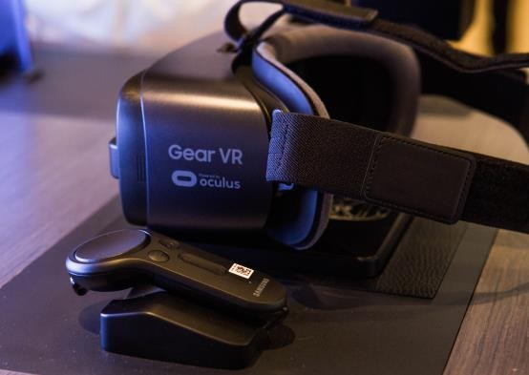

**Conclusion**:-The HTC Vive, Google Cardboard, Google Daydream, and Samsung Gear VR are all popular VR headsets with unique features and capabilities. While the HTC Vive offers the most advanced and immersive VR experience, the Google Cardboard and Daydream are more affordable and accessible options for smartphone users. The Samsung Gear VR is a high-end headset that offers a premium VR experience for Samsung smartphone users.