**NAME : MANGESH A. GHADWAJE**

**ROLL NO:24**

**BATCH : B2**

**COURSE: AWT PRACTICAL**

**Assginment No. 3**

**Problem Statment : Create a Node.js program that facilities the transfer of textual data from one file to another the program must efficiently read the content of a specified file and write them into new file.**

**CODE:**

const fs=require('fs'); fs.readFile('source1.txt','utf8',(err,data)=>

{

if(err)

{

console.log("Error in reading file:",err); return;

}

fs.writeFile('destination1.txt',data,'utf8',(err)=>

{

if(err)

{

console.log("Error in Writing file:",err); return;

}

console.log("Data trasnsferred Successfully");

});

});

**OUTPUT:**

**Source1.txt**

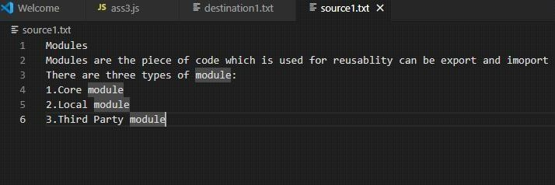

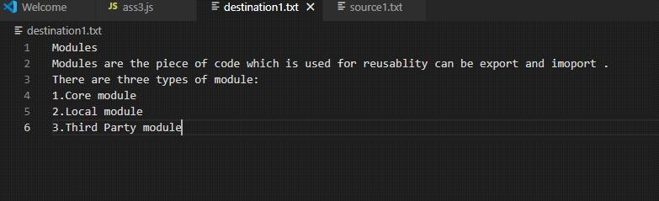**Destination1.txt**

