**Name: - Vikas Rangnath Shinde**

**Class:-FYMCA Div:-A**

**Roll No: -63 Batch:- A3**

**Assignment: - 3**

**Title:**Write at least 10 SQL queries on the suitable database application using SQL DML

statements: Insert, Select, Update, Delete with operators(Arithmetic Operators, Logical

Operators, Comparison Operator, Special Operator), functions (Number function, Aggregate

Function, Character Function, Conversion Function, Date Function)

**Problem Statement:**

**A) Create tables in ORACLE using SQL DDL statements.**

Sailor(sid:integer, sname:string, rating:integer, age:real)

Boat(bid:integer, bname:string, color:string)

Reserves(sid:integer, bid:integer, day:date)

**1. Insert following records in the above tables**

**Sailors:**

CREATE TABLE Sailor (

sid INTEGER,

sname VARCHAR(20),

rating INTEGER,

age REAL);

INSERT INTO sailor VALUES(22, 'Dustin', 7, 45.0);

**OUTPUT:**

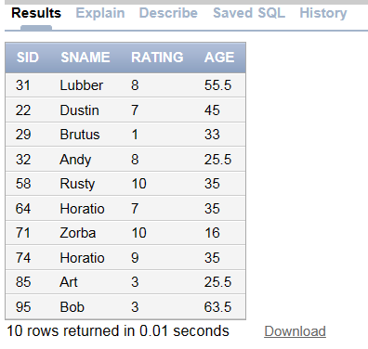

**Boat:**

CREATE TABLE Boat (

bid INTEGER,

bname VARCHAR(20),

color VARCHAR(20)

);

INSERT INTO Boat VALUES (104, 'Marine', 'red');

**OUTPUT:**

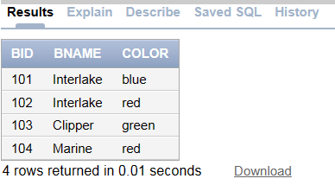

**Reserves:**

CREATE TABLE Reserves (

sid INTEGER,

bid INTEGER,

day DATE

);

INSERT INTO Reserves VALUES(22, 101, '10/10/98');

**OUTPUT:**

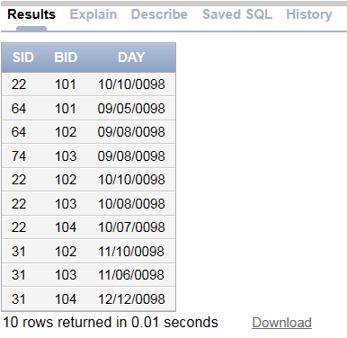

**2. Find the name and age of all sailors**

SELECT sname, age.

FROM Sailor;

**OUTPUT:**

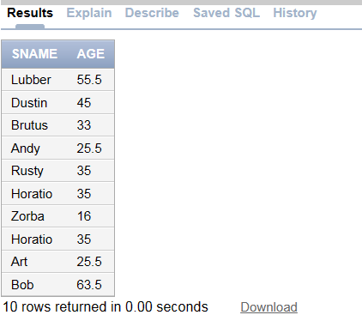

**3. Find all sailors with a rating above 7**

SELECT *

FROM Sailor

WHERE rating > 7;

**OUTPUT:**

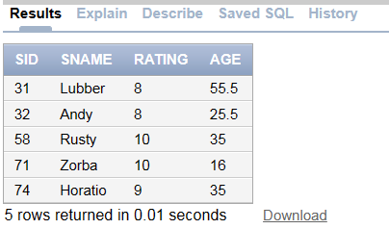

**4. Increase ratings of sailors by 10% whose age is less than 40**

UPDATE Sailor

SET rating = rating * 1.1

WHERE age < 40;

**OUTPUT:**

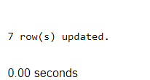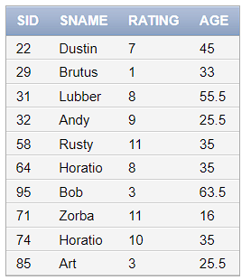

**5. Update rating of all sailors by 2 who have reserved boat on 11/12/98**

UPDATE Sailor

SET rating = rating + 2

WHERE sid IN (SELECT sid FROM Reserves WHERE day = '1998-11-12');

**OUTPUT:**

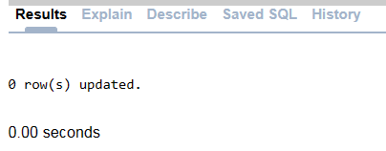

**6. Delete sailors whose rating is less than 3 and age is above 60**

DELETE FROM Sailor

WHERE rating < 3 AND age > 60;

**OUTPUT:**

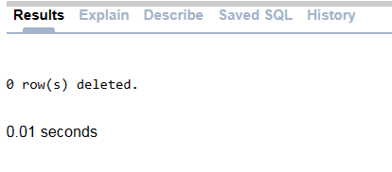

**7. Delete names of sailors who have reserved boat 102**

UPDATE Sailor

SET sname = NULL

WHERE sid IN (SELECT sid FROM Reserves WHERE bid = 102);

**OUTPUT:**

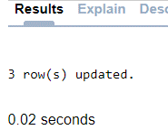 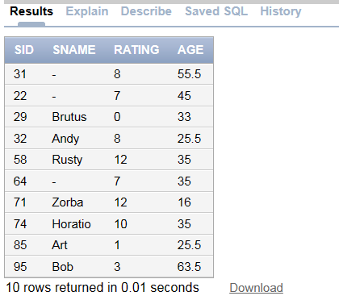

**B) Consider same database given in the Part A.**

**1. Find name of sailors and display the names in upper case who have reserved boat with name‘Interlake’.**

SELECT UPPER(Sailor.sname) AS UpperCaseName

FROM Sailor

JOIN Reserves ON Sailor.sid = Reserves.sid

JOIN Boat ON Reserves.bid = Boat.bid

WHERE Boat.bname = 'Interlake';

**OUTPUT:**

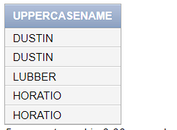

**2. Find the ratings of sailors whose name contain ‘us’ substring.**

SELECT rating

FROM Sailor

WHERE UPPER(sname) LIKE '%US%';

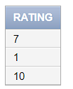 **OUTPUT:**

**3. Find the average age of sailors with a rating of 8.**

SELECT AVG(age) AS AverageAge

FROM Sailor

WHERE rating = 8;

**OUTPUT:**

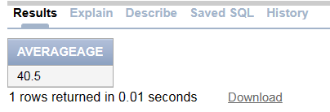

**4. Count the number of sailors with rating greater than 5**

SELECT COUNT(*) AS SailorCount

FROM Sailor

WHERE rating > 5;

**OUTPUT:**

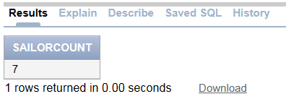

**5. Select date of reservation of boat with bid =101 reserved by sailor with**

**sid =64 add 2 months in the date and display it.**

SELECT

day AS ReservationDate,

ADD_MONTHS(day, 2) AS AddedTwoMonths

FROM Reserves

WHERE bid = 101 AND sid = 64;

**OUTPUT:**

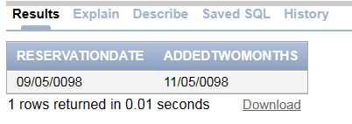

**6. Find the months between date 12/02/2021 and system current date.**

SELECT MONTHS_BETWEEN(SYSDATE, TO_DATE('12/02/2021', 'MM/DD/YYYY')) AS MonthsDifference

FROM dual;

**OUTPUT:**

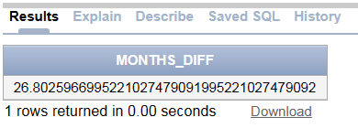

**7. Find name of the boat with month of reservation of boat.**

SELECT

Boat.bname AS BoatName,

EXTRACT(MONTH FROM Reserves.day) AS ReservationMonth

FROM Reserves

JOIN Boat ON Reserves.bid = Boat.bid;

**OUTPUT:**

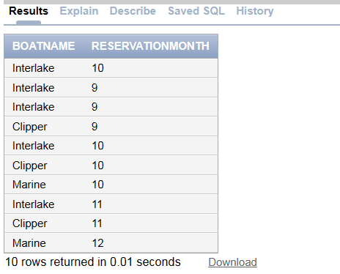

**8. Demonstrate use of following numeric functions with suitable examples**

**ABS, SIGN, POWER, ROUND, MOD, FLOOR, CEIL and TRUNC.**

**1. ABS - Absolute Value**

SELECT ABS(rating) AS AbsoluteRating

FROM Sailor;

**OUTPUT:**

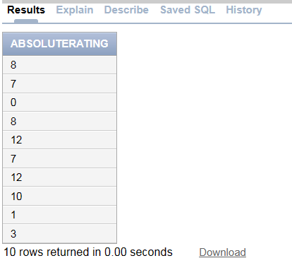

**2. SIGN - Sign Function**

SELECT SIGN(rating) AS SignRating

FROM Sailor;

**OUTPUT:**

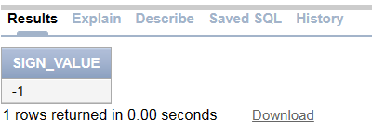

**3. POWER - Exponentiation**

SELECT POWER(rating, 2) AS PowerRating

FROM Sailor;

**OUTPUT:**

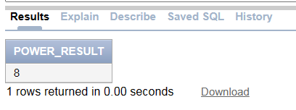

**4. ROUND**

SELECT ROUND(15.67, 1) AS rounded_value FROM dual;

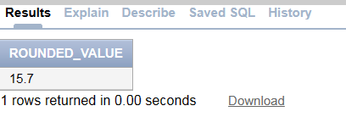

**5. MOD**

SELECT MOD(15, 4) AS modulo_result FROM dual;

**OUTPUT:**

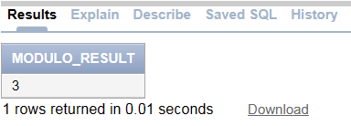

**6. FLOOR**

SELECT FLOOR(rating) AS FloorRating FROM Sailor;

**OUTPUT:**

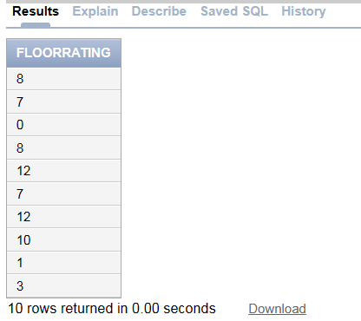

**7. CEIL**

SELECT CEIL(rating) AS CeilRating FROM Sailor;

**OUTPUT:**

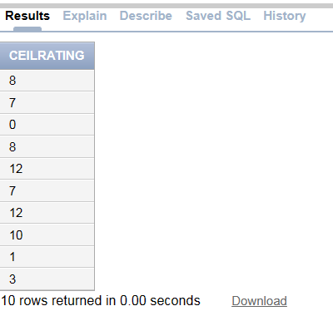

**8. TRUNC**

SELECT TRUNC(rating) AS TruncatedRating FROM Sailor;

**OUTPUT:**

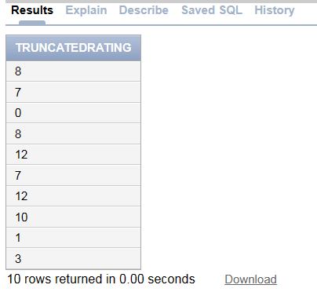

**9. Find the square root of ages of all sailors.**

SELECT sname, SQRT(age) AS SquareRootOfAge

FROM Sailor;

**OUTPUT:**

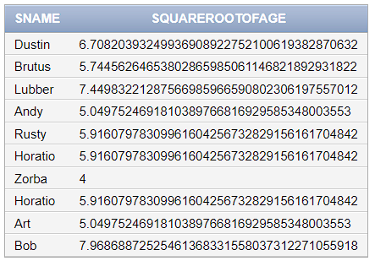

**10. Display dates of all boat reservations in the format e.g 19-Jun-2005**

SELECT TO_CHAR(day, 'DD-Mon-YYYY') AS FormattedReservationDate

FROM Reserves;

**OUTPUT:**

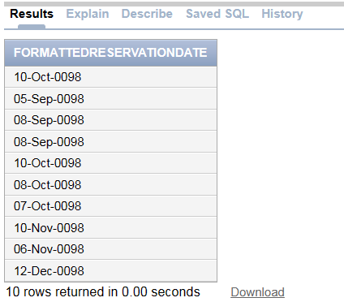

**11. Find the min and max rating from Sailors.**

SELECT MIN(rating) AS MinRating, MAX(rating) AS MaxRating

FROM Sailor;

**OUTPUT:**

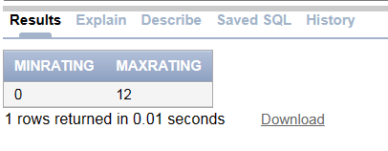

**c) Consider same database given in the Part A. Use Arithmetic Operators,Logical Operators ,Comparison Operator and Special Operator.**

**1. Find the names and ages of sailors whose name begins and ends with B and has at least three characters.**

SELECT sname, age

FROM Sailor

WHERE UPPER(sname) LIKE 'B%B' AND LENGTH(sname) >= 3;

**OUTPUT:**

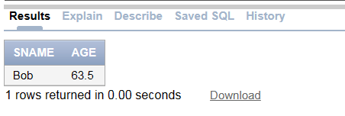

**2. Find the names and ages of sailors whose name begins with A or L.**

SELECT sname, age FROM Sailor WHERE sname LIKE 'A%' OR sname LIKE 'L%';

**OUTPUT:**

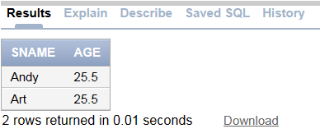

**3. Find the names of sailors whose rating is greater than 7 and age is between 33 to 45.**

SELECT sname, age FROM Sailor

WHERE rating > 7 AND age BETWEEN 33 AND 45;

**OUTPUT:**

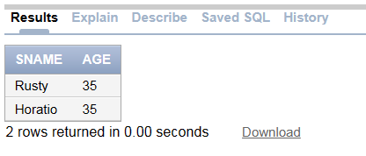

**4. Find the names of sailors who have not reserved a boat on 10/10/98.**

SELECT s.sname, s.age

FROM Sailor s

WHERE NOT EXISTS (

SELECT 1

FROM Reserves r

WHERE r.sid = s.sid AND r.day = TO_DATE('10/10/98', 'MM/DD/YY')

);

**OUTPUT:**

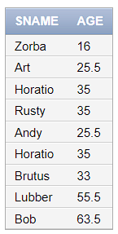

**5. Find the names of sailors who have reserved boat 103. (use IN operator)**

SELECT sname, age

FROM Sailor

WHERE sid IN (SELECT sid FROM Reserves WHERE bid = 103);

**OUTPUT:**

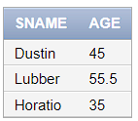

**6. Find the names of sailors who have reserved boat number 103. (use EXISTS operator)**

SELECT sname, age

FROM Sailor s

WHERE EXISTS (

SELECT 1

FROM Reserves r

WHERE r.sid = s.sid AND r.bid = 103

);

**OUTPUT:**

