**NAME : MANGESH A. GHADWAJE**

**ROLL NO:24**

**BATCH : B2**

**COURSE: SPMT PRACTICAL**

**Assginment No. 1**

**Problem Statement :**

**Consider any real life problem and create a MS Project application and prepare a project plan for the same by using project Calendar**

**Code :**

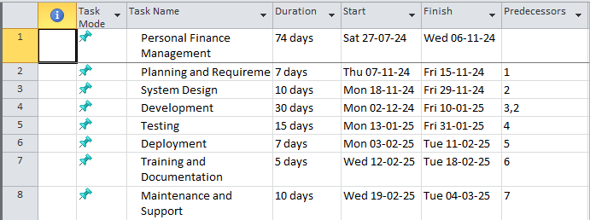

**Gantt Chart :**

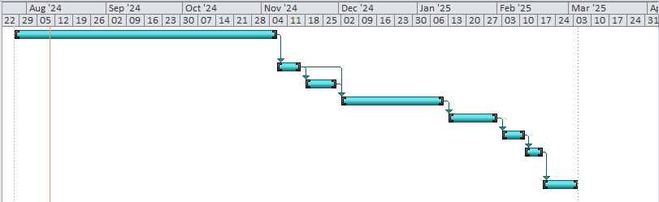

**Calender :**

