**NAME : MANGESH A. GHADWAJE**

**ROLL NO:24**

**BATCH : B2**

**COURSE: SPMT PRACTICAL**

**Assginment No. 3**

**Problem Statement :**

**Prepare the Work breakdown structure for Hospital Construction System**

**Code :**

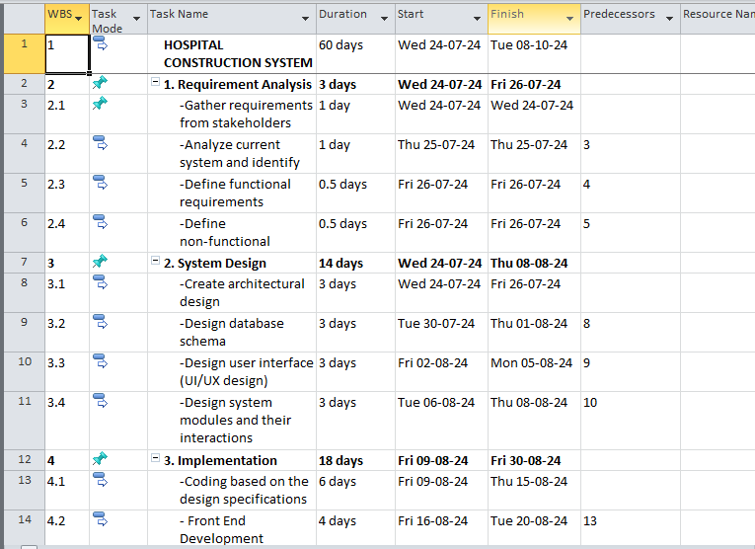

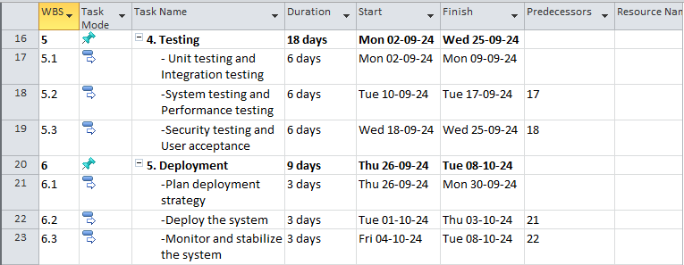

**Gantt Chart :**

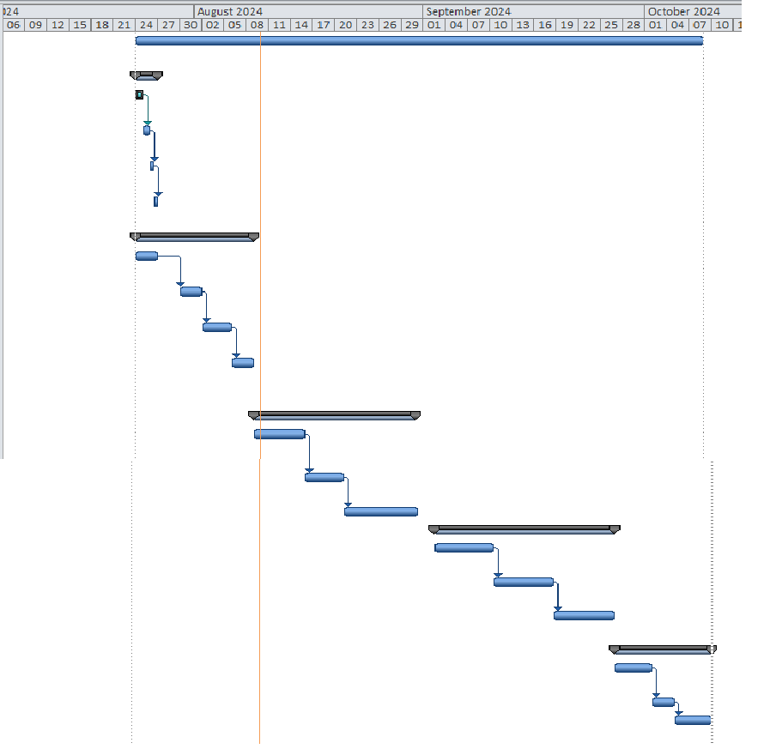

**PERT Diagram :**

