**NAME : MANGESH A. GHADWAJE**

**ROLL NO: 24**

**BATCH : B2**

**COURSE: SPMT PRACTICAL**

**Assginment No. 7**

**Problem Statement :**

**Binary Search Testing Technique: Basis paths Design, develop, code and run the program in any suitable language to implement the binary search algorithm. Determine the basis paths and using them derive different test cases, execute these test cases and discuss the test results.**

**Code :**

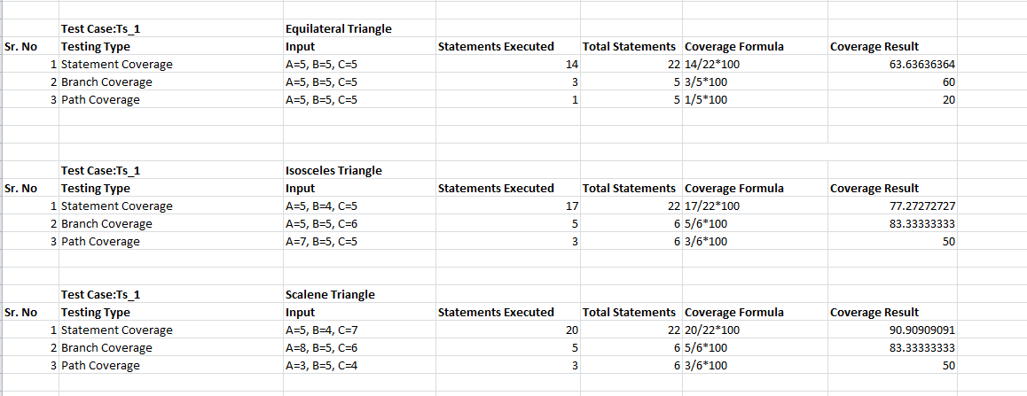

**Binary search :**

***#include <stdio.h>***

***int main()***

***{***

***int first, middle,last, n, i, search, a[100];***

***setbuf(stdout, NULL);***

***printf("ENTER THE SIZE OF ARRAY:");***

***scanf("%d", &n);***

***printf("ENTER %d ELEMENT IN ASCENDING ORDER:\n",n);***

***for(i=0; i<n; i++)***

***scanf("%d", &a[i]);***

***printf("ENTER THE VALUE TO BE SEARCH:\n");***

***scanf("%d", &search);***

***first=0;***

***last=n-1;***

***middle=(first+last)/2;***

***while(first <= last)***

***{***

***if(a[middle]<search)***

***first = middle + 1;***

***else if(a[middle] == search)***

***{***

***printf("ELEMENT FOUND AT INDEX %d.\n",middle);***

***break;***

***}***

***else***

***last = middle - 1;***

***middle = (first + last)/2;***

***}***

***if(first > last)***

***printf("ELEMENT NOT FOUND IN THE LIST.\n");***

***return 0;***

***}***