**NAME : MANGESH A. GHADWAJE**

**ROLL NO: 24**

**BATCH : B2**

**COURSE: SPMT PRACTICAL**

**Assginment No. 8**

**Problem Statement :**

**Triangle Problem Testing Technique: White Box Testing Design and develop a program in a language of your choice to solve the triangle problem defined as follows: Accept three integers which are supposed to be the three sides of a triangle and determine if the three values represent an equilateral triangle, isosceles triangle, scalene triangle, or they do not form a triangle at all. Assume that the upper limit for the size of any side is 10. Derive test cases for your program and perform white box testing techniques, execute these test cases and discuss the results**

**Code :**

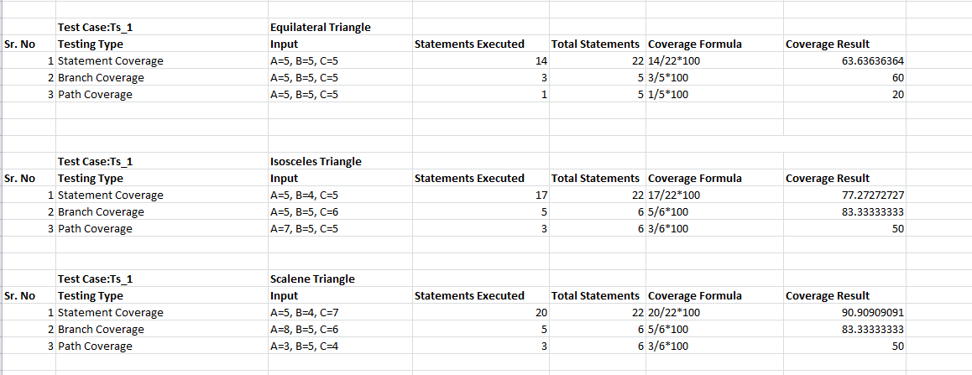

**TRIANGLE CODE :**

***#include <stdio.h>***

***int main()***

***{***

***int a, b, c;***

***printf("Enter three sides of a triangle (1-10): ");***

***if (scanf("%d %d %d", &a, &b, &c) != 3)***

***{***

***printf("Invalid input: Please enter three valid integers.\n");***

***return 1;***

***}***

***if (a <= 0 || b <= 0 || c <= 0)***

***{***

***printf("Sides must be positive integers.\n");***

***return 1;***

***}***

***if (a > 10 || b > 10 || c > 10)***

***{***

***printf("Sides must be less than or equal to 10.\n");***

***return 1;***

***}***

***if (a == b && b == c)***

***{***

***printf("Equilateral triangle\n");***

***}***

***else if (a == b || b == c || a == c)***

***{***

***printf("Isosceles triangle\n");***

***}***

***else {***

***printf("Scalene triangle\n");***

***}***

***return 0;***

***}***