PortWare

**Mangesh Ingle1, Prof. Deepa Manoj2**

*1 Student, MCA Department, Bharti Vidyapeeth’s Institute Of Management And Information Technology Studies, Maharashtra, India*

*2 Professor, MCA Department, Bharti Vidyapeeth’s Institute Of Management And Information Technology Studies, Maharashtra, India*

***Abstract:* PORTWARE is a mobile technology, which provides alternative to have any system configurations as per the user requirement. In simple words handheld device will be having basic display hardware with minimal hardware attach to it. The basic idea behind the technology is to free the user from having a particular set of hardware and software for long duration. As the technology is evolving rapidly, more and more versions of operating systems are coming into picture with the combinations of different processors. So a portable system is required to do the computational work, which can process the input rapidly and produce the output. It follows the basic strategy of input-process-output, only processing part is kept portable. The current technology offers all the features where hardware and software are present in the mobile device itself so the user cannot change his/her system configuration. PORTWARE(Portable,Hardware,Software) acts like a CLOUD(Communities and Libraries Online Union Database) computing which is well known to its storage advantages and portability, only difference is that it has different set of hardware and software which can be manageable by organizations which actually sales the mobile device.**

***Key Words:*** *PORTWARE, CLOUD*

I) **INTRODUCTION**

Call Switchable Glass technology is introduced in the year 2013, which is a conductive OLED using liquid crystal molecule to display images.

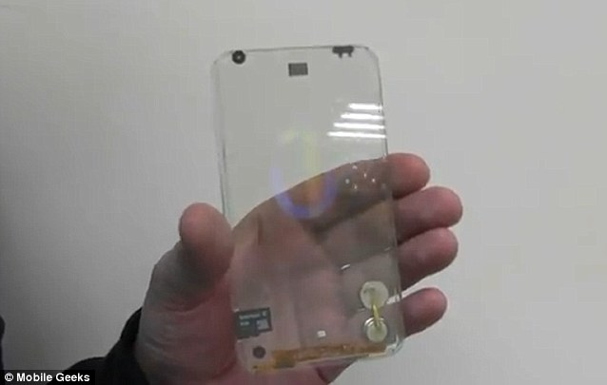

This technology got tremendous response and appreciation from all over the world but got stuck as in terms of performance and the up-gradations. So alternative to this technology, portware is there which can have the same display with SIM () card, sensors and a battery. This display can do two things send data as an input and take data as an output. All the required processing is done on portware. The strength lies in the portability of the system where different control units can control and process the data rapidly that the final user is always gets the feeling of traditional mobile device. A complex artificial intelligence and advanced control unit can back the system for multitasking .Authenticated cloud system can provide storage that user demands. Portware is a reliable futuristic technology which is a feasible solution in terms of business and technology updation to everyone regardless of their current device configuration.

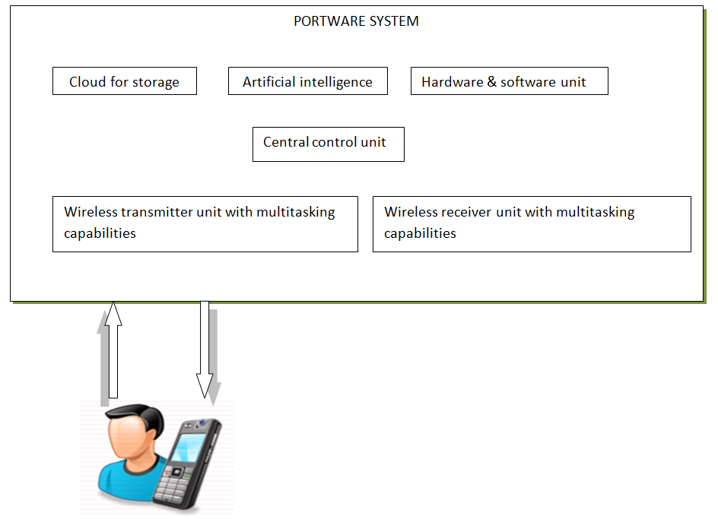

The various major components to portware system are:

***User*** — It is an individual who has the display device with basic hardware like sensors, battery and SIM card attach to it. User can operate their device as traditional smartphone and perform all the necessary operations like making a call, sending an email, sending a sms etc.

***Wireless receiver unit*** — Wireless receiver unit (WRU) is an advanced system which is responsible for receiving the binary data came from the device, which is ultimately transferred to the hardware and software unit with the help of central control unit.

***Wireless transmitter unit*** — Wireless transmitter unit (WTU) performs transmission of data to the user device.

***Hardware and Software unit*** ***—*** Hardware and software unit is actual responsible for portability property of device. Organizations can keep all the advanced combinations of processors and operating systems which can be replaceable as needed by the user. [2]

***Artificial Intelligence*** — Artificial Intelligence (AI) is an alternative backup system  for central control system. Portware is a complex technology as it performs everything on organization side so AI is a necessary unit to the portware.

***Cloud Storage*** — Device does not save any data on itself .It utilizes cloud storage as standard memory card.

***Central Control unit*** — Central control unit (CCU) is a heart of portware system which acts as a middleware between all units. Central control unit is responsible for intercommunication between all the units.

**II)** **WHAT MAKES MOBILE DIFFERENT? [4]**

In many respects, developing mobile applications is similar to software engineering for other embedded applications. Common issues include integration with device hardware, as well as traditional issues of security, performance, reliability, and storage limitations. However, mobile applications present some additional requirements that are less commonly found with traditional software applications, including:

***Potential interaction with other applications*** ***–*** most embedded devices only have factory-installed software, but mobile devices may have numerous applications from varied sources, with the possibility of interactions among them.

***Sensor handling –*** most modern mobile devices, e.g., “smartphones”, include an accelerometer that responds to device movement, a touch screen that responds to numerous gestures, along with real and/or virtual keyboards, a global positioning system, a microphone usable by applications other than voice calls, one or more cameras, and multiple networking protocols.

***Native and hybrid (mobile web) applications –*** most embedded devices use only software installed directly on the device, but mobile devices often include applications that invoke services over the telephone network or the Internet via a web browser and affect data and displays on the device.

***Families of hardware and software platforms –*** most embedded devices execute code that is custom-built for the properties of that device, but mobile devices may have to support applications that were written for all of the varied devices supporting the operating system, and also for different versions of the operating system. An Android developer, for example, must decide whether to build a single application or multiple versions to run on the broad range of Android devices and operating system releases [4].

***Security –*** most embedded devices are “closed”, in the sense that there is no straightforward way to attack the embedded software and affect its operation, but mobile platforms are open, allowing the installation of new “malware” applications that can affect the overall operation of the device, including the surreptitious transmission of local data by such an application.

***User interfaces –*** with a custom-built embedded application, the developer can control all aspects of the user experience, but a mobile application must share common elements of the user interface with other applications and must adhere to externally developed user interface guidelines, many of which are implemented in the software development kits (SDKs) that are part of the platform. [4]

**III) PORTABILITY AS PER FIVE IMPORTANT PLATFORMS (IPHONE, ANDROID, BLACKBERRY, WINDOWS PHONE, SYMBIAN) [3]**

Application developers quickly developed apps for the iPhone platform following Apple’s creation of the AppStore. As noted above, other providers of mobile platforms and devices have done the same (or are in the process of doing so). An important issue for the application developer is to decide which platform(s) to support in the highly fragmented world of mobile development. Today, there are at least five important platforms (iPhone, Android, BlackBerry, Windows Phone, and Symbian).

From the standpoint of the application developer, it’s quite expensive to support multiple platforms, especially when there are multiple versions and variants for each of them. The application developer has several options:

1) Develop for a single platform only and use, to the extent possible, a common subset of the features available across all variants and versions of that platform; thus, for example, the developer would have only a single code base for an application that would run on different versions of the iPhone, the iPad, and possibly the iPod Touch. While that approach would simplify the developer’s work, the resulting application would not be able to take advantage of all of the differentiating features of each device.

2) Develop native applications for each platform and variant, trading off the development and maintenance costs against the ability to optimize the application for each platform.

3) Develop mobile web applications, thus minimizing the amount of native code for each platform; it remains uncertain whether this approach will meet the needs of the market.

4) Use one or more layer(s) of abstraction that can map a “write once” application into native executable programs that will run on multiple platforms. Each of these approaches presents a set of research questions, and suggests the need for customized tools to support cross-platform development and testing. [3]

**IV) FRAGMENTATION OF MOBILE SERVICES AND DATA USAGE**

***Mobile services provided by the network provider and mobile companies –***

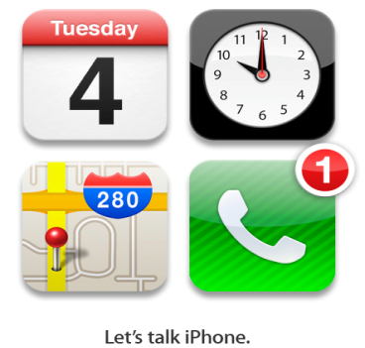

***Data services provided by the network provider –***

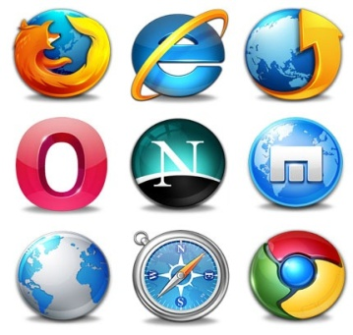

**V) STUDY RELATED TO MOBILE NETWORK AND WIFI –**

***Mobile networks –*** Every mobile device has SIM card, which is nothing but the small motherboard integrated with your mobile hardware. Because of SIM card in the mobile, device can send and receive signals continuously.

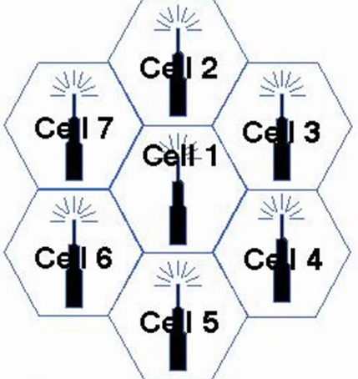

The area where we live is divided into cells and these cells contains BTS (Base Transceiver System).Whenever mobile is switched ON, mobile starts sending signals, which are ultimately picked by these base stations. When we speak our voice is converted to analog electrical signals via microphone in our device, which gets converted to digital signals. These digital signals then sent to the nearest base station in the form of microwaves. Now BTS converts these microwaves into the digital signal again and transfer the data to other BTS, to whom the initiator is calling [5].

***WIFI –*** Wi-Fi is fully capable of transferring huge amount of data through the air. Wi-Fi is a type of electromagnetic radiation such as visible lights, radio waves, x rays, and gamma rays. The wavelength of waves makes the Wi-Fi so interesting. The wavelength of normal radio waves is 30M, Short waves like x-rays has wavelength of 10NM. Visible lights has the wavelength of 400-700NM. But miraculously, the wavelength of Wi-Fi is about 12 Centimeters, which is quite huge as compared to others. This is only one Wi-Fi signal so one can imagine the whole continuous signal transmission.



Wi-Fi essentially carries a set of instruction which can inform our handheld device about what to do to each pixel on our screen. The instructions are turned into code, which only needs two different modes ON and OFF. For example code for letter A might be like OFF- OFF-ON- OFF- OFF=A. To transmit any multimedia content huge amount of mode combinations are required. Here WI-FI has edge over all the technologies because electromagnetic radiations can transfer at the speed of light which is 670616629 MPH. Thus WI-FI helps to transfer data super quickly [6] [1].

**VI) FINDINGS RELATED TO THE STUDIES DONE-**

The Device display can be made for viewing purpose by keeping the processing of input portable. Although the device has minimal set of hardware that are useful to connect to the portware system through all the network securities. Now comes how to transfer the internal hardware data from the network to portware system’s wireless receiver unit. WI-FI and mobile network are the best feasible solution to transmit the hardware intercommunication data to portware. As electromagnetic radiation can transfer the data at the speed of light so there will be no delay or waiting time on the device and the end user will use his/her device like traditional way without knowing about the portability of complete hardware and software. The portware system has hardware and software unit where an organization has combinations of different processors and operating system which can be assigned to end user as per requested configurations.

**VII) ADVANTAGES OF PORTWARE –**

* End user can have choice to upgrade system configuration without changing the device.
* End users also have option to choose from variety of platforms which are available in the market.
* Organization will get benefited as most of the money is not spent on manufacturing of the mobile itself.
* Rather than spending money on manufacturing, organization can focus on strict and errorless services to the end user.
* Cost ratio will decrease, drastically as money will be spent on maintenance of the portware system.

**VIII) DISADVANTAGES OF PORTWARE –**

* Using Wi-Fi for transmission may cost havoc because multiple WI-FI signals can overlap or bounce back from each other, which can cause uncertainty in the data.
* Multitasking on device may get affected as multiple channel allotment is required.
* Addition and up-gradation of functional blocks is difficult as it directly concerns with the end user.

**VIII) CONCLUSION –**

* It is clearly evident that technology like portware will be the future of mobile computing.
* Indeed, technology is growing. alternatives to portware may come in future but portware system will be consider as a base to all future enhancements
* As the technology matures, new data processing techniques are developed, and as standards are developed, it is safe to say that PORTWARE will become an important mobile computing system available to the user community.

**IX) REFERENCES –**

[1] http://www.mywireless.org

[2] http://www.open-mpi.org/projects/hwloc

[3] http://www.lucasmoffitt.com/research- integration-of-portable-digital-devices-in-quality-learning-environments

[4] http://www.cmu.edu/silicon-valley/wmse/wasserman-foser2010.pdf Fring, Brian. 2009. Mobile Design and Development.

O’Reilly.)

[5]https://www.youtube.com/watch?v=xv9dRENgDoc

[6]https://www.youtube.com/watch?v=xmabFJUKMdg