Complex Networks_2(Computer Assignment-2)

Q1. Ans:-
The degree distribution of the E-R graph is as follows:-
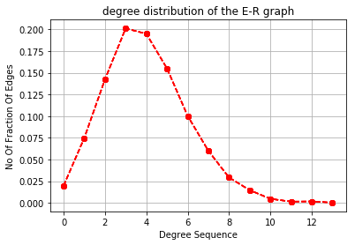
I Don’t Plotted theoretical curve on top of it.

Q2.Ans:-

Plotting The size of the giant component in ER graph as a function of the average degree As shown below,

