Experiment No. 5

Aim : Configuration of FTP server in ubuntu 18.04.

Implementation :-

- First you have to update for these command sudo apt-get update.
- If u done upadate the install the vsftpd package using command sudo apt-get install vsftpd.

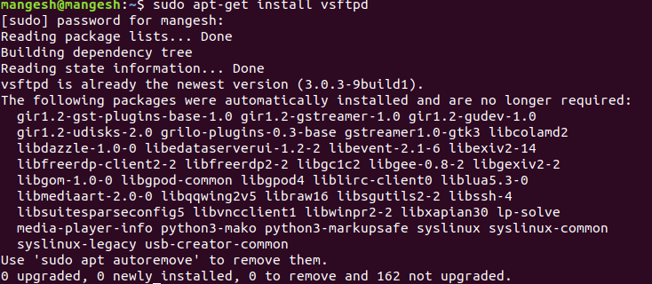
- Then know your ip address using command ip a.

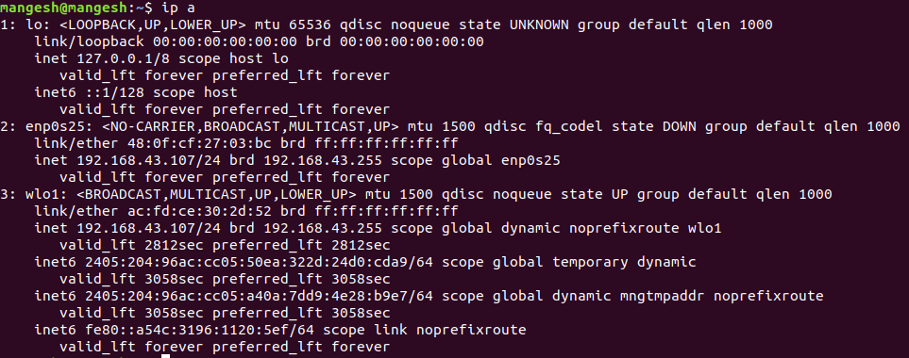
- The go to configuration file using command sudo nano /etc/vsftpd.conf.
- Then make the anonymous_enable=YES in the configuration file.and save it.

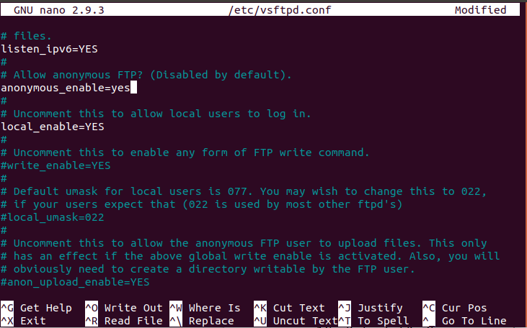
- After that restart the ftp service using command sudo systemctl restart vsftpd.
- sudo systemctl enable vsftpd run command for enable the service.
- Yoy can check status wheather service is enable or not using sudo systemctl status vsftpd.
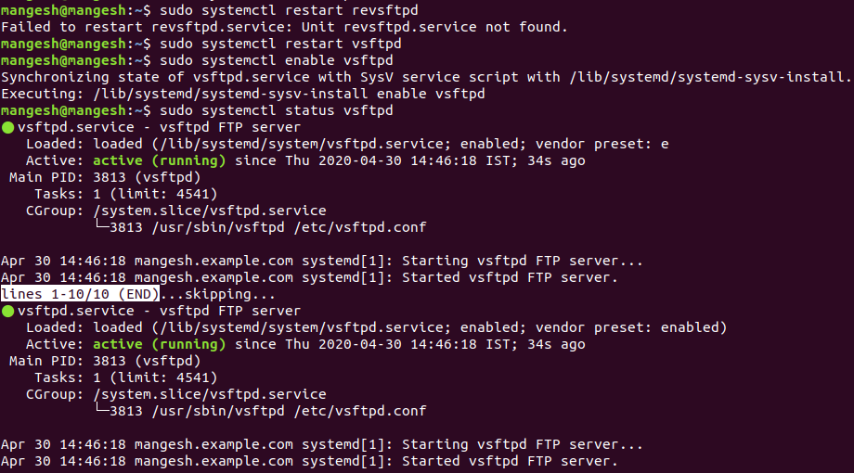

- Now goes to browser and search for ftp://192.168.43.107 in that i will put my ip address.
- Then i put files and directories in srv/ftp. And i will get that file in browser.
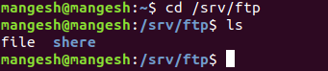

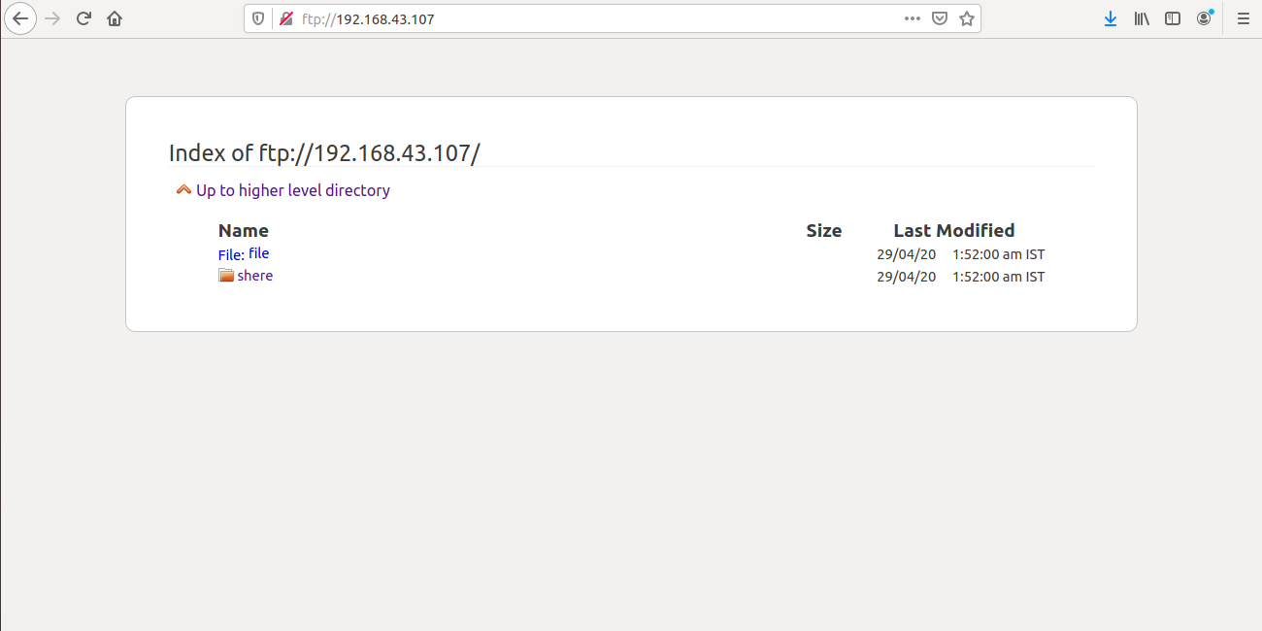
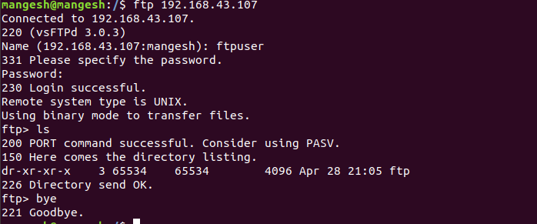
- In these ftp is configured.

