Experiment No. 7

Aim : Configuration of proxy server in ubuntu 18.04 using firefox.

Implementation :-

- First search the system ipv4 address in firefox .

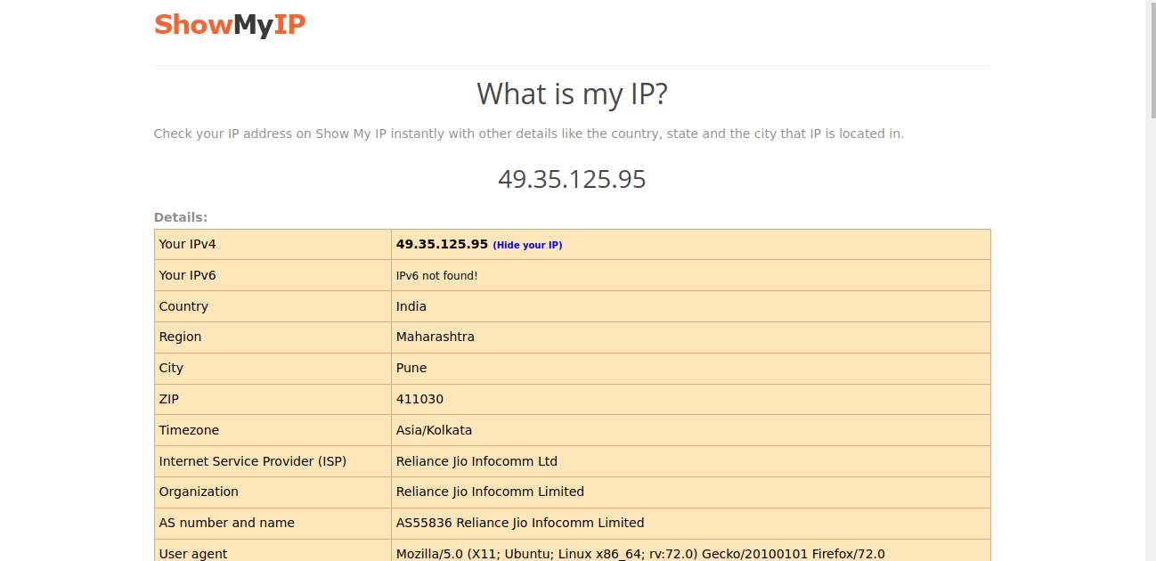
- Then goto options tab in the firefox and search for the proxy setting
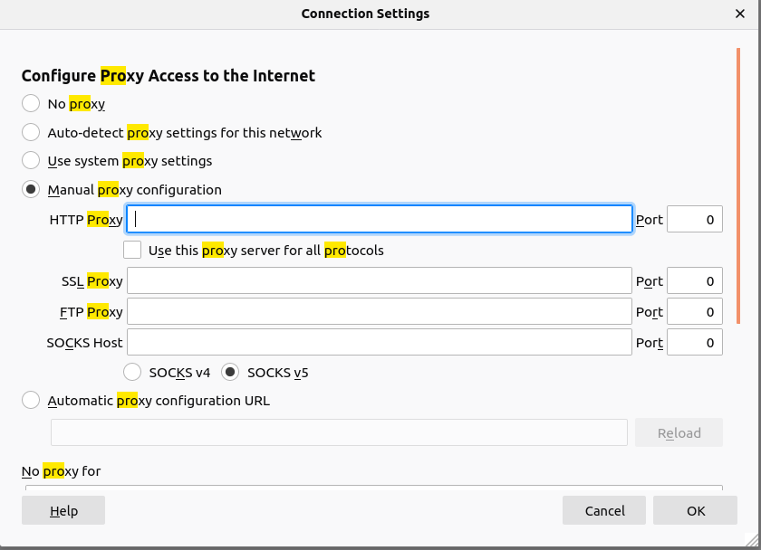
- Configure the mannual setting. For that we have to search for another proxy server ipv4 address that will be filled in the manual proxy configuration and save it by clicking ok.
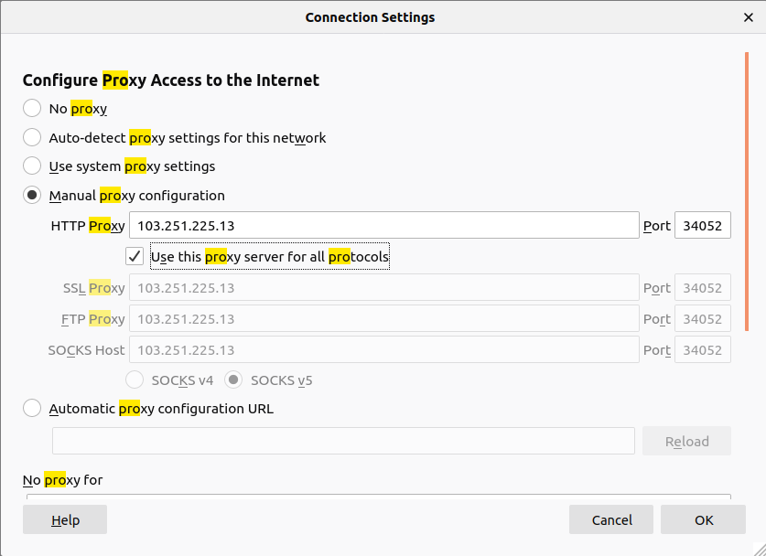
- After setting the configuration we have to search as ipv4 address at that time we have to seen proxy server ipv4 address on firefox.

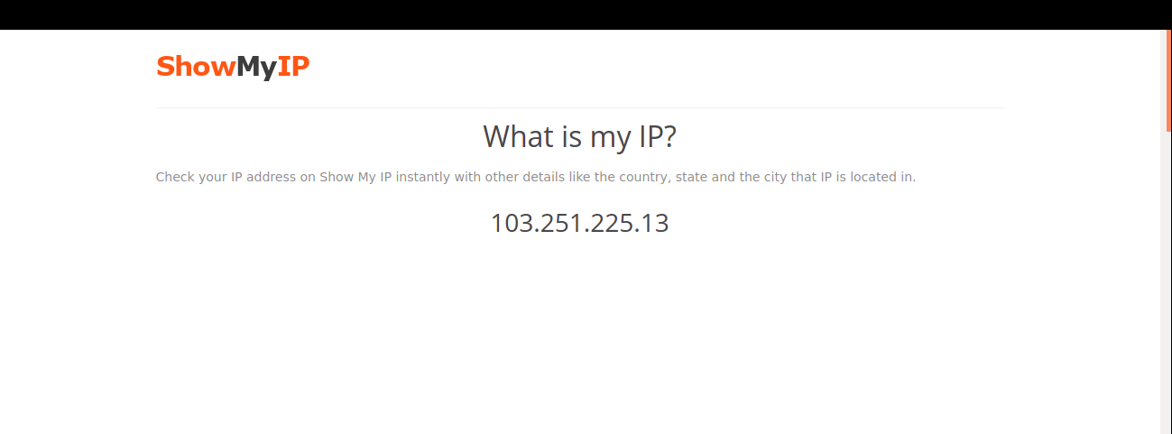
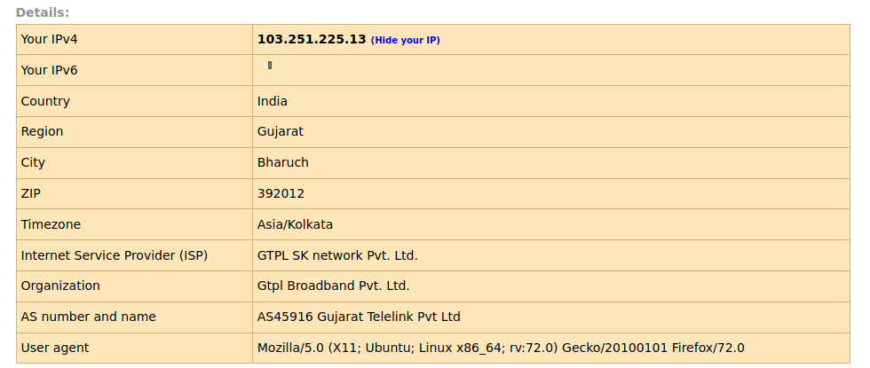

- Finally , the proxy server configured.

