Experiment No. 9

Aim : Configuration of NS2 simulator in ubuntu 18.04.

Implementation :-

- First you have to update for these command sudo apt-get update.
- If you done with upadate the install ns-allinone-2.35.tar.gz and
extract using command tar zxvf ns-allinone-2.35.tar.gz

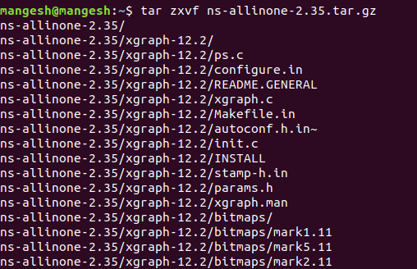
- Then check in the folder ns-allinone-2.35 gcc and g++ version which are 4.8 then its ok. otherwise install using sudo apt install gcc-4.8
sudo apt install g++-4.8

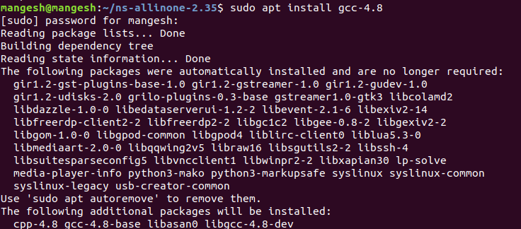
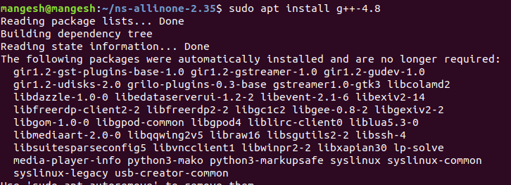
- ns2 , nam and xgraph all these were softwares are confortable with
4.8 versions of gcc and g++.
- So we need to change these settings in the Makefile.in
- We have to modify at three locations as follows
1. ns-2.35/Makefile.in
2. nam-1.15/Makefile.in
3. xgraph-12.2/Makefile.in
- Change in above file as @CC@ ==>gcc-4.8 and @CPP@ ==>g++-4.8
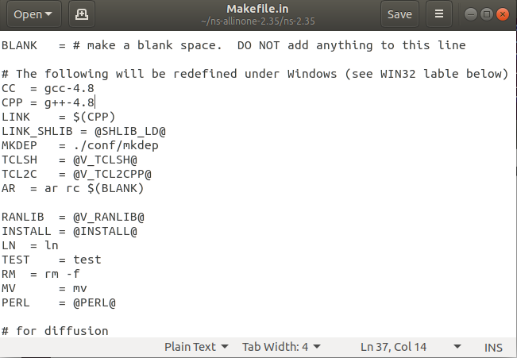

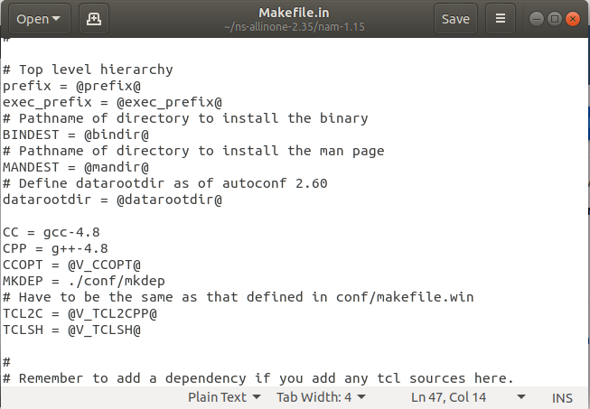
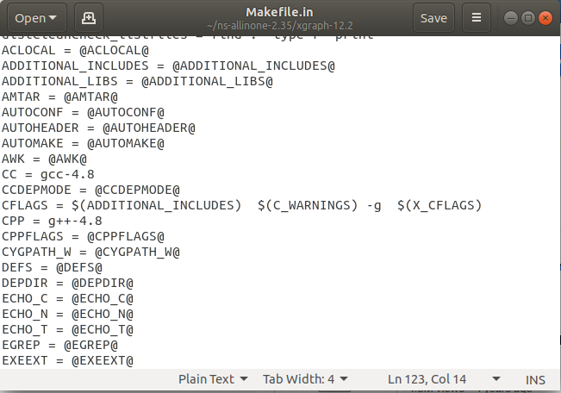

- In file ns-2.35/linkstate/ls.h change as follows
In line number 137 , change erase to this->erase
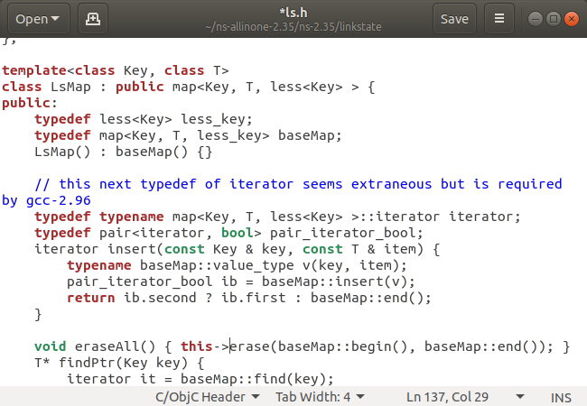
- Then installation done using ./install
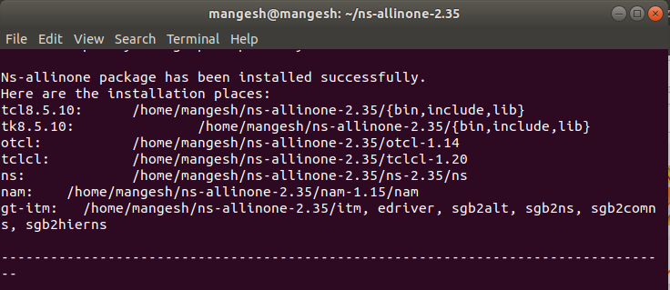
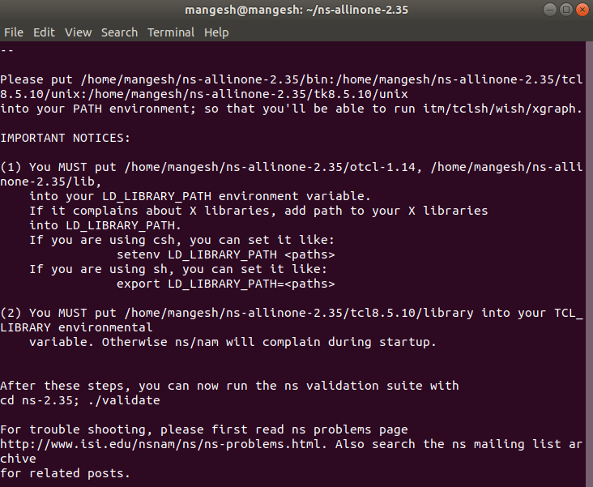
- Set the PATH and LD_LIBRARY_PATH to th .bashrc file
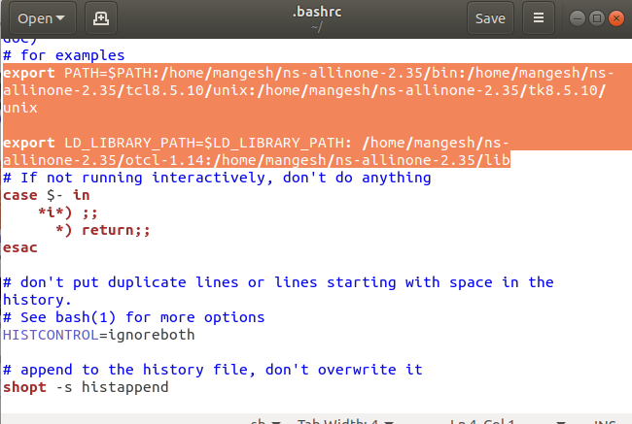
- then check the command ns and nam
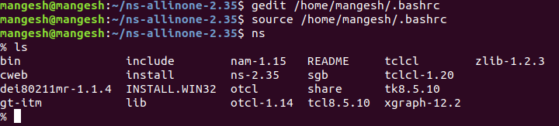
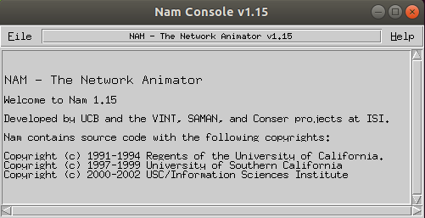
NS 2 is successfully configured.

