CS544 - Homework#1

Consider the M/M/1/<\infinity\> system
λ - arrival rate
μ - service rate

We have u(t) – The utilization of the system in the non-stationary state defined by
--------- (1)
- What is the origin of this formula ?
We know that in the stationary state the average number of customers in the system is given by :

Converting the above equation to find the value of 𝛒 we get :
----> (1.a)
However, in the non stationary state the value of n is not constant. Instead, it is a function of
time and let’s denote it as x(t) and utilization at time t as u(t).
x(t) → Mean number of customers in the system at time t (in non-stationary state)
u(t) → Utilization of the system at time t (in non-stationary state)

Substituting x(t) for n and u(t) for 𝛒 into the above equation (1.a) we have above we get :

Thus, we know that the above formula appoximates the value of utilization of the system in the
non-stationary.

- Propose a differential equation using the formula (1) for the evolution overtime of the mean number of customers in the system x(t) as a function of the u(t), μ and λ.
Answer :
We know that in the M/M/1/infinity system, in the non-stationary state the utilization of the system is a function of time as shown in the above equation (1) :

Now, the mean number of customers in the system can be represented by a state diagram as shown below :
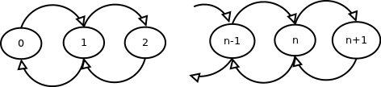
Here, given the value x(t) the mean number of customers at time t we can write equation for the mean number of customer at time (t+Δt) as below :
x(t+Δt) = x(t) + λ.Δt – u(t).μ. Δt
- Solve numerically this differential equation by applying the Fourth-order Runge-Kutta method.
In order to chose the best value of h (integration step) we tried the following values of h:
- h = 3, h=1, h=0.01, h=0.001, h=0.0001
Below is the graph which shows the plot of x(t) for λ = 0.8 μ = 1 and x(t=0)=0 :
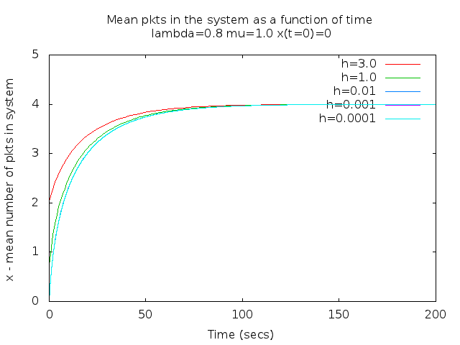
From the graph it can be observed that for larger values of h the resulting values of x(t) are coarse and the system settles down into stationary state in less number of iterations. Where as with the smaller value of h the values of x(t) are more finer and the curve is much smoother. However, a large number of iterations are needed for the system to reach a stable state.
In particular in the above runs with h=3 and h=1 the results are not satisfactory as the curve is not smooth. With h=0.01, h=0.001 and h=0.0001 the curves generated as almost overlapping and smooth. However, we observed that both h-0.001 and h=0.0001 we need a large number of iterations for the system to reach a stable state.
With these observations we felt that h=0.01 is a good compromise for a smooth enough curve but quick enough for the system to reach a stable state. Hence, we have selected h=0.01 for all our future graphs. This would give us a sample rate of 100 samples per second.
The program runge-kutta.c :
The program runge-kutta.c implements the runga-kutta method to solve the differential equation derived in answer for Q2. The program takes the following arguments :
Usage : ./runge-kutta -h <h_val> -x <x0> -l <lambda_val> -u <mu_val> [-p n]
-h <h_val> : Where h_val is the integration step for Runge-Kutta method
-x <x0> : Where x0 is the initial number of customers in the system at time t=0
-l <lambda_val> : Where lambda_val is the Poissonian incoming rate
-u <mu_val> : Where mu_val is the Exponential service rate
-p <n> : Where n is the number of customers for which we need probability P(N=n)
The overall logic of the code is as shown in the flowchart below. One of the key aspects is that the loop of calculating the value of x(t) continues until the value of x(t) settles down for 50 iterations. This ensures that the program stops automatically when the x(t) value settles down instead of trial and error way of identifying the number of iterations.

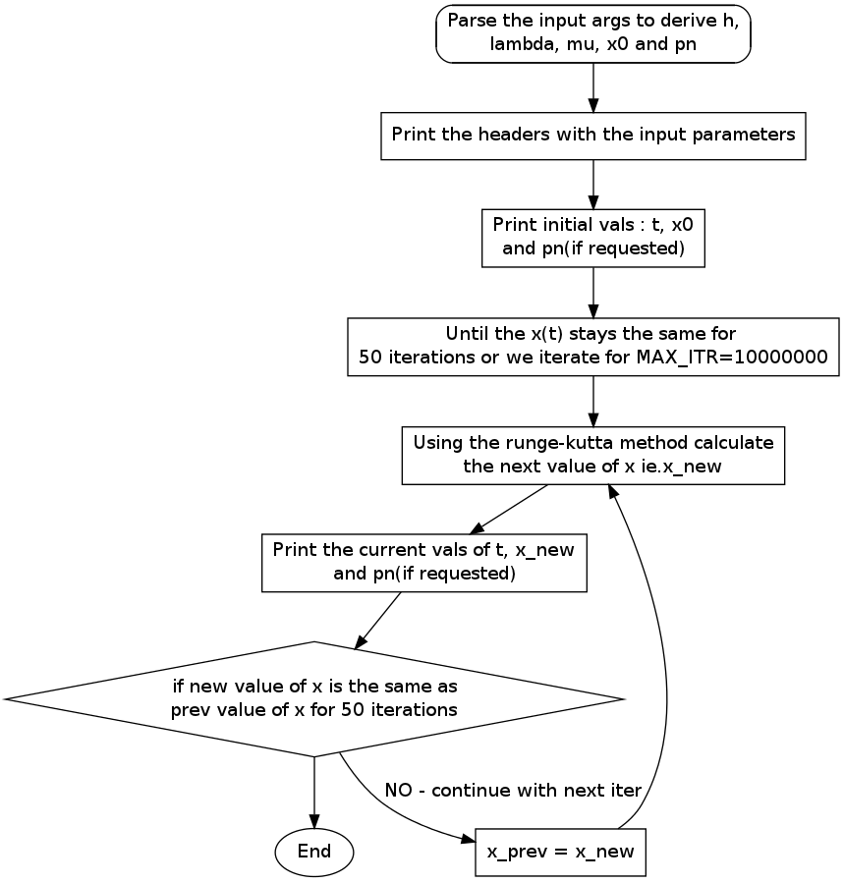Flow-chart of runge-kutta.c
  - The plot for x(t) for λ = 0.8 μ = 1 and x(t=0)=0 is as below. The mean number of customer settles down at 4 and this matches with the expected mean number of customers in the system in stationary state.
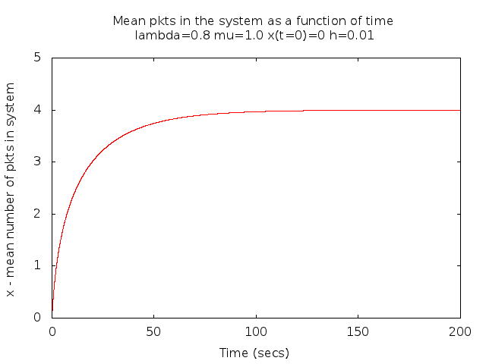
  - The plot for x(t) for λ = 0.8 μ = 1 and x(t=0)=6 is as below. The mean number of customer settles down at 4 and this matches with the expected mean number of customers in the system in stationary state.
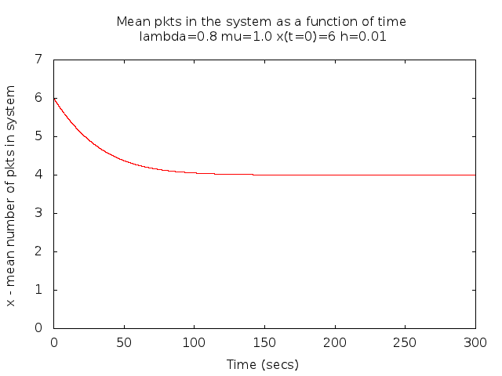
  - The plot for x(t) for λ = 0.6 μ = 1 and x(t=0)=0 is as below. The mean number of customer settles down at 1.5 and this matches with the expected mean number of customers in the system in stationary state.
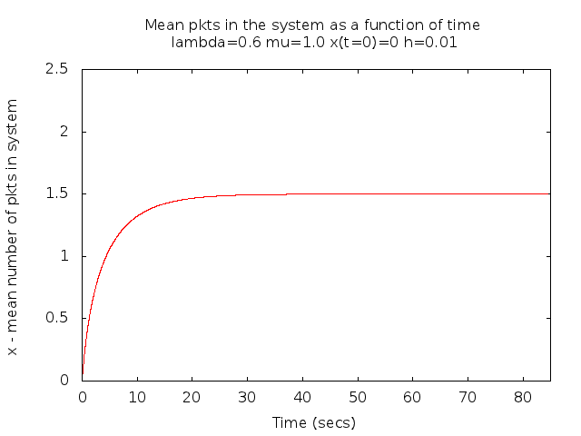
  - The plot for x(t) for λ = 0.6 μ = 1 and x(t=0)=3 is as below. The mean number of customer settles down at 1.5 and this matches with the expected mean number of customers in the system in stationary state.
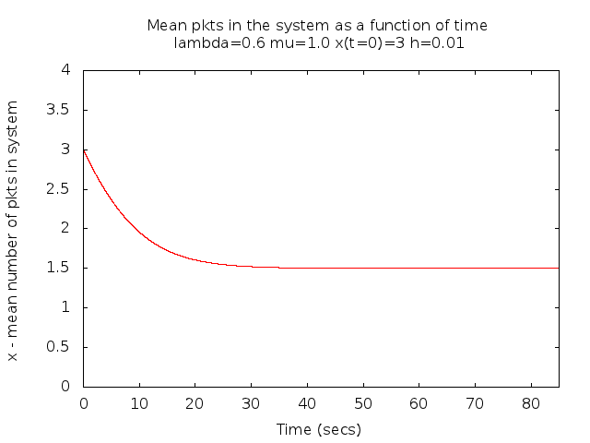
- Plot the values for

