CS 544 Computer Networks II

Spring 2011

HomeWork 1

|  |  |
| --- | --- |
| Mangesh Thakare | A20250279 |
| Sanjeev Bagewadi | A20237384 |
| Suryanarayana T V N B | A20191735 |

Contents

1. Introduction 4

2. Problem 1 - Origin of equation for non stationary state 4

3. Problem 2: Differential equation for mean number of customers in non-stationary state. 5

4. Problem 3: Solution using 4th order Runge kutta method 7

5. Problem 4: For the best integration step determined in (3) plot as a function of time t the following state probabilities : a. P3(t) for λ = 0.8, μ = 1, x(t=0)=0 b. P1(t) for λ = 0.6, μ = 1, x(t=0)=0 12

5.a. Plot probability P3(t) for λ = 0.8, μ = 1, x(t=0)=0 13

6. Observations 14

7. Conclusions 14

8. Appendix 15

a. Table of values for Q3 for different integration steps (ie.h) 15

b. Table of values for x(t) for different values of λ , μ and x(t=0) 18

λ=0.8 , μ=1,x(t=0)=0 18

λ=0.8 , μ=1,x(t=0)=6 18

λ=0.6 , μ=1,x(t=0)=0 18

λ=0.6 , μ=1,x(t=0)=3 18

c. Table of values for Pn(t) for different values of λ, μ and x(t=0) 20

Table of Figures

Figure 1State transition diagram for mean number of customers 5

Figure 2 Mean number packets for different value of h 7

Figure 3Flow-chart of solutions using 4th order runge-kutta 8

Figure 4Mean number of customers for lambda = 0.8 and mu = 1 9

Figure 5 Mean number of customers for lambda=0.8 mu=1 and x(0)=6 10

Figure 6 Mean number of customers for lambda = 0.6 and mu = 1 11

# Introduction

Consider the M/M/1/∞ system   
  
 λ - arrival rate

μ - service rate

We have u(t) – The utilization of the system in the non-stationary state defined by

$u(t)=\frac{x(t)}{x(t)+1}$--------- (1)

# Problem 1 - Origin of equation for non stationary state

**What is the origin of this formula?**

We know that in the stationary state the average number of customers in the system is given by:

$n=\frac{ρ}{(1 - ρ)}$

Converting the above equation to find the value of ρ we get:

$ρ=\frac{n}{(1+n)}$----> (1.a)

However, in the non-stationary state the value of n is not constant. Instead, it is a function of  
 time and let’s denote it as x(t) and utilization at time t as u(t).

x(t) → Mean number of customers in the system at time t (in non-stationary state)

u(t) → Utilization of the system at time t (in non-stationary state)

Substituting x(t) for ***n***  and u(t) for 𝛒 into the above equation (1.a) we have above we get :

$u(t)=\frac{x(t)}{x(t)+1}$

Thus, we know that the above formula approximates the value of utilization of the system in the  
 non-stationary.

# Problem 2: Differential equation for mean number of customers in non-stationary state.

1. **Propose a differential equation using the formula (1) for the evolution overtime of the mean number of customers in the system x(t) as a function of the u(t), μ and λ.**

**Answer**:

We know that in the M/M/1/∞ system, in the non-stationary state the utilization of the system is a function of time as shown in the above equation (1):

$u(t)=\frac{x(t)}{x(t)+1}$

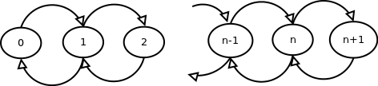Now, the mean number of customers in the system can be represented by a state diagram as shown:

Figure State transition diagram for mean number of customers

Here, given the value x(t) the mean number of customers at time t we can write equation for the mean number of customer at time (t+Δt) as below:

To start with we assume that there at any instant t, in non-stationary region there are x(t) mean number of customers

Consider Δ t be very small time interval such that Δ t → 0.

The mean number of arrivals in Δ t is λ Δ t

The mean number of customers serviced depends on mean number of customers available at that instant t. The system is capable of servicing of μ customers per unit time (seconds). The actual number of customers serviced depends on utilization factor at time t. So in time Δ t after t ,

The number of customers serviced would be

= (service rate x utilization factor x time duration)

= μ . u (t) . Δ t

So the average number of customers at time (t + Δ t ) would be given by

x(t+Δt) = x(t) + λ.Δt – u(t).μ. Δt

x(t+Δ t) – x(t) = (λ – μ . u(t) ) Δt

$$\frac{x\left(t+Δt\right)- x(t)}{Δt}=λ-μ.u(t)$$

We can rewrite the above equation as

$$\lim_{n→∞}{{\left(\frac{x(t+Δt-x(t)}{Δt }\right)}^{}=λ-μ.u(t) }$$

$$Substituting for u\left(t\right)gives$$

$$\frac{dx}{dt}=μ \frac{x(t)}{x\left(t\right)+1}$$

This equation gives the differential equation for mean number of customers as a function of time for the non-stationary state.

# Problem 3: Solution using 4th order Runge Kutta method

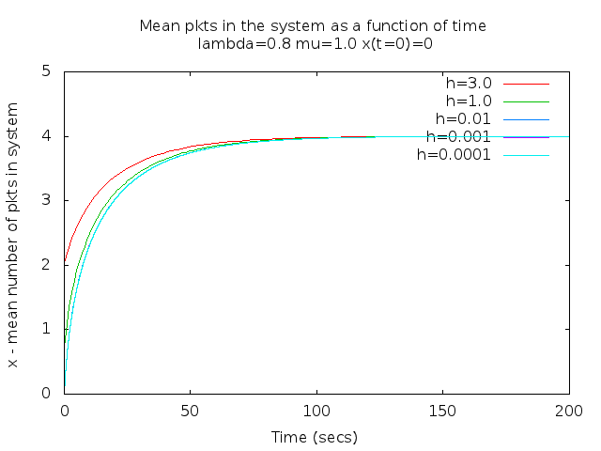In order to choose the best value of h (integration step) we tried the following values of h:

h = 3, h=1, h=0.01, h=0.001, h=0.0001. ***The table of select generated values of x(t) are provided in the table in the Appendix section 8.a.***

Figure 1 shows the plot of x(t) for λ = 0.8 μ = 1 and x(t=0)=0 :

Figure Mean number packets for different value of h

From the graph it can be observed that for larger values of h the resulting values of x(t) are coarse and the system settles down into stationary state in less number of iterations. Whereas with the smaller value of h the values of x(t) are more finer and the curve is much smoother. However, a large number of iterations are needed for the system to reach a stable state.

In particular in the above runs we observed that when h is changed from 3 to 1 we see improvements in the resulting curve. With smaller value of h , which is 1 in case of (3 and 1), we get a new curve, indicating 3 is not small enough.

Similarly comparing the plots for h=1 and even smaller value h = 0.01,we get more information with smaller value, hence we discard h=1. For the similar we can discard the value of h=0.1 (not shown here)

When we take further below i.e h = 0.001, there is no significant gain the information. Variation in graphs is not visible, the plot overlap each other Also reducing value of h for unnoticeable information gain adds n fold computational overhead

With these observations we decide that h=0.01 is a good optimum value for a smooth enough curve and quick enough for the system to reach a stable state. **Hence, we have selected h=0.01 for all our future graphs. This would give us a sample rate of 100 samples per second.**

**The program runge-kutta.c** :

The program runge-kutta.c implements the 4th order runga-kutta method to solve the differential equation derived in answer for Q2. The program takes the following arguments :

Usage : ./runge-kutta -h <h_val> -x <x0> -l <lambda_val> -u <mu_val> [-p n]

-h <h_val> :Where h_val is the integration step for Runge-Kutta method

Figure Flow-chart of solutions using 4th order runge-kutta

-x <x0> : Where x0 is the initial number of customers in the system at time t=0   
 -l <lambda_val> : Where lambda_val is the Poissonian incoming rate

-u <mu_val> : Where mu_val is the Exponential service rate

-p <n> : Where n is the number of customers for which we need probability P(N=n)   
  
The overall logic of the code is as shown in the flowchart below. *One of the key aspects is that the loop of calculating the value of x(t) continues until the value of x(t) settles down for 50 iterations. This ensures that the program stops automatically when the x(t) value settles down instead of trial and error way of identifying the number of iterations.*

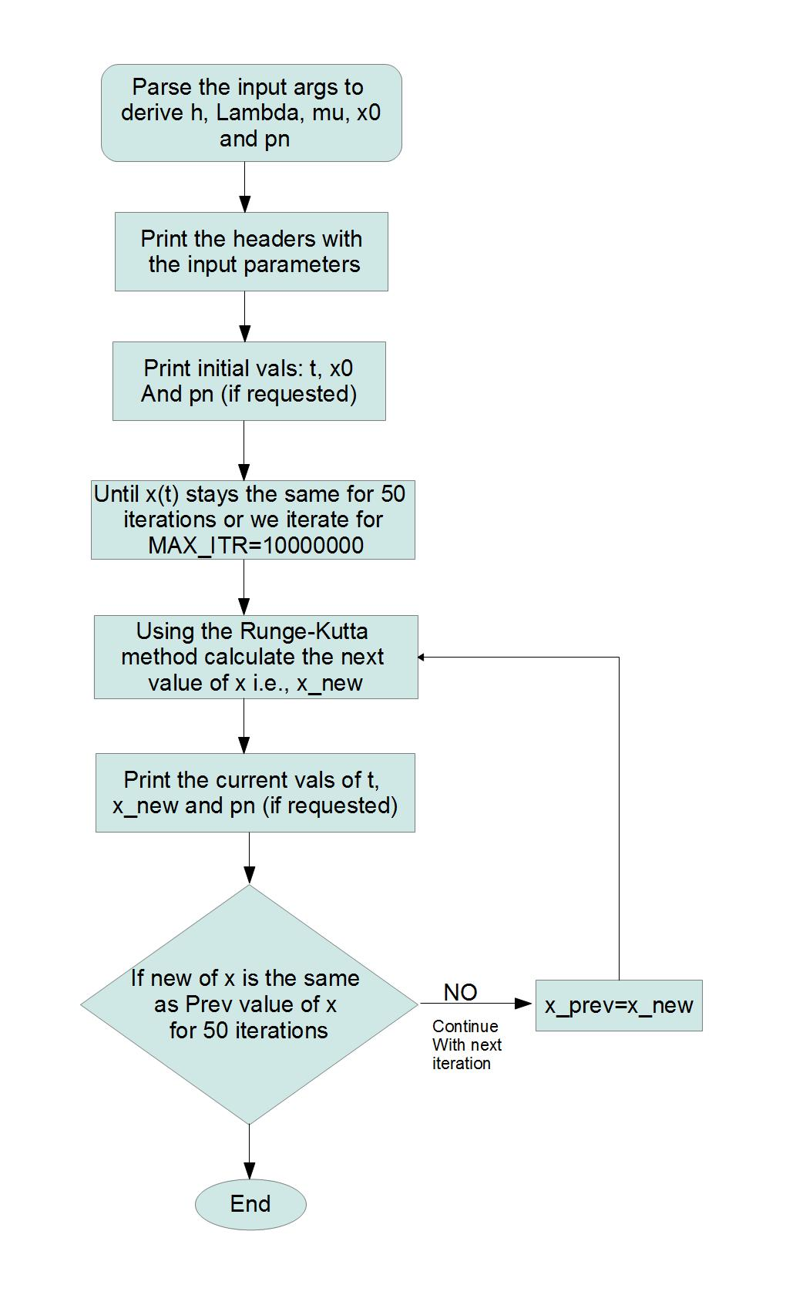

# Plot x(t) λ = 0.8 μ = 1 and x(t=0)=0

The plot for x(t) for λ = 0.8 μ = 1 and x(t=0)=0 is as below. ***The table of select generated values of x(t) are provided in the table in the Appendix section 8.b.*** The mean number of customer settles down at 4 and this matches with the expected mean number of customers in the system in stationary state.

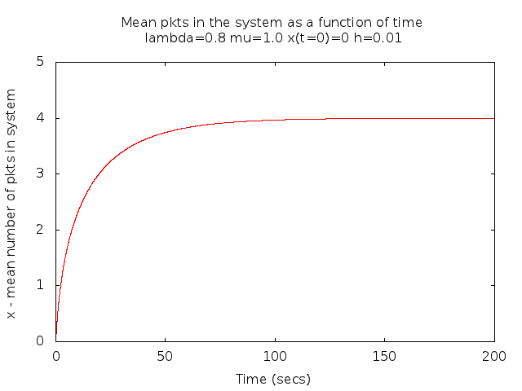

Figure Mean number of customers for lambda = 0.8 and mu = 1

# Plot (t) for λ = 0.8 μ = 1 and x(t=0)=6

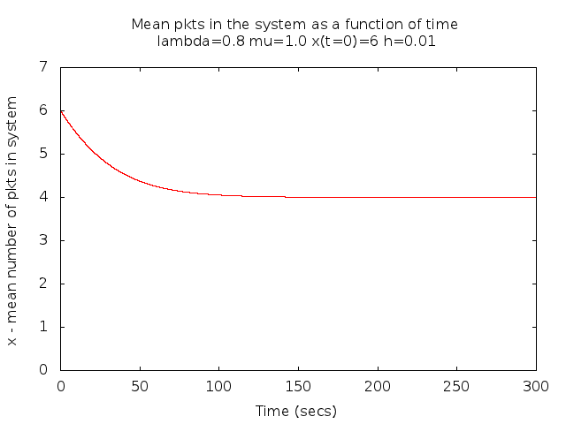The plot for x(t) for λ = 0.8 μ = 1 and x(t=0)=6 is as below. ***The table of select generated values of x(t) are provided in the table in the Appendix section 8.b.*** The mean number of customer settles down at 4 and this matches with the expected mean number of customers in the system in stationary state.

Figure Mean number of customers for lambda=0.8 mu=1 and x(0)=6

# Plot (t) for λ = 0.8 μ = 1 and x(t=0)=0

The plot for x(t) for λ = 0.6 μ = 1 and x(t=0)=0 is as below. ***The table of select generated values of x(t) are provided in the table in the Appendix section 8.b.*** The mean number of customer settles down at 1.5 and this matches with the expected mean number of customers in the system in stationary state.

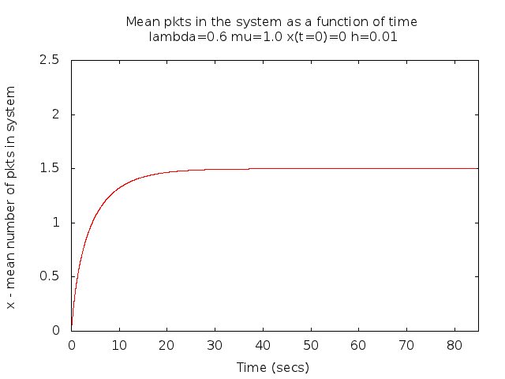

Figure Mean number of customers for lambda = 0.6 and mu = 1 x(0)=0

# Plot for x(t) for λ = 0.6 μ = 1 and x(t=0)=3

The plot for x(t) for λ = 0.6 μ = 1 and x(t=0)=3 is as below. ***The table of select generated values of x(t) are provided in the table in the Appendix section 8.b.*** The mean number of customer settles down at 1.5 and this matches with the expected mean number of customers in the system in stationary state.

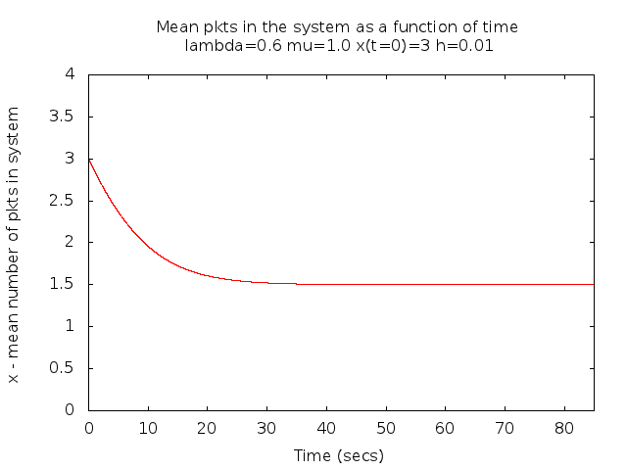

Figure Mean number of customers for lambda = 0.6 and mu = 1 x(0)=3

# Problem 4: For the best integration step determined in (3) plot as a function of time t the following state probabilities : a. P3(t) for λ = 0.8, μ = 1, x(t=0)=0 b. P1(t) for λ = 0.6, μ = 1, x(t=0)=0

**Method Used for deriving state probabilityPn(t) using x(t) and u(t)**

We know that in the stationary state the state probability Pn(t) is given by :

$Pn\left(t\right)=\left(1-ρ\right).ρ^n$ where ρ is the utilization in case of M/M/1/∞ system.

However, as shown in the answer for Q1 we have shown that utilization in non-stationary state can be approximated by the formula :

$u(t)=\frac{x(t)}{x(t)+1}$---- (4.1)  
  
Substituting u(t) for ρ in the above equation we could approximate the state probabilities in the non-stationary state. Thus we can calculate the state probabilities in the non-stationary state using the following formula :

$Pn\left(t\right)=\left(1-u\left(t\right)\right).(u\left(t\right))^n$ where, u(t) is given by x(t) as shown in equation (4.1)

The program runge-kutta.c takes an additional option “-p n” where n represents the ***State n*** for which we want to calculate the state-probabilities. With this option the program prints out the state probability Pn(t) as a function of time for the given input parameters of lambda, mu and x(t=0).

## 5.a. Plot probability P3(t) for λ = 0.8, μ = 1, x(t=0)=0

To plot the state probability for this the command would be :

./runge-kutta –l 0.8 –u 1 –x 0 –h 0.01 –p 3

***The table of select generated values of x(t) are provided in the table in the Appendix section 8.c.***  
The resulting numbers were plotted to generate the following plot :

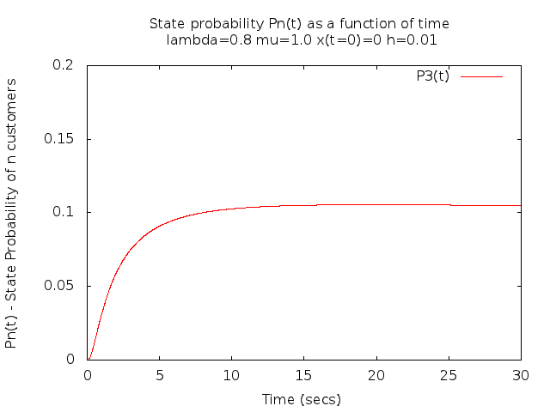

Notice that the value of P3(t) settles down at 0.1024 which is the value that is expected in the stationary state.  
  
  
5.b. Plot probability P1(t) for λ = 0.6, μ = 1, x(t=0)=0

To plot the state probability for this the command would be :

./runge-kutta –l 0.6 –u 1 –x 0 –h 0.01 –p 1

***The table of select generated values of x(t) are provided in the table in the Appendix section 8.c.***  
The resulting numbers were plotted to generate the following plot :

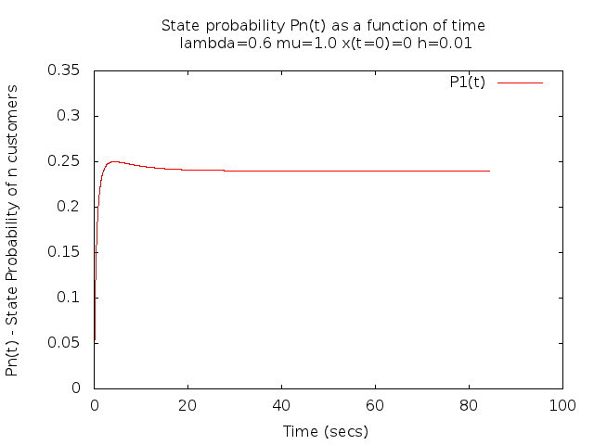

Notice that the value of P1(t) settles down at :0.24 which is the value of P1(t) in the stationary state.

# Observations

The above solutions to the differential equations show that it is possible to plot the values of x(t)-the mean number of customers in the system in the non-stationary state using the given approximation for u(t) – utilization and we find that it settles down to the expected values in the stationary state. For example with λ = 0.8 and μ = 1 we know that the mean number of customers in the system in stationary state should be 4 and our plot for x(t) does settles down at 4. Similarly for λ = 0.6 and μ = 1 we know that the mean number of customers in the stationary state should be 1.5 and our plot for x(t) does settles down at 1.5.

Similarly we also were able to plot the state probabilities during the non-stationary state using u(t) as calculated above in place of **ρ** (which is the utilization for stationary state). And they too eventually settle down at the stationary values over a period of time.

# Conclusions

These above observations prove that u(t) = x(t) / (x(t) +1) is a good approximation and allows us to derive x(t) and the state probabilities for the non-stationary state and they are fairly accurate as the approximation eventually settles down at the same value as that of stationary state.

Also, we can conclude that a the integration step h of 0.01 gives a fairly smooth graph for the solution of the differential equations proposed for Q2 when solved using the Runge-Kutta Fourth Order method.

# Appendix

# Table of values for Q3 for different integration steps (ie.h)

Below are the tables which show the values of x(t) plotted using different values of h. Since the samples are large we have provided here only a selected set of values for every set. The complete set of results can be found in the following files :

- output-3-h-0.0001.dat : Results for x(t) for h=0.0001, lambda=0.8, mu=1.0 and x(t=0)=0

- output-3-h-0.001.dat : Results for x(t) for h=0.001, lambda=0.8, mu=1.0 and x(t=0)=0

- output-3-h-0.01.dat : Results for x(t) for h=0.01, lambda=0.8, mu=1.0 and x(t=0)=0

- output-3-h-1.0.dat : Results for x(t) generated for h=1.0, lambda=0.8, mu=1.0 and x(t=0)=0

- output-3-h-3.0.dat : Results for x(t) generated for h=3, lambda=0.8, mu=1.0 and x(t=0)=0

Table : x(t) for different values of h

| **h=0.0001** | | **h=0.001** | | **h=0.01** | | **h=1.0** | | **h=3.0** | |
| --- | --- | --- | --- | --- | --- | --- | --- | --- | --- |
| **t(secs)** | **x(t)** | **t(secs)** | **x(t)** | **t(secs)** | **x(t)** | **t(secs)** | **x(t)** | **t(secs)** | **x(t)** |
| 0 | 0 | 0 | 0 | 0 | 0 | 0 | 0 | 0 | 0 |
| 0.1 | 0.0763884 | 0.288 | 0.2042632 | 0.31 | 0.2240878 | 0 | 0.7259259 | 0 | 2.0470588 |
| 0.3002 | 0.2113144 | 0.72 | 0.4438575 | 0.93 | 0.5473031 | 1 | 1.0879229 | 3 | 2.4132261 |
| 0.5004 | 0.3288652 | 1.584 | 0.8023735 | 1.55 | 0.794335 | 2 | 1.3574602 | 6 | 2.6810931 |
| 0.7006 | 0.4337363 | 2.448 | 1.0748169 | 2.17 | 0.9973629 | 3 | 1.5755063 | 9 | 2.8885737 |
| 1.101 | 0.6160936 | 3.312 | 1.2970249 | 2.79 | 1.1708621 | 5 | 1.9184153 | 12 | 3.0546337 |
| 1.5014 | 0.7722681 | 4.176 | 1.4853884 | 3.41 | 1.3228197 | 7 | 2.1832013 | 15 | 3.1904151 |
| 1.9018 | 0.9096273 | 5.04 | 1.6490288 | 4.03 | 1.4581944 | 9 | 2.3974394 | 18 | 3.3031228 |
| 2.3022 | 1.0326375 | 5.904 | 1.7936375 | 4.65 | 1.5803142 | 11 | 2.5757944 | 21 | 3.397725 |
| 2.7026 | 1.1442474 | 6.768 | 1.923047 | 5.27 | 1.69154 | 13 | 2.7271759 | 24 | 3.4778105 |
| 3.103 | 1.2465248 | 7.632 | 2.0399821 | 5.89 | 1.7936182 | 15 | 2.8574752 | 27 | 3.5460628 |
| 3.5034 | 1.3409854 | 8.496 | 2.1464615 | 6.51 | 1.887883 | 17 | 2.9708242 | 30 | 3.6045439 |
| 4.3042 | 1.5108043 | 9.36 | 2.2440292 | 7.13 | 1.975381 | 19 | 3.0702503 | 33 | 3.6548724 |
| 5.9058 | 1.7937028 | 10.224 | 2.3338974 | 7.75 | 2.0569508 | 21 | 3.1580473 | 36 | 3.6983416 |
| 7.5074 | 2.0236165 | 11.088 | 2.4170375 | 8.37 | 2.1332766 | 23 | 3.2359999 | 39 | 3.7359993 |
| 9.109 | 2.2163614 | 11.952 | 2.4942424 | 8.99 | 2.2049251 | 25 | 3.3055272 | 42 | 3.768705 |
| 10.7106 | 2.3813475 | 12.816 | 2.5661689 | 9.61 | 2.2723717 | 27 | 3.3677778 | 45 | 3.7971706 |
| 12.3122 | 2.5247042 | 13.68 | 2.6333682 | 10.23 | 2.33602 | 29 | 3.4236956 | 48 | 3.821991 |
| **h=0.0001** | | **h=0.001** | | **h=0.01** | | **h=1.0** | | **h=3.0** | |
| **t(secs)** | **x(t)** | **t(secs)** | **x(t)** | **t(secs)** | **x(t)** | **t(secs)** | **x(t)** | **t(secs)** | **x(t)** |
| 13.9138 | 2.6506829 | 14.544 | 2.6963078 | 10.85 | 2.396216 | 31 | 3.474066 | 51 | 3.8436665 |
| 15.5154 | 2.762372 | 15.408 | 2.7553885 | 11.47 | 2.4532589 | 33 | 3.5195499 | 54 | 3.8626209 |
| 17.117 | 2.8620964 | 16.272 | 2.8109567 | 12.09 | 2.5074094 | 35 | 3.5607087 | 57 | 3.879215 |
| 18.7186 | 2.9516563 | 17.136 | 2.8633144 | 12.71 | 2.5588963 | 37 | 3.5980232 | 60 | 3.893757 |
| 20.3202 | 3.0324779 | 18 | 2.9127261 | 13.33 | 2.6079218 | 39 | 3.631908 | 63 | 3.9065117 |
| 21.9218 | 3.1057126 | 18.864 | 2.9594255 | 13.95 | 2.6546655 | 41 | 3.6627233 | 66 | 3.9177071 |
| 23.5234 | 3.1723051 | 19.728 | 3.0036201 | 14.57 | 2.6992875 | 43 | 3.6907834 | 69 | 3.9275404 |
| 25.125 | 3.233041 | 20.592 | 3.045495 | 15.19 | 2.7419318 | 47 | 3.739709 | 72 | 3.936182 |
| 26.7266 | 3.2885813 | 21.456 | 3.085216 | 15.81 | 2.782728 | 51 | 3.7805274 | 75 | 3.9437803 |
| 28.3282 | 3.3394877 | 22.32 | 3.1229324 | 16.43 | 2.8217934 | 55 | 3.8146911 | 78 | 3.950464 |
| 29.9298 | 3.386242 | 23.184 | 3.1587794 | 17.05 | 2.8592343 | 59 | 3.8433598 | 81 | 3.9563454 |
| 31.5314 | 3.4292605 | 24.048 | 3.1928792 | 17.67 | 2.8951479 | 63 | 3.8674689 | 84 | 3.9615227 |
| 33.133 | 3.4689056 | 24.912 | 3.2253434 | 18.29 | 2.9296228 | 67 | 3.8877797 | 87 | 3.9660813 |
| 34.7346 | 3.5054947 | 25.776 | 3.2562736 | 18.91 | 2.9627404 | 71 | 3.9049157 | 90 | 3.9700964 |
| 36.3362 | 3.5393073 | 26.64 | 3.2857631 | 19.53 | 2.9945753 | 75 | 3.919391 | 93 | 3.9736334 |
| 37.9378 | 3.5705907 | 27.504 | 3.3138974 | 20.15 | 3.0251965 | 79 | 3.9316311 | 96 | 3.9767499 |
| 39.5394 | 3.599565 | 28.368 | 3.3407552 | 20.77 | 3.0546675 | 83 | 3.9419903 | 99 | 3.9794964 |
| 41.141 | 3.6264264 | 58.14 | 3.81786 | 22.01 | 3.110391 | 87 | 3.9507637 | 102 | 3.9819171 |
| 42.7426 | 3.6513508 | 59.436 | 3.8273911 | 24.49 | 3.2103675 | 91 | 3.9581988 | 105 | 3.9840511 |
| 44.3442 | 3.6744966 | 60.732 | 3.8364065 | 26.97 | 3.2972732 | 95 | 3.9645029 | 108 | 3.9859325 |
| 45.9458 | 3.6960063 | 62.028 | 3.844936 | 29.45 | 3.3732446 | 99 | 3.9698503 | 111 | 3.9875913 |
| 47.5474 | 3.7160091 | 63.324 | 3.8530073 | 32.24 | 3.4477281 | 103 | 3.9743879 | 114 | 3.9890541 |
| 49.149 | 3.7346219 | 64.62 | 3.8606464 | 35.96 | 3.5320551 | 107 | 3.9782395 | 117 | 3.990344 |
| 49.9498 | 3.7434407 | 65.916 | 3.8678778 | 39.68 | 3.6023951 | 111 | 3.9815097 | 120 | 3.9914817 |
| 50.7506 | 3.7519512 | 67.212 | 3.8747242 | 43.4 | 3.6613945 | 115 | 3.9842868 | 123 | 3.9924851 |
| 51.5514 | 3.7601651 | 68.508 | 3.8812073 | 47.12 | 3.7111026 | 119 | 3.9866457 | 126 | 3.9933701 |
| 52.3522 | 3.7680938 | 69.804 | 3.8873471 | 50.84 | 3.7531347 | 123 | 3.9886496 | 129 | 3.9941508 |
| 53.153 | 3.7757481 | 71.1 | 3.8931626 | 54.56 | 3.7887818 | 127 | 3.9903523 | 132 | 3.9948394 |
| 53.9538 | 3.7831383 | 72.396 | 3.8986718 | 58.28 | 3.8190883 | 131 | 3.9917991 | 135 | 3.9954469 |
| 54.7546 | 3.7902742 | 73.692 | 3.9038912 | 62 | 3.8449071 | 135 | 3.9930286 | 138 | 3.9959828 |
| 55.5554 | 3.7971655 | 74.988 | 3.9088369 | 65.72 | 3.8669405 | 139 | 3.9940735 | 141 | 3.9964556 |
| 56.3562 | 3.803821 | 76.284 | 3.9135235 | 69.44 | 3.8857705 | 143 | 3.9949617 | 144 | 3.9968727 |
| 57.157 | 3.8102496 | 77.58 | 3.9179652 | 73.16 | 3.9018824 | 147 | 3.9957167 | 147 | 3.9972407 |
| 57.9578 | 3.8164595 | 78.876 | 3.9221751 | 76.88 | 3.9156828 | 151 | 3.9963584 | 150 | 3.9975654 |
| 58.7586 | 3.8224586 | 80.388 | 3.9268104 | 80.29 | 3.9265956 | 155 | 3.9969039 | 153 | 3.9978518 |
| 59.5594 | 3.8282547 | 82.116 | 3.9317661 | 84.94 | 3.9392093 | 159 | 3.9973677 | 156 | 3.9981045 |
| 60.3602 | 3.8338551 | 83.844 | 3.936382 | 89.9 | 3.9502605 | 163 | 3.9977619 | 159 | 3.9983275 |
| 61.161 | 3.8392668 | 85.572 | 3.9406818 | 94.86 | 3.9592862 | 171 | 3.9983821 | 162 | 3.9985243 |
| 61.9618 | 3.8444966 | 87.3 | 3.9446878 | 99.82 | 3.9666631 | 179 | 3.9988304 | 165 | 3.9986979 |
| 62.7626 | 3.8495509 | 89.028 | 3.9484204 | 104.78 | 3.9726961 | 187 | 3.9991544 | 168 | 3.998851 |
| 63.5634 | 3.854436 | 90.756 | 3.9518987 | 109.74 | 3.9776323 | 195 | 3.9993887 | 171 | 3.9989862 |
| 64.3642 | 3.8591579 | 92.484 | 3.9551403 | 114.7 | 3.9816729 | 203 | 3.999558 | 174 | 3.9991054 |
| **h=0.0001** | | **h=0.001** | | **h=0.01** | | **h=1.0** | | **h=3.0** | |
| **t(secs)** | **x(t)** | **t(secs)** | **x(t)** | **t(secs)** | **x(t)** | **t(secs)** | **x(t)** | **t(secs)** | **x(t)** |
| 65.165 | 3.8637223 | 94.212 | 3.9581616 | 119.66 | 3.9849813 | 211 | 3.9996805 | 177 | 3.9992107 |
| 65.9658 | 3.8681348 | 95.94 | 3.9609778 | 124.62 | 3.9876911 | 219 | 3.999769 | 180 | 3.9993035 |
| 66.7666 | 3.8724007 | 97.668 | 3.963603 | 129.58 | 3.9899109 | 227 | 3.999833 | 183 | 3.9993854 |
| 67.5674 | 3.8765251 | 99.396 | 3.9660505 | 134.54 | 3.9917298 | 235 | 3.9998792 | 186 | 3.9994577 |
| 68.3682 | 3.8805129 | 101.124 | 3.9683323 | 139.5 | 3.9932203 | 243 | 3.9999127 | 189 | 3.9995215 |
| 69.169 | 3.8843689 | 103.104 | 3.9707579 | 150.66 | 3.9956638 | 251 | 3.9999369 | 192 | 3.9995778 |
| 70.7706 | 3.8917034 | 105.12 | 3.9730357 | 163.06 | 3.9973605 | 259 | 3.9999544 | 195 | 3.9996274 |
| 72.3722 | 3.898563 | 107.136 | 3.9751352 | 175.46 | 3.9983931 | 267 | 3.999967 | 198 | 3.9996712 |
| 73.9738 | 3.9049797 | 109.152 | 3.9770705 | 187.86 | 3.9990216 | 275 | 3.9999761 | 201 | 3.9997099 |
| 75.5754 | 3.9109831 | 111.168 | 3.9788545 | 200.26 | 3.9994043 | 283 | 3.9999828 | 204 | 3.999744 |
| 78.7786 | 3.9218584 | 113.184 | 3.9804992 | 212.66 | 3.9996373 | 291 | 3.9999875 | 207 | 3.9997741 |
| 81.9818 | 3.9313865 | 115.2 | 3.9820154 | 225.06 | 3.9997791 | 299 | 3.999991 | 210 | 3.9998007 |
| 85.185 | 3.9397387 | 117.216 | 3.9834134 | 237.46 | 3.9998655 | 307 | 3.9999935 | 213 | 3.9998241 |
| 88.3882 | 3.9470633 | 119.232 | 3.9847024 | 249.86 | 3.9999181 | 315 | 3.9999953 | 216 | 3.9998448 |
| 91.5914 | 3.9534892 | 121.248 | 3.985891 | 262.26 | 3.9999501 | 323 | 3.9999966 | 219 | 3.9998631 |
| 94.7946 | 3.9591287 | 123.264 | 3.9869869 | 274.66 | 3.9999696 | 331 | 3.9999975 | 222 | 3.9998792 |
| 97.9978 | 3.9640795 | 125.28 | 3.9879975 | 287.06 | 3.9999815 | 339 | 3.9999982 | 225 | 3.9998934 |
| 101.201 | 3.9684267 | 127.296 | 3.9889295 | 299.46 | 3.9999887 | 347 | 3.9999987 | 228 | 3.9999059 |
| 104.4042 | 3.9722449 | 129.312 | 3.9897889 | 310.48 | 3.9999928 | 355 | 3.9999991 | 231 | 3.999917 |
| 107.6074 | 3.9755991 | 131.328 | 3.9905815 | 311.04 | 3.9999929 | 363 | 3.9999993 | 234 | 3.9999267 |
| 110.8106 | 3.9785462 | 133.344 | 3.9913125 | 311.6 | 3.9999931 | 371 | 3.9999995 | 237 | 3.9999354 |
| 114.0138 | 3.981136 | 135.36 | 3.9919867 | 312.16 | 3.9999932 | 379 | 3.9999996 | 240 | 3.999943 |
| 117.217 | 3.9834121 | 137.376 | 3.9926084 | 312.72 | 3.9999934 | 387 | 3.9999997 | 243 | 3.9999497 |
| 120.4202 | 3.9854128 | 139.392 | 3.9931819 | 313.28 | 3.9999935 | 395 | 3.9999998 | 246 | 3.9999556 |
| 123.6234 | 3.9871715 | 141.408 | 3.9937108 | 313.84 | 3.9999937 | 403 | 3.9999999 | 249 | 3.9999608 |
| 126.8266 | 3.9887178 | 143.424 | 3.9941986 | 314.4 | 3.9999938 | 411 | 3.9999999 | 252 | 3.9999654 |
| 130.0298 | 3.9900773 | 145.44 | 3.9946485 | 314.96 | 3.9999939 | 419 | 3.9999999 | 255 | 3.9999695 |
| 133.233 | 3.9912727 | 147.456 | 3.9950636 | 315.52 | 3.9999941 | 427 | 3.9999999 | 258 | 3.9999731 |
| 136.4362 | 3.9923238 | 149.472 | 3.9954464 | 316.08 | 3.9999942 | 435 | 4 | 261 | 3.9999762 |
| 139.6394 | 3.9932482 | 151.488 | 3.9957994 | 316.64 | 3.9999943 | 443 | 4 | 264 | 3.999979 |
| 142.8426 | 3.9940611 | 153.684 | 3.996153 | 317.14 | 3.9999945 | 451 | 4 | 267 | 3.9999815 |
| 146.0458 | 3.9947761 | 155.988 | 3.9964919 | 317.7 | 3.9999946 | 459 | 4 | 270 | 3.9999815 |
| 149.249 | 3.9954049 | 158.292 | 3.996801 | 318.26 | 3.9999947 |  |  |  |
| 152.4522 | 3.9959579 | 160.596 | 3.9970828 | 318.82 | 3.9999948 |  |  |  |
| 155.6554 | 3.9964444 | 162.9 | 3.9973397 | 319.38 | 3.9999949 |  |  |  |
| 158.8586 | 3.9968722 | 165.204 | 3.9975741 | 319.94 | 3.999995 |  |  |  |
| 162.0618 | 3.9972486 | 167.508 | 3.9977877 |  |  |  |  |  |
| 165.265 | 3.9975796 | 169.812 | 3.9979826 |  |  |  |  |  |
| 168.4682 | 3.9978708 | 172.116 | 3.9981603 |  |  |  |  |  |
| 171.6714 | 3.998127 | 174.42 | 3.9983223 |  |  |  |  |  |
| 174.8746 | 3.9983523 | 176.724 | 3.9984701 |  |  |  |  |  |
| 178.0778 | 3.9985505 | 179.028 | 3.9986048 |  |  |  |  |  |
| 181.281 | 3.9987249 | 181.332 | 3.9987277 |  |  |  |  |  |
| 184.4842 | 3.9988783 | 186.886 | 3.9989812 |  |  |  |  |  |
| 187.6874 | 3.9990132 | 194.95 | 3.9992621 |  |  |  |  |  |
| 190.8906 | 3.9991319 | 203.014 | 3.9994656 |  |  |  |  |  |
| 194.0938 | 3.9992363 | 211.078 | 3.9996129 |  |  |  |  |  |
| 197.297 | 3.9993281 | 219.142 | 3.9997197 |  |  |  |  |  |
| 200.5002 | 3.999409 | 227.206 | 3.999797 |  |  |  |  |  |
| 202.2019 | 3.9994478 | 235.27 | 3.9998529 |  |  |  |  |  |
| 203.8035 | 3.9994821 | 243.334 | 3.9998935 |  |  |  |  |  |
|  |  | 251.398 | 3.9999229 |  |  |  |  |  |
|  |  | 259.462 | 3.9999441 |  |  |  |  |  |

# Table of values for x(t) for different values of **λ , μ and x(t=0)**

Below is the table of values for x(t) for different values of λ, μ and x(t=0). The number of samples generated are large and hence not all of them have been included in the table belowt. Only a select 100 odd values are put here. However, the complete set of values used to plot the graph are available in the following files :

* output-3-a.dat : Results for x(t) generated for lambda=0.8, mu=1.0 and x(t=0)=0 for h=0.01
* output-3-b.dat : Results for x(t) generated for lambda=0.8, mu=1.0 and x(t=0)=6 for h=0.01
* output-3-c.dat : Results for x(t) generated for lambda=0.6, mu=1.0 and x(t=0)=0 for h=0.01
* output-3-d.dat : Results for x(t) generated for lambda=0.6, mu=1.0 and x(t=0)=3 for h=0.01

***Table 2:Sample values for x(t) for different values of*** *λ, μ and x(t=0)*

| λ=0.8 , μ=1,x(t=0)=0 | | λ=0.8 , μ=1,x(t=0)=6 | | λ=0.6 , μ=1,x(t=0)=0 | | λ=0.6 , μ=1,x(t=0)=3 | |
| --- | --- | --- | --- | --- | --- | --- | --- |
| **t(secs)** | **x(t)** | **t(secs)** | **x(t)** | **t(secs)** | **x(t)** | **t(secs)** | **x(t)** |
| 0 | 0 | 0 | 6 | 0 | 0 | 0 | 3 |
| 0 | 0.0079868 | 0 | 5.9994286 | 0 | 0.0059901 | 0.01 | 2.9970013 |
| 0.51 | 0.3402718 | 5.61 | 5.6970877 | 0.22 | 0.1246883 | 0.03 | 2.9940063 |
| 1.53 | 0.787159 | 11.22 | 5.4302662 | 0.44 | 0.2241563 | 0.05 | 2.991015 |
| 2.55 | 1.1066057 | 16.83 | 5.1972671 | 0.66 | 0.3099012 | 0.07 | 2.9880275 |
| 3.57 | 1.3591874 | 17.34 | 5.1776903 | 0.88 | 0.3852464 | 0.09 | 2.9850438 |
| 4.59 | 1.5690045 | 17.85 | 5.1583734 | 1.1 | 0.452379 | 0.11 | 2.9820638 |
| 5.61 | 1.748558 | 18.36 | 5.1393145 | 1.32 | 0.5128284 | 0.15 | 2.9761151 |
| 6.63 | 1.9053176 | 18.87 | 5.1205117 | 1.54 | 0.5677134 | 0.19 | 2.9701814 |
| 7.65 | 2.0441654 | 19.38 | 5.1019633 | 2.31 | 0.7266696 | 0.23 | 2.9642628 |
| 8.67 | 2.168498 | 19.89 | 5.0836671 | 3.63 | 0.9208036 | 0.31 | 2.9524707 |
| 9.69 | 2.2807899 | 20.4 | 5.0656214 | 4.95 | 1.0558053 | 0.39 | 2.9407388 |
| 10.71 | 2.382909 | 20.91 | 5.047824 | 6.27 | 1.1543261 | 0.47 | 2.9290672 |
| 11.73 | 2.4763055 | 21.42 | 5.0302732 | 7.59 | 1.2283423 | 0.55 | 2.9174559 |
| 12.75 | 2.5621315 | 21.93 | 5.0129667 | 8.91 | 1.2850227 | 0.63 | 2.905905 |
| 13.77 | 2.6413201 | 22.44 | 4.9959027 | 10.23 | 1.32901 | 0.71 | 2.8944145 |
| 14.79 | 2.7146388 | 23.46 | 4.9624938 | 11.55 | 1.3634774 | 0.79 | 2.8829845 |
| λ=0.8 , μ=1,x(t=0)=0 | | λ=0.8 , μ=1,x(t=0)=6 | | λ=0.6 , μ=1,x(t=0)=0 | | λ=0.6 , μ=1,x(t=0)=3 | |
| **t(secs)** | **x(t)** | **t(secs)** | **x(t)** | **t(secs)** | **x(t)** | **t(secs)** | **x(t)** |
| 15.81 | 2.782728 | 24.48 | 4.9300297 | 12.87 | 1.3906794 | 0.87 | 2.8716149 |
| 16.83 | 2.8461285 | 25.5 | 4.8984938 | 14.19 | 1.4122643 | 0.95 | 2.8603059 |
| 17.85 | 2.9053012 | 26.52 | 4.8678691 | 15.51 | 1.4294636 | 1.03 | 2.8490574 |
| 18.87 | 2.9606432 | 27.54 | 4.8381382 | 16.83 | 1.4432128 | 1.19 | 2.8267421 |
| 28.89 | 3.3569524 | 28.56 | 4.809284 | 18.15 | 1.454232 | 1.35 | 2.8046694 |
| 29.91 | 3.3862749 | 29.58 | 4.7812888 | 19.47 | 1.4630809 | 1.51 | 2.7828392 |
| 30.93 | 3.4140828 | 30.6 | 4.7541351 | 20.79 | 1.4701983 | 1.67 | 2.7612518 |
| 31.95 | 3.4404719 | 31.62 | 4.7278052 | 22.11 | 1.4759302 | 1.83 | 2.7399072 |
| 32.97 | 3.4655302 | 32.64 | 4.7022813 | 23.43 | 1.480551 | 2.15 | 2.6979462 |
| 33.99 | 3.4893386 | 33.66 | 4.6775456 | 24.75 | 1.4842791 | 2.47 | 2.6569557 |
| 35.01 | 3.5119717 | 38.76 | 4.5650705 | 26.07 | 1.4872889 | 2.79 | 2.6169344 |
| 36.03 | 3.5334984 | 43.86 | 4.4696605 | 27.39 | 1.4897202 | 3.43 | 2.5397901 |
| 37.05 | 3.5539826 | 48.96 | 4.3891948 | 28.71 | 1.4916848 | 4.07 | 2.4664868 |
| 38.07 | 3.5734834 | 54.06 | 4.3216806 | 30.03 | 1.4932729 | 4.71 | 2.3969851 |
| 39.09 | 3.5920558 | 55.08 | 4.3095678 | 31.35 | 1.4945571 | 5.35 | 2.3312329 |
| 40.11 | 3.609751 | 59.16 | 4.2652874 | 32.67 | 1.4955957 | 5.99 | 2.2691652 |
| 41.13 | 3.6266168 | 63.24 | 4.2270654 | 33.99 | 1.4964358 | 6.63 | 2.2107049 |
| 42.15 | 3.6426975 | 67.32 | 4.1941444 | 35.31 | 1.4971155 | 7.27 | 2.1557635 |
| 43.17 | 3.6580347 | 71.4 | 4.1658431 | 36.63 | 1.4976655 | 7.91 | 2.1042416 |
| 44.19 | 3.6726675 | 75.48 | 4.1415538 | 37.95 | 1.4981105 | 8.55 | 2.0560302 |
| 45.21 | 3.6866323 | 79.56 | 4.1207379 | 39.27 | 1.4984706 | 9.19 | 2.0110119 |
| 46.23 | 3.6999633 | 83.64 | 4.1029213 | 40.59 | 1.4987621 | 9.83 | 1.9690618 |
| 47.25 | 3.7126926 | 87.72 | 4.0876885 | 41.91 | 1.498998 | 10.47 | 1.9300495 |
| 48.27 | 3.7248504 | 91.8 | 4.074677 | 43.23 | 1.4991889 | 11.11 | 1.8938397 |
| 49.29 | 3.736465 | 95.88 | 4.0635719 | 44.55 | 1.4993434 | 11.75 | 1.8602942 |
| 50.31 | 3.7475633 | 99.96 | 4.0541006 | 45.87 | 1.4994685 | 12.39 | 1.829273 |
| 51.33 | 3.7581705 | 104.04 | 4.0460274 | 47.19 | 1.4995698 | 13.03 | 1.8006356 |
| 52.35 | 3.7683103 | 108.12 | 4.0391497 | 48.51 | 1.4996517 | 13.67 | 1.7742424 |
| 53.37 | 3.7780052 | 112.2 | 4.0332928 | 49.83 | 1.4997181 | 14.31 | 1.7499554 |
| 54.39 | 3.7872764 | 116.28 | 4.0283072 | 51.15 | 1.4997718 | 14.95 | 1.7276395 |
| 55.41 | 3.7961439 | 120.36 | 4.0240647 | 52.47 | 1.4998153 | 15.59 | 1.7071633 |
| 56.43 | 3.8046267 | 124.44 | 4.0204554 | 53.79 | 1.4998505 | 16.23 | 1.6883997 |
| 57.45 | 3.8127428 | 128.52 | 4.0173855 | 55.11 | 1.4998789 | 16.87 | 1.6712266 |
| 58.47 | 3.8205092 | 132.6 | 4.014775 | 56.43 | 1.499902 | 17.51 | 1.655527 |
| 59.49 | 3.8279421 | 136.68 | 4.0125555 | 57.75 | 1.4999207 | 18.15 | 1.6411898 |
| 60.51 | 3.8350566 | 140.76 | 4.0106687 | 59.07 | 1.4999358 | 18.79 | 1.6281099 |
| 61.53 | 3.8418673 | 144.84 | 4.0090649 | 60.39 | 1.499948 | 19.43 | 1.6161877 |
| 62.55 | 3.848388 | 148.92 | 4.0077019 | 61.71 | 1.4999579 | 20.07 | 1.6053302 |
| 63.57 | 3.8546318 | 153 | 4.0065435 | 63.03 | 1.4999659 | 20.71 | 1.5954499 |
| 70.09 | 3.8887693 | 156.58 | 4.0056714 | 64.35 | 1.4999724 | 21.35 | 1.5864654 |
| 76.11 | 3.9129984 | 160.66 | 4.0048181 | 65.67 | 1.4999777 | 21.99 | 1.5783009 |
| 82.13 | 3.9318768 | 164.74 | 4.0040931 | 66.99 | 1.4999819 | 22.63 | 1.5708861 |
| λ=0.8 , μ=1,x(t=0)=0 | | λ=0.8 , μ=1,x(t=0)=6 | | λ=0.6 , μ=1,x(t=0)=0 | | λ=0.6 , μ=1,x(t=0)=3 | |
| **t(secs)** | **x(t)** | **t(secs)** | **x(t)** | **t(secs)** | **x(t)** | **t(secs)** | **x(t)** |
| 88.15 | 3.9466146 | 168.82 | 4.0034771 | 68.31 | 1.4999854 | 23.27 | 1.5641558 |
| 94.17 | 3.9581371 | 172.9 | 4.0029538 | 69.63 | 1.4999882 | 23.91 | 1.55805 |
| 100.19 | 3.9671562 | 176.98 | 4.0025092 | 70.95 | 1.4999904 | 24.55 | 1.5525133 |
| 106.21 | 3.9742221 | 181.06 | 4.0021315 | 71.17 | 1.4999907 | 25.19 | 1.5474949 |
| 112.23 | 3.9797617 | 185.14 | 4.0018106 | 71.39 | 1.4999911 | 25.83 | 1.5429479 |
| 118.25 | 3.984107 | 189.22 | 4.001538 | 71.61 | 1.4999914 | 26.47 | 1.5388296 |
| 124.27 | 3.9875171 | 193.3 | 4.0013064 | 71.83 | 1.4999917 | 29.03 | 1.5259076 |
| 130.29 | 3.990194 | 197.38 | 4.0011097 | 72.05 | 1.499992 | 31.59 | 1.5172564 |
| 136.31 | 3.992296 | 201.46 | 4.0009426 | 72.27 | 1.4999922 | 34.15 | 1.5114808 |
| 142.33 | 3.9939468 | 205.54 | 4.0008007 | 72.49 | 1.4999925 | 36.71 | 1.5076324 |
| 148.35 | 3.9952436 | 209.62 | 4.0006801 | 72.71 | 1.4999928 | 39.27 | 1.5050713 |
| 154.37 | 3.9962624 | 213.7 | 4.0005777 | 72.93 | 1.499993 | 41.83 | 1.5033685 |
| 160.39 | 3.9970628 | 217.78 | 4.0004907 | 73.15 | 1.4999933 | 44.39 | 1.5022369 |
| 163.41 | 3.9973972 | 221.86 | 4.0004168 | 73.37 | 1.4999935 | 46.95 | 1.5014853 |
| 169.43 | 3.9979545 | 225.94 | 4.0003541 | 73.59 | 1.4999937 | 49.51 | 1.5009861 |
| 175.45 | 3.9983924 | 230.02 | 4.0003007 | 73.81 | 1.4999939 | 52.07 | 1.5006546 |
| 181.47 | 3.9987366 | 234.1 | 4.0002555 | 74.03 | 1.4999941 | 54.63 | 1.5004345 |
| 187.49 | 3.999007 | 238.18 | 4.000217 | 74.25 | 1.4999943 | 57.19 | 1.5002885 |
| 193.51 | 3.9992196 | 242.26 | 4.0001843 | 74.47 | 1.4999945 | 59.75 | 1.5001915 |
| 199.53 | 3.9993866 | 246.34 | 4.0001566 | 74.69 | 1.4999947 | 62.31 | 1.5001271 |
| 205.55 | 3.9995179 | 250.42 | 4.000133 | 74.91 | 1.4999949 | 64.87 | 1.5000844 |
| 211.57 | 3.9996211 | 254.5 | 4.000113 | 75.13 | 1.4999951 | 67.11 | 1.5000589 |
| 217.59 | 3.9997022 | 258.58 | 4.0000959 | 75.35 | 1.4999953 | 68.39 | 1.500048 |
| 223.61 | 3.9997659 | 262.66 | 4.0000815 | 75.57 | 1.4999954 | 69.67 | 1.5000391 |
| 229.63 | 3.999816 | 266.74 | 4.0000692 | 75.79 | 1.4999956 | 70.95 | 1.5000319 |
| 235.65 | 3.9998554 | 270.82 | 4.0000588 | 76.01 | 1.4999957 | 72.23 | 1.500026 |
| 241.67 | 3.9998864 | 274.9 | 4.0000499 | 76.23 | 1.4999959 | 73.51 | 1.5000212 |
| 247.69 | 3.9999107 | 278.98 | 4.0000424 | 76.45 | 1.499996 | 74.79 | 1.5000172 |
| 253.71 | 3.9999298 | 283.06 | 4.000036 | 76.67 | 1.4999962 | 76.07 | 1.500014 |
| 259.73 | 3.9999448 | 287.14 | 4.0000306 | 76.89 | 1.4999963 | 77.35 | 1.5000114 |
| 265.75 | 3.9999566 | 291.22 | 4.000026 | 77.11 | 1.4999964 | 78.63 | 1.5000093 |
| 271.77 | 3.9999659 | 295.3 | 4.0000221 | 77.33 | 1.4999965 | 79.91 | 1.5000076 |
| 277.79 | 3.9999732 | 299.38 | 4.0000188 | 77.55 | 1.4999967 | 81.19 | 1.5000062 |
| 283.81 | 3.9999789 | 303.46 | 4.0000159 | 77.77 | 1.4999968 | 82.47 | 1.500005 |
| 289.83 | 3.9999835 | 307.54 | 4.0000135 | 77.99 | 1.4999969 | 83.75 | 1.5000041 |
| 295.85 | 3.999987 | 311.62 | 4.0000115 | 78.21 | 1.499997 | 85.03 | 1.5000033 |
| 301.87 | 3.9999898 | 315.7 | 4.0000098 | 78.43 | 1.4999971 | 86.31 | 1.5000027 |
| 307.89 | 3.999992 | 319.78 | 4.0000083 | 78.65 | 1.4999972 | 87.59 | 1.5000022 |
| 313.91 | 3.9999937 | 323.86 | 4.000007 | 78.87 | 1.4999973 | 88.55 | 1.5000019 |
| 319.93 | 3.999995 | 327.94 | 4.000006 | 79.09 | 1.4999974 | 89.19 | 1.5000017 |
|  |  | 332.02 | 4.0000051 | 79.31 | 1.4999975 | 89.83 | 1.5000016 |
|  |  |  |  | 79.53 | 1.4999976 | 90.24 | 1.5000015 |
|  |  |  |  |  |  | 90.56 | 1.5000014 |
|  |  |  |  |  |  | 90.88 | 1.5000013 |
|  |  |  |  |  |  | 91.2 | 1.5000012 |
|  |  |  |  |  |  | 91.52 | 1.5000012 |
|  |  |  |  |  |  | 91.84 | 1.5000011 |

# Table of values for Pn(t) for different values of λ, μ and x(t=0)

Below is the table of values for Pn(t) for different values of λ, μ and x(t=0). The number of samples generated are large and hence not all of them have been included in the table below. Only a select 100 odd values are put here. However, the complete set of values used to plot the graph are available in the following files :

* output-4-a.dat : Results for state probability P3(t) generated for lambda=0.8, mu=1.0 and x(t=0)=0 for h=0.01
* output-4-b.dat : Results for state probability P1(t) generated for lambda=0.6, mu=1.0 and x(t=0)=0 for h=0.01

| **Average number of pkts in the system as a function of time. Parameters for this plot of P3(t)**  **# lambda = 0.8 mu = 1.0 h = 0.01 x0 = 0** | | | **Average number of pkts in the system as a function of time. Parameters for this plot P1(t)**  **# lambda = 0.6 mu = 1.0 h = 0.01 x0 = 0** | | |
| --- | --- | --- | --- | --- | --- |
| **# time** | **Avg-number-of-pkts** | **P(n=3)** | **# time** | **Avg-number-of-pkts** | **P(n=1)** |
| 0 | 0 | 0 | 0 | 0 | 0 |
| 0 | 0.0079868 | 0 | 0 | 0.0059901 | 0.005919 |
| 0.01 | 0.0158946 | 0.000004 | 0.02 | 0.0177935 | 0.017177 |
| 0.02 | 0.0237256 | 0.000012 | 0.04 | 0.0293696 | 0.027718 |
| 0.03 | 0.0314816 | 0.000028 | 0.06 | 0.0407277 | 0.037602 |
| 0.04 | 0.0391644 | 0.000052 | 0.1 | 0.0628244 | 0.055617 |
| 0.35 | 0.2484957 | 0.006316 | 0.14 | 0.0841472 | 0.071592 |
| 0.66 | 0.4191186 | 0.018152 | 0.18 | 0.104752 | 0.085829 |
| 0.97 | 0.5650316 | 0.030069 | 0.22 | 0.1246883 | 0.098574 |
| 1.28 | 0.6934199 | 0.040544 | 0.26 | 0.1440005 | 0.11003 |
| 1.9 | 0.9132162 | 0.056841 | 0.34 | 0.1809067 | 0.129725 |
| 2.52 | 1.0983305 | 0.068344 | 0.42 | 0.2157434 | 0.145967 |
| 3.14 | 1.2589266 | 0.076629 | 0.5 | 0.2487347 | 0.159513 |
| 3.76 | 1.4010383 | 0.082747 | 0.58 | 0.2800679 | 0.170922 |
| 4.38 | 1.5285938 | 0.08737 | 0.66 | 0.3099012 | 0.180612 |
| 5 | 1.6443189 | 0.090929 | 0.74 | 0.3383696 | 0.188903 |
| 5.62 | 1.7501959 | 0.093714 | 0.82 | 0.3655895 | 0.196044 |
| 6.24 | 1.84772 | 0.095922 | 0.9 | 0.391662 | 0.202229 |
| 6.86 | 1.9380509 | 0.097692 | 0.98 | 0.4166756 | 0.207614 |
| 7.48 | 2.0221102 | 0.099123 | 1.06 | 0.4407085 | 0.212324 |
| 8.72 | 2.1742659 | 0.101243 | 1.22 | 0.4861009 | 0.220105 |
| 9.96 | 2.3087457 | 0.102677 | 1.38 | 0.5283092 | 0.226186 |
| 11.2 | 2.4287877 | 0.103659 | 1.54 | 0.5677134 | 0.230991 |
| **Average number of pkts in the system as a function of time. Parameters for this plot of P3(t)**  **# lambda = 0.8 mu = 1.0 h = 0.01 x0 = 0** | | | **Average number of pkts in the system as a function of time. Parameters for this plot P1(t)**  **# lambda = 0.6 mu = 1.0 h = 0.01 x0 = 0** | | |
| **# time** | **Avg-number-of-pkts** | **P(n=3)** | **# time** | **Avg-number-of-pkts** | **P(n=1)** |
| 12.44 | 2.5367885 | 0.104332 | 1.7 | 0.6046264 | 0.234822 |
| 13.68 | 2.6345792 | 0.104789 | 1.86 | 0.6393091 | 0.237897 |
| 14.92 | 2.7235954 | 0.105094 | 2.02 | 0.6719817 | 0.240378 |
| 16.16 | 2.8049867 | 0.105288 | 2.18 | 0.7028324 | 0.242386 |
| 17.4 | 2.87969 | 0.105402 | 2.34 | 0.7320231 | 0.244016 |
| 18.64 | 2.9484801 | 0.105457 | 2.5 | 0.7596944 | 0.245338 |
| 19.88 | 3.0120064 | 0.105468 | 2.66 | 0.7859694 | 0.24641 |
| 21.12 | 3.070819 | 0.105447 | 2.98 | 0.8347513 | 0.247972 |
| 22.36 | 3.1253885 | 0.105403 | 3.3 | 0.8790985 | 0.248965 |
| 23.6 | 3.176121 | 0.105341 | 3.62 | 0.9195947 | 0.249561 |
| 24.84 | 3.2233696 | 0.105267 | 3.94 | 0.9567157 | 0.249878 |
| 26.08 | 3.2674433 | 0.105185 | 4.26 | 0.9908548 | 0.249995 |
| 28.56 | 3.3471244 | 0.105004 | 4.58 | 1.0223415 | 0.249969 |
| 31.04 | 3.4169953 | 0.104815 | 4.9 | 1.0514547 | 0.249843 |
| 33.52 | 3.4785184 | 0.104627 | 5.22 | 1.0784333 | 0.249644 |
| 36 | 3.5328805 | 0.104446 | 5.54 | 1.1034829 | 0.249395 |
| 38.48 | 3.5810574 | 0.104273 | 5.86 | 1.1267826 | 0.249112 |
| 40.96 | 3.6238615 | 0.104111 | 6.5 | 1.1687398 | 0.248487 |
| 43.44 | 3.6619752 | 0.10396 | 7.14 | 1.2053499 | 0.247832 |
| 45.92 | 3.6959768 | 0.103821 | 7.78 | 1.2374389 | 0.247185 |
| 48.4 | 3.7263603 | 0.103692 | 8.42 | 1.2656716 | 0.246563 |
| 50.88 | 3.7535499 | 0.103575 | 9.06 | 1.2905909 | 0.245976 |
| 55.84 | 3.7997658 | 0.103369 | 9.7 | 1.3126453 | 0.245431 |
| 60.8 | 3.8370232 | 0.103198 | 10.34 | 1.3322098 | 0.244927 |
| 65.76 | 3.8671591 | 0.103056 | 10.98 | 1.3496004 | 0.244465 |
| 70.72 | 3.8915991 | 0.102939 | 11.62 | 1.3650856 | 0.244043 |
| 75.68 | 3.9114616 | 0.102843 | 12.26 | 1.3788953 | 0.243658 |
| 80.64 | 3.9276312 | 0.102764 | 12.9 | 1.391227 | 0.243308 |
| 85.6 | 3.9408124 | 0.102698 | 13.54 | 1.4022519 | 0.24299 |
| 90.56 | 3.9515693 | 0.102645 | 14.18 | 1.4121186 | 0.242702 |
| 95.52 | 3.9603556 | 0.102601 | 14.82 | 1.4209568 | 0.242441 |
| 100.48 | 3.9675375 | 0.102565 | 15.46 | 1.4288801 | 0.242205 |
| 105.44 | 3.9734113 | 0.102535 | 16.1 | 1.4359883 | 0.241992 |
| 110.4 | 3.9782177 | 0.102511 | 16.74 | 1.4423693 | 0.241799 |
| 115.36 | 3.9821522 | 0.102491 | 17.38 | 1.4481007 | 0.241624 |
| 120.32 | 3.9853738 | 0.102475 | 18.02 | 1.4532512 | 0.241466 |
| 125.28 | 3.9880126 | 0.102461 | 18.66 | 1.4578818 | 0.241324 |
| 130.24 | 3.9901743 | 0.10245 | 19.3 | 1.4620466 | 0.241195 |
| 135.2 | 3.9919456 | 0.102441 | 19.94 | 1.4657939 | 0.241079 |
| 140.16 | 3.9933972 | 0.102434 | 20.58 | 1.4691666 | 0.240974 |
| **Average number of pkts in the system as a function of time. Parameters for this plot of P3(t)**  **# lambda = 0.8 mu = 1.0 h = 0.01 x0 = 0** | | | **Average number of pkts in the system as a function of time. Parameters for this plot P1(t)**  **# lambda = 0.6 mu = 1.0 h = 0.01 x0 = 0** | | |
| **# time** | **Avg-number-of-pkts** | **P(n=3)** | **# time** | **Avg-number-of-pkts** | **P(n=1)** |
| 145.12 | 3.9945868 | 0.102428 | 21.22 | 1.472203 | 0.240879 |
| 150.08 | 3.995562 | 0.102423 | 21.86 | 1.4749374 | 0.240794 |
| 155.04 | 3.9963613 | 0.102419 | 23.14 | 1.4796192 | 0.240647 |
| 160 | 3.9970166 | 0.102415 | 24.42 | 1.4834206 | 0.240527 |
| 164.96 | 3.9975538 | 0.102413 | 25.7 | 1.4865091 | 0.240429 |
| 169.92 | 3.9979942 | 0.10241 | 26.98 | 1.4890197 | 0.24035 |
| 174.88 | 3.9983554 | 0.102408 | 28.26 | 1.4910614 | 0.240285 |
| 179.84 | 3.9986514 | 0.102407 | 29.54 | 1.4927224 | 0.240232 |
| 184.8 | 3.9988942 | 0.102406 | 30.82 | 1.494074 | 0.240189 |
| 189.76 | 3.9990933 | 0.102405 | 32.1 | 1.4951741 | 0.240154 |
| 194.72 | 3.9992565 | 0.102404 | 33.38 | 1.4960696 | 0.240126 |
| 199.68 | 3.9993903 | 0.102403 | 34.66 | 1.4967988 | 0.240102 |
| 204.64 | 3.9995001 | 0.102403 | 35.94 | 1.4973925 | 0.240083 |
| 209.6 | 3.99959 | 0.102402 | 37.22 | 1.497876 | 0.240068 |
| 214.56 | 3.9996638 | 0.102402 | 38.5 | 1.4982698 | 0.240055 |
| 219.52 | 3.9997243 | 0.102401 | 39.78 | 1.4985906 | 0.240045 |
| 224.48 | 3.999774 | 0.102401 | 41.06 | 1.4988518 | 0.240037 |
| 229.44 | 3.9998146 | 0.102401 | 43.62 | 1.499238 | 0.240024 |
| 234.4 | 3.999848 | 0.102401 | 46.18 | 1.4994943 | 0.240016 |
| 239.36 | 3.9998754 | 0.102401 | 48.74 | 1.4996643 | 0.240011 |
| 244.32 | 3.9998978 | 0.102401 | 51.3 | 1.4997772 | 0.240007 |
| 249.28 | 3.9999162 | 0.1024 | 53.86 | 1.4998521 | 0.240005 |
| 254.24 | 3.9999313 | 0.1024 | 56.42 | 1.4999018 | 0.240003 |
| 259.2 | 3.9999436 | 0.1024 | 58.98 | 1.4999348 | 0.240002 |
| 264.16 | 3.9999538 | 0.1024 | 61.54 | 1.4999568 | 0.240001 |
| 269.12 | 3.9999621 | 0.1024 | 64.1 | 1.4999713 | 0.240001 |
| 274.08 | 3.9999689 | 0.1024 | 66.66 | 1.4999809 | 0.240001 |
| 279.04 | 3.9999745 | 0.1024 | 69.22 | 1.4999874 | 0.24 |
| 284 | 3.9999791 | 0.1024 | 71.78 | 1.4999916 | 0.24 |
| 288.96 | 3.9999829 | 0.1024 | 74.34 | 1.4999944 | 0.24 |
| 293.92 | 3.9999859 | 0.1024 | 76.9 | 1.4999963 | 0.24 |
| 298.88 | 3.9999885 | 0.1024 | 79.46 | 1.4999975 | 0.24 |
| 303.84 | 3.9999906 | 0.1024 | 82.02 | 1.4999984 | 0.24 |