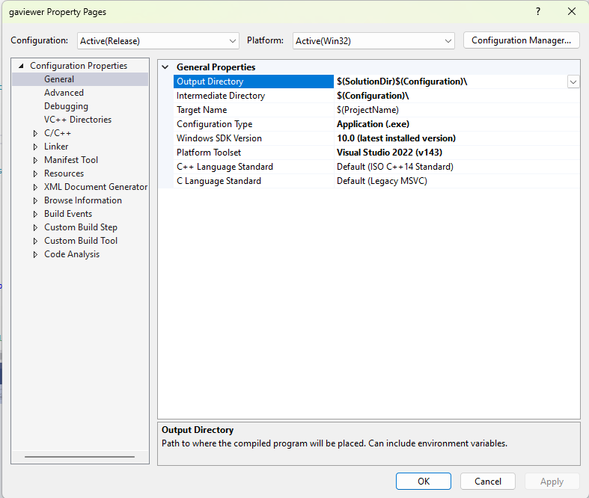
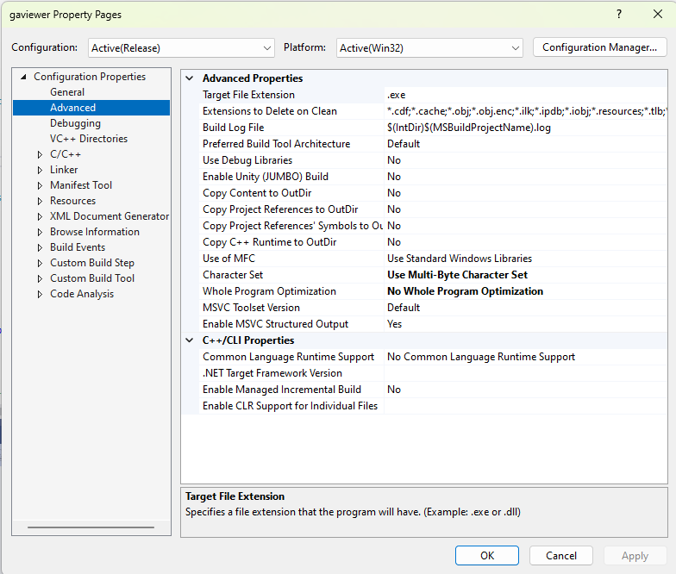
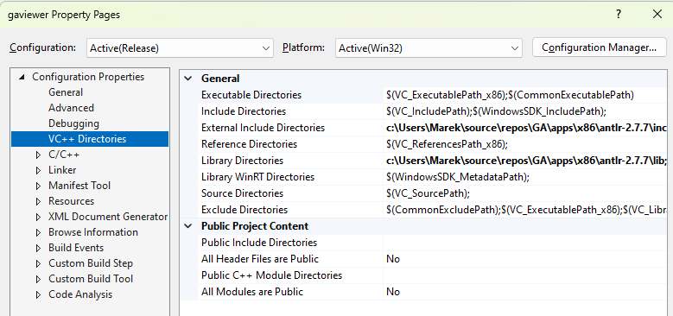
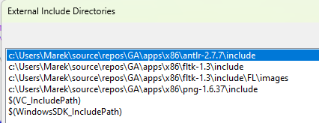
c:\Users\Marek\source\repos\GA\apps\x86\antlr-2.7.7\include
c:\Users\Marek\source\repos\GA\apps\x86\fltk-1.3\include
c:\Users\Marek\source\repos\GA\apps\x86\fltk-1.3\include\FL\images
c:\Users\Marek\source\repos\GA\apps\x86\png-1.6.37\include

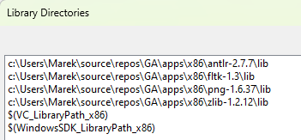
c:\Users\Marek\source\repos\GA\apps\x86\antlr-2.7.7\lib
c:\Users\Marek\source\repos\GA\apps\x86\fltk-1.3\lib
c:\Users\Marek\source\repos\GA\apps\x86\png-1.6.37\lib
c:\Users\Marek\source\repos\GA\apps\x86\zlib-1.2.12\lib
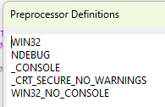

C++ command line:
/ifcOutput "Release\" /GS /GL /analyze- /W3 /Zc:wchar_t /Zi /Gm- /O2 /Fd"Release\vc143.pdb" /Zc:inline /fp:precise /D "WIN32" /D "NDEBUG" /D "_CONSOLE" /D "_CRT_SECURE_NO_WARNINGS" /D "WIN32_NO_CONSOLE" /D "_MBCS" /errorReport:prompt /WX- /Zc:forScope /Gd /Oy- /MD /FC /Fa"Release\" /EHsc /nologo /Fo"Release\" /Ot /Fp"Release\gaviewer.pch" /diagnostics:column

LINKER
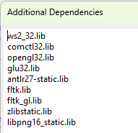

Linker command line:
/OUT:"C:\Users\marek\source\repos\GA\work\GAViewer-0.86\vs2008\Release\gaviewer.exe" /MANIFEST /LTCG /PDB:"C:\Users\marek\source\repos\GA\work\GAViewer-0.86\vs2008\Release\gaviewer.pdb" /DYNAMICBASE:NO "ws2_32.lib" "comctl32.lib" "opengl32.lib" "glu32.lib" "antlr27-static.lib" "fltk.lib" "fltk_gl.lib" "zlibstatic.lib" "libpng16_static.lib" "kernel32.lib" "user32.lib" "gdi32.lib" "winspool.lib" "comdlg32.lib" "advapi32.lib" "shell32.lib" "ole32.lib" "oleaut32.lib" "uuid.lib" "odbc32.lib" "odbccp32.lib" /DEBUG /MACHINE:X86 /OPT:REF /SAFESEH /INCREMENTAL:NO /PGD:"C:\Users\marek\source\repos\GA\work\GAViewer-0.86\vs2008\Release\gaviewer.pgd" /SUBSYSTEM:WINDOWS /MANIFESTUAC:"level='asInvoker' uiAccess='false'" /ManifestFile:"Release\gaviewer.exe.intermediate.manifest" /LTCGOUT:"Release\gaviewer.iobj" /OPT:ICF /ERRORREPORT:PROMPT /ILK:"Release\gaviewer.ilk" /NOLOGO /TLBID:1

