Indian Election Results 2024 SQL Project

Query : Find out the total number of seats.

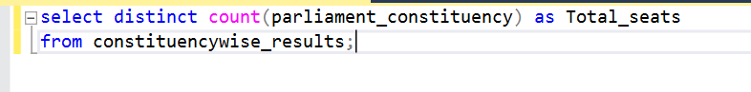

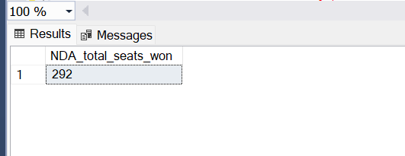

Query: What are the total number of seats available for elections in each state?

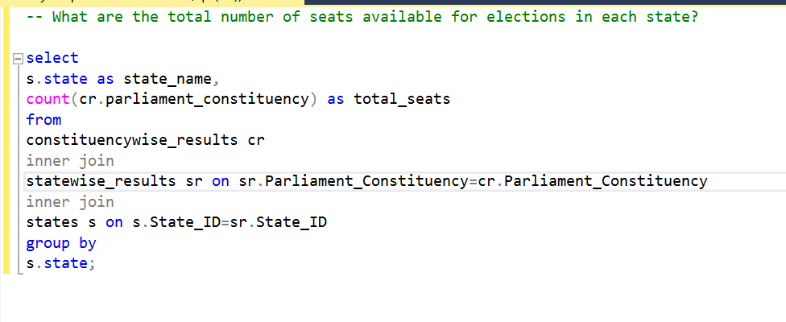

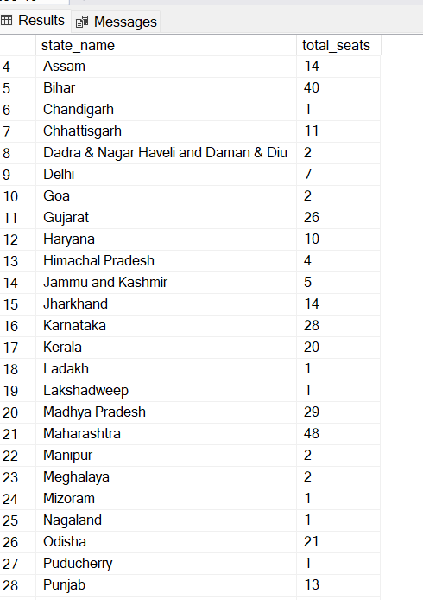

Query : What are the total number of seats won by NDA Alliance?

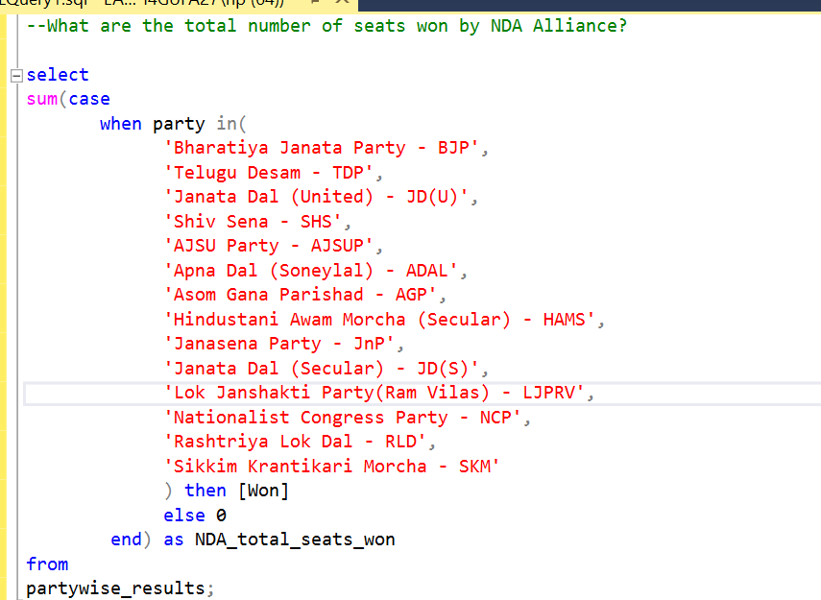



Query: Seats won by NDA Alliance Parties.

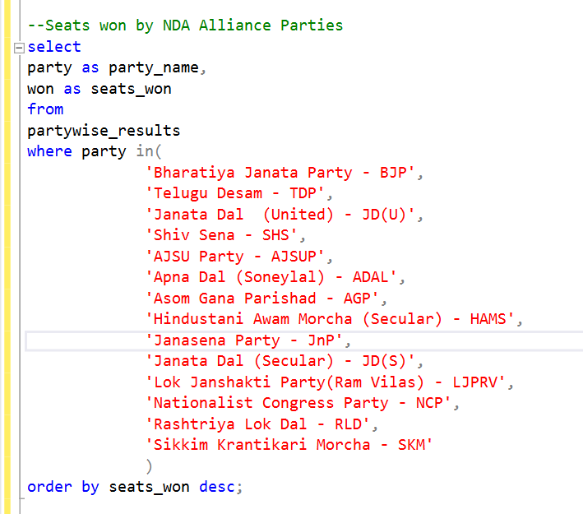

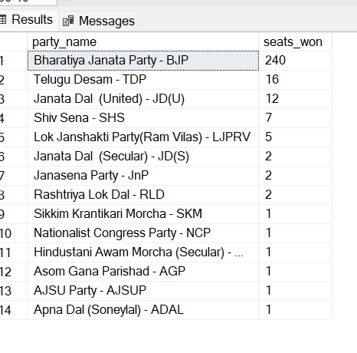

Query: Total seats won by INDIA Alliance.

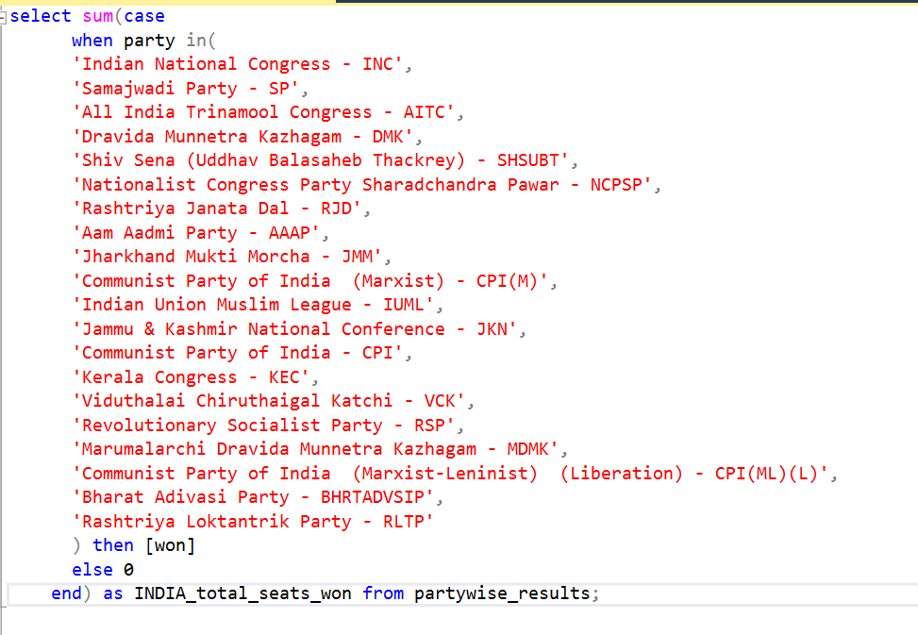

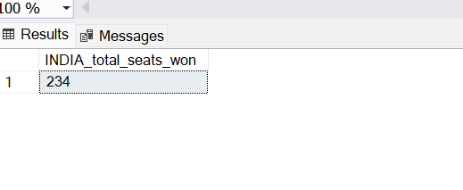

Query: Seats won by INDIA Alliance Parties.

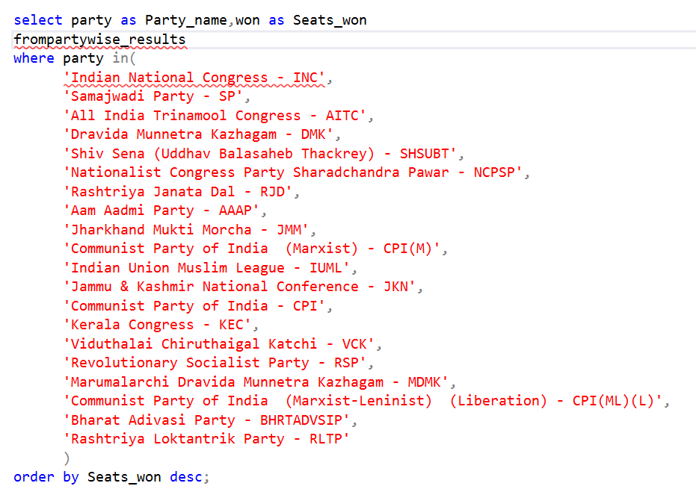

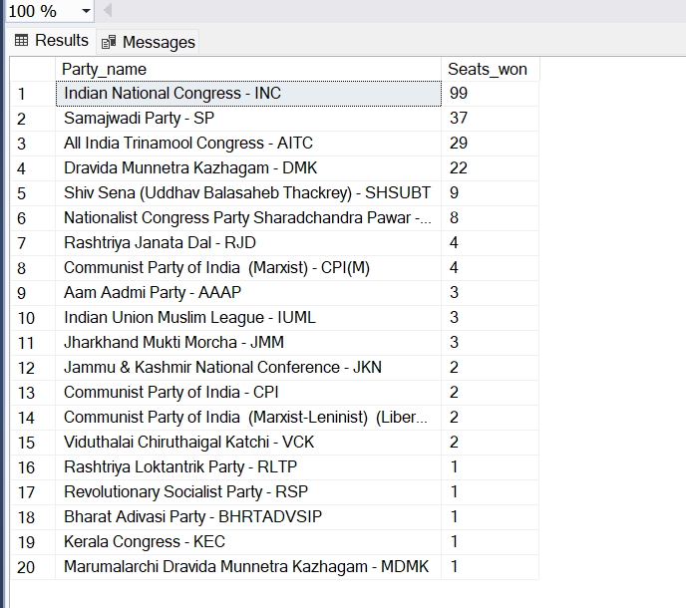

Query: Add new column field in table partywise_results to get the Party Alliance as NDA, INDIA and others.

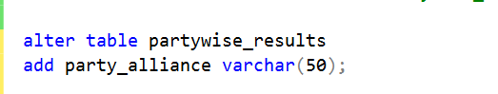

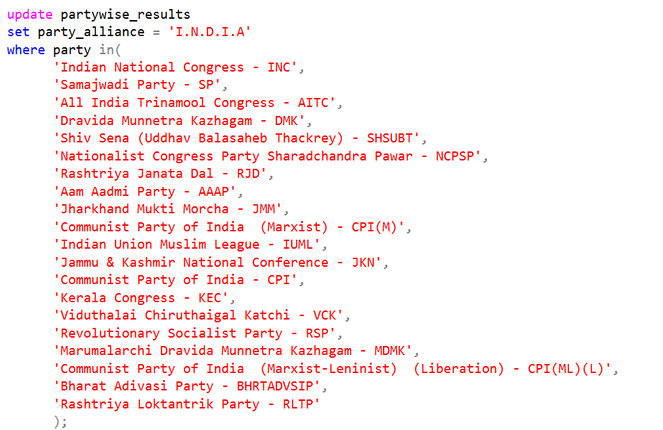

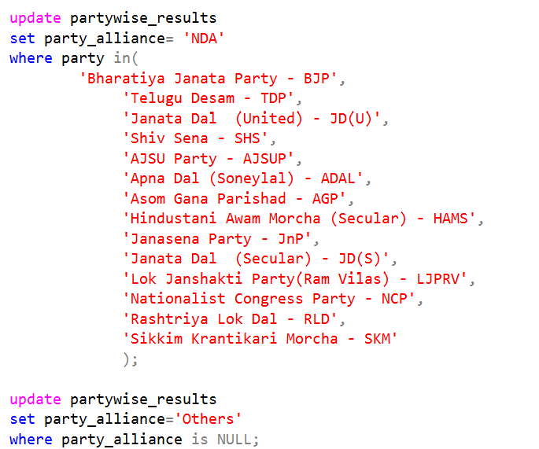



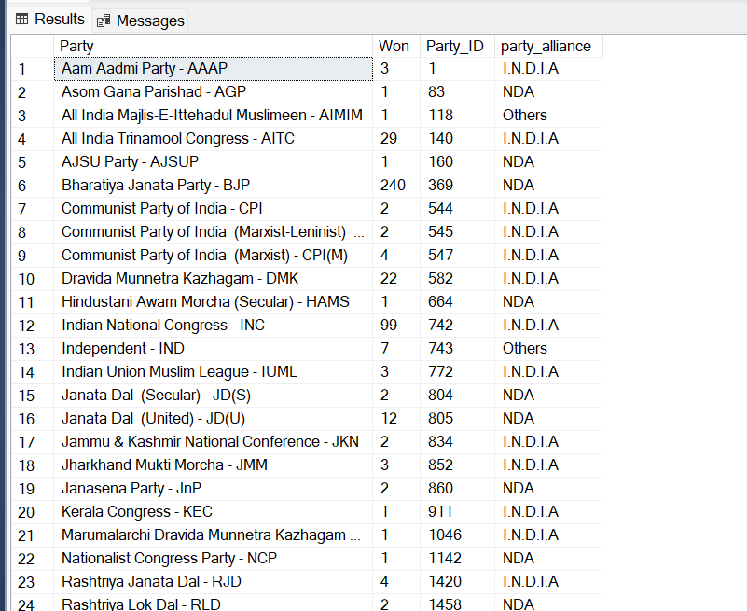

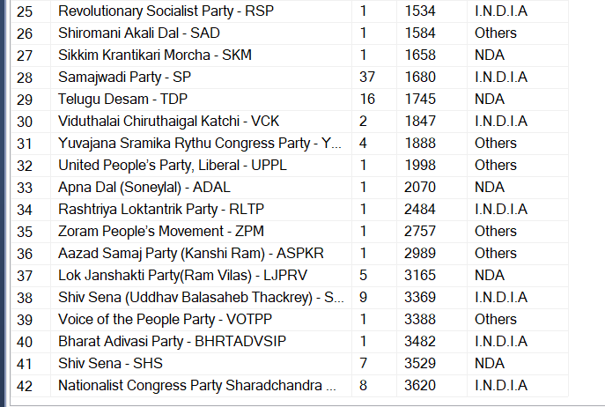

Query: Which party alliance(NDA, INDIA or other) won the most seats across all states?

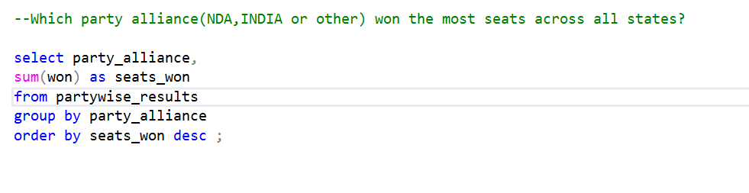

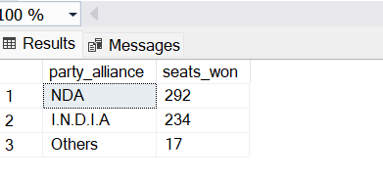

Query: Show winning candidates name, their party name, total votes and the margin of victory for a specific state and constituency.

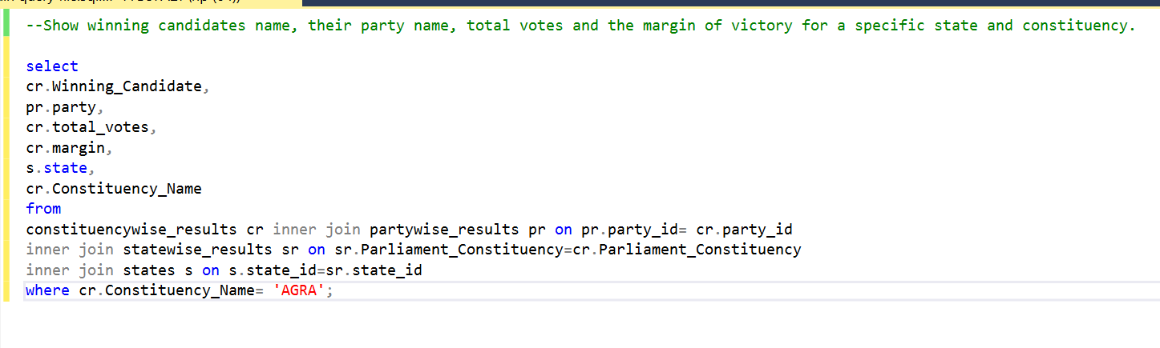

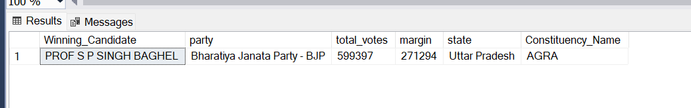

Query: Which parties won the most seats in state and how many seats did each party win?

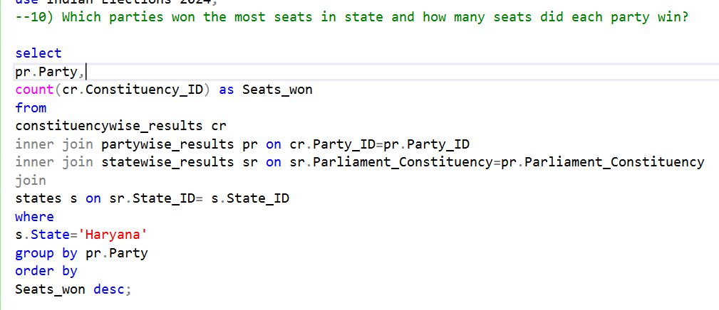

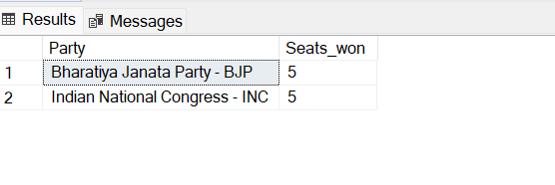

Query: What is the total number of seats won by each party alliance (NDA, INDIA and Others) in each state for the India Elections 2024?

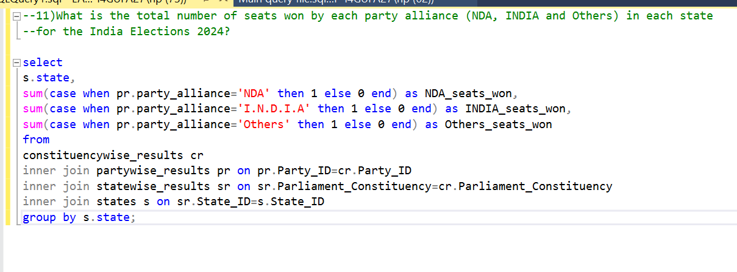

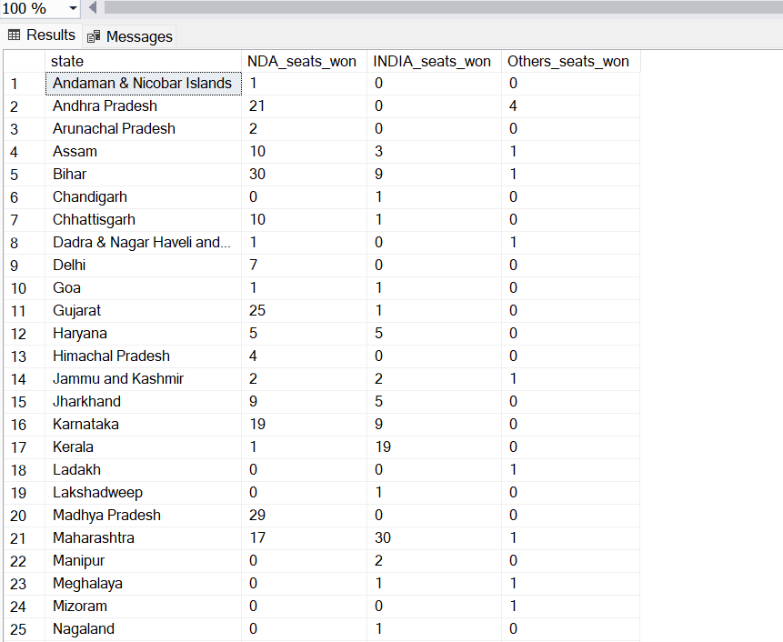

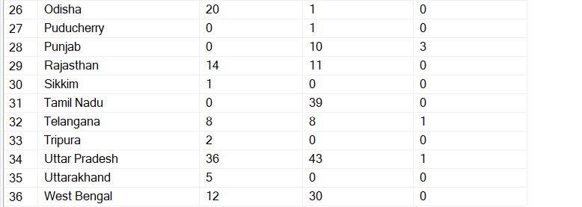

Query: Which candidate received the highest number of EVM votes in each constituency (Top 10)?

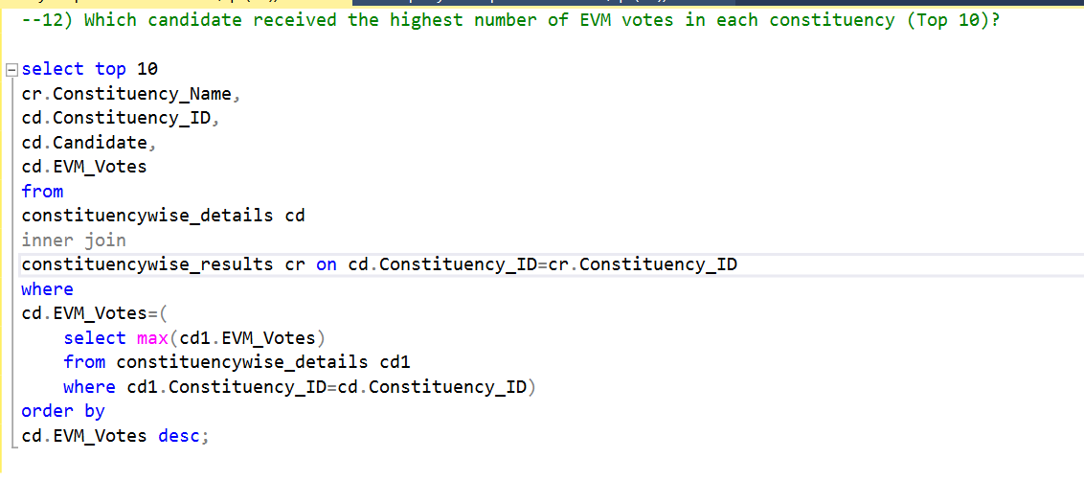

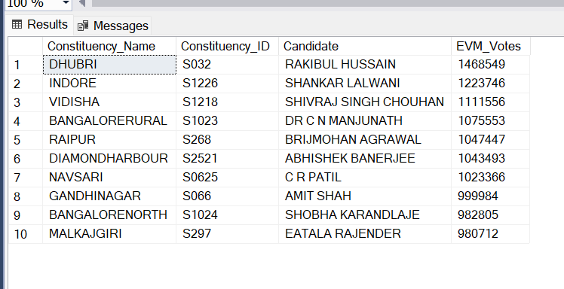

Query: Which candidate won and which candidate was the runner up in each constituency of state for the 2024 elections?

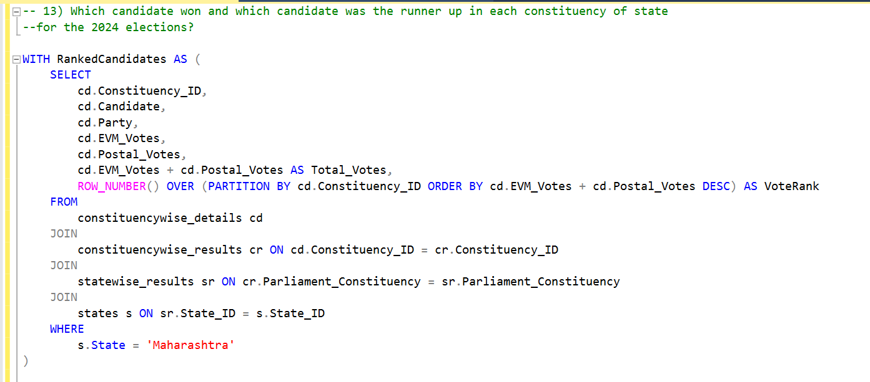

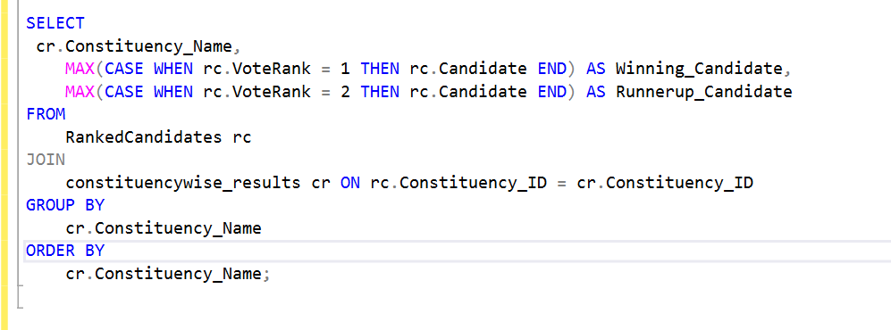

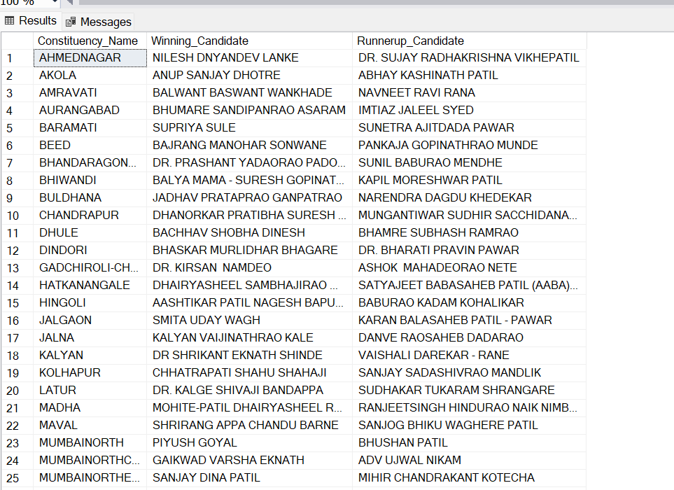

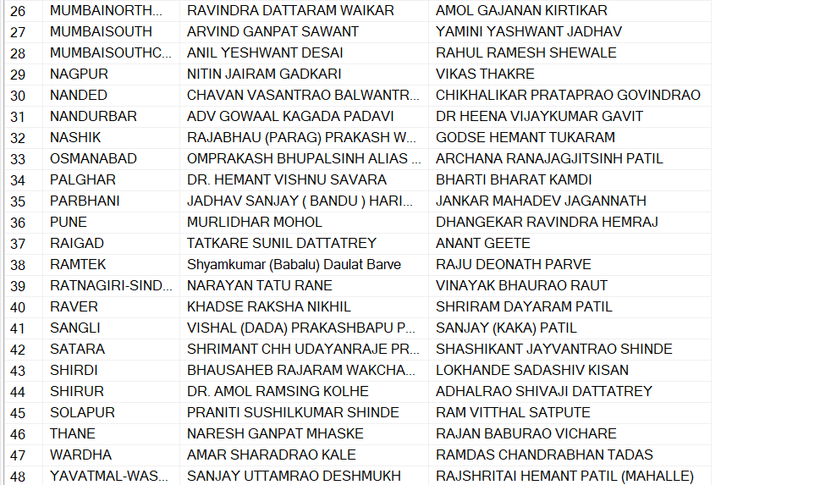

Query: Winning candidate's name, their party name, total votes, and the margin of victory for a specific state and constituency?

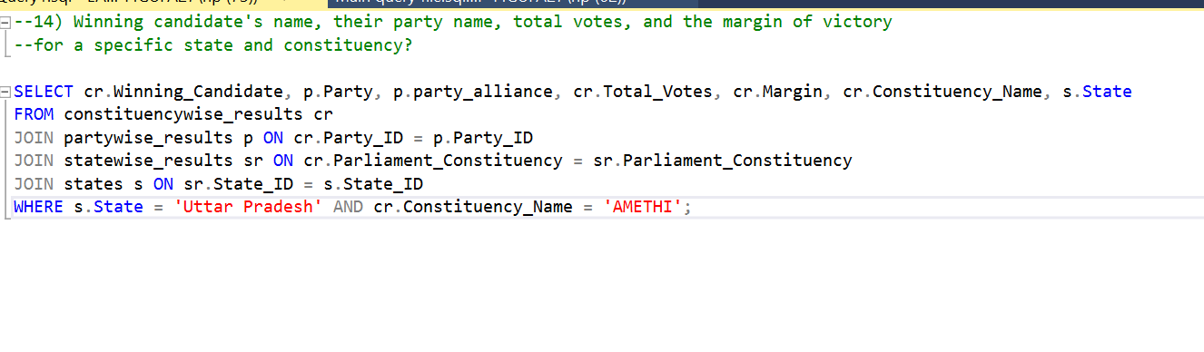

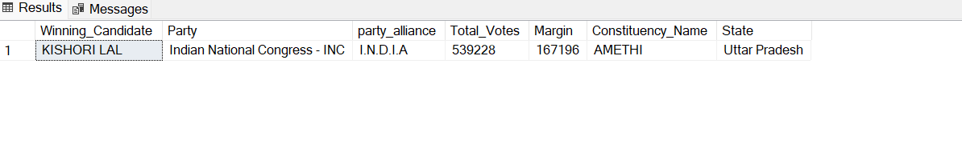

Query: For the state of Maharashtra, what are the total number of seats, total number of candidates, total number of parties, total votes(including EVM and Postal),and the breakdown of EVM and Postal votes?

