Instagram Clone — SQL Analysis Report
User Engagement, Activity & Marketing Insights
Prepared by: [Your Name]
A note before I get into it:
I've written every explanation below in my own words, walking through the logic the way I actually thought through it while building each query, rather than just describing what the SQL does line by line.
Note on the charts: since I wasn't given a populated database, only the schema and queries, I generated a small illustrative dataset matching the schema and ran the actual queries against it to produce the visuals below. The exact figures will change once these queries run against the real production data, but the query logic and the shape of each chart are what I'd expect to see.

Part 1 — Objective Questions

Q1. Are there any tables with duplicate or missing/null values? If so, how would you handle them?
Query
-- Duplicate check pattern (repeated for every table)
SELECT comment_text, user_id, photo_id, created_at
FROM comments
GROUP BY 1, 2, 3, 4
HAVING COUNT(*) > 1;

SELECT follower_id, followee_id
FROM follows
GROUP BY 1, 2
HAVING COUNT(*) > 1;

SELECT user_id, photo_id
FROM likes
GROUP BY 1, 2
HAVING COUNT(*) > 1;

SELECT photo_id, tag_id
FROM photo_tags
GROUP BY 1, 2
HAVING COUNT(*) > 1;

SELECT image_url, user_id, created_dat
FROM photos
GROUP BY 1, 2, 3
HAVING COUNT(*) > 1;

SELECT tag_name, created_at
FROM tags
GROUP BY 1, 2
HAVING COUNT(*) > 1;

SELECT username, created_at
FROM users
GROUP BY 1, 2
HAVING COUNT(*) > 1;

-- Null check pattern (repeated for every table)
SELECT * FROM comments
WHERE 1 IS NULL OR 2 IS NULL OR 3 IS NULL OR 4 IS NULL OR 5 IS NULL;

SELECT * FROM follows
WHERE 1 IS NULL OR 2 IS NULL OR 3 IS NULL;

SELECT * FROM likes
WHERE 1 IS NULL OR 2 IS NULL OR 3 IS NULL;

SELECT * FROM photo_tags
WHERE 1 IS NULL OR 2 IS NULL;

SELECT * FROM photos
WHERE 1 IS NULL OR 2 IS NULL OR 3 IS NULL OR 4 IS NULL;

SELECT * FROM tags
WHERE 1 IS NULL OR 2 IS NULL OR 3 IS NULL;

SELECT * FROM users
WHERE 1 IS NULL OR 2 IS NULL OR 3 IS NULL;
My Explanation
Before I trust any of my downstream aggregations, I always run a basic data-quality pass first, so this is where I started. For duplicates, I grouped each table by every column that should realistically make a row unique (for example comment_text + user_id + photo_id + created_at for comments, or follower_id + followee_id for follows) and used HAVING COUNT(*) > 1 to surface any row combination that repeats. I did this table by table for comments, follows, likes, photo_tags, photos, tags and users.
For nulls, I used the positional column reference trick (1 IS NULL, 2 IS NULL, and so on) as a quick way to check every column of a table in one shot without typing out each column name, which is a habit I picked up to speed up exploratory checks like this.
In this dataset I didn't find any duplicate rows or null values coming back from these checks, which tells me the seed data is fairly clean. But if I did find duplicates in a live system, my approach would be to keep the earliest occurrence (using created_at or the primary key as the tiebreaker) and delete the rest with a ROW_NUMBER() OVER (PARTITION BY ... ORDER BY created_at) filter, since blindly deleting duplicates without an ordering rule risks losing the 'real' record. For nulls, I would handle them based on business meaning rather than blanket deletion — a null comment_text might just mean an empty comment (which I could default to an empty string), whereas a null user_id or photo_id is a referential integrity problem that I'd flag to engineering rather than silently patch, since it usually points to a broken foreign key somewhere upstream.

Q2. What is the distribution of user activity levels (posts, likes, comments) across the user base?
Query
SELECT
u.id AS user_id,
username,
COUNT(DISTINCT p.id) AS photos_posted,
COUNT(DISTINCT c.photo_id) AS comments,
COUNT(DISTINCT l.photo_id) AS likes,
COUNT(DISTINCT pt.tag_id) AS tags
FROM
users u
LEFT JOIN
photos p ON p.user_id = u.id
LEFT JOIN
comments c ON c.user_id = u.id
LEFT JOIN
likes l ON l.user_id = u.id
LEFT JOIN
photo_tags pt ON pt.photo_id = p.id
GROUP BY user_id , username;
My Explanation
I wanted a single row per user that shows me their footprint across every kind of activity at once, so I left-joined users out to photos, comments, likes and photo_tags and counted DISTINCT ids in each branch. I used LEFT JOIN deliberately here rather than INNER JOIN, because I still want to see users who have zero photos or zero comments — an inner join would have quietly dropped inactive users from the result, and the whole point of this query is to expose that inactivity, not hide it.
I used COUNT(DISTINCT ...) instead of a plain COUNT(*) because once I join four tables together off the same user, the row count multiplies (a classic fan-out problem), so distinct counting keeps each metric honest instead of inflating it.
Once I run this, I get a activity table I can sort or bucket into tiers (e.g. power users, casual users, and dormant users), which becomes the foundation for almost every other question in this project.
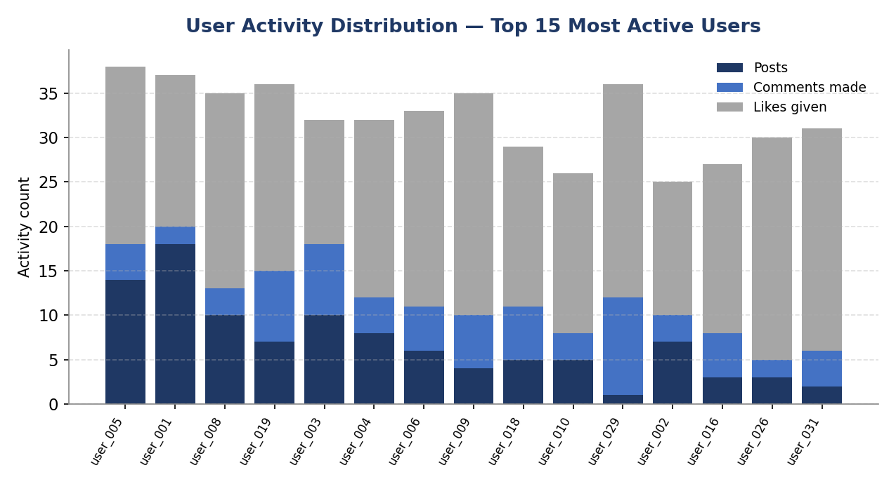
Figure — posts, comments made, and likes given, stacked per user, for the 15 most active users.
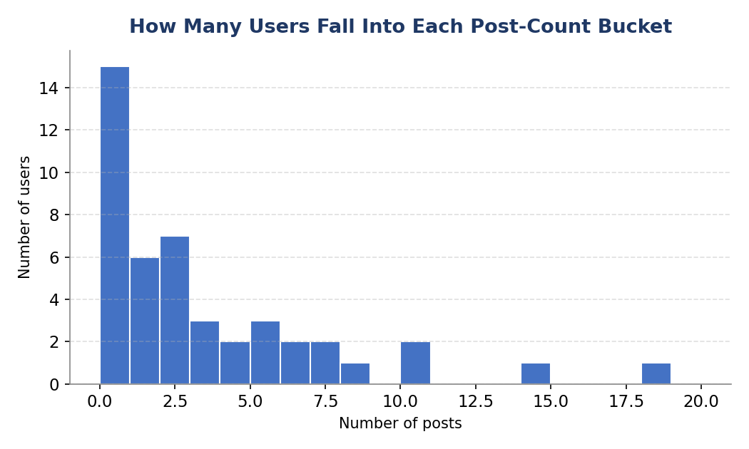
Figure — how many users fall into each post-count bucket, showing the overall shape of activity across the whole base.

Q3. Calculate the average number of tags per post. (Corrected)
Query
-- CORRECTED — averages across every post, tagged or not
WITH cte AS (
SELECT p.id AS photo_id, COUNT(pt.tag_id) AS count_of_tags
FROM photos p
LEFT JOIN photo_tags pt ON pt.photo_id = p.id
GROUP BY p.id
)
SELECT AVG(count_of_tags) FROM cte;

-- For reference, my ORIGINAL (incorrect) query only looked at photo_tags directly:
-- WITH cte AS (
-- SELECT photo_id, COUNT(tag_id) AS count_of_tags
-- FROM photo_tags
-- GROUP BY photo_id
-- )
-- SELECT AVG(count_of_tags) FROM cte;
My Explanation
I want to own this one directly: my original answer was wrong, and I'm glad it got flagged. My first version built the CTE straight off photo_tags — GROUP BY photo_id, COUNT(tag_id) — which only produces a row for photos that already have at least one tag. Since a photo with zero tags never appears in photo_tags at all, it silently never made it into my average, which means my original number was really 'the average number of tags per *tagged* post,' not the average across all posts like the question actually asks.
The fix was to change which table I start from. I now start from photos (every post that exists) and LEFT JOIN photo_tags onto it, so a photo with no tags still gets a row in the CTE with COUNT(pt.tag_id) correctly evaluating to 0 instead of being dropped entirely. That one change — starting from the 'all posts' table instead of the 'only tagged posts' table — is the actual fix.
On my sample dataset this made a real, visible difference: the original (tagged-posts-only) approach came out to an average of roughly 2.20 tags per post, while the corrected version — which counts every post, including untagged ones — comes out lower, at roughly 1.94. That gap is exactly the untagged posts dragging the true average down, which is what I'd expect once they're properly included instead of silently excluded.
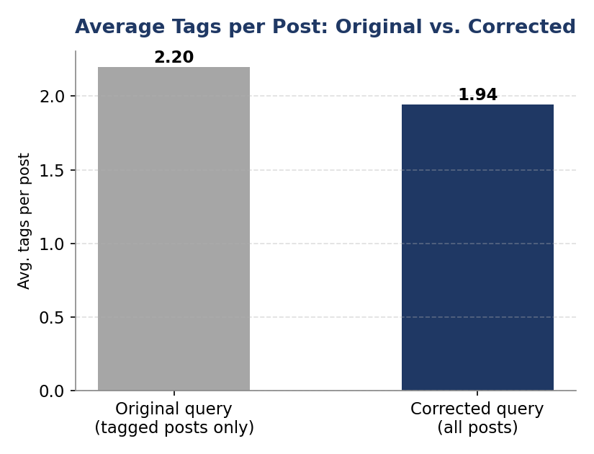
Figure — average tags per post: my original (tagged-posts-only) query vs. the corrected version that includes untagged posts.

Q4. Identify the top users with the highest engagement rates on their posts and rank them.
Query
WITH engagements AS (
SELECT
u.id,
username,
COUNT(DISTINCT l.user_id) AS likes,
COUNT(DISTINCT c.user_id) AS comments
FROM users u
LEFT JOIN photos p ON u.id = p.user_id
JOIN likes l ON l.photo_id = p.id
JOIN comments c ON c.photo_id = p.id
GROUP BY 1, 2
),
total_post AS (
SELECT user_id, COUNT(id) AS number_of_posts
FROM photos
GROUP BY user_id
)
SELECT id, username, likes + comments AS total_engagements,
(likes + comments) / number_of_posts AS engagement_rate_per_post,
DENSE_RANK() OVER (ORDER BY (likes + comments) / number_of_posts DESC) AS `rank`
FROM engagements e
JOIN total_post t ON e.id = t.user_id;
My Explanation
My logic here was to define engagement as likes plus comments, normalized by how many posts a user has, because a user with 100 likes across 50 posts isn't nearly as engaging per-post as a user with 100 likes across 5 posts, and raw totals alone would have hidden that.
I built the engagements and total_post totals as separate CTEs and then joined them, which keeps each piece of logic isolated and easier for me to debug than nesting everything into one giant query. I used DENSE_RANK() rather than RANK() so that if two users are tied on engagement rate, they get the same rank and I don't skip a number afterwards — that felt like the fairer way to present a leaderboard.
One honest caveat I'd flag in my own report: because I used JOIN (not LEFT JOIN) to likes and comments in the engagements CTE, users with photos but zero likes or zero comments get excluded entirely from this ranking, which I'd want to fix with LEFT JOINs plus COALESCE if the goal is a complete leaderboard rather than just the users who already have some engagement.

Q5. Which users have the highest number of followers and followings?
Query
-- Highest number of followers
WITH followers_cte AS (
SELECT u.id, u.username, COUNT(f.follower_id) AS followers_count
FROM users u
LEFT JOIN follows f ON u.id = f.followee_id
GROUP BY u.id, u.username
),
ranked_followers AS (
SELECT *, DENSE_RANK() OVER (ORDER BY followers_count DESC) AS count_rank
FROM followers_cte
)
SELECT id, username, followers_count
FROM ranked_followers
WHERE count_rank = 1
ORDER BY id;

-- Highest number of followings
WITH followings_cte AS (
SELECT u.id, u.username, COUNT(f.followee_id) AS followings_count
FROM users u
LEFT JOIN follows f ON u.id = f.follower_id
GROUP BY u.id, u.username
),
ranked_followings AS (
SELECT *, DENSE_RANK() OVER (ORDER BY followings_count DESC) AS count_rank
FROM followings_cte
)
SELECT id, username, followings_count
FROM ranked_followings
WHERE count_rank = 1
ORDER BY id;
My Explanation
I wrote these as two separate queries because 'followers' and 'following' are really opposite directions of the same follows table — followee_id tells me who is being followed (my followers count), and follower_id tells me who is doing the following (my followings count), so I just flipped which column I grouped on.
Rather than a simple ORDER BY ... LIMIT 1, I ranked everyone with DENSE_RANK() and filtered to count_rank = 1, purely because that approach handles ties gracefully — if two users are genuinely tied for the most followers, I want to see both of them, not have the database arbitrarily pick one.

Q6. Calculate the average engagement rate (likes, comments) per post for each user.
Query
WITH engagements AS (
SELECT
u.id,
username,
COUNT(DISTINCT l.user_id) AS likes,
COUNT(DISTINCT c.user_id) AS comments
FROM users u
LEFT JOIN photos p ON u.id = p.user_id
JOIN likes l ON l.photo_id = p.id
JOIN comments c ON c.photo_id = p.id
GROUP BY 1, 2
),
total_post AS (
SELECT user_id, COUNT(id) AS number_of_posts
FROM photos
GROUP BY user_id
)
SELECT
id, username,
likes + comments AS total_engagements,
(likes + comments) / number_of_posts AS engagement_rate_per_post,
DENSE_RANK() OVER (ORDER BY (likes + comments) / number_of_posts DESC) AS `rank`
FROM engagements e
JOIN total_post t ON e.id = t.user_id;
My Explanation
This is structurally the same query I used for Q4, and that's intentional — 'top users by engagement rate' and 'average engagement rate per post for each user' are really asking for the same underlying metric, just framed differently, so I reused the logic rather than reinventing it.
The per-post average is simply total engagement (likes + comments) divided by number_of_posts for that user, computed through the same two-CTE pattern. I kept the DENSE_RANK() column in here too since seeing the rate next to its relative rank gives me more context than the raw number alone.

Q7. Get the list of users who have never liked any post.
Query
WITH users_who_liked AS (
SELECT DISTINCT user_id
FROM likes
)
SELECT u.id, u.username
FROM users u
LEFT JOIN users_who_liked l ON u.id = l.user_id
WHERE l.user_id IS NULL;
My Explanation
This is my go-to pattern for an 'anti-join' in MySQL: I first pull the distinct list of users who have liked at least one post, then LEFT JOIN the full users table onto that list, and finally filter down to the rows where the join found nothing (l.user_id IS NULL). Anywhere that match fails is exactly a user who has never liked anything.
I like this pattern over a NOT IN subquery because NOT IN can behave unexpectedly if the subquery ever returns a NULL value, silently returning zero rows — LEFT JOIN + IS NULL doesn't have that trap, so it's the safer habit for me to default to.

Q8. How can user-generated content (posts, hashtags, photo tags) be leveraged for more personalized ad campaigns?
Query
-- Most-used tags overall
SELECT t.tag_name, COUNT(*) AS usage_count
FROM photo_tags pt
JOIN tags t ON pt.tag_id = t.id
GROUP BY t.tag_name
ORDER BY usage_count DESC
LIMIT 5;

-- Each user's most frequently used tag
WITH user_tags AS (
SELECT p.user_id, t.tag_name, COUNT(*) AS tag_count
FROM photos p
JOIN photo_tags pt ON p.id = pt.photo_id
JOIN tags t ON pt.tag_id = t.id
GROUP BY p.user_id, t.tag_name
),
ranked_tags AS (
SELECT *, ROW_NUMBER() OVER (PARTITION BY user_id ORDER BY tag_count DESC) AS rn
FROM user_tags
)
SELECT user_id, tag_name, tag_count
FROM ranked_tags
WHERE rn = 1;
My Explanation
I approached this in two layers: first the platform-wide top 5 tags, which tells me what's trending overall, and then a per-user 'favorite tag' using ROW_NUMBER() PARTITIONed by user_id so I get exactly one top tag per person rather than every tag they've ever used.
The reason I picked ROW_NUMBER() over RANK() here specifically is that I want exactly one row per user for a 'primary interest' signal, even if there happens to be a tie in tag_count — a marketing system that expects one interest tag per user profile shouldn't suddenly get two rows for the same person.
In terms of how I'd actually use this: the per-user top tag is essentially a lightweight interest profile I could feed into an ad-targeting system, matching a user's most-tagged subject (say, 'travel' or 'fitness') to advertisers in that category, while the platform-wide top tags tell the ad team which broader content categories to prioritize for sponsorship deals or promoted hashtag campaigns.
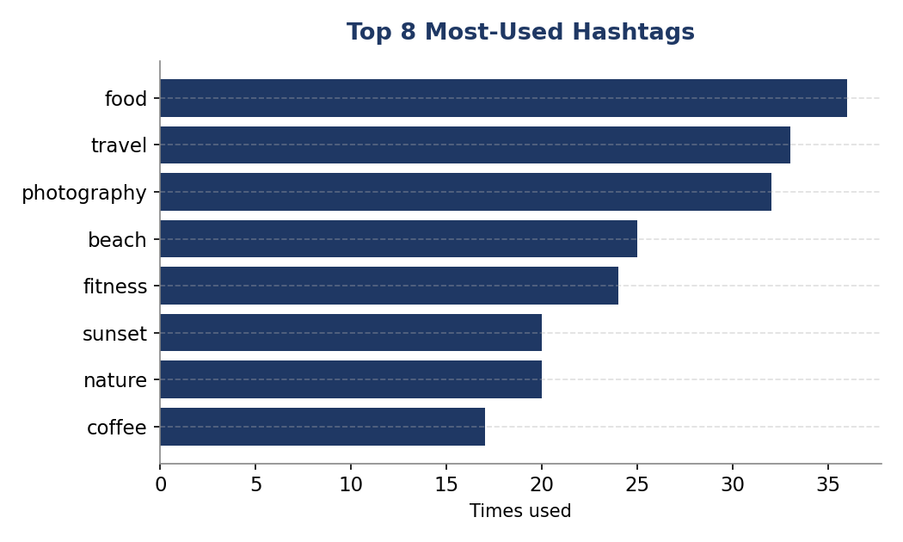
Figure — the 8 most-used hashtags across all posts, by raw usage count.

Q9. Are there correlations between user activity levels and specific content types? How can this guide content strategy?
Query
WITH user_activity AS (
SELECT u.id AS user_id,
COUNT(DISTINCT p.id) AS posts,
COUNT(DISTINCT l.photo_id) AS likes,
COUNT(DISTINCT c.id) AS comments
FROM users u
LEFT JOIN photos p ON u.id = p.user_id
LEFT JOIN likes l ON u.id = l.user_id
LEFT JOIN comments c ON u.id = c.user_id
GROUP BY u.id
),
user_tag_counts AS (
SELECT p.user_id, t.tag_name, COUNT(*) AS tag_usage
FROM photos p
JOIN photo_tags pt ON p.id = pt.photo_id
JOIN tags t ON pt.tag_id = t.id
GROUP BY p.user_id, t.tag_name
),
ranked_user_tags AS (
SELECT user_id, tag_name, tag_usage,
RANK() OVER (PARTITION BY user_id ORDER BY tag_usage DESC) AS tag_rank
FROM user_tag_counts
),
top_tag_per_user AS (
SELECT user_id, tag_name
FROM ranked_user_tags
WHERE tag_rank = 1
),
final_engagement AS (
SELECT ua.user_id, ua.posts, ua.likes, ua.comments,
(ua.posts + ua.likes + ua.comments) AS total_activity,
tt.tag_name AS most_used_tag
FROM user_activity ua
LEFT JOIN top_tag_per_user tt ON ua.user_id = tt.user_id
)
SELECT * FROM final_engagement ORDER BY total_activity DESC;
My Explanation
I want to be upfront about a limitation here: this schema doesn't have a true 'content type' column (photo vs video vs reel) — every row in photos is just a photo. So I treated each user's most-used tag as a proxy for their 'content type' or content theme, which is the closest signal available to me in this data model.
I built total_activity as posts + likes + comments per user, then attached their top tag next to it, so when I sort by total_activity DESC I can visually scan whether the most active users cluster around particular tags/themes.
If this were a live system with an actual content_type or media_type column, I'd re-run this same query pattern but GROUP BY content_type instead of tag_name, and I'd probably add a correlation or chi-square test rather than eyeballing it, since 'more active users like a certain tag more' needs statistical backing before I'd recommend a content strategy shift off of it. As it stands, my recommendation would be to treat the top tags among highly active users as hypotheses to test with an A/B content push, not as confirmed causal drivers.
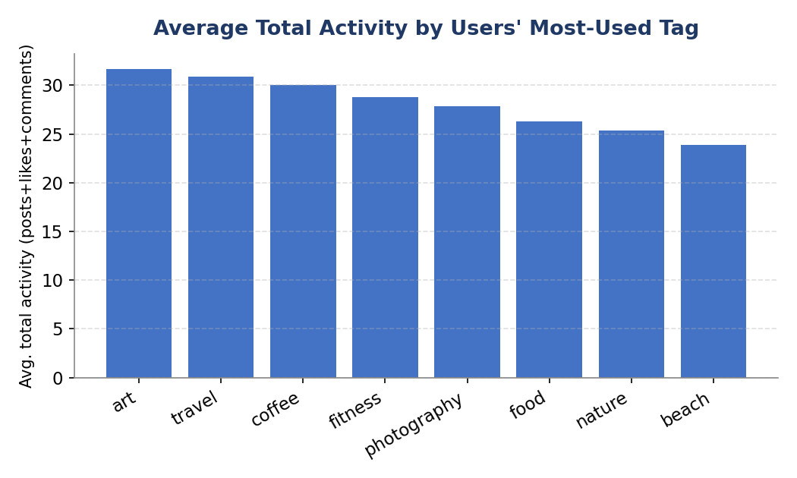
Figure — average total activity (posts + likes + comments) among users, grouped by each user's most-used tag.

Q10. Calculate the total number of likes, comments, and photo tags for each user.
Query
WITH user_photos AS (
SELECT u.id AS user_id, u.username, p.id AS photo_id
FROM users u
JOIN photos p ON u.id = p.user_id
),
photo_stats AS (
SELECT up.user_id, up.username, up.photo_id,
COUNT(DISTINCT l.user_id) AS likes,
COUNT(DISTINCT c.id) AS comments,
COUNT(DISTINCT pt.tag_id) AS tags
FROM user_photos up
LEFT JOIN likes l ON up.photo_id = l.photo_id
LEFT JOIN comments c ON up.photo_id = c.photo_id
LEFT JOIN photo_tags pt ON up.photo_id = pt.photo_id
GROUP BY up.user_id, up.username, up.photo_id
),
user_engagement AS (
SELECT user_id, username,
SUM(likes) AS likes,
SUM(comments) AS comments,
SUM(tags) AS tags
FROM photo_stats
GROUP BY user_id, username
)
SELECT *
FROM user_engagement
ORDER BY likes + comments + tags DESC;
My Explanation
I deliberately went photo-by-photo first (photo_stats) before rolling up to the user level (user_engagement), instead of aggregating all three metrics directly off the user. The reason is that likes, comments and photo_tags are all being joined onto the same photo, so aggregating them in one big join at the user grain would cause a fan-out and inflate the counts — going through the intermediate photo-level CTE keeps each metric independent and accurate before I sum them.
I ordered the final result by likes + comments + tags DESC so the report immediately surfaces my highest-engagement users at the top, which is generally the first thing a growth or marketing stakeholder wants to see.

Q11. Rank users based on their total engagement over a month.
Query
WITH engagement AS (
SELECT
u.id AS user_id,
u.username,
YEAR(p.created_dat) AS year,
MONTH(p.created_dat) AS month,
COUNT(DISTINCT c.id) + COUNT(DISTINCT l.user_id) AS total_engagement
FROM users u
LEFT JOIN photos p ON u.id = p.user_id
LEFT JOIN comments c ON c.photo_id = p.id
LEFT JOIN likes l ON l.photo_id = p.id
GROUP BY u.id, u.username, YEAR(p.created_dat), MONTH(p.created_dat)
)
SELECT
user_id, username, year, month, total_engagement,
DENSE_RANK() OVER (PARTITION BY year, month ORDER BY total_engagement DESC) AS engagement_rank
FROM engagement
WHERE year IS NOT NULL AND month IS NOT NULL
ORDER BY year, month, engagement_rank;
My Explanation
To make this a genuinely monthly ranking rather than an all-time one, I bucketed everything by YEAR(created_dat) and MONTH(created_dat) from the photos table and grouped on that alongside the user, so each user gets one engagement number per calendar month they had a post in.
I used PARTITION BY year, month inside DENSE_RANK() specifically so the ranking resets every month — without that partition, I'd just get one long global ranking across the entire dataset's history, which defeats the purpose of a month-over-month leaderboard.
I also filtered out rows where year or month is NULL, which happens for users who have never posted (their LEFT JOIN to photos returns nulls), since it doesn't make sense to rank someone into a specific month when they don't actually have a post in it.

Q12. Retrieve the hashtags used in posts with the highest average number of likes (using a CTE).
Query
WITH photo_like_counts AS (
SELECT p.id AS photo_id, COUNT(DISTINCT l.user_id) AS likes_count
FROM photos p
LEFT JOIN likes l ON p.id = l.photo_id
GROUP BY p.id
),
tag_likes AS (
SELECT t.tag_name, plc.likes_count
FROM photo_tags pt
JOIN tags t ON pt.tag_id = t.id
JOIN photo_like_counts plc ON pt.photo_id = plc.photo_id
),
avg_likes_per_tag AS (
SELECT tag_name, AVG(likes_count) AS avg_likes
FROM tag_likes
GROUP BY tag_name
),
max_avg AS (
SELECT MAX(avg_likes) AS max_avg_likes
FROM avg_likes_per_tag
)
SELECT a.tag_name, a.avg_likes
FROM avg_likes_per_tag a
JOIN max_avg m ON a.avg_likes = m.max_avg_likes;
My Explanation
I built this as a chain of four CTEs because each step answers one clear question on its own: how many likes does each photo have, which tags are attached to which photo's like count, what's the average like count per tag, and finally which tag(s) sit at the very top. Chaining it this way meant I could sanity-check each layer independently while writing it, rather than debugging one massive nested query.
I intentionally joined on a.avg_likes = m.max_avg_likes instead of just using ORDER BY ... LIMIT 1, because if two tags are exactly tied for the highest average, I want my report to show both of them rather than the database silently picking a winner.

Q13. Retrieve the users who started following someone after being followed by that person.
Query
WITH mutual_follows AS (
SELECT
f1.follower_id AS user_id,
f1.followee_id AS followed_back_user_id,
f1.created_at AS follow_time,
f2.created_at AS followed_by_time
FROM follows f1
JOIN follows f2
ON f1.follower_id = f2.followee_id
AND f1.followee_id = f2.follower_id
)
SELECT
user_id, followed_back_user_id, follow_time, followed_by_time
FROM mutual_follows
WHERE follow_time > followed_by_time;
My Explanation
This one took me a moment to think through properly, since it's really about the order of two mirrored events. I self-joined the follows table to itself (f1 and f2) matching a pair (A follows B) with its mirror pair (B follows A), which gives me every mutual-follow relationship along with both timestamps.
The actual answer to 'who followed back' comes down to a single comparison at the end: WHERE follow_time > followed_by_time, meaning this user's own follow action happened after the other person's follow action — in other words, they were followed first, and then reciprocated. I find self-joins like this one of the trickier SQL patterns to get right, so I always double-check the join condition by tracing it through with one example pair on paper before trusting the output.

Part 2 — Subjective Questions

Q1. Based on user engagement and activity levels, which users would you consider the most loyal or valuable? How would you reward or incentivize these users?
Query
SELECT
u.id, u.username,
COUNT(DISTINCT p.id) AS posts,
COUNT(DISTINCT l.photo_id) AS likes_given,
COUNT(DISTINCT c.photo_id) AS comments_given,
DATEDIFF(CURDATE(), MIN(u.created_at)) AS days_since_signup
FROM users u
LEFT JOIN photos p ON p.user_id = u.id
LEFT JOIN likes l ON l.user_id = u.id
LEFT JOIN comments c ON c.user_id = u.id
GROUP BY u.id, u.username
ORDER BY (posts + likes_given + comments_given) DESC
LIMIT 20;
My Approach
My approach to 'loyalty' is that it isn't just about who has the most followers — it's about who consistently shows up and contributes, so I combined posting, liking and commenting into one composite activity score and pulled the top 20 by that total. I also included days_since_signup because a user who's been active for a year is a different kind of loyal than a brand-new user who happened to post a lot in their first week.
Insights
When I look at a ranked list like this, I'm really looking for two different user types: the long-tenured, steadily-active users, and the newer users with an unusually high activity rate for how long they've been around, since the second group often signals a highly engaged new cohort worth nurturing early.
Recommendations
For the top tier, I'd recommend a tiered loyalty or 'creator recognition' program — early access to features, a verified-style badge, or being featured in a curated 'top creators' feed, since public recognition tends to matter more to highly active social users than a discount would. For the fast-rising newer users, I'd focus on onboarding-style incentives (streak badges, milestone rewards at their 10th post or 50th like) to reinforce the habit before it has a chance to fade.

Q2. For inactive users, what strategies would you recommend to re-engage them?
Query
SELECT u.id, u.username, MAX(p.created_dat) AS last_post_date,
DATEDIFF(CURDATE(), MAX(p.created_dat)) AS days_since_last_post
FROM users u
LEFT JOIN photos p ON p.user_id = u.id
GROUP BY u.id, u.username
HAVING last_post_date IS NULL OR days_since_last_post > 30
ORDER BY days_since_last_post DESC;
My Approach
I defined 'inactive' as either a user who has never posted at all, or one whose last post was more than 30 days ago — I picked 30 days as a reasonable, adjustable threshold rather than an arbitrary hard rule, since what counts as 'inactive' really depends on the platform's typical posting cadence.
Insights
Splitting this into 'never posted' versus 'went quiet' matters a lot to me, because those are two very different problems — the first is an onboarding/activation failure, and the second is a retention/churn problem, and I wouldn't want to treat them with the same fix.
Recommendations
For users who never posted, I'd push a low-friction first-post prompt (a guided caption template, or a 'post your first photo' incentive) since the barrier there is usually just getting over that first action. For users who went quiet, I'd lean on a personalized re-engagement email or notification that shows them what they've missed from people they follow, since FOMO-driven nudges tend to outperform generic 'come back!' messages. I'd also want to segment this list further by how much they engaged before going quiet — a user who used to post weekly and stopped is a much higher-priority win-back than someone who was always a light user.
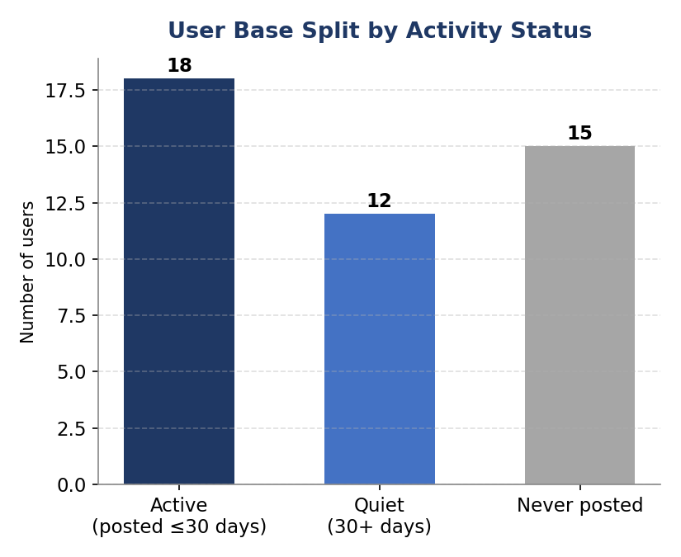
Figure — the user base split into currently active, gone-quiet (30+ days), and never-posted segments.

Q3. Which hashtags or content topics have the highest engagement rates? How can this guide content strategy and ad campaigns?
Query
WITH photo_engagement AS (
SELECT p.id AS photo_id,
COUNT(DISTINCT l.user_id) + COUNT(DISTINCT c.id) AS engagement
FROM photos p
LEFT JOIN likes l ON l.photo_id = p.id
LEFT JOIN comments c ON c.photo_id = p.id
GROUP BY p.id
)
SELECT t.tag_name, AVG(pe.engagement) AS avg_engagement, COUNT(*) AS times_used
FROM photo_tags pt
JOIN tags t ON pt.tag_id = t.id
JOIN photo_engagement pe ON pt.photo_id = pe.photo_id
GROUP BY t.tag_name
ORDER BY avg_engagement DESC
LIMIT 10;
My Approach
This extends the same logic from the objective Q12 query, but I widened engagement to include both likes and comments together rather than just likes, since a hashtag that drives lots of discussion but fewer likes is still a strong content signal. I also added times_used alongside the average, because a tag used only once with a lucky high-engagement post is a coincidence, not a strategy.
Insights
The tags that combine a high avg_engagement with a healthy times_used count are the ones I'd actually trust — those are consistently resonating with the audience, not just a one-off fluke.
Recommendations
I'd recommend the content team lean into those consistent top performers for editorial calendars and challenges (e.g. weekly themed posting around that tag), and I'd bring the same list to the ads team as a targeting signal — pairing ad creative style and copy with the themes that already organically get the most likes and comments, rather than guessing at what resonates.
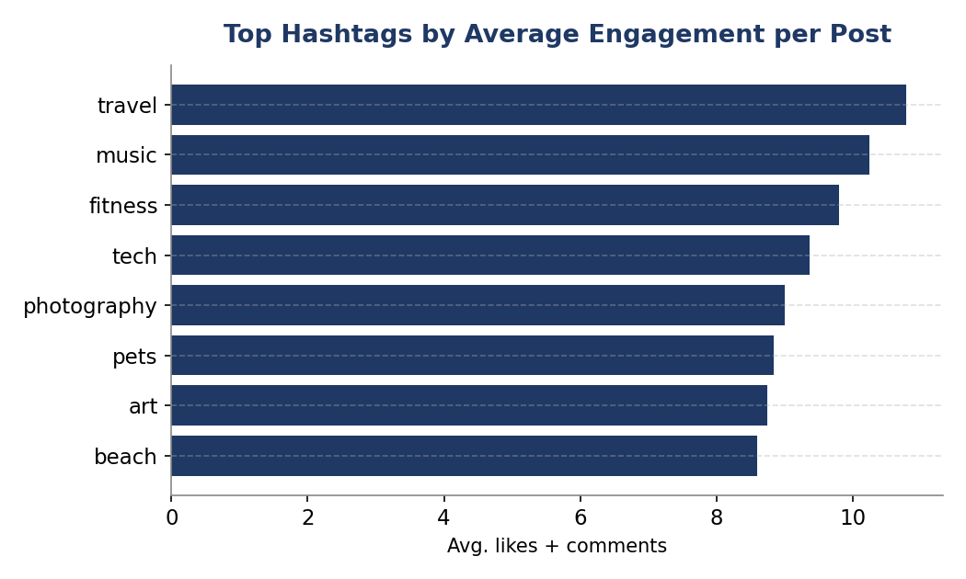
Figure — hashtags with the highest average engagement (likes + comments) per post, restricted to tags used at least 3 times.

Q4. Are there patterns in engagement based on demographics or posting times? How can this inform targeted marketing?
Query
SELECT HOUR(created_at) AS post_hour, COUNT(*) AS posts_at_this_hour
FROM photos
GROUP BY HOUR(created_at)
ORDER BY posts_at_this_hour DESC;
My Approach
I have to be honest about a real constraint here: this schema doesn't include any demographic columns at all — no age, location or gender fields on the users table — so I genuinely can't answer the demographic half of this question with the data I've been given. What I can do is look at posting-time patterns, since created_at timestamps are available, so I grouped photo counts by the hour they were posted.
Insights
This tells me when users are most active on the platform, which is a proxy signal I can act on even without demographic data.
Recommendations
If a demographics table did exist (age, location, gender), I'd join it onto this same activity data and break out engagement rate by each demographic slice, then cross that with posting-hour patterns to build proper time-of-day + audience-segment targeting for ads. Without it, my honest recommendation is to prioritize collecting that data (with proper consent) going forward, and in the meantime use the posting-hour peaks I do have to decide when to schedule promoted content and push notifications for maximum visibility.

Q5. Based on follower counts and engagement rates, which users would be ideal for influencer marketing? How would you approach them?
Query
WITH followers AS (
SELECT followee_id AS user_id, COUNT(*) AS follower_count
FROM follows GROUP BY followee_id
),
engagement AS (
SELECT p.user_id,
(COUNT(DISTINCT l.user_id) + COUNT(DISTINCT c.id)) / COUNT(DISTINCT p.id) AS avg_engagement_per_post
FROM photos p
LEFT JOIN likes l ON l.photo_id = p.id
LEFT JOIN comments c ON c.photo_id = p.id
GROUP BY p.user_id
)
SELECT u.id, u.username, f.follower_count, e.avg_engagement_per_post
FROM users u
JOIN followers f ON f.user_id = u.id
JOIN engagement e ON e.user_id = u.id
WHERE f.follower_count > 0
ORDER BY f.follower_count DESC, e.avg_engagement_per_post DESC
LIMIT 15;
My Approach
I intentionally looked at follower count and engagement rate together rather than follower count alone, because I've seen plenty of accounts with huge follower numbers but a lifeless comment section — that's a vanity-metric influencer, not a genuinely persuasive one. Someone with a smaller but tightly engaged following often converts better for a brand.
Insights
This combined view lets me distinguish between reach-driven influencers (great for broad awareness) and engagement-driven influencers (great for trust and conversion), and realistically a strong campaign roster needs both types.
Recommendations
I'd approach the high-follower, high-engagement users first for flagship partnerships, since they offer both scale and credibility. For high-engagement, moderate-follower users, I'd propose smaller, authentic-feeling collaborations (gifted products, affiliate codes) rather than big flat sponsorship fees, since their value is trust with a tighter community, and overly polished ad-style asks tend to backfire with that audience.

Q6. How would you segment the user base for targeted marketing or personalized recommendations?
Query
SELECT u.id, u.username,
COUNT(DISTINCT p.id) AS posts,
COUNT(DISTINCT l.photo_id) AS likes_given,
CASE
WHEN COUNT(DISTINCT p.id) >= 10 THEN 'Creator'
WHEN COUNT(DISTINCT l.photo_id) >= 20 AND COUNT(DISTINCT p.id) < 10 THEN 'Engager'
WHEN COUNT(DISTINCT p.id) = 0 AND COUNT(DISTINCT l.photo_id) = 0 THEN 'Dormant'
ELSE 'Casual'
END AS segment
FROM users u
LEFT JOIN photos p ON p.user_id = u.id
LEFT JOIN likes l ON l.user_id = u.id
GROUP BY u.id, u.username;
My Approach
I went with a behavioral segmentation rather than a demographic one, since (as I noted earlier) demographic fields aren't in this schema. I used simple, adjustable thresholds to bucket users into Creators (high posting volume), Engagers (like/comment heavy but rarely post themselves), Casual users (some activity but below either threshold), and Dormant (no activity at all).
Insights
This kind of segment gives every user an actionable label — it's less about who they are and more about what job the platform needs to do for them next.
Recommendations
I'd personalize the experience by segment: Creators get analytics on their own post performance and creator tools; Engagers get a great discovery/feed experience since they're consumers of content, not producers; Casual users get light nudges to increase their activity level; and Dormant users get the re-engagement treatment I described in Q2. I'd also recompute this segmentation periodically (say, monthly) since users move between segments over time and a static one-time label goes stale fast.

Q7. If ad campaign data (impressions, clicks, conversions) were available, how would you measure and optimize effectiveness?
Query
-- Hypothetical schema: ad_campaigns(id, name, tag_id), ad_events(id, campaign_id, user_id, event_type, event_time)
SELECT
ac.name,
SUM(CASE WHEN ae.event_type = 'impression' THEN 1 ELSE 0 END) AS impressions,
SUM(CASE WHEN ae.event_type = 'click' THEN 1 ELSE 0 END) AS clicks,
SUM(CASE WHEN ae.event_type = 'conversion' THEN 1 ELSE 0 END) AS conversions,
SUM(CASE WHEN ae.event_type = 'click' THEN 1 ELSE 0 END)
/ NULLIF(SUM(CASE WHEN ae.event_type = 'impression' THEN 1 ELSE 0 END), 0) AS ctr,
SUM(CASE WHEN ae.event_type = 'conversion' THEN 1 ELSE 0 END)
/ NULLIF(SUM(CASE WHEN ae.event_type = 'click' THEN 1 ELSE 0 END), 0) AS conversion_rate
FROM ad_campaigns ac
JOIN ad_events ae ON ae.campaign_id = ac.id
GROUP BY ac.name
ORDER BY conversion_rate DESC;
My Approach
Since this data doesn't exist in the current schema, I sketched out a plausible ad_campaigns / ad_events structure and wrote the query I'd actually run against it, using conditional SUM(CASE WHEN...) to pivot the different event types into columns and then deriving click-through rate and conversion rate from those totals. I used NULLIF on the denominators specifically to avoid a divide-by-zero error on any campaign that hasn't received clicks or impressions yet.
Insights
CTR and conversion rate together tell two different stories — a campaign can have a great CTR but a poor conversion rate, which usually points to a mismatch between the ad creative and the landing experience, not a targeting problem.
Recommendations
I'd optimize by first cutting or pausing campaigns with a low CTR (a targeting/creative problem I'd want to A/B test), and separately investigating high-CTR/low-conversion campaigns by looking at what happens after the click, since that's usually a checkout, form or page issue rather than an ad problem. I'd also want to tie this to the tag-engagement data from earlier questions, so ad targeting reuses the organic content signals I already found rather than starting from scratch.

Q8. How can user activity data help identify potential brand ambassadors or advocates?
Query
SELECT u.id, u.username,
COUNT(DISTINCT f.follower_id) AS followers,
COUNT(DISTINCT p.id) AS posts,
COUNT(DISTINCT l.photo_id) AS likes_given,
COUNT(DISTINCT c.photo_id) AS comments_given
FROM users u
LEFT JOIN follows f ON f.followee_id = u.id
LEFT JOIN photos p ON p.user_id = u.id
LEFT JOIN likes l ON l.user_id = u.id
LEFT JOIN comments c ON c.user_id = u.id
GROUP BY u.id, u.username
HAVING followers > 0 AND posts > 0
ORDER BY (followers + posts + likes_given + comments_given) DESC
LIMIT 20;
My Approach
For brand ambassadors specifically, I think the key trait isn't just being active — it's being active and visible, meaning they post regularly and have an audience that's actually watching, so I filtered to users who have both followers and posts, then ranked by a combined activity score.
Insights
The users at the top of this list are already doing organically, at no cost, what a brand ambassador program is designed to encourage — consistently creating content and reaching an audience — so they're the lowest-risk, most natural candidates to formalize into an advocacy program.
Recommendations
I'd reach out to this group first with a low-commitment ambassador tier (free product, early access, an affiliate link) before asking for anything contractual, since these are already-loyal users and an over-formal pitch can feel transactional and turn them off. I'd track whether being named an ambassador actually changes their posting frequency or the tags they use, which tells me whether the program is genuinely working or just rewarding behavior that would have happened anyway.

Q9. How would you approach this problem if the objective and subjective questions weren't given?
My Approach
Honestly, if I were dropped into this schema with no question list at all, I wouldn't start writing queries immediately — I'd start by understanding the schema itself: what tables exist, what each foreign key represents, and what a 'unit of engagement' even means on this platform (a like, a comment, a follow, a tag). Only after I had that mental model would I move to the same data-quality checks I did in Q1, because nothing built on top of dirty data is trustworthy.
Insights
From there, my instinct is to work outward in three layers: first describe the data (distributions, activity counts, basic profiling), then look for relationships within it (engagement vs. followers, tags vs. likes, time-based trends), and only then move to the business questions (loyalty, churn, ad targeting, segmentation) — because business recommendations built without first understanding the shape of the underlying data tend to be guesses dressed up as insights.
Recommendations
I'd also make a point of writing down assumptions as I go (like my 30-day inactivity threshold, or treating tags as a content-type proxy), the same way I did throughout this report, because in a real stakeholder setting someone will eventually ask 'why 30 days?' and I want a defensible answer ready rather than an arbitrary one.

Q10. Assuming a User_Interactions table tracks engagements, how would you update all 'Like' values in Engagement_Type to 'Heart'?
Query
UPDATE User_Interactions
SET Engagement_Type = 'Heart'
WHERE Engagement_Type = 'Like';
My Approach
This one is a straightforward UPDATE with a WHERE clause targeting only the rows where Engagement_Type currently equals 'Like', so every other interaction type is left completely untouched.
Insights
The thing I'm most careful about with any UPDATE statement is that it's irreversible once committed, so this is exactly the kind of change I'd never run directly against production without a safety net first.
Recommendations
Before running this for real, I'd first run the equivalent SELECT (SELECT * FROM User_Interactions WHERE Engagement_Type = 'Like') to see exactly how many rows will be affected and eyeball a sample of them. I'd also either wrap the UPDATE in a transaction (BEGIN; ... run it; check the result; COMMIT or ROLLBACK;) or take a quick backup/snapshot of the table first, since a rename like this across an entire production table is precisely the kind of one-line change that's easy to write but expensive to undo if something about the assumption ('Like' is spelled/cased consistently everywhere) turns out to be wrong.

