**HOMEWORK 1 – MACROECONOMIC FORECASTING FALL 2020**

**ASHLEY MURRAY, CHRISTOPHER LAI, JOSHUA GAINER, JUNNE CHOE**

1. Gain comfort with your selected econometric software package

For this part of the homework, use the data on the dollar-euro exchange rate in the attached excel spreadsheet. Copy the data into an Eviews workfile. As this part of the homework is about making different types of charts, be sure the charts follow all of the guidelines and conventions discussed by the book (e.g., properly titled, no chart junk, etc.)

a. (10 points) Plot the data as a line graph and submit the plot.

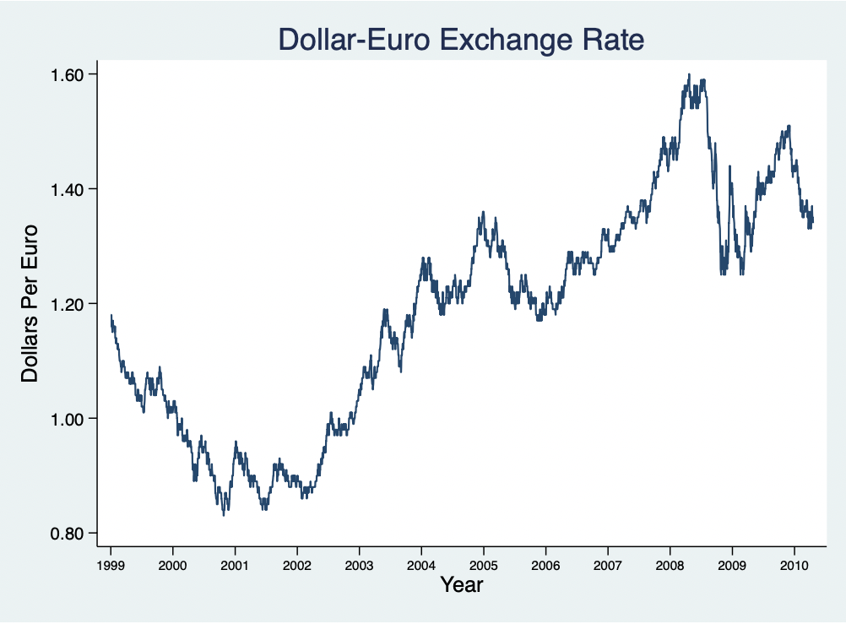

b. (10 points) Create a new series that is equal to the percent change in the exchange rate. Produce a line graph of this new series and submit it.

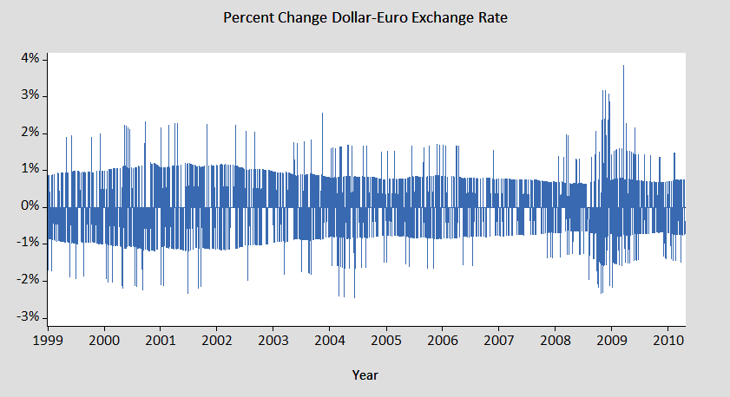

c. (10 points) Create a new series equal to the percent change series lagged one period. Produce a scatter plot of the percent change series versus the lagged percent change series and submit it.

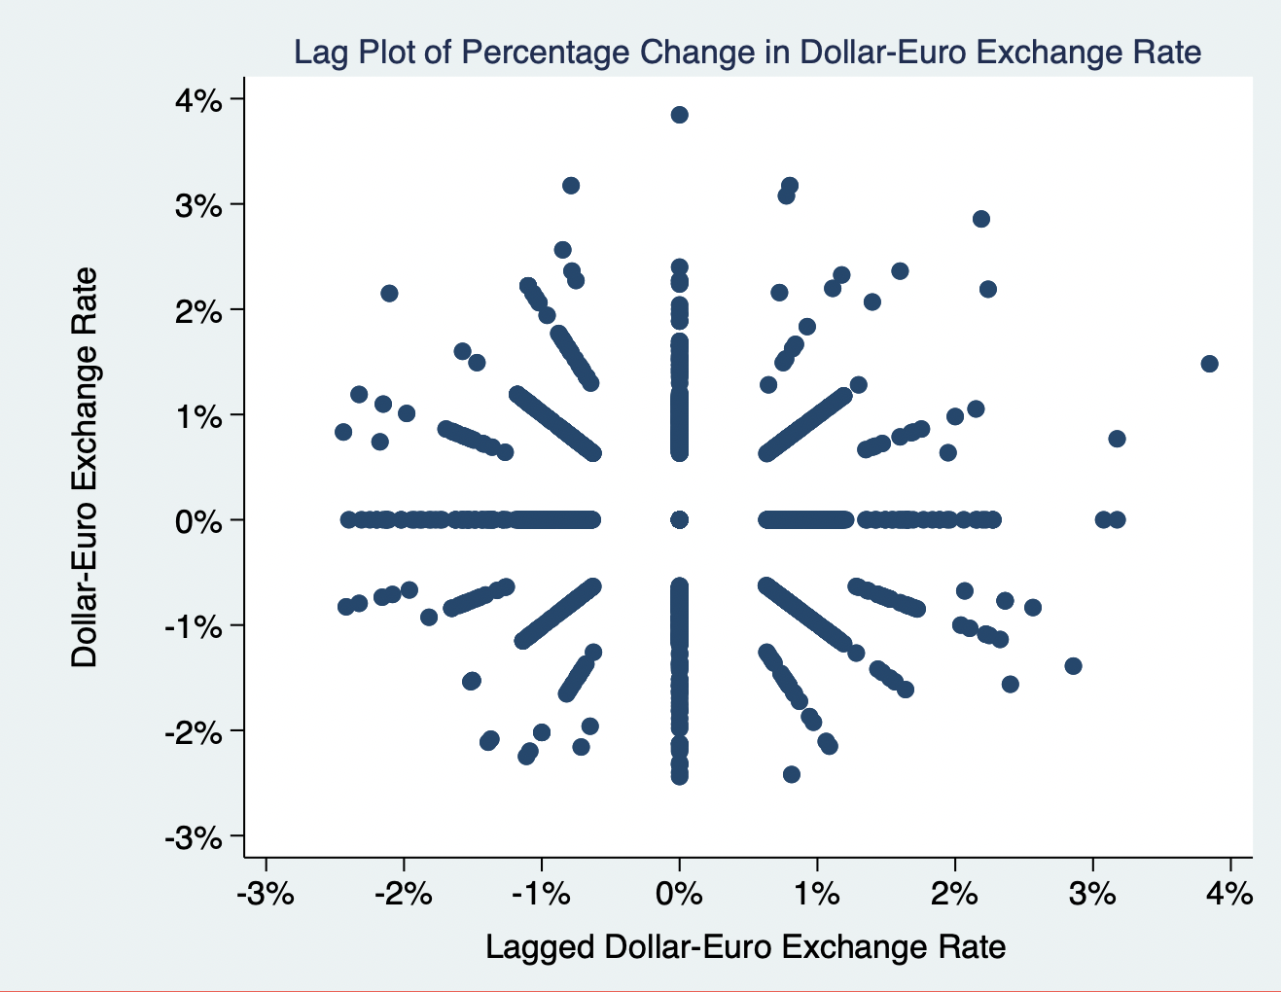

d. (10 points) Run a regression of the percent change series on the lagged percent change series. Submit the regression results.

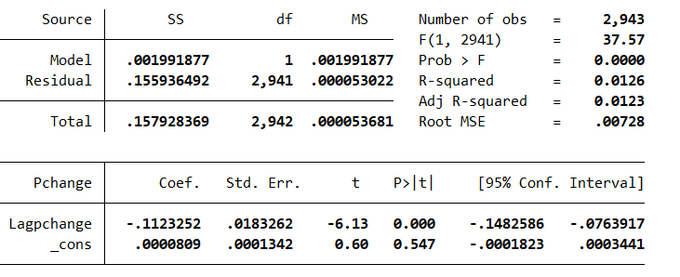

e. (10 points) Produce a plot of the residuals (do not show any other series in the plot) from the regression and submit the plot.

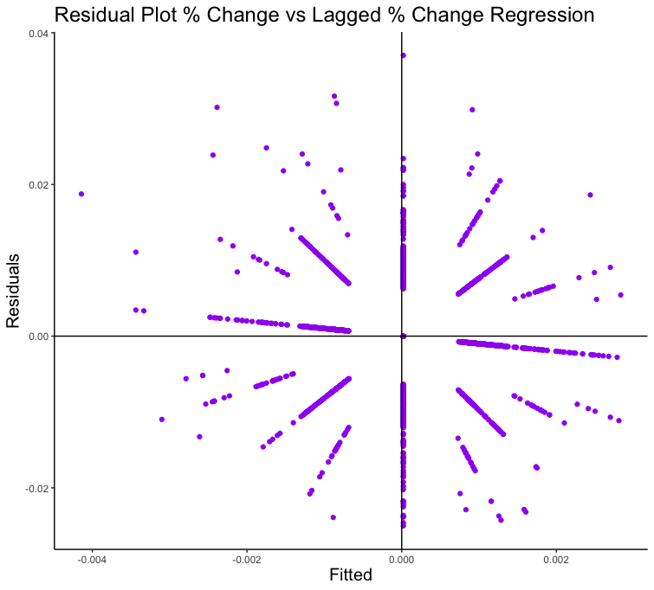

No need to provide a writeup, just complete the pieces of the assignment and submit all of the requested materials.

2. Use of Econometric software for graphical analysis of foreign exchange rate data

Use the foreign exchange rate data provided for this assignment (hmwk week 1.dat) Magyar Select, a marketing firm representing a group of Hungarian wineries, is considering entering into a contract to sell 8,000 cases of premium Hungarian dessert wine to AMI Imports, a worldwide distributor based in New York and London. The contract must be signed now, but payment and delivery are due 90 days hence. Payment is to be in U.S. dollars; Magyar is therefore concerned about the U.S. dollar/Hungarian forint ($/Ft) exchange rate volatility over the next 90 days. Magyar has hired you to analyze and forecast the exchange rate, on which it has collected data for the last 620 days. Naturally you suggest that Magyar begin with a graphical examination of the data.

a. (20 points) Take logs and produce a time series plot of the log of the $/Ft exchange rate. Discuss. (three or four sentences)

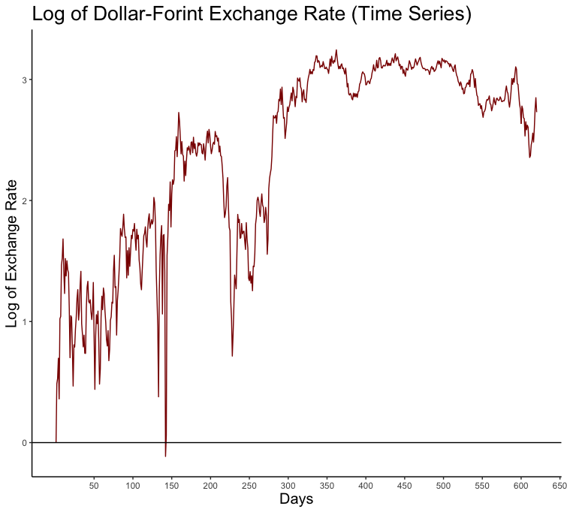

The graph has an overall upward trend from the first to the 300th day. However, at around the 130th day, there was extreme volatility, going as far as below zero, for a short duration of time. The exchange rate shot up shortly after and remained stable, then dropped sharply at around the 230th day. After that the rate rose again, then beginning from around the 300th observation had a stable horizontal trend with little volatility, hovering at around 3 units. At the last 20 days, there was a slight drop in the rate.

b. (20 points) Produce a scatterplot of the log of the $/Ft exchange rate against the lagged log of the $/Ft exchange rate. Discuss. (two or three sentences)

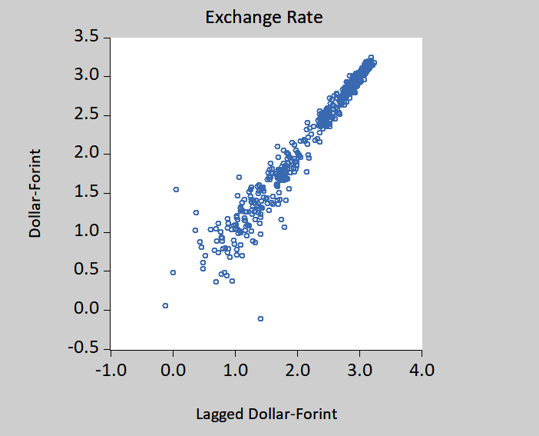

The points seem to lie on a line with a 45-degree angle starting from the origin, becoming more and more clustered together as we go towards those in the upper-right corner. This suggests that the next period’s exchange rate is close to the previous period’s exchange rate, and this relationship is more prominent when the exchange rate is high. When compared to the previous time series graph, we can determine that the points closer to the lower-left corner correspond to observations 1 to 300, where the exchange rate is both lower and more volatile, while the points closer to the upper-right corner correspond to observations 300 and above, where the exchange rate is both higher and less volatile.

c. (10 points) Create a series that is the change in the log $/Ft exchange rate. Run a test for normality of the series. Do the log exchange rate changes appear normally distributed? If not, what is the nature of the deviation from normality?

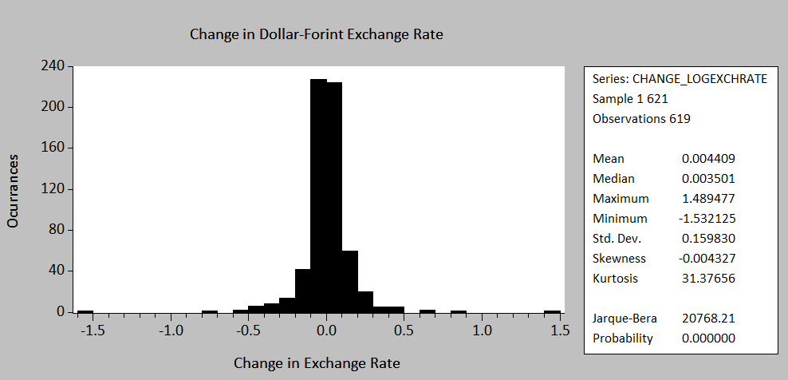

The Jarque-Bera Test for Normality gives a value far from 0 as well as a p-value of 0, suggesting that the changes in the log exchange rate are very unlikely to follow a normal distribution. The skewness is slightly negative (–0.004) but near zero, so the distribution isn’t very asymmetric. However, the Kurtosis value is 31.377, opposed to being approximately 3 when the data is normally distributed. Thus, the data is highly leptokurtic, which probably causes the deviation from normality more than any trivial symmetry deviations given by the skewness.