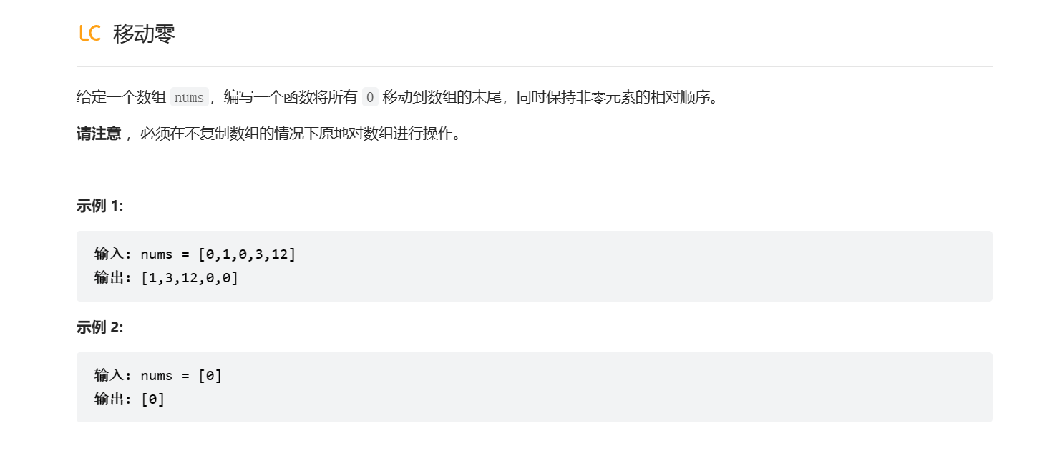

void moveZeroes(int\* nums, int numsSize){

int t1=0,t2=0;

if(nums==NULL)

{

    return 0;

}

while(t2<numsSize)

{

    if(nums[t2]!=0)

    {

        nums[t1]=nums[t2];

        t1++;

    }

        t2++;

}

while(t1<numsSize)

{

    nums[t1]=0;

    t1++;

}

return nums;

}

