

Cyber Security – Assessment # 11

Week 11 Time: 2 - Hours
Name: Haider Jamal Marks: 100

Q1. ICMP Flood Attack & Defense
- Perform an ICMP flood on a target using 3 different tools/methods.
Answer:
Method 1: ICMP Echo Flood (Direct Source)
Launched using pentmenu's ICMP Echo Flood module (hping3 backend), targeting the Windows victim VM (150.1.7.102) from Kali (150.1.7.101) with the real source IP.
- Pentmenu>2 → 1
- Target: 150.1.7.102
- Source: 150.1.7.101
This floods raw ICMP Echo Requests at maximum NIC speed, ignoring RTT throttling, overwhelming the target's ability to process and reply to legitimate traffic.

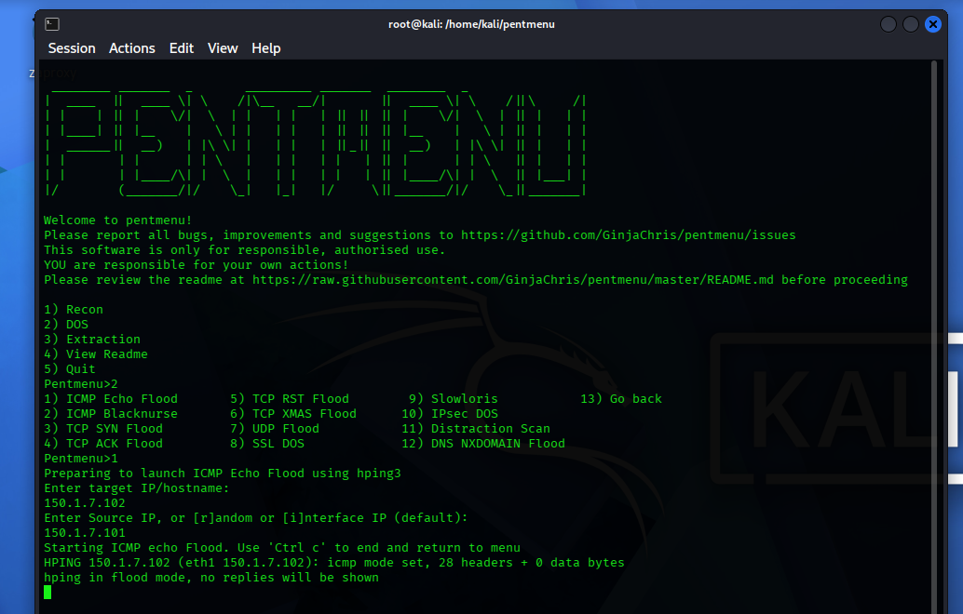

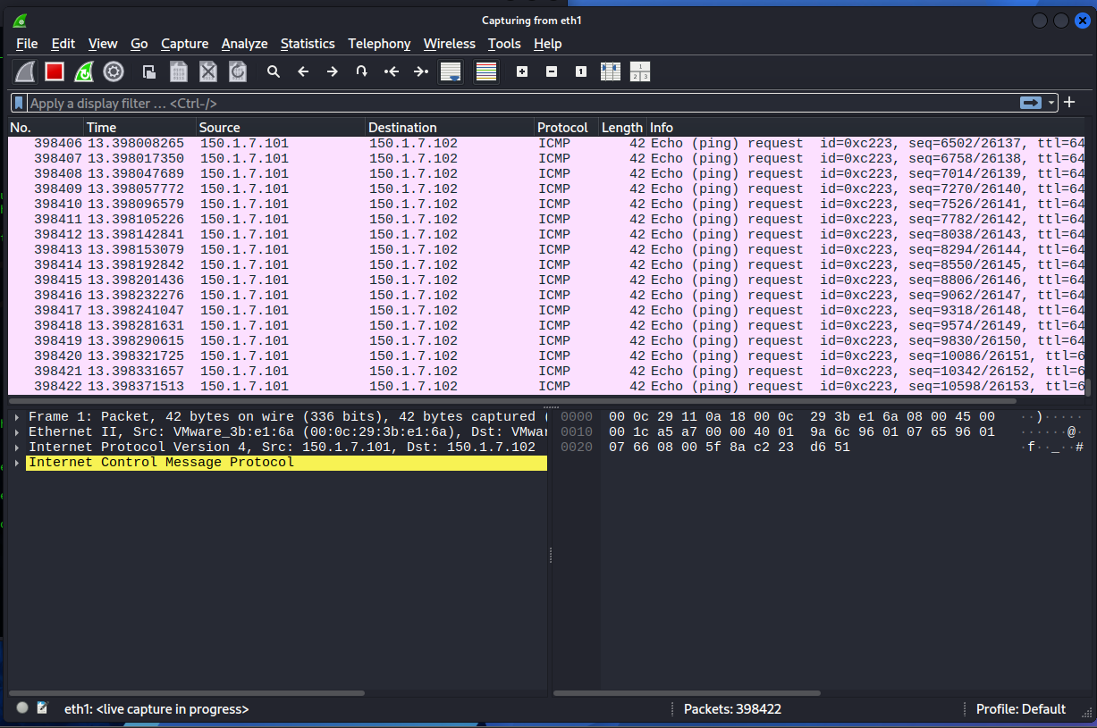

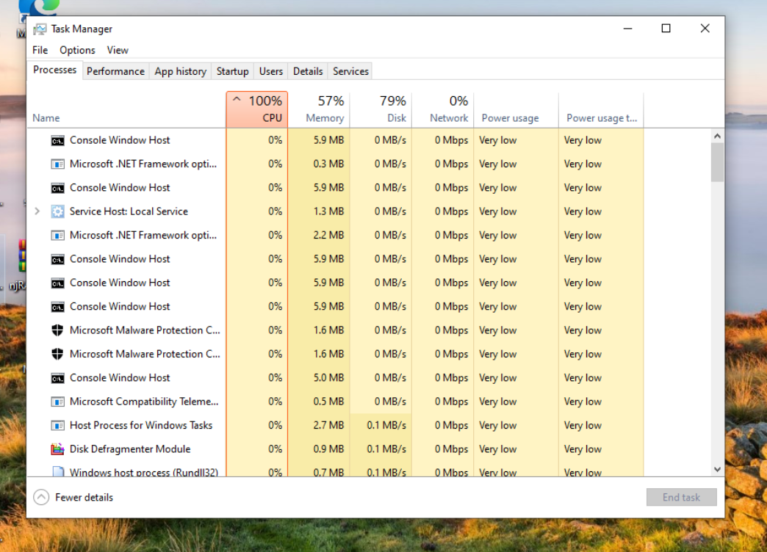

Method 2: ICMP Blacknurse Flood
Used pentmenu's ICMP Blacknurse module, which sends ICMP Type 3 (Destination Unreachable), Code 3 (Port Unreachable) packets instead of standard Echo Requests.
- Pentmenu>2 → 2
- Target: 150.1.7.102
- Source: 150.1.7.101
Unlike Method 1, this exploits inefficient handling of ICMP error-type packets — low bandwidth but disproportionately high CPU cost on vulnerable devices.

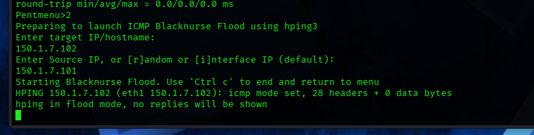
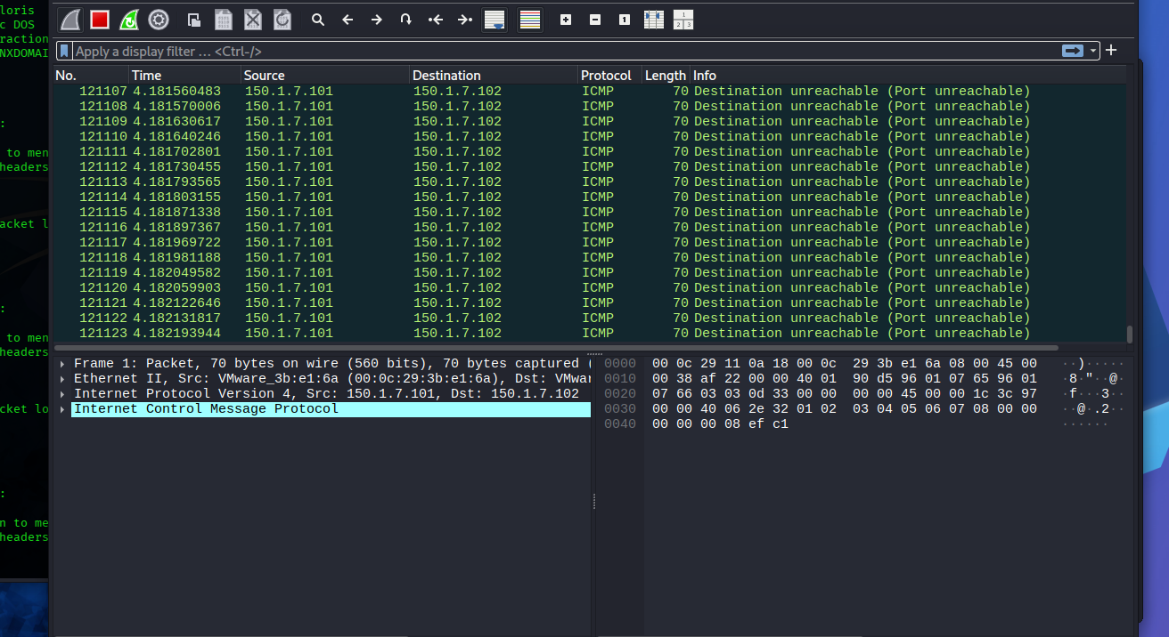
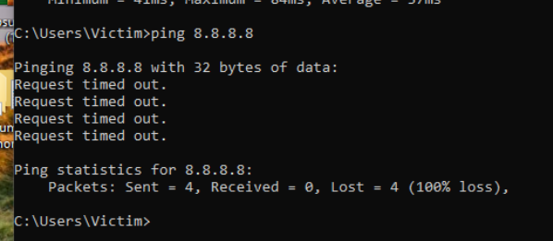

Method 3: ICMP Echo Flood with Randomized Source IP
Same module as Method 1, but with source set to random (r) instead of the real Kali IP, correctly targeting 150.1.7.102 this time.
- Pentmenu>2 → 1
- Target: 150.1.7.102
- Source: r
This spoofs a different source IP on every packet, defeating simple source-IP-based blocking — demonstrating why single-IP firewall rules alone are insufficient defense.

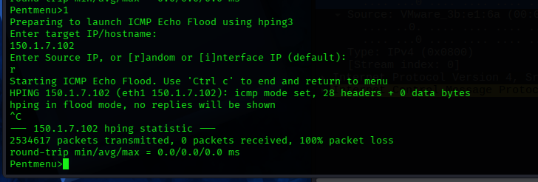
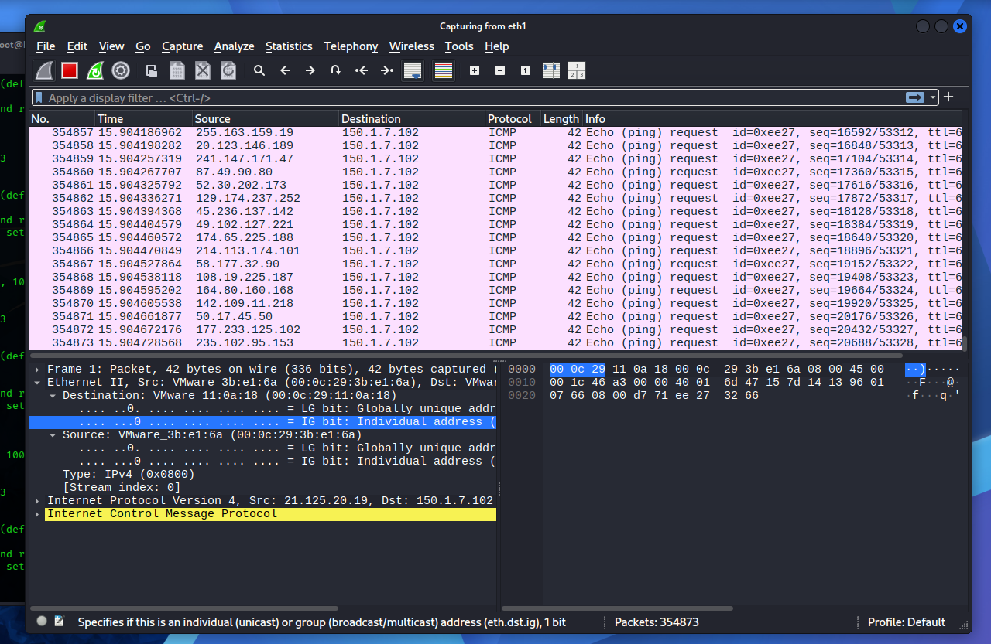
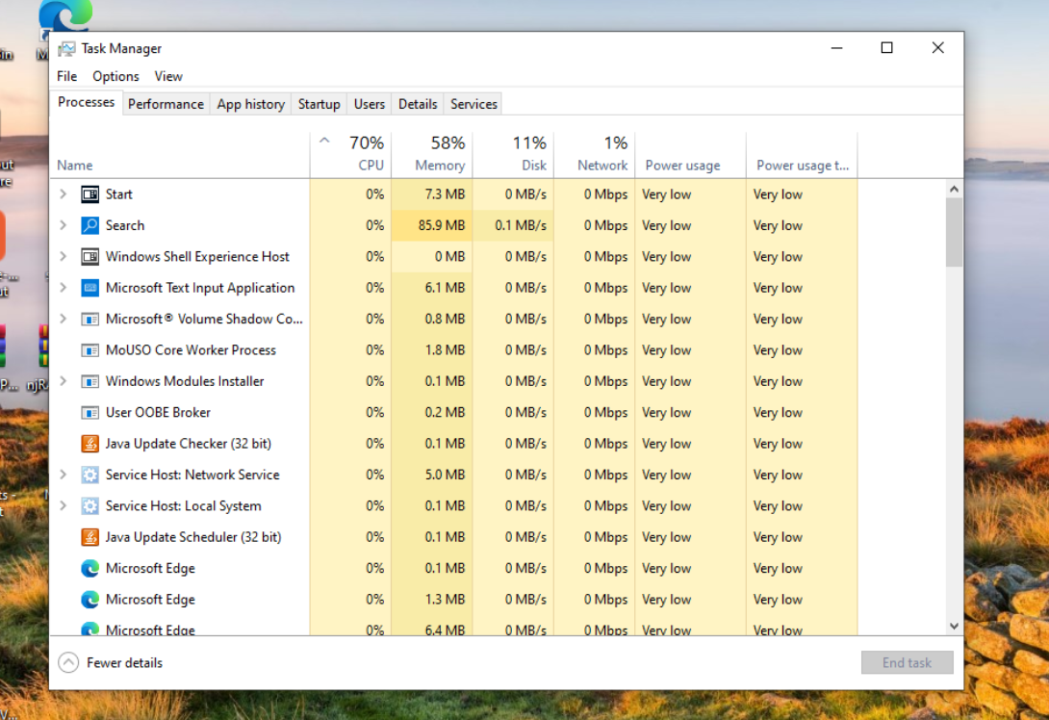

- Block the attack using 3 different defensive techniques.
- Defensive products may be purchased; budget is unlimited.
Answer:
Part B: Defense — 3 Techniques
Defense 1: Host-Based Firewall Rule (Windows Firewall)
CMD Command:
- netsh advfirewall firewall add rule name="Block_Kali_ICMP" protocol=icmpv4:8,any dir=in remoteip=150.1.7.101 action=block
- Blocks ICMP Echo Requests (type 8) specifically from the attacker's IP, while still allowing legitimate ICMP traffic from other sources.

Result: Re-ran Method 1 flood after applying this rule — CPU usage dropped from 100% to 24%, confirming the rule mitigated the attack's impact.
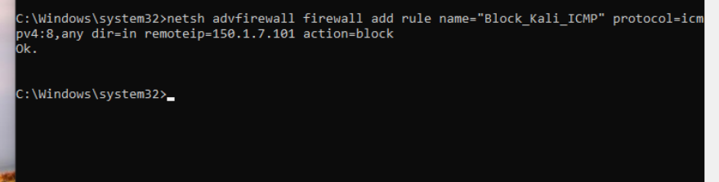
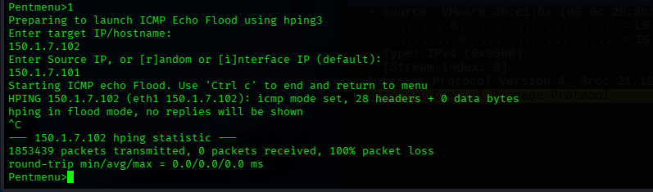

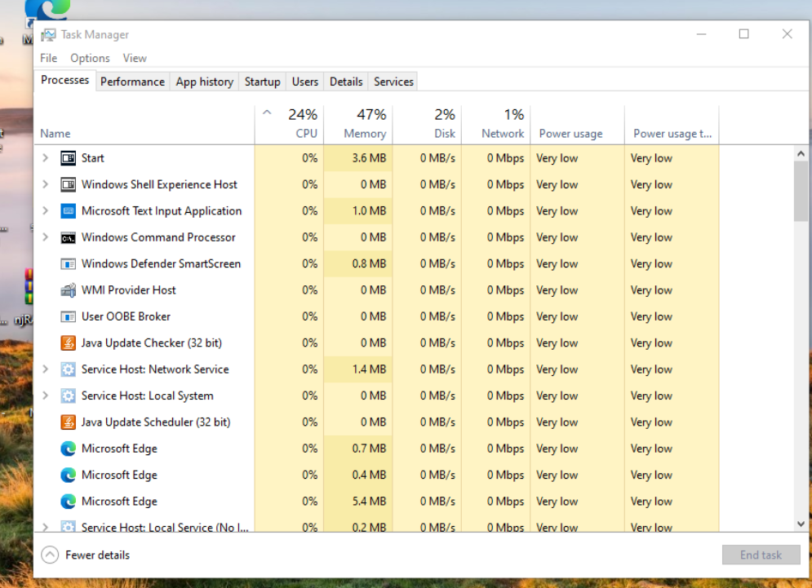
- Limitation: Only blocks by known source IP — ineffective against Method 3's randomized-source flood.
Defense 2: Network-Level ICMP Rate-Limiting (Gateway/Router)
- policy-map ICMP-LIMIT
- class class-default
- police cir 8000 conform-action transmit exceed-action drop
- !
- interface GigabitEthernet0/0
- service-policy input ICMP-LIMIT
Caps ICMP throughput at 8000 bits/sec at the network edge, dropping excess regardless of source IP — mitigates spoofed/randomized-source floods (Method 3) that host-based IP blocking cannot stop.

Defense 3: Dedicated DDoS Mitigation Appliance (Unlimited Budget)
Deploy a purpose-built appliance such as Cisco Firepower NGFW or F5 BIG-IP DDoS Hybrid Defender at the network perimeter. These perform stateful, hardware-level flood detection and drop malicious traffic at line-rate before it reaches internal hosts — unlike host-based firewalls, which still consume CPU evaluating every packet before dropping it.
This provides scalable protection against high-volume, distributed, and spoofed-source attacks that per-IP or per-interface rules cannot fully address.

