### 项目：搭建学生管理系统

1.建立数据库

mysql -uroot -p

CREATE DATABASE student_sys

USE student_sys;

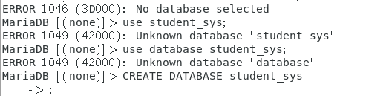

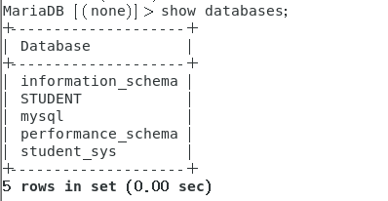

2.根据需求建立《学生信息表》《学生成绩表》

学生信息表

CREATE TABLE IF NOT EXISTS `studentinfo`(

`stu_id` INT UNSIGNED AUTO_INCREMENT,

`stu_name` VARCHAR(25) NOT NULL,

`stu_sex` VARCHAR(10) NOT NULL,

`stu_num` VARCHAR(100)NOT NULL,

`stu_code` VARCHAR(100)NOT NULL,

PRIMARY KEY ( `stu_id` )

)ENGINE=InnoDB DEFAULT CHARSET=utf8;

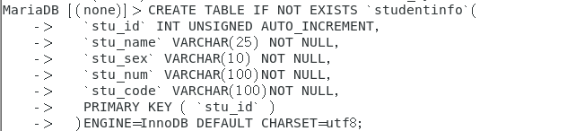

学生成绩表

CREATE TABLE IF NOT EXISTS `studentrecord`(

`record_id` INT UNSIGNED AUTO_INCREMENT,

`stu_num` VARCHAR(100)NOT NULL,

`match_record` INT NOT NULL,

`datasec_record` INT NOT NULL,

PRIMARY KEY ( `record_id` )

)ENGINE=InnoDB DEFAULT CHARSET=utf8;

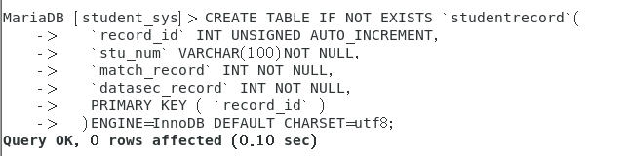

USE student_sys;

SHOW TABLES;

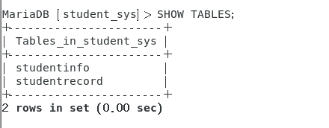

SHOW COLUMNS FROM studentinfo;

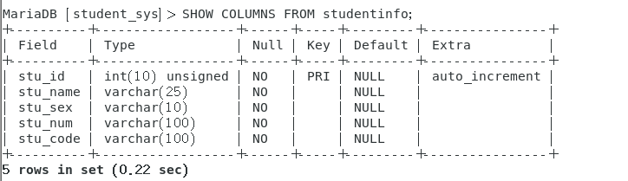

SHOW COLUMNS FROM studentrecord;

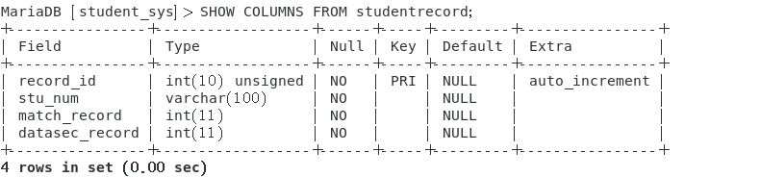

/*****************************************/

/*****************************************/

--插入数据

/* 学生信息 */

单条数据输入：

INSERT INTO studentinfo

( stu_name,stu_sex,stu_num,stu_code)

VALUES

("", "李璐璐", "女","AT08474","62513257312636")

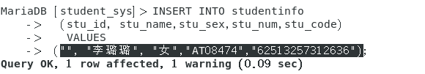

多条数据输入：

INSERT INTO studentinfo

(stu_name,stu_sex,stu_num,stu_code)

VALUES

("黄鱼", "男","AT08908","67346873246878"),

("李丽丽", "女","AT08490","73984732984783");

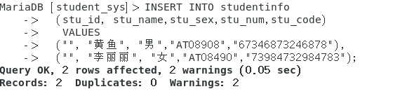

/* 学生成绩 */

多条数据输入：

INSERT INTO studentrecord

(record_id, stu_num,match_record,datasec_record)

VALUES

("", "AT08908", "80","85"),

("", "AT08474", "90","70"),

("", "AT08490", "95","95");

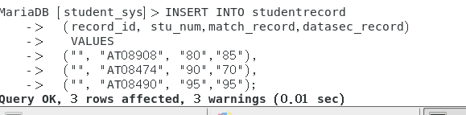

--查询数据

SELECT COUNT(*) FROM studentinfo;

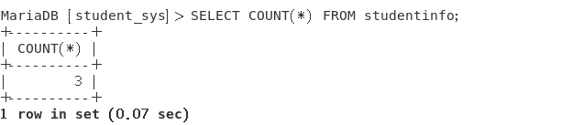

SELECT * FROM studentinfo;

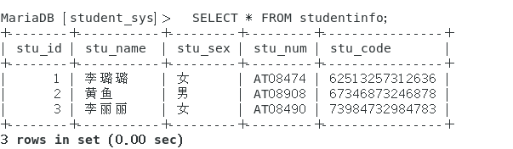

SELECT stu_id,stu_name,stu_sex,stu_num,stu_code FROM studentinfo;

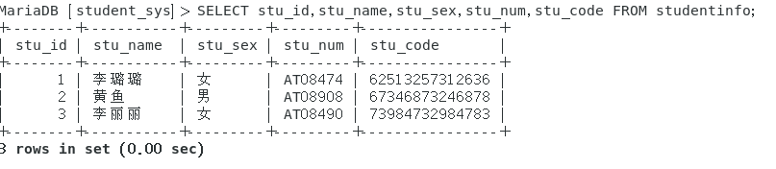

------ 显示条数查询

SELECT * FROM studentinfo LIMIT 0,100;

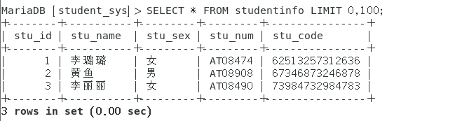

------ 联合查询

SELECT stu_id,stu_name,stu_sex,stu_num,stu_code

FROM studentinfo

UNION

SELECT ALL FROM studentrecord;



Example01

SELECT stu_name,stu_num

FROM studentinfo

UNION

SELECT match_record,datasec_record

FROM studentrecord;

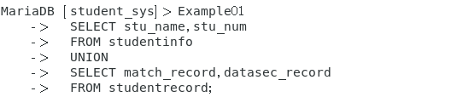

------ 带条件查询

SELECT * FROM studentinfo LIMIT 0,100;

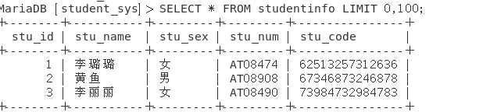

SELECT *

FROM studentinfo

WHERE stu_name = "黄三";

------ 模糊查询 LIKE

SELECT * FROM studentinfo LIMIT 0,100;

SELECT *

FROM studentinfo

WHERE stu_name LIKE "黄%";

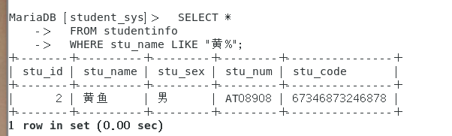

SELECT * FROM studentinfo LIMIT 0,100;

SELECT *

FROM studentinfo

WHERE stu_name LIKE "%黄%";

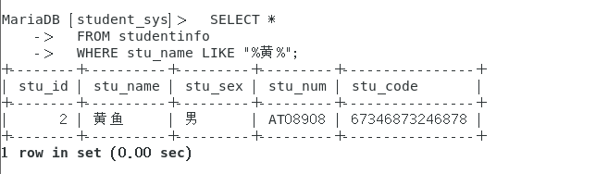

------ 排序 ORDER BY

SELECT field1, field2,...fieldN table_name1, table_name2...

ORDER BY field1 [ASC [DESC][默认 ASC]], [field2...] [ASC [DESC][默认 ASC]]



SELECT stu_num,match_record,datasec_record

FROM studentrecord

WHERE match_record >= 90

ORDER BY match_record;

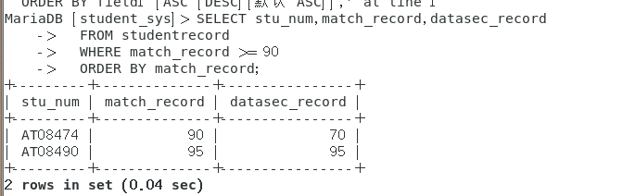

------ 分组 GROUP BY

SELECT match_record,COUNT(*) datasec_record

FROM studentrecord

GROUP BY match_record;

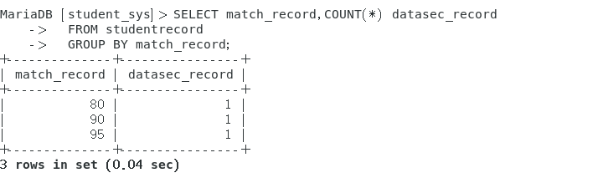

--删除数据

DELETE FROM studentinfo WHERE stu_name = "黄鱼";

