CS-559 Team 5 Project Report
15 Dec 2022
Team Name: Project2AKAJ
Anjali Sangamreddy
Kevin Mengarelli
Alan Clark
Jason Wong

Introduction
We created a kaggle.com account named Project2AKAJ, a team account to be shared by all of us, because it wasn't immediately apparent how Kaggle.com team competitions work. The correct approach would have been for each of us to create an individual account, and then form our four separate accounts into a team. Any team member can then submit solutions to the competition, instead of having to share a login account.
That was the first lesson learned.

The Data
After reviewing the format of the data provided, we created Python code to upload it, convert it to numerical form, and organize it.
The data provided for the Scrabble contest consisted of five comma-separated value (CSV) files:
- train.csv
- test.csv
- sample_submission.csv
- games.csv
- turns.csv
The train.csv file contained the results from a series of two-player games, in which a live player competed against a bot. The names of the bots all ended with “Bot” to clarify which was which. For each game, each of the two players received a game score and an overall rating.
The shorter test.csv file contained similar data, but with the ratings for live players replaced by “NA”. The objective was to use models trained on train.csv to predict the scores of the live players in test.csv. The predictions were to be submitted in the form given by sample_submission.csv.
Given all that, there didn't seem to be any use for the games.csv and turns.csv files. Therefore, our initial approach ignored them.
We also concluded that we didn't need the scores for the various bots, since they wouldn't be useful in predicting ratings for the human players. We created simple, relatively crude code to read in train.csv, and sort the data into two numpy arrays: x_train, consisting of game ID and human player's score for each game; and y_train, containing the human player's rating for that game. From test.csv, we produced x_test in the same way. Of course, there was no y_test, since that was the target.

The Models
Model A - Parametric
The first model, using the initial approach to the data, applied sklearn.neural_network's MLPRegressor in a simple fashion:
modelA = MLPRegressor()
modelA.fit(x_train, y_train)
predictionA = modelA.predict(x_test)
Following the approach used for all subsequent models, it then zipped together the test.csv game IDs and the rating predicted by the model for the human player's rating in each game, producing a new .csv file in the format required for submission.
Model B - Non-Parametric
The second model applied sklearn.tree's DecisionTreeRegressor, again very simply:
modelB = DecisionTreeRegressor()
modelB.fit(x_train, y_train)
predictionB = modelB.predict(x_test)

Model C - Non-Parametric
KNN

Model D - Parametric
LinearRegression

Model E - Stacking Model with Linear Regression
StackingRegressor

Model F - Parametric
LogisticRegression

Model G (Parametric)
XGBRegressor

Model H (Parametric)
LGBMRegressor

Model I (Parametric)
RandomForestRegressor

The Preprocessing

Scores and Kaggle Ranking
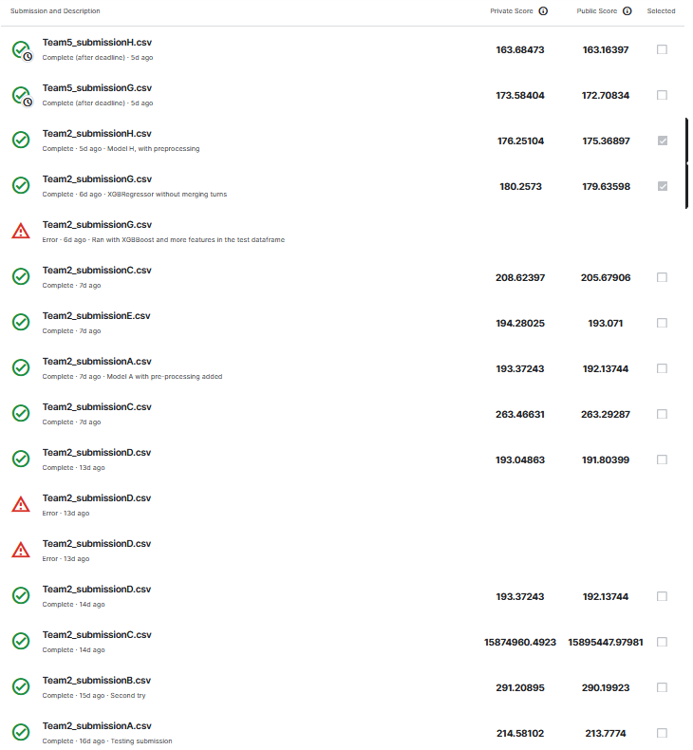
Our best-scoring models were submitted after the competition had closed, so we can't claim those results.

Conclusion

