Pre4Sim1
Change m1 and m2
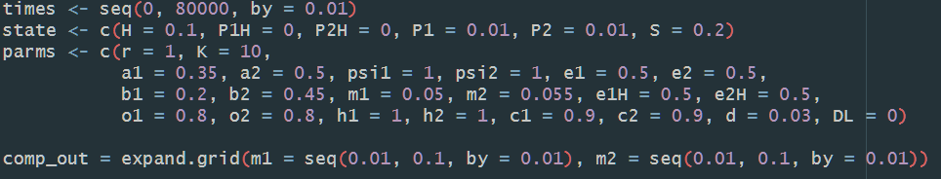
When α₁ < α₂, β₁ <β_{2,} and P₁ alone cannot persist H.
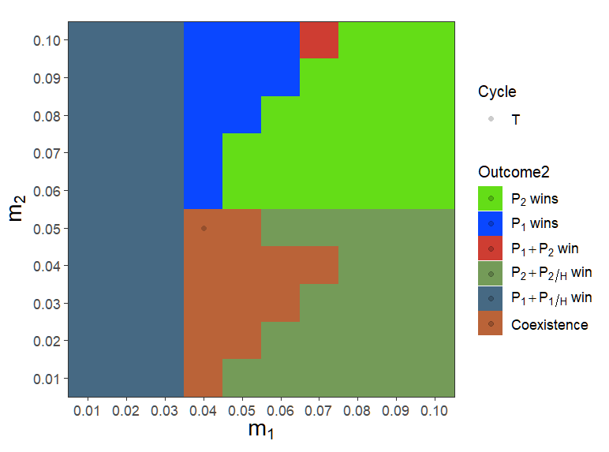
When m1 = m2 = 0.05, two strains can coexist.

Pre4Sim5
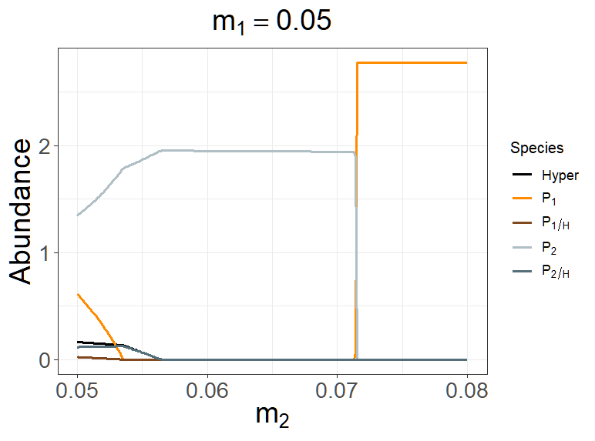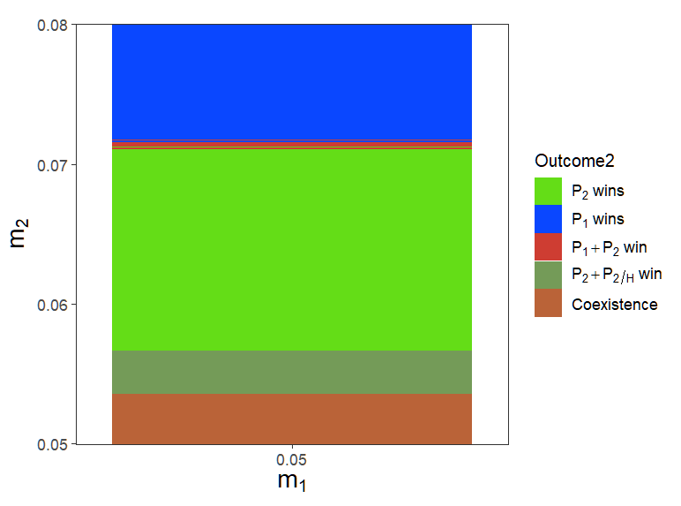
Fixed m1 = 0.05, increase m2 from 0.05 to 0.1, the abundance of P2 will gradually increase (m2 = 0.05 to 0.0567), until the hyperparasite extinct and then slightly decrease (m2 = 0.0567 to 0.07), and drop to extinction (m2 > 0.0716 ≒ 0.07142, which approximately meets the exploitative competition outcome, S* rule)

