Matthew Angelucci CIS3308 HW 02 DB Part 01/25/2020

1. Matthew Angelucci tuf33872
2. ://dump
3. “://dump is a new sort of media-sharing website that emphasizes content over everything else. It is mean to be a combination of "dumping ground of novel, user-generated content" and "a less toxic, more civil alternative to 4chan, but with less emphasis on discussion". The idea is very much in experimental phases and I will be expanding on the concept further in the semester.
4. **Table design of user_role, web_user_ and user_post**

**user_role:**

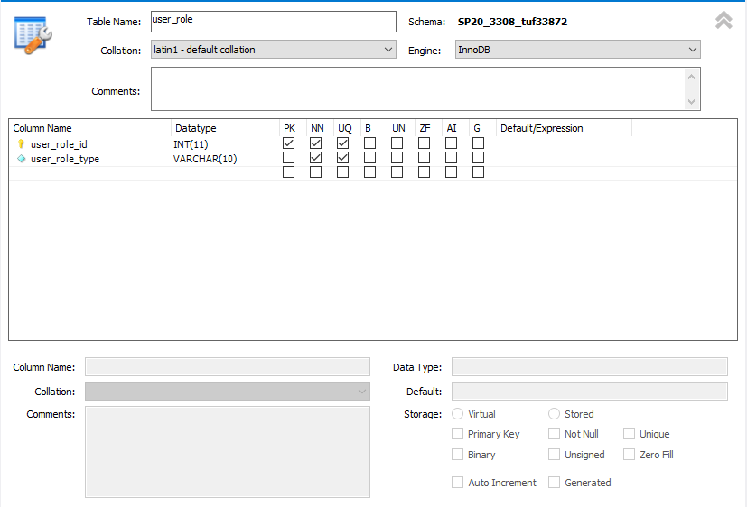

Web_user:

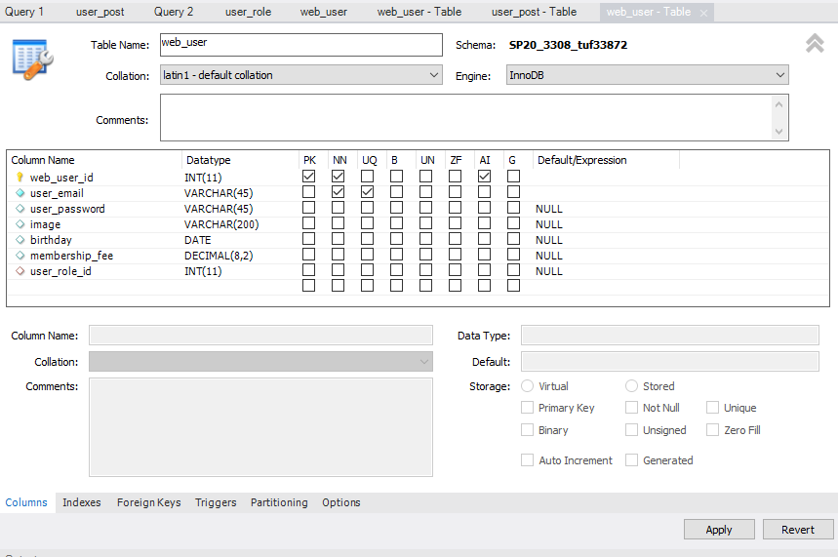

User_post:

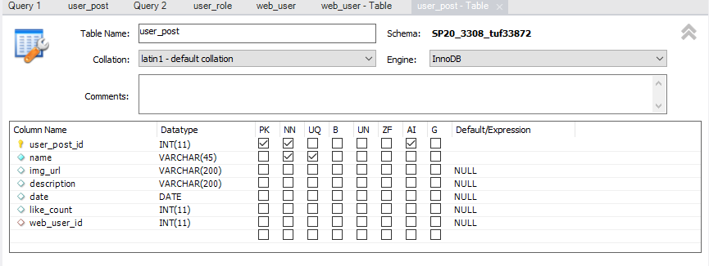

1. Execute SQL Statements
   1. Select statement that lists all columns of user_post table, sorting columns by order appealing to the user and ordering by the first column, like_count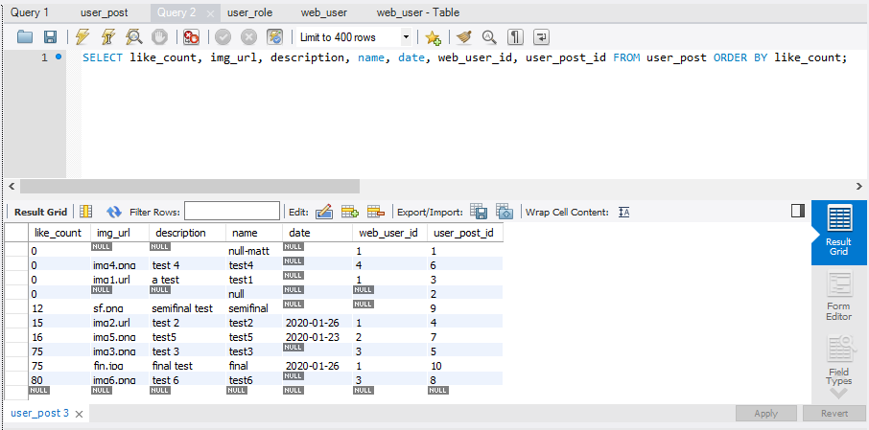
   2. SELECT statement above but adding WHERE clause

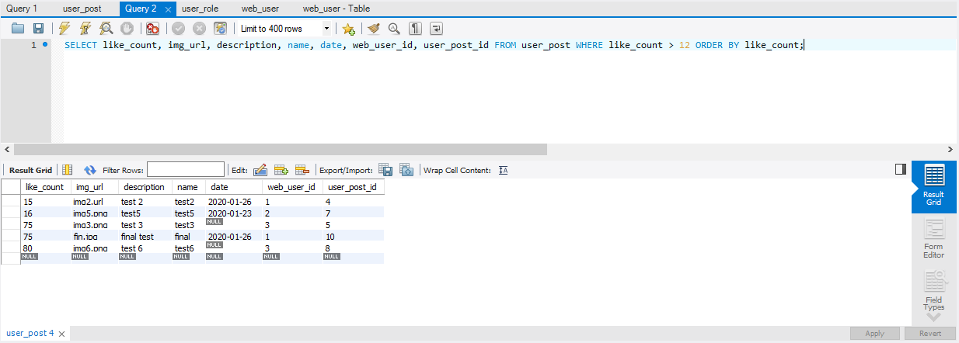

* 1. SELECT statement with JOIN as specified in instructions

