Completion Rate of US Colleges
Linear Regression Project
Jacob Patenaude – 301203788
STAT 350 – Jiguar Cao – Fall 2016

ABSTRACT
The US Department of Education collected and released data on US colleges to allow prospective students, administrators, and researchers alike to learn about the true cost and value of education in the US. This paper seeks to find a linear relationship amongst the many given variables to predict the completion rate of undergraduate students across the US.
KEYWORDS
College Scorecard, Regression, Education, US, United States, Completion Rate, Tuition, Debt
DATASET
The College Scorecard dataset is released by the US Department of Education. It is very large with over 120,000 rows and over 1700 columns. It is provided both as a spreadsheet in standard comma-separated values (CSV) format and as a database in the SQLite format. The data is collected on many colleges from the 1996 through to 2013; therefore, the data is collected on an average of around 7,000 schools per year, with many schools closing or opening across the dataset’s time range. Many of the variables in the dataset are split across many columns. For example, ACT test scores are given as percentiles across all students in a given year in both cumulative and per-test-section terms. One final note about the dataset is that due to the large variation in types, sizes, and administrative tendencies across US colleges, no one row has a value for every column, meaning that in order to run a more powerful analysis without missing values, many rows and years had to be forfeit.
INTRODUCTION + GOALS
My goal with the dataset was to investigate the completion rate (C200_4_POOLED_SUPP) of students at colleges in the US. The chosen column is the two-year pooled average of completion rates of all students at four-year colleges who completed within eight years (two hundred percent of expected completion time of four years) where colleges with fewer than thirty students are suppressed. Another goal was to produce code which could be easily modified to change which covariates and response were involved due to the many columns which were available.
SELECTED COVARIATES
Column | Explanation
TUITIONFEE_OUT  AKA Tuition | Tuition cost for out-of-state students. Note that I selected the out-of-state cost for a more fair comparison across the US.
DEBT_MDN AKA MedianDebt | Median federal debt taken on by a student
PCTFLOAN AKA FederalLoanProportion | Percentage of students who took out federal loans
PPTUG_EF AKA PartTimeProportion | Percentage of students enrolled part-time
UGDS AKA NumStudents | Number of enrolled undergraduate students
CONTROL AKA Type | One of “Public”, “Private for-profit”, or “Private nonprofit”
ACTCM25 AKA CumulativeACT_25 | The 25th percentile of cumulative ACT test scores
ACTCM75 AKA CumulativeACT_75 | The 75th percentile of cumulative ACT test scores
INITIAL CHALLENGES
There were several challenges associated with working with this dataset. Foremost was the sparsity of the dataset: many variables about each college were either missing or invalid resulting in many incomplete rows within the dataset. The worst offender of this was my use of the “C200_4_POOLED_SUPP” column for completion rate. I desired to use this column for completion rate as completion rate is definitely something that would have high variance from year to year and would be affected strongly by colleges with very few students enrolled; however, this column is reported only for the final year of the dataset: 2013. Additionally, many of the finer-grained data on finances such as median debt, when broken down by income-status, are suppressed for privacy reasons by the colleges. Another challenge was learning to work with the RSQLite package as I chose to work with the SQLite database rather than the CSV for accessing the database for a combination of learning outcomes, familiarity with SQLite outside of R, and its smaller hard-disk size (1.1GB vs 1.3GB) as reasons. Also, to meet my goal of creating abstract and modular code that supports adjusting covariates and completion rates on the fly, I learned to work extensively with paste and cat as well as with control structures within R. Finally, for its additional plotting capabilities and for my own learning, I chose to use the GGPlot2 package for plotting within R. After restricting my data to only rows containing all of my covariates without any missing values, I was left with 1,273 rows.

SIMPLE REGRESSION
To initially break down the relationships that may be present within the dataset, I did not want to have all of the variables plotted together on a scatterplot as that would have been difficult to see and interpret due to there being nine variables involved (the above covariates and the response). Instead, I went through each of the covariates and plotted them against the response variable along with the slopes and intercepts given by a simple regression model. For each of these plots, I have annotated them with whether or not the regression was significant and, for the numeric variables, what the intercept and slope were. Unfortunately type, which was my only categorical variable, was the only insignificant covariate in predicting completion rate and as such was not included in the final model. The plots of these regressions are included in the appendix of this report.
MODEL SELECTION
From all of the significant covariates, I ran backwards and both type AIC and BIC step functions to select my model from all possible models ranging from the empty model (only intercept) up to a model containing all covariates and their interaction terms up to degree two (i.e. three-way interaction terms). AIC and BIC stand for Akaike Information Criterion and Bayesian Information Criterion, respectively. The process for these step functions was to begin with the entire model and work backwards (and forwards in the case of the “Both” variant) to find the model which minimises the given criterion. In R, the criterion were calculated as:

AIC = -2 * L + 2 * K
BIC = -2 * L + ln(N) * K
Where:
- L is the natural logarithm of the value of the likelihood function for the multiple linear regression model
- N is the number of rows used in the model
- K is the number of parameters in the model

Step Type | AIC | BIC
Reverse AIC | 5356.13 | 5443.665
Both AIC | 5278.752 | 5469.269
Reverse BIC | 5360.435 | 5427.373
Both BIC | 5327.972 | 5410.358

I chose to work with the model selected by Both BIC as the model it generated was far simpler than that generated by the AIC methods. In addition to all of the covariates without an interaction term, the model included the following interaction terms:
- MedianDebt:NumStudents
- MedianDebt:CumulativeACT_25
- MedianDebt:CumulativeACT_75
- FederalLoanProportion:PartTimeProportion
- PartTimeProportion:NumStudents
- PartTimeProportion:CumulativeACT_25
- CumulativeACT_25:CumulativeACT_75
- MedianDebt:CumulativeACT_25:CumulativeACT_75

MODEL COEFFICIENTS
The model that was selected by the “Both BIC” step function gave the following coefficients with their estimates, standard errors, and p-values (using the student distribution). Note that PartTimeProportion and CumulativeACT_75 were both above the 0.1% significance threshold in this model, though that could be because those terms are included in several interaction terms.
Variable | Estimate | Std. Error | t-value | Pr(>|t|)
(Intercept) | 122.6841 | 32.62112 | 3.760879 | 0.0001771041
Tuition | 0.000291748 | 4.115023E-05 | 7.089827 | 2.233775E-12
MedianDebt | -0.008866092 | 0.001877961 | -4.721126 | 2.608464E-06
FederalLoanProportion | -13.24845 | 2.928631 | -4.523771 | 6.649026E-06
PartTimeProportion | 37.28926 | 21.3265 | 1.748494 | 0.08062256
NumStudents | 0.001427097 | 0.0002175743 | 6.559124 | 7.887633E-11
CumulativeACT_25 | -7.97641 | 2.038973 | -3.911975 | 9.644275E-05
CumulativeACT_75 | -3.397522 | 1.214174 | -2.798218 | 0.005217016
MedianDebt, NumStudents | -5.204117E-08 | 1.139727E-08 | -4.566109 | 5.456086E-06
MedianDebt, CumulativeACT_25 | 0.0006546689 | 0.0001141825 | 5.733532 | 1.230565E-08
MedianDebt, CumulativeACT_75 | 0.0002902575 | 7.11298E-05 | 4.080673 | 4.773536E-05
FederalLoanProportion, PartTimeProportion | 54.49015 | 15.38158 | 3.542558 | 0.0004107766
PartTimeProportion, NumStudents | -0.001778983 | 0.0003389121 | -5.2491 | 1.792753E-07
PartTimeProportion, CumulativeACT_25 | -4.277801 | 0.9289801 | -4.604836 | 4.546803E-06
CumulativeACT_25, CumulativeACT_75 | 0.3080335 | 0.05818093 | 5.294406 | 1.40804E-07
MedianDebt, CumulativeACT_25, CumulativeACT_75 | -2.034075E-05 | 3.362523E-06 | -6.049253 | 1.916663E-09

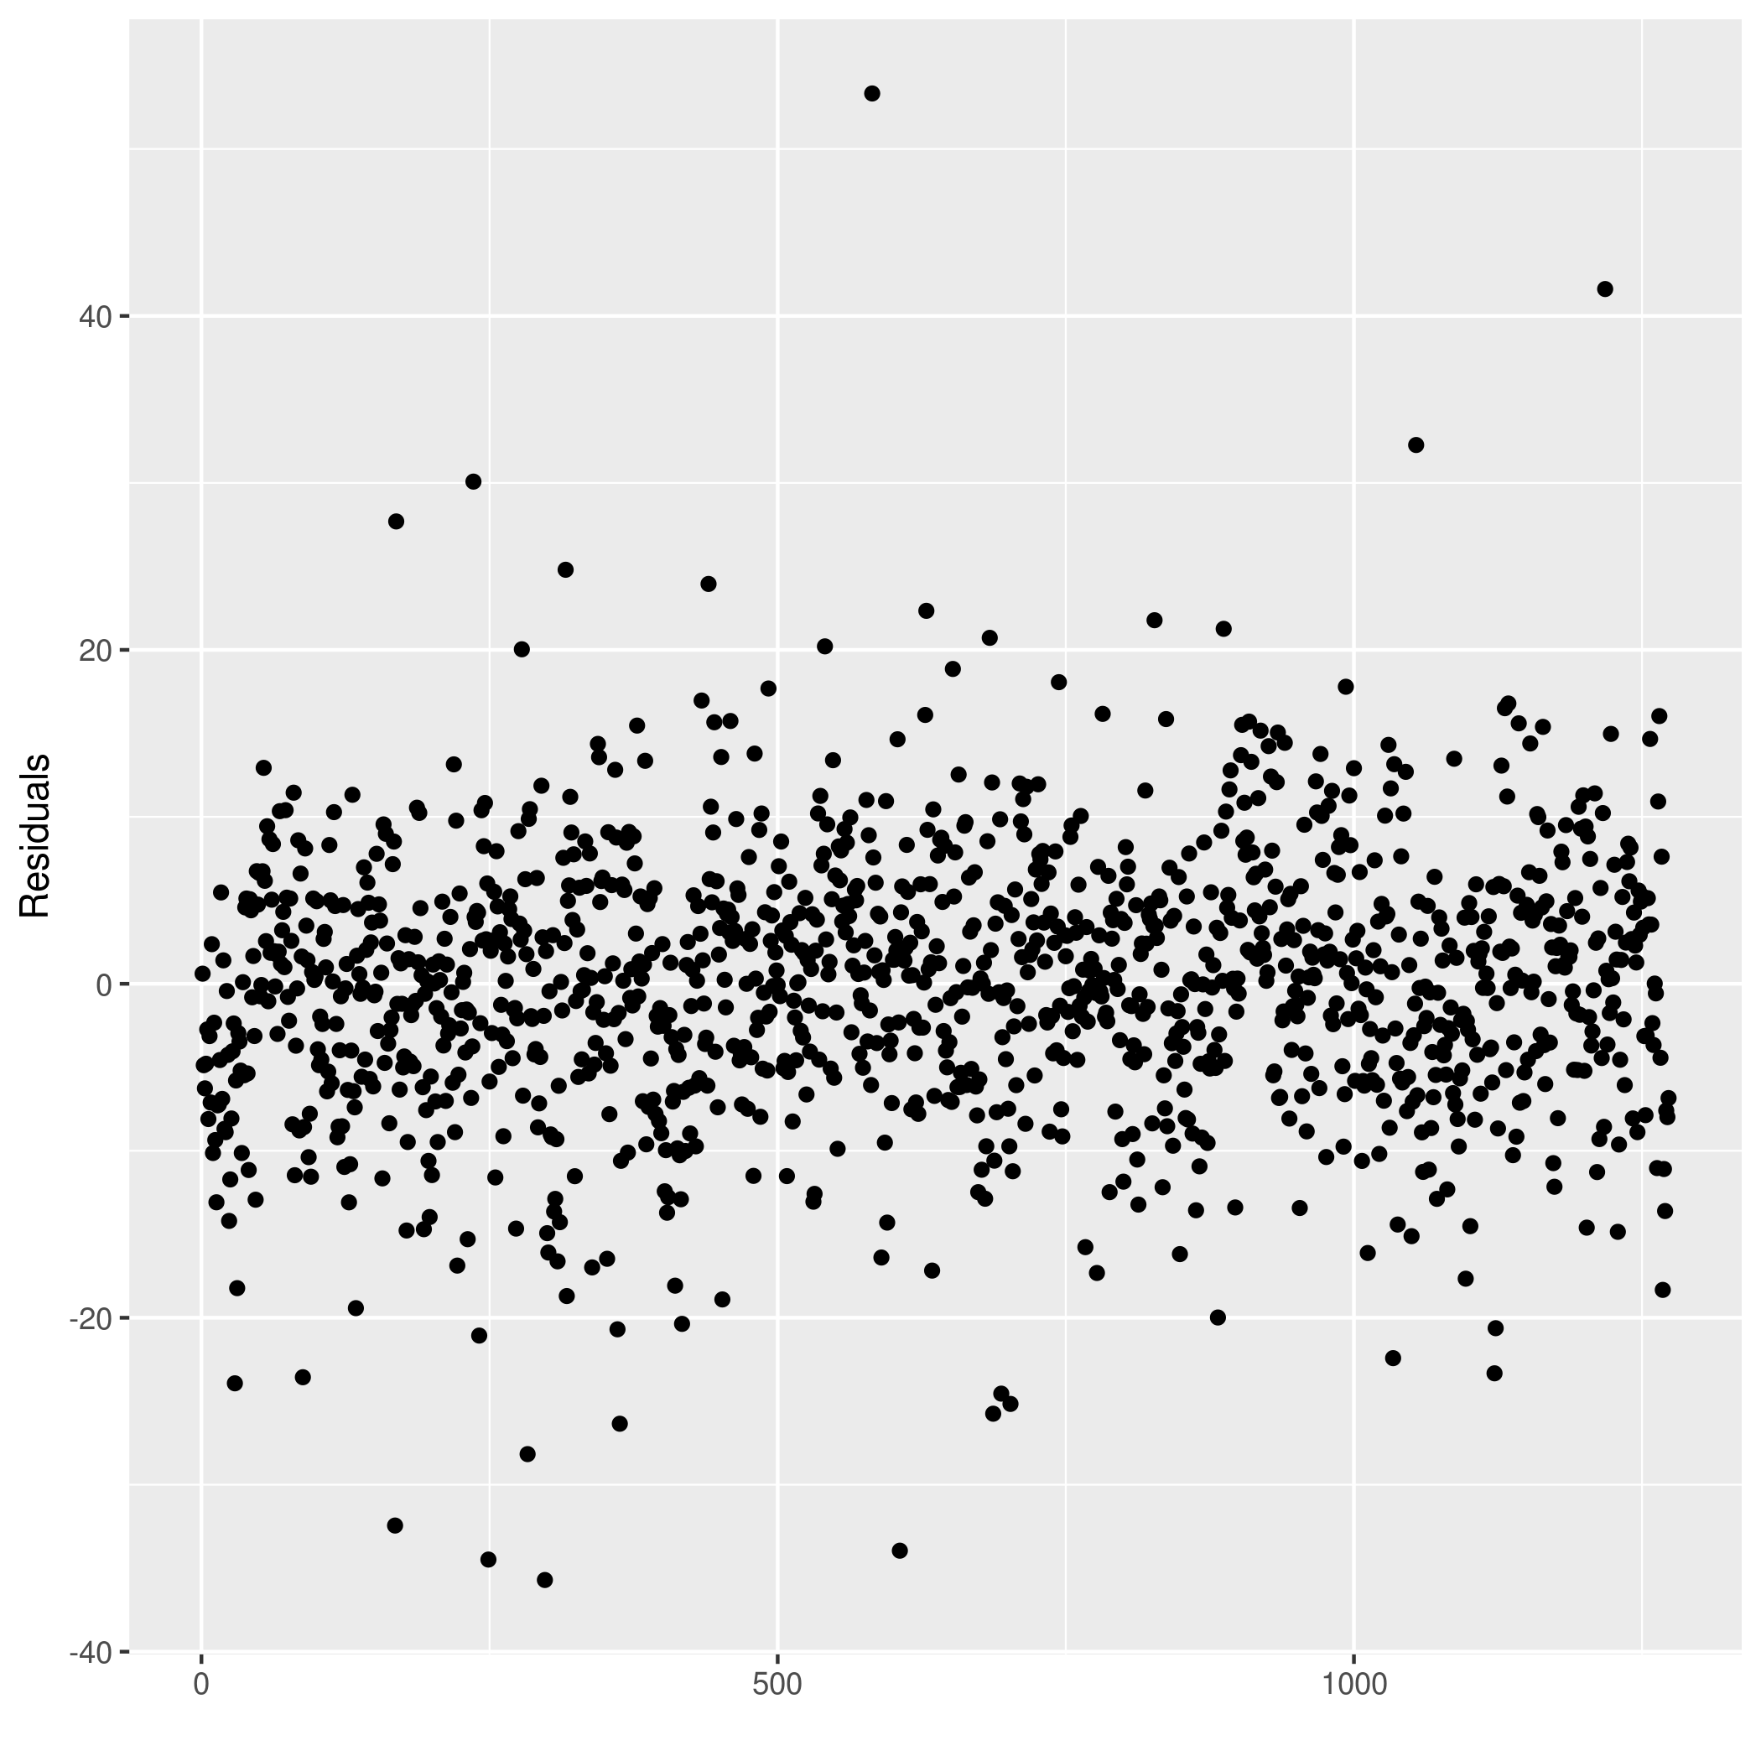
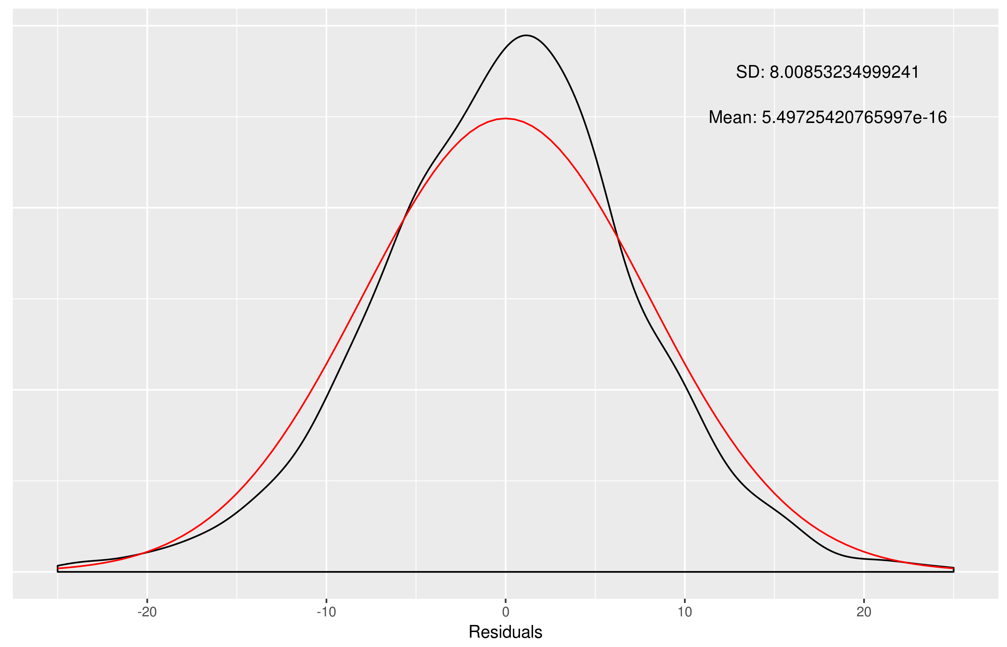
MODEL ASSUMPTIONS
As I have modelled the data using the multiple linear regression technique, in addition to assuming an approximately linear relationship between the response and covariates, the following assumptions about the residuals must be satisfied:
- They are independent of each other

- They are normally distributed with zero mean and constant variance

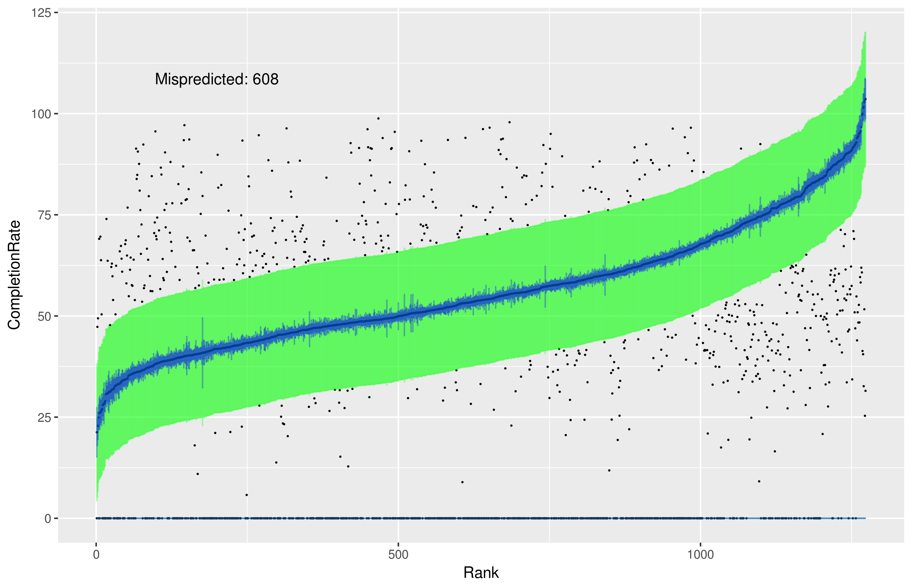
RESULTS
The selected model, while containing many significant covariates, did not fully explain nor predict the completion rate of students. The given multiple R² value was 0.7775 and the given adjusted R² value was 0.7748 meaning the model explains around 77-78% of the variance within the response. To demonstrate the predictive power of the model (or really, the lack thereof), I plotted the predicted completion rates against the actual completion rates, sorted by ascending predicted completion rate. I also plotted the prediction and confidence intervals at the standard 95% threshold. To reduce the noise of the plot, I masked any actual completion rates which fell within the prediction interval, which gave a nice measure of the number of colleges for which the completion rate was mispredicted. Note that prediction intervals are always wider than confidence intervals and so the prediction interval is in green, while the confidence interval is in blue. Note also that about half of all colleges were mispredicted (608 out of 1273).
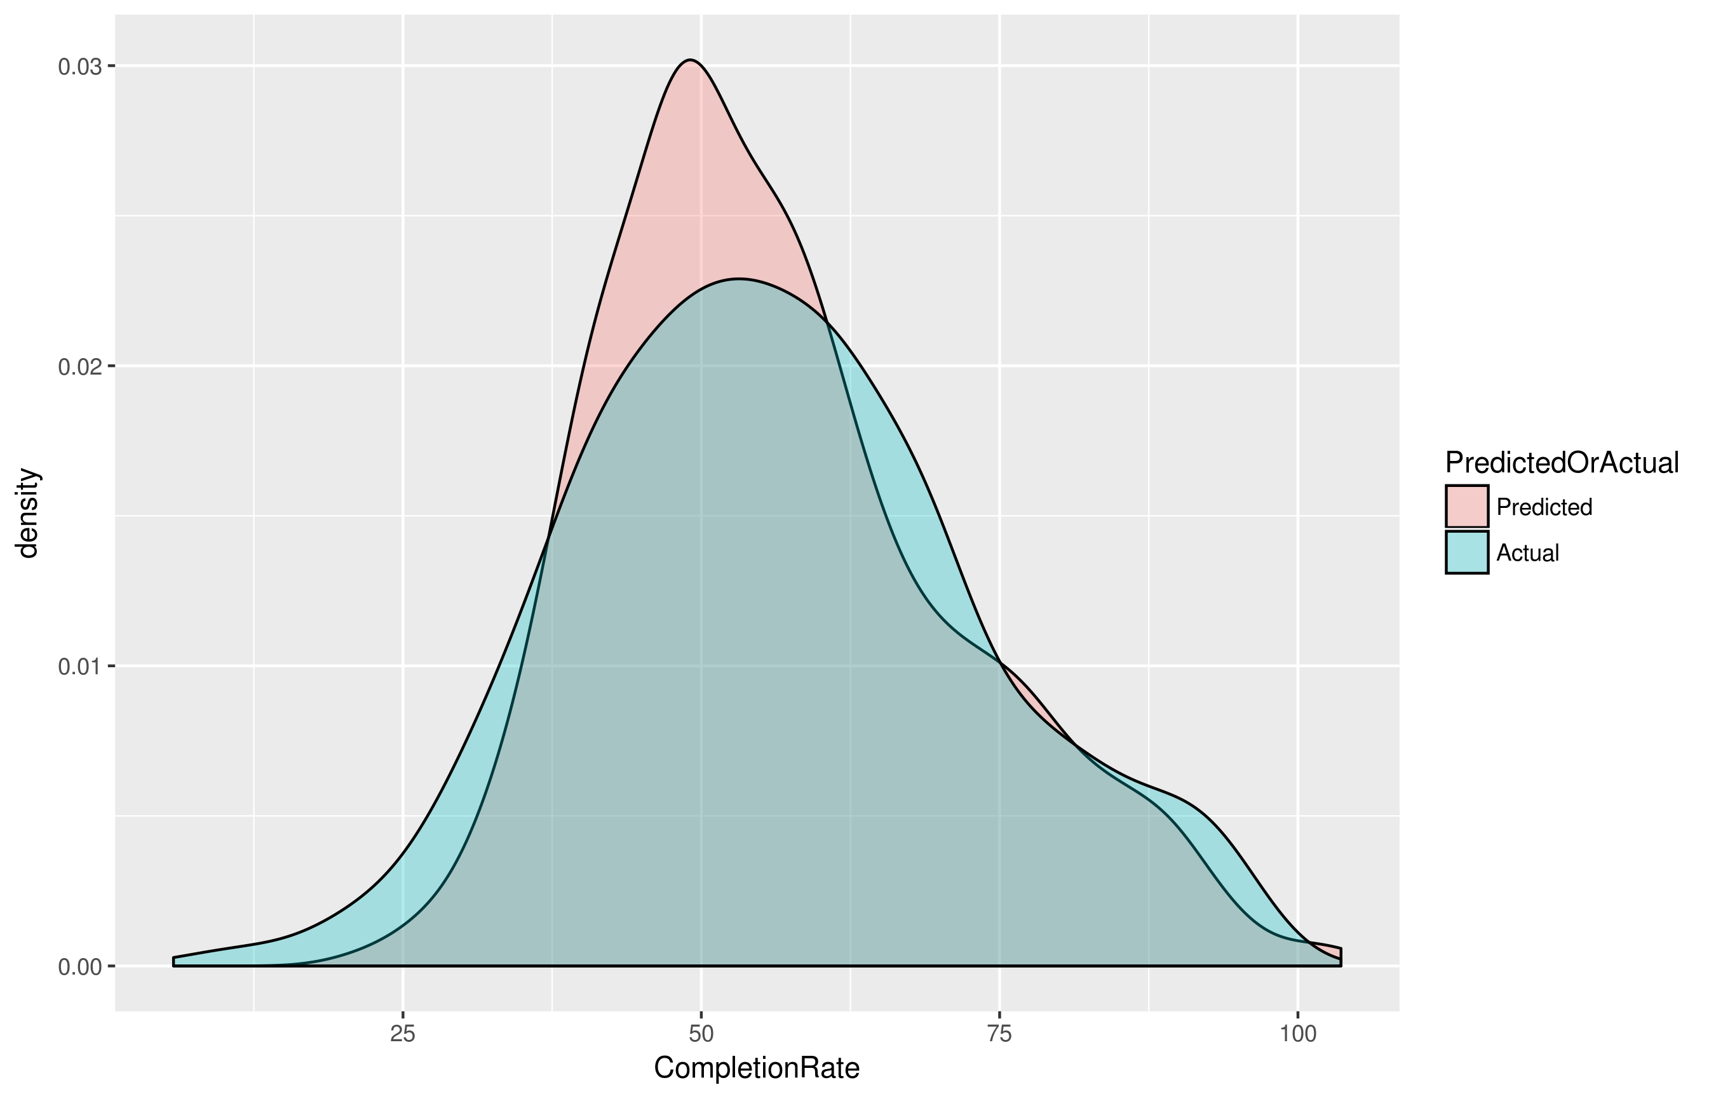
Additionally, to get an idea of how the data was being predicted, I plotted the density of fitted against actual completion rates:
As you can see, the predicted values were more tightly surrounding the mean completion rate, likely due to the so-called “regression effect” of the linear regression model, wherein predicted values are “regressed” to the mean.
CONCLUSIONS
Ultimately, while the model theoretically explains the completion rate of students very well, when plotting and exploring further, it becomes clear that there is simply too much variance for the model to be able to accurately predict the completion rate from the given covariates. This is further hindered by the limitation of only working with complete cases in the year 2013, which greatly (by about two orders of magnitude) reduces the number of rows from which to draw conclusions.
NEXT STEPS
Unfortunately, due to the restrictions I mentioned, there may be little I can do to improve the behaviour of the model. There are definitely many outliers within the set as evidenced by the sharp spikes in the confidence interval plot, or the evident outliers in the residual plot, so some care could be taken to remove those values; however, because I created my code to be very modular, I would like to revisit the dataset to explore other combinations of response and covariate variables to see what other patterns may emerge from the data.
ATTRIBUTIONS
The College Scorecard dataset is made freely available by the US Department of Education; however, the copy of the dataset I used is made available by Kaggle at: https://www.kaggle.com/kaggle/college-scorecard
Please note that there is existing exploration of this dataset under the kernels section at Kaggle. I utilised some of this exploration to debug my usage of the RSQLite package.

APPENDIX: SIMPLE LINEAR REGRESSION PLOTS
