**Project-based Learning Report**

**Chongqing University Students’ Awareness to the Euthanasia**



**Class: 009**

**Team Members:** Cao xueli (20174443)

Long Yuting (20174365) Wang Yu (20174759)

Xie Minghui (20174319)

Guo Ziduo (20174346)

Xie Chunlong (20174378)

**Supervisor: Wang Xu**

**College of Foreign Languages and Cultures**

**Chongqing University**

**June 2018**

**大学英语项目研究报告**

**重庆大学学生对安乐死的看法**



**教学班:** 009

**项目组:** 曹雪莉 (20174443)（计算机学院）

龙雨婷 (20174365)（计算机学院）

王彧 (20174759)（经管学院）

谢明辉 (20174319)（计算机学院）

郭子铎 （20174346）（计算机学院）

谢春龙 （20174378）（计算机学院）

**指导教师:**  王旭

**重庆大学外国语学院**

**2018年6月**

# **Abstract**

This study examined Chongqing University students’ awareness on euthanasia. A few months ago, our group members found that although euthanasia is illegal in China, it is getting attention by more and more people. So we do this research trying to know how much Chongqing University students know about euthanasia and what are they attitudes. Before we did this research, we have read some literature on the Internet to get a more clear understanding on euthanasia and to browse other studies similar to ours. To do this research, we designed a questionnaire with 15 questions and distributed it to Chongqing University students via the Internet. After we got the data, our group members made analysis on different parts of it and got our conclusion. In our results, Chongqing University students, no matter what their gender, specialty and grade are, mostly held a positive attitude towards euthanasia. And most of them hoped in the future euthanasia would be legalized in China. Interestingly, there were some slight differences among genders and specialties.

**Key word**s: euthanasia, Chongqing University students’ awareness, legalization in China

Content

**Abstract** 1

**1.Introduction(郭子铎)** 3

**1.1 Background** 3

**1.2 Significance & purpose of this study** 3

**1.3 Main content** 3

**1.4 Research Method** 4

**2.Literature Review** 4

**2.1 The basic concept of euthanasia（龙雨婷）** 4

2.1.1 The broad sense of euthanasia and the narrow sense of euthanasia 5

2.1.2 Active and passive euthanasia 5

**2.2 The development and present situation of euthanasia** 5

**2.3 Different researches and their theories（谢明辉）** 6

2.3.1 Some theories concerning euthanasia 7

2.3.2 The reasons why the legislation of euthanasia in China is very necessary 7

2.3.3 The reasons why euthanasia should not be legalized in China at the moment 8

**2.4 The similar researches（谢春龙）** 8

2.4.1 Different regions’ perception to euthanasia 8

2.4.2 Awareness of medical students and medical stuff to euthanasia 9

2.4.3 College students ' views on euthanasia 10

**2.5 Our research’s value** 11

2.5.1 Practical significance 11

2.5.2 The special role of college students 11

**3.Methodology（曹雪莉）** 12

**3.1 Participants** 12

**3.2 Material** 12

3.2.1 Questionnaires 12

3.2.2 SPSSAU Online Analysis 12

**4.Results and Data Analysis** 13

**4.1 The Degree of Understanding to The Euthanasia（龙雨婷）** 13

**4.2 The Degree of Approval to The Euthanasia（郭子铎）** 16

**4.3 Reasons for China’s Delay in Legalizing Euthanasia（王彧）** 18

**4.4 The Way out of euthanasia（王彧）** 20

**4.5 Professional Analysis（曹雪莉）** 22

4.5.1 The Validity of Our Data 22

4.5.2 The Influence of Gender 23

4.5.3 The Influence of Specialties 24

**4.6 The discussion of comparison between our data result and other similar researches(谢春龙)** 24

4.6.1 The extent of knowing the euthanasia: 24

4.6.2 The degree of approval to the euthanasia: 25

4.6.3 The reasons for approval and disapproval of the euthanasia 26

**5.Conclusion（谢明辉）** 27

**Works Sited** 29

**Appendix** 31

# **1.Introduction(郭子铎)**

**1.1 Background**As is known to all, whether euthanasia should be made legal has always been a sensitive question among all over the world, especially in Christian nations. It’s not simply to be a matter of law, but also up to moral views to man’s life. Currently, euthanasia is forbidden by Chinese law, and we can hear more and more voices of calling on for euthanasia legalization. There are also some places in the world where euthanasia is legal which proves the possibility of using euthanasia. But on the other hand, there are plenty of people who strongly against the using of euthanasia especially in the field of medical treatment. Because they believe using euthanasia is the way doctors being irresponsible.

## **1.2 Significance & purpose of this study**

We believe that the investigation among college students’ attitude towards euthanasia is very significant. And through the investigation, we believe that we can find the sense of values towards life and death present-day of college students. No matter what the result ends, it will be the understanding of the dignity of death.

## **1.3 Main content**

The study mainly consists of three parts, “the current situation of euthanasia in China”, “the public’s two main attitudes toward euthanasia based on China’s national conditions ‘and “analysis of the survey and discussion on the feasibility of euthanasia in Chinese legislation”.

In the first part, the study will talk about the current situation of euthanasia in China. The problem of euthanasia in China has not yet been formally discussed, but the advanced medical technology in China, which makes euthanasia a problem, has a large number of introduction and promotion. Although our country has quietly cases of euthanasia, euthanasia has not obtained legal status. And we will carry out research more deeply on why Chinese government bans the use of euthanasia on humans. The study will also compare different attitudes between Chinese government and some western governments.

Then, we’ll give out some questionnaires in our college and Xijie. The questionnaires will ask public’s level of understanding and acceptance about euthanasia. And we are going to analyze the reasons why the two different attitudes show up.

Eventually, the study will use the data we collected to analyze the two sides of euthanasia’s legalization in China and we’ll discuss the feasibility of euthanasia in Chinese legislation.

## **1.4 Research Method**

We mainly used questionnaires to collected opinions from students, and local people, which include electronic questionnaires for students and paper questionnaires for local people. On the other hand, we will interview some people how they look upon euthanasia in Chinese law selection at random. To look into it, we will also browse some scientific.

# **2.Literature Review**

## **2.1 The basic concept of euthanasia（龙雨婷）**

The word ‘euthanasia’ arouses a mixture of feelings and images in most people. On the basis of its Greek derivation, the word comes from eu, meaning well, and thanatos, meaning death. Thus, euthanasia is defined as ‘good’ or easy, painless death. It is more fully defined in Webster's Dictionary (1961) as the ‘act or practice of painlessly putting to death persons suffering from incurable and distressing disease’. As medical technology has advanced, the subject of euthanasia has been the topic of debate not only by physicians and other health professionals, but also by lawyers, theologians, politicians and the lay public. (Carolyn Winget & Frederic T. Kapp & Rosalee C. Yeaworth, 1977 )

The essence of euthanasia is not to decide life and death, but to decide whether it is pain or ease when death. The purpose is to avoid the mental and physical pain through artificial adjustment and control, so as to achieve the feeling of comfort and happiness. It can also be said that this is the improvement of the self-feeling state of the dead.

Generally speaking, euthanasia can be divided into broad sense or narrow sense, active or passive and positive or negative.

### 2.1.1 The br**oad sense of euthanasia and the narrow sense of euthanas**ia

The broad sense of euthanasia refers to the death of some infants at birth which are severe disability or dementia, some severe psychotic or disabled in the society, and the vegetable in the irreversible coma.

Euthanasia in a narrow sense refers to a way in which prompts patients who suffer from terminal illness and are in extreme pain to die without pain and rapidly.

### 2.1.2 Active and passive euthanasia

Active or positive euthanasia means that doctors take some measures to speed up the death of patients in order to relieve the pain of dying patients with serious diseases.

Passive or negative euthanasia means the doctor suspends his measures to maintain the life of the patient who is dying of a terminal illness. ( Tao Ouyang，1996）

## **2.2 The development and present situation of euthanasia**

With the progress of medicine, the controversy over euthanasia has never ceased. In seventeenth Century, Francis Bacon mentioned "mercy killing" many times in his works. In 1930s, many countries in Europe and America have actively advocated euthanasia. Euthanasia has become a new human rights movement, and even a voluntary euthanasia association has been established. Just because German Nazis intervened and usurped the name of euthanasia, they slaughtered millions of innocent people, making euthanasia very bad. After the Second World War, due to the development of medical science and biomedical engineering technology, the development and deepening of humanitarianism in the west, euthanasia has become a hot topic in many countries. Until now, people still have different opinions about euthanasia. But in general, after more than half a century of debate, the ratio of supporting euthanasia is increasing.

Nevertheless, many countries are cautious about whether to enact euthanasia law. Since 1970s, euthanasia has been legalized in some countries and regions. In 1976, the United States, the British, the Japanese, the Dutch and other countries held the first international euthanasia conference in Tokyo, and signed the Tokyo Declaration on euthanasia, which required respect for the right of "the will of life" and "the death of dignity". In 1980, the International Association for the rights of the dead was established. In February 9, 1993, the Holland parliament passed the euthanasia law, allowing doctors to practice euthanasia under strict conditions. This is the most liberal and open way to euthanasia so far. It can be seen that although euthanasia is difficult, there is no denying that it has made some progress. （Guorang Wang, 2004）

The problem of euthanasia has aroused widespread concern in the medical, legal, ethical and public sectors in China for more than ten years. Although our current law does not recognize euthanasia, it is not expressly prohibited. For example, the Ministry of health of our country has repeatedly relaxed the limit of the use of narcotic drugs for advanced cancer patients. In fact, it is the recognition of euthanasia in a certain range of Chinese laws or policies. At the present stage of China, despite the high demand for euthanasia legislation, the right attitude towards euthanasia legislation should be positive and prudent.

## **2.3 Different researches and their theories（谢明辉）**

There are many different researches concerning euthanasia, they analysis euthanasia from different perspectives, now let me show you some different theories to you.

### 2.3.1 Some theories concerning euthanasia

The dispute between the sacred theory of life and the theory of quality of life is the primary ethical controversy in euthanasia. The sacred theory of life denies that euthanasia has ethical value and believes that human life is “sacrosanct.” Any person must not arbitrarily end his life against God’s will, including his own life and any other person’s life, that is, “Man’s living is not an option. But an obligation." Due to Western religious traditions, the view of the sacred theory of life is quite popular. The quality of life theory affirms that euthanasia has ethical value, highlights the importance of human rights and human social values, and believes that people have social attributes. Therefore, on the one hand, people must ensure that the minimum quality of life is necessary to continue to survive. On the other hand, with social values, when the social value is destroyed, the quality of human life loses its meaning. People have the freedom to choose to end their lives.

### 2.3.2 The reasons why the legislation of euthanasia in China is very necessary

Euthanasia is a persistent and controversial issue in China. From Chinese scholar zhao zubing’s research, Euthanasia helps ease the pressure of inadequate medical funding. The medical resources of a country are limited and it is impossible to treat each patient equally. (zhao) According to the authoritative data in 2013, the current death rate of cancer in China has been rising in a straight line. If these patients are treated with unrestricted treatment to continue their lives, it is conservatively calculated that each patient will spend RMB 300,000 per year. This will not only increase the burden on the government and society, but also increase the burden on the family. For example, many patients admitted to having a serious illness. The home economy "has returned to liberation overnight". If we euthanize terminally ill patients, we can not only save the family's emotional crisis, but also relieve the family and society's burden, thereby more rationally distributing social medical resources. (zhao) We should use limited medical resources in more valuable places, such as cancer patients. From a certain point of view, it is a waste of resources. On the contrary, we can put more resources on the establishment of basic medical and health facilities, enhance the physical fitness of citizens, and increase research efforts in cancer prevention and cancer treatment.

In addition, euthanasia does not constitute a criminal law offence. Euthanasia is where the doctor respects the autonomy of the patient's life at the request of the patient, but the patient dies peacefully and can resolve the pain of the patient. The implementation of euthanasia does not have serious social harm. Euthanasia has a constitutional nature. It protects the citizens’ right to life autonomy and citizens’ right to human dignity(Zhao) On the other hand, euthanasia is widely accepted by society.

### 2.3.3 The reasons why euthanasia should not be legalized in China at the moment

The reason why euthanasia is not legalized in many countries is because it has many negative factors. Euthanasia is difficult to fully reflect the autonomy of the parties and is not conducive to the protection of their right to life and health. China is currently unable to provide comprehensive medical protection. Therefore, it is difficult to guarantee the equality of patients and to exercise their rights voluntarily. In the Netherlands, because of the provision of universal health care, economic factors that accelerate the death of relatives do not exist. In China, socially disadvantaged groups are in the state of self-paying or semi-arrival medical care, and medical insurance is not sound. (Wang) On the other hand, controlling the market access of private equity funds must be based on two aspects. One is the determination of the eligibility of private equity fund managers and the other is the requirement for eligibility of private equity fund investors(Wang). Therefore, we should perfect information. Otherwise, the correct execution of euthanasia cannot be guaranteed. On the other hand, the traditional Chinese moral concept is deeply rooted. International context and political considerations is another important factor.

## **2.4 The similar researches（谢春龙）**

Over the years, domestic scholars have done a lot of similar research. To better understand and study the subject, we divide the similarity study into three parts.

### 2.4.1 Different regions’ perception to euthanasia

Euthanasia is a persistent and controversial issue in the country. Almost every region of the country had done research on euthanasia. In Guangzhou, 70%~80% of participants are in favor of euthanasia and it is a tendency to increase with age. Teachers have the highest degree of consent to euthanasia in different occupations(Liu&Cui,1997). In Chengdu, 58.7% of participants approve of euthanasia. The age is younger, and the income is higher, the approval rate is higher. Besides, the most important reason for euthanasia is to protect patients from unnecessary suffering(Jiang&You&Xie,2008). In Henan, 50.3% are in favor of euthanasia. Higher education tends to favor euthanasia legalization. But The doctor's approval rate is only 36.8%(Zhao,2014). In Beijing, the proportion of people in favor of euthanasia is 79. 2%. Higher education is related to approval of euthanasia and the doctor's approval rate for euthanasia is highest at 81. 8%(Wu,2010).

We can see that people in different regions agree on euthanasia differently. People in the developed regions have a higher degree of approval. These surveys also have commonalities, for example, the higher the level of education, the more support for euthanasia. But there are many different results, such as doctors ' understanding of euthanasia and the influence of age on euthanasia.

### 2.4.2 Awareness of medical students and medical stuff to euthanasia

In Jiangsu Province, in a survey for medical students on euthanasia attitude in medical college, 63. 9% respondents agree to the implementation of euthanasia, but 63.34% of the respondents do not agree with the current legislation in China to implement euthanasia. The overall cognition of medical students to euthanasia is not high, and medical students are more contradictory to whether they should implement euthanasia(Zheng&Chen&Gong,2017). However, in another investigation, the awareness rate of euthanasia is 63.9% and 63. 5% of the respondents think that the legislation of euthanasia in China is very necessary. "*Most respondents have some understanding for euthanasia, and the cognition on the death and euthanasia in medical students is limited because of the influence of traditional ideas. The attitude on euthanasia of respondents is rigorous. It is necessary to strengthen the ethical and death education among the medical students, and rightly guide students to understand death and euthanasia* (Zhao&Yang)”. The medical students in different areas know very differently about euthanasia. Compared to ordinary college students, they have more consideration and concern about euthanasia.

In the investigation of Study on the attitude of clinical medical staff to euthanasia and related problems, medical staff in different departments are basically consistent in their attitude towards euthanasia, most of them express a clear attitude towards euthanasia, with a neutral attitude of no more than 20%, and the attitude of approval is obviously more than those who hold negative attitude. 62.5% said they were willing to kill for the patient. In the clinical work, most medical personnel have met the patient or his family member to offer the request of euthanasia for the patient. Most medical staff are active in the implementation of the euthanasia and are willing to be the perpetrators of euthanasia(Yang,2000).

### 2.4.3 College students ' views on euthanasia

From research of He and Shan(He&Shan,2009): Students basically affirm the legitimacy of euthanasia. There is a similar understanding of the conditions for the implementation of euthanasia. The legalization of euthanasia holds an objective and cautious attitude on the basis of basic agreement. The understanding of the conditions for the legalization of euthanasia is more comprehensive, that is, on the basis of respecting the patients ' wishes, seeking the objective audit of social justice. The implementation object of euthanasia embodies the humanism concept of contemporary college students. The choice of the timetable of legalization of euthanasia can be seen that college students according to their own knowledge that the social understanding that euthanasia is based on social concepts, will be the rule of law, social economy and social security and other aspects of the conditions and improve. Some scholars consider that the condition for legalizing euthanasia has matured in country. In this investigation, the proportion of euthanasia is 87.1%, which accounts for the overwhelming majority, indicating that the degree of education is positively correlated with the approval of euthanasia(He&Zheng&Wei,2005). The relationship between euthanasia and medical students is much larger, but there is no obvious difference between the majors and the attitude towards euthanasia.

But in some studies, things are different. In a survey, the pro-euthanasia vote was only 48.9%. Because of the different knowledge structure and the difference of thinking mode, the support rate of the students of science and engineering to euthanasia is higher than that of literature and history students. Students from cities are more supportive of euthanasia than students from rural sources(Huang&Zhao,2009).

## **2.5 Our research’s value**

The value of our research is mainly because euthanasia itself has a long-term research significance, while college students are also as a solid force for the future of this society exist

### 2.5.1 Practical significance

Euthanasia as a research topic, it is very controversial. In history, many foreign scholars have studied this problem and tried to find the justification or improper basis of euthanasia. But the basis of scholars ' submission is always incomplete and has its own flaws. At home, because of the traditional ethical values of China's national conditions, the research on euthanasia has not made great progress. The problems that come out of euthanasia are complex and confusing, because it is related to a wide range of fields, including law, philosophy, medicine, ethics, traditional culture and so on. At the same time, it also covers people's desire for survival, fear of death, fear of crime, concern for ethics. With the progress of society, people's ideas change gradually, people's demand for euthanasia also appears more and more urgently. It is more and more important to discuss the legalization of euthanasia. The study of euthanasia is not only to find out the way of euthanasia, but also is very significant.

### 2.5.2 The special role of college students

Euthanasia as a social and cultural phenomenon cannot be avoided in human society, since the 1930s in some European countries and in the United States some people advocated euthanasia, people have not stopped arguing. Because euthanasia involves the right of human life and the security and stability of society, so the discussion and treatment of euthanasia appears especially cautious. The analysis and discussion of the theory of euthanasia and the empirical research are all indispensable, and the two should be paid equal attention. Modern college students not only have a strong ability to accept the new things, but the cognitive side of the thing, but also have the courage to change, stress efficiency, pay attention to the characteristics of reality(He&Shan,2007). As college students move towards society, their cognitive views on euthanasia will undoubtedly. Mainstream consciousness has a far-reaching impact. As the recipient of the new culture and the Master of the future of the society, the concept of euthanasia is of great significance to the legislation of euthanasia in our country. Keep abreast of the pace of the times, we have conducted a questionnaire survey on the understanding of euthanasia among students in Chongqing University and obtained more abundant data, hoping to compare with the existing similar research. From different levels and in different ways, we can get meaningful results. We hope to provide as many useful research materials and evidences as possible for future euthanasia research and legislation.

# **3.Methodology（曹雪莉）**

## **3.1 Participants**

We distributed 71 questionnaires to Chongqing University students including 37 boys and 34 girls. 52 of them are freshmen, 8 of them are sophomores, 8 of them are juniors, 2 of them are seniors and only 1 of them is postgraduate. They are from different specialties such as engineering, architecture and science.

## **3.2 Material**

### 3.2.1 Questionnaires

We tried to distribute questionnaires online to know about Chongqing University students' awareness of euthanasia more efficiently. And with the help of the Internet, we can get accurate analysis of data and obvious difference among data.

### 3.2.2 SPSSAU Online Analysis

With the help of SPSSAU, an online data analysis application, we put all our data into two parts, quantitative data and fixed class data. From quantitative data, we can compare data between different choices to get a direct result. From fixed class data, we put data into different classes to research a certain kind of people’s choices, such as different genders.

# **4.Results and Data Analysis**

Based on the purpose of our study, our questionnaire mainly focused on four aspects. The first aspect was written to roughly know about CQU students’ understandings of euthanasia. The second aspect wanted to have a clear research on whether CQU students were for euthanasia and deeply investigate on the reasons they were for or against euthanasia. The third aspect focused on CQU students’ opinions about why euthanasia was still not illegal in China. The last aspect was about CQU students’ viewpoints on the future situation of euthanasia in China.

jin

## **4.1 The Degree of Understanding to The Euthanasia（龙雨婷）**

**4.1.1** **How much do you know about the euthanasia?**

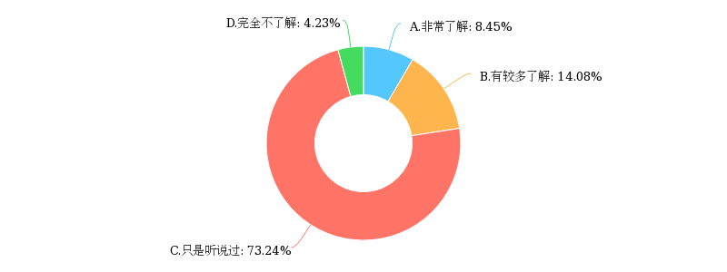As you can see from this chart, nearly three fourths of the students have just heard of euthanasia. 14.08% know more about it and only 8.45% know it well. Nevertheless, merely 4.23% students know nothing about it.

We can see that the vast majority of students from CQU know more or less about euthanasia. In addition, the proportion of students who know nothing about euthanasia and the proportion of students who know it well are both very small. It indicates that most of the students in CQU have heard about euthanasia, however, the overall cognitive level of them for the degree of understanding of euthanasia is not very high. This may be related to the fact that euthanasia has not been formally discussed in China, which leads to the unpopularity of the concept of euthanasia.

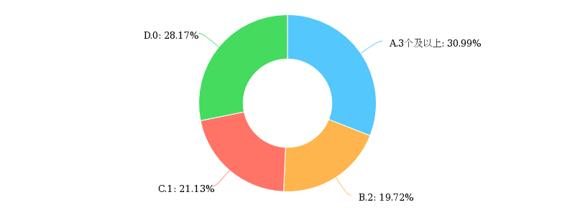**4.1.2** **How many countries or regions do you know allow the euthanasia?**

According to the question “How many countries or regions do you know allow the euthanasia?”, the result is roughly average. 30.99% students know three or more than three countries. 28.17% know zero. 21.13% know one country and 19.72% know two countries. The result is roughly average.

Students' attention to news is different in their daily lives, thus their related knowledge about the present situation of euthanasia is different. We can learn that students’ degree of understanding to euthanasia’s present situation vary from person to person.

**4.1.3** **The following descriptions are consistent with your situation?**

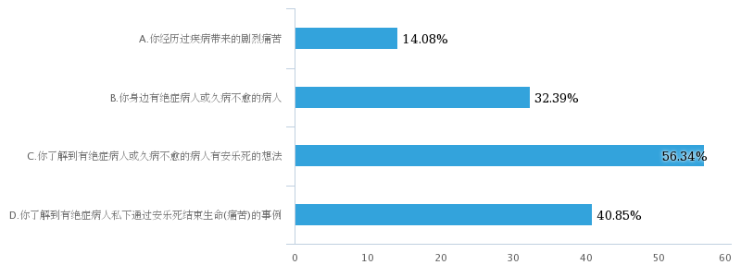In this question, students need to choose from the following descriptions which are consistent with their situation. The top three answers are “You know patients with incurable diseases or those who had not recovered for a long time had the idea of euthanasia.”, “You know terminally ill patients who had died through euthanasia in private.” and “You have terminally ill patients or patients who are not cured for a long time in your around.”

Students of CQU have more or less been through the related issues about euthanasia. This shows that problems related to euthanasia do exist in our lives and more and more people pay attention to it. Regulating the laws related to euthanasia as early as possible is meaningful. It is necessary to seriously explore the related issues of euthanasia, such as the rationality of legislation, related ethical issues, medical problems and so on.

**4.1.4** **Who do you think can decide the euthanasia?**

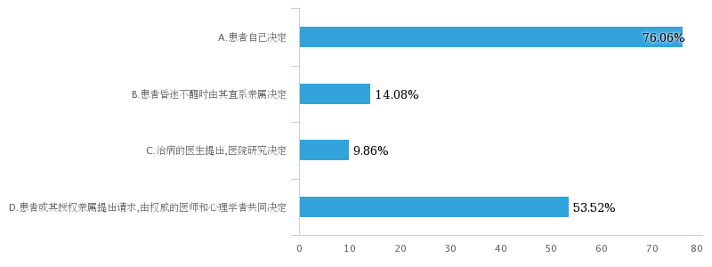According to the question “Who do you think can decide the euthanasia?”, 76% of the students advocate that it should be decided by patients themselves. Meanwhile, 53.52% think the patient or his authorized relatives have the right to decide the euthanasia by making a request jointly decided by authoritative doctors and psychologists. We can see that there are still a few students hold the opinions that it can be decided by direct relatives when the patient is in a coma or it can be decided by the doctor.

It shows that most of the students have a sense of human rights. They firmly believe that the right to decide whether a person continue to live or not should belong to himself. Nobody has the right to deprive others’ right to life. In addition, these data also show the students’ highly concern about the moral problems in the process of euthanasia. We may be able to draw the conclusion from it that ethical problems will be a great obstacle to the legalization of euthanasia.

## **4.2 The Degree of Approval to The Euthanasia（郭子铎）**

**4.2.1** **If you are an ill patient with a terminal disease, would you want to die of the euthanasia?**

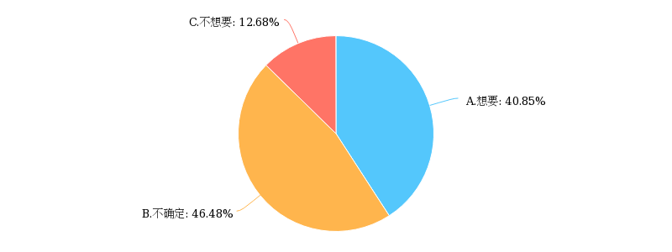

We can see that half of the people are unclear to this question or never thought about it and about people who prove or disprove we can see that three-quarter of them agree about using euthanasia on themselves and facing the terminal disease, they would like to die in an easy way.

**4.2.2** **If you are one of the closest relatives or friends of the patient in last question, would you agree to the patient's euthanasia?**

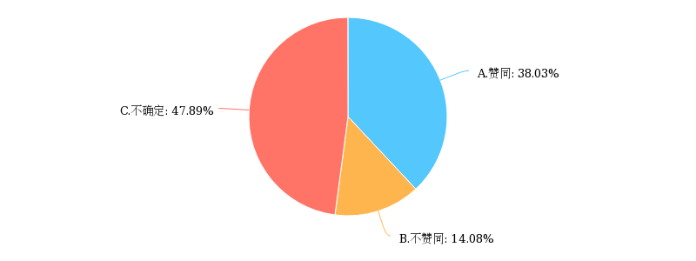

If you look at the shape of the Pie chart you can see that it’s quite similar to the first question which means that no matter they are facing the dilemma about themselves or their relatives, they have the same answer.

**4.2.3** **If you are in favor of the euthanasia, the reasons are:**

图片包含 屏幕截图

已生成高可信度的说明

We can see the two main reasons are the respects to the human rights and the way the patient and his family to get rid of the pressure of economy and emotion. So, we can say that the reasons make euthanasia be accepted by people are its use and the human rights it symbolizes.

**4.2.4** **If you are against the euthanasia, the reasons are:**

图片包含 屏幕截图

已生成高可信度的说明There are three main reasons and they are:

It may become the excuse to avoid the duty to support people’s parent. Someone may easily end their lives just because of the pressure of economy or emotion problem. It may become the instrument of crime.

We can say that the three main reason are all talking about it dangerous use and what social crisis it may bring. So, we can say that euthanasia can be a two-edged sword.

## **4.3 Reasons for China’s Delay in Legalizing Euthanasia（王彧）**

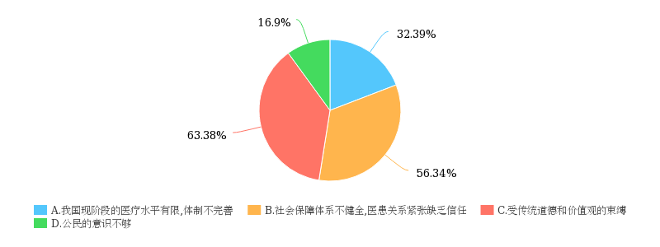**4.3.1** **What do you think are the reasons why our country does not implement the euthanasia at this stage?**

As the pie chart shows that 63% of people choose that “it is affected by traditional thinking and the value people taken.”56% of people think the lack of trust between patient and doctor is the reason. Meanwhile, 32% hold the view that the medical level now is still low. A few people think it is because of a lack of consciousness.

The way people think and the value they choose to follow can affect the degree of accepting new concepts such as “euthanasia”. And traditional thoughts can be dated back to millions years ago, which shows it has a stubborn influence in our daily life, and that maybe leads us to the related option.

**4.3.2** **If the euthanasia can be legalized in China, the reasons are:**

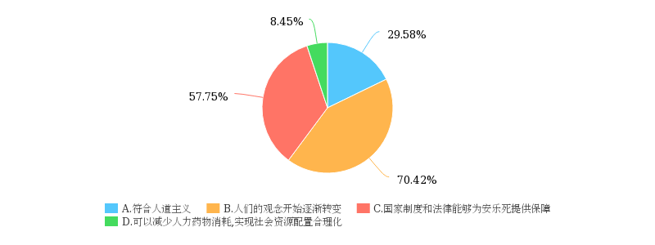In this question, 70% of people suggest it is because of the change in residents’ value. 57% owe it to the establishment of relevant laws. Nearly 30% advocate it shows humanitarianism. Only 8% choose it can reduce the waste of medical resource.

The same as last question, the value is a main factor when people try to accept new things, if the attitude towards euthanasia is changing, that means the existence of euthanasia is becoming easier to be accepted, so as becoming legal.

## **4.4 The Way out of euthanasia（王彧）**

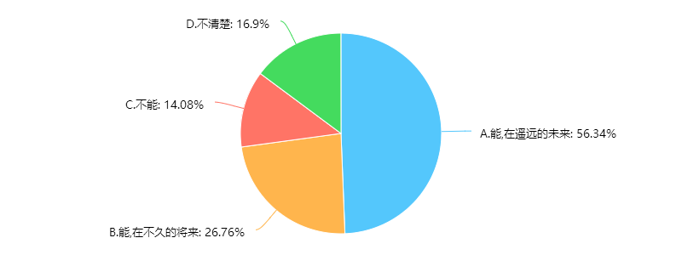4.4.1 Do you think the euthanasia can be implemented in China?

As for this question, there are 56% of people choosing “Yes, but it has a long way to go.” And another 26% approve, they choose “Yes, and it can be implemented soon.” A few students give a negative answer, the rest choose an unknown answer.

There are over 80% of students believe the euthanasia can be legalized in China even if some of them think it is not for now. That shows more and more people, especially young people, can accept this new method of death. Meanwhile, it indicates the confidence of students in the process of the improvement of Chinese law.

**4.4.2 What conditions do you think society should meet before the euthanasia is legalized?**

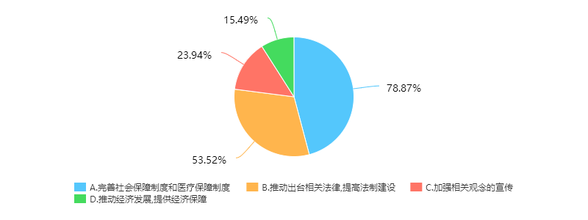The top two answer of this question can be list that “the social security system should be improved.” “There ought to be a relevant law that can ensure the proceeding of euthanasia.” Different from 4.3, “advertising on concepts” only occupies the third place.

The consequence of this question illustrates that the concepts affect the acceptance, but in the process of carrying out the euthanasia, the law and the system are the solid foundations which can guarantee the legalization.

## **4.5 Professional Analysis（曹雪莉）**

### 4.5.1 The Validity of Our Data

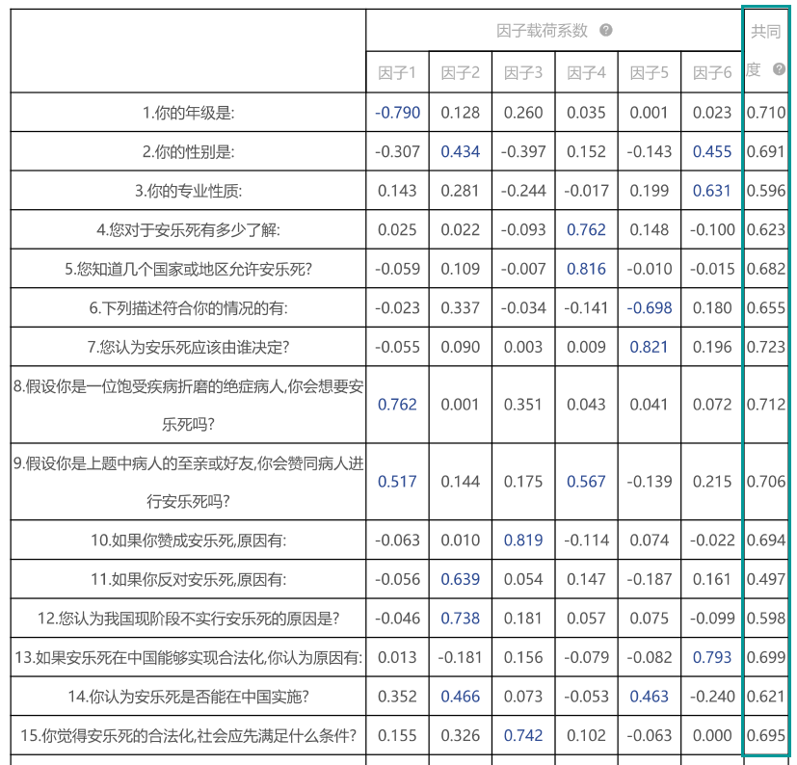Communalities represent the relevance of one item to other items and help us to know whether the choices of our questions are suitable and valid. The standard value of communalities is usually 0.4. From the chart above, all communalities of our data are higher than the standard value, which means the information of our research items can be effectively extracted.

### 4.5.2 The Influence of Gender

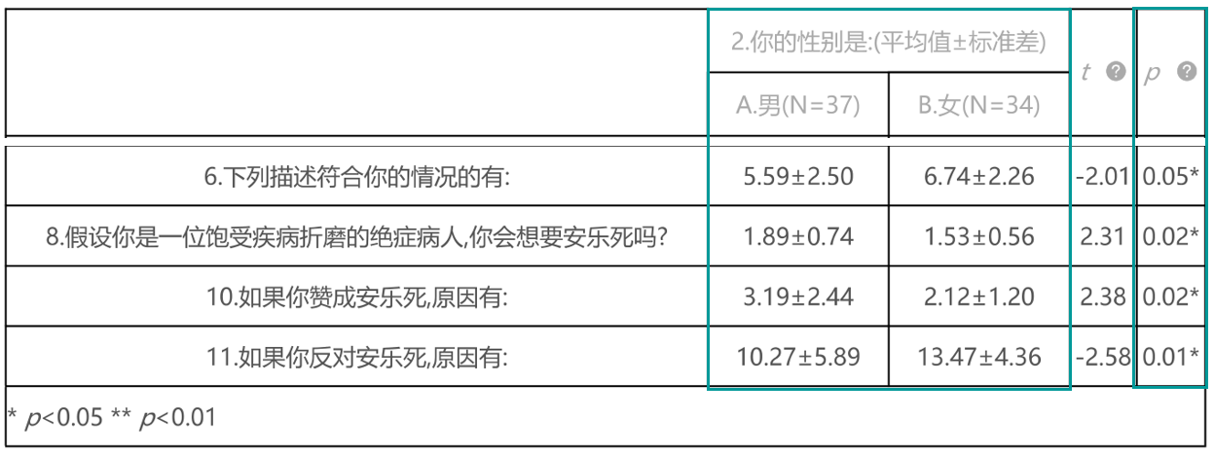T test (full name: Independent-samples T test) results:

The variable “p” in the chart indicates the differences between genders. When “p” is lower than 0.05 or 0.01, we pick these questions out to conduct further analysis. So with the help of SPSSAU, we can know the effect of gender mainly reflects on question 6, 8, 10 and 11.

In question 6, the average value of male students is much lower than females’. From this, we know that female students in Chongqing University know more about euthanasia than male students.

We can put questions 8, 10 and 11 together to analyze. In question 8 and 10, the average value of male students is higher than females’. Accordingly, in question 11, the result is that the average value of female students is higher. All these 3 questions tell us on thing, male students take a more open attitude towards euthanasia and they are more willing to accept euthanasia than female students.

### 4.5.3 The Influence of Specialties

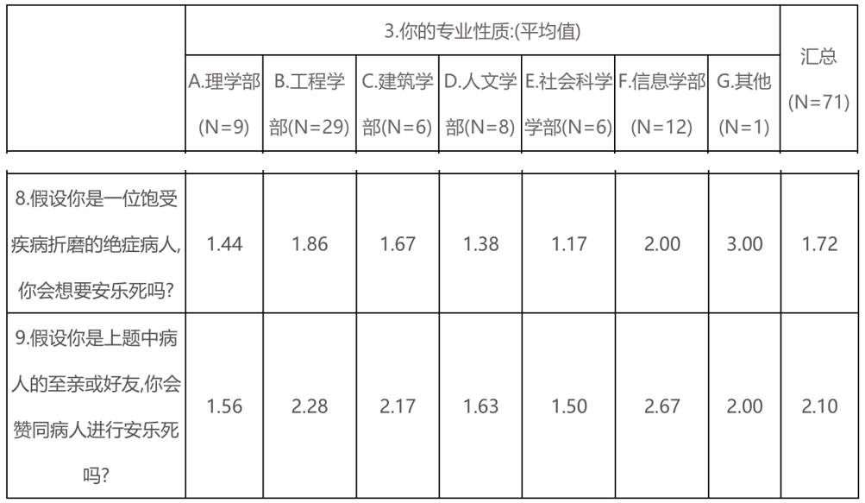Variance analysis results:

Variance analysis is also a way to explore the differences between different categories. Actually, question 8 and 9 mainly focus on whether Chongqing University students are for euthanasia. Interestingly, we found distinct differences between specialties. The data in the chart shows students major in information science agree with euthanasia most but euthanasia gains least approval from those who major in social science. We may think why the two specialties have such huge diversity. In fact, students major in information science often sit in font of computers and they get in contact with the new world almost every second. They love to hug new things and want to try everything new. However, students who major in social science learn more about economic, politics and sociology. They tend to be more cautious about new things. So that is why these two kinds of students behave so differently.

## **4.6 The discussion of comparison between our data result and other similar researches(谢春龙)**

### 4.6.1 The extent of knowing the euthanasia:

From several euthanasia researches to ordinary people, we can see that the basic knowing degree of their research participant to the euthanasia are approximately from 60%-70%. Our research result with some similar research result to college student revel that college students’ knowing degree are approximately from 70%-80%. It’s clear that the knowledge width of the euthanasia to college students is broader than most ordinary people and this difference is about 10 percentage points. And it also indicates that this difference is not obvious, and the knowing degree of the college students compared to the ordinary people is roughly same in a way. In the question of the extent of knowing the euthanasia in our research, we can see that only 8.45% students are very aware of the euthanasia, but 73.24% express that they just have heard the name of the euthanasia. So, the most students know less about the question of the euthanasia like most ordinary people.

The euthanasia is an objective reality that exists in China now. We cannot avoid this question owing to its sensitivity but to solve it form the protection to people’s basic interests, which is consistent with the values of social work. As a conclusion, it’s necessary to improve the whole society’s values and raise people’s awareness to the question connected to their own basic rights, which helps to improve the citizens’ comprehensive quality. Besides, the society should put more importance on the new generation of the intellectuals to improve their self-culture and self-value. The new generation should also attach more attention on their own professional knowledge. The euthanasia is not the thing that we cannot to solve, but we have to prepare adequately for the better solution of the euthanasia question.

### 4.6.2 The degree of approval to the euthanasia:

According to the research result which was made by Ma, Qian and Fang, 53,1% of the survey participants who have had illness are willing to choose euthanasia and the people’s acceptance rate is 62.0% who do not have illness history. In the He’s data result, he pointed that the favor rate is nearly closed to two thirds and over 70.0% people are not against the euthanasia when they encounter the unfortunate accident. Besides, his research also indicates that 84.0% agree the dying people should have their own rights to decide the way of their death. But in Huang ‘s research result, the approval people are just accounted for 48.%. Return to our research, 40.85% want to die of the euthanasia when they have a terminal disease and 46.48% are not clear to their choice while just 12.68% definitely express their unwilling, which is similar to He’s research and is different to Huang’s research. The reason for the differences may be originated from the distance, culture, education and so on. And our data result is confirmed most similar research result which their approval rate varies roughly from 60% to 80% and it is also true of most general research result about the euthanasia investigation, which the approval rate is varied roughly range 50% to 80%.

From another perspective, our result can explain that the college students can more easily accept the euthanasia than most general people due to their higher education. But in another way, this difference is not obvious because college students have more consideration when they judge this confusion question. When they meet this question of the euthanasia, they have more related knowledge and logical thinking way about it over most people. As a result, they can see more clearly by their critical thinking and mindset and are easily more confused by this tough question than most people who just know less about the euthanasia and they judge this question just on its surface but for college students they can put their thinking way into the inside of this question. With the development of the people’s awareness, they can accept the euthanasia but maybe they just think that they have the basic right when they face the choice of death and most people are subjective to this question. It’s different to college students. The college students consider more factors such as the medicine, the criminal, the society safety and so on and they are more objective to the euthanasia. They treat this question from a more academic and integrated angle, some of them are hesitated to do this selection and the approval rate of euthanasia will may be lower than most ordinary people as the depth and width of the education and academic learning in the future.

### 4.6.3 The reasons for approval and disapproval of the euthanasia

From the euthanasia research to the college students of He and Zheng, 83.8% students think that the moral value is the reason to obstruct the implantation of the euthanasia. And we can know that 88.0% students consider that the individuals should have their right to decide their own life and 73.9% believe that pursuit to the quality of one’s life is the goal to achieve the life value be the result of Huang and Zhao. Furthermore, the Chengdu’s citizens who participate Jiang’s investigation, they hold the view that the protection away from the unnecessary pain is the key reason to accept the euthanasia. Our research result shows that the major reason for the approval of the euthanasia is that it can lighten the patient’s painfulness and the main reason of the disapproval to the euthanasia is that it may cause the criminal.

Above all, we can draw the conclusion that people have the similar views to the euthanasia among ordinary people and college students. They think that the euthanasia question is belonged to the catalogue of the morality and the value concept. And people can have their basic right to choose their life when they have to face the death directly and the euthanasia can relieve people’s painfulness from the heavy illness. On the contrary, they think that the main hinder to the euthanasia is that it may cause the much more criminal and make the importance and the life value become weaker and lighter below its own level. So, it’s clear that people concern this question form the life value and life right, which is the common sense in society’s awareness and is not much related to one’s education or the culture but the moral value that is much same in Chinese traditional ethical concepts.

# **5.Conclusion（谢明辉）**

As this research demonstrates, though there are different opinions among people of different genders and profession and grades, most of the respondents do care about euthanasia. From our questionnaires, CQU students just heard about euthanasia, but they didn’t understand it, mainly because the problems have not spread concern in society, and school lack the education of euthanasia. Few of them clearly understand euthanasia, what euthanasia is, and what countries and regions are allowed to euthanasia. However, students of CQU have more or less been through the related issues about euthanasia. There are still euthanasia-related issues in our country. Students with more open minds are paying more attention to euthanasia. Judging from the survey results, most students believe that the decision to implement euthanasia depends on the patient himself. This shows that students have a strong sense of autonomy. On the other hand, whether you are a patient or a relative of a patient, they are all in favor of euthanasia mainly because of the respects to the human rights and the way the patient and his family to get rid of the pressure of economy and emotion. At this stage, China has not legalized euthanasia, mainly because of the shackles of traditional concepts and values. In addition, China’s current medical level has not yet reached the standard of euthanasia. However, many students believe that euthanasia will eventually be legalized in China because people’s values are gradually changing, the level of health care is gradually improving

To sum up, students of CQU still hope for the future of euthanasia. With the development of society, the issue of euthanasia will eventually cause people's widespread concern, and moral problems of euthanasia and legalization will eventually be solved.

# **Works Sited**

[1] Carolyn Winget, Frederic T. Kapp and Rosalee C. Yeaworth, 1977, Attitudes towards Euthanasia, Journal of Medical Ethics, Vol. 3, No. 1 (Mar., 1977), pp. 18-25

[2] 王国让，2004，安乐死的发展现状及立法探讨，中国卫生事业管理2004年01期

[3] 欧阳涛,1996，安乐死的现状与立法，法制与社会发展1996年第5期

[4] 江洁清,2000，安乐死的现状与发展趋势，福建公安高等专科学校学报.社会公共安全研究2000年04期

[5] 赵祖斌，论安乐死在中国的合法化，湖北科技学院学报，2003

[6] 王徐美慧，安乐死在中国当下不应该合法化，华中师范大学法学院，湖北武汉，2005

[7] 匡智华，我国私募基金法律监管研究，山东大学，2008

[8] 韩文娟，我国私募基金法律监管探析，华东政法大学，2005

[9] 夏强，安乐死合法化探究，中国刑事法杂志，200

[10] 赫伯特·西蒙.管理行为，北京：机械 工业出版社，2004.

[11] 王政勋，正当行为论，北京：法律出版社，2000

[12] 魏俊斌，张义松，安乐死行为的法理分析，法制博览，2017

[13] 刘国宁，崔常安，1997，广州市不同人群对“安乐死”态度的调查研究，预防医学文献信息1997年第3卷第2期

[14] 姜永东，游桂英，谢红，2008，成都市民对安乐死态度的流行病学调查，现代预防医学 2008 年第 35卷第2期

[15] 赵桂增等，2014，河南省公众对安乐死的认知、态度及意向调查，医学与社会，2014年10月第27卷第10期

[16] 吴晓瑞等，2010，北京地区安乐死社会心态的调查分析，中国医学伦理学，2010年2月第23卷第1期

[17] 郑亚楠，陈匡明，龚茜，2017，江西省某医学院医学生对安乐死的态度调查，医学与社会，2017年3月，第30卷第3期

[18] 赵龙，杨秀木，2017，医学生对安乐死的认知和态度调查，预防医学2017年第42卷第5期

[19] 杨洪，肖水源，董群惠，杨德森，2000，临床医务人员对安乐死的态度及相关问题的研究，中国心理卫生杂志2000年

第14卷第2期

[20] 何农，单盈，2007，浙江地区大学生对安乐死认同度的调查与分析，科教前沿，2009.7（下旬刊）

[21] 何农，郑布英，何卫妹，2005，大学生对安乐死意向的调查及其立法思考，中国医学伦理学2005年12月第18卷第6期

[22] 黄根茂，赵浩斌，2009，对武汉师范院校应届毕业生有关安乐死的伦理学调查与思考，中国医学伦理学2009年12月第22卷第6期

# **Appendix**

**Questionnaire on Chongqing University Students’ Awareness to the Euthanasia**

1.(single)Your grade is:

A. Freshman

B. Sophomore

C. Junior

D. Senior

E. Postgraduate

2. (single) Your gender is:

A. Male

B. Female

3. (single) Your professional nature is:

A. Department of Science

B. Faculty of Engineering

C. Architectural divisions

D. Faculty of Humanities

E. Faculty of Social Sciences

F. Faculty of Information

G. Others

4. (single) How much do you know about the euthanasia?

A. Very knowledgeable

B. A greater understanding

C. Just heard

D. Totally not understanding

5. (single) How many countries or regions do you know allow the euthanasia?

A.3 and above

B.2

C.1

D.0

6. (multiple) The following descriptions are consistent with your situation?

A. You've been through the fierce pain of a disease

B. You have terminally ill patients or patients with long illness at your side

C. You know the patients with terminal illness or a prolonged illness who have the idea of euthanasia

D. You know the case of terminally ill patients who end their lives (suffering) by euthanasia privately

7.(multiple) Who do you think can decide the euthanasia?

A. Patients decide for themselves

B. A patient is in a coma and is determined by his immediate family

C. Doctor of medical treatment proposed, hospital research decision

D. A request from a patient or an authorized relative, determined by an authoritative physician and psychologist

8. (single) If you are an ill patient with a terminal disease, would you want to die of the euthanasia?

A. Want

B. Not sure

C. Don't want

9. (single) If you are one of the closest relatives or friends of the patient in last question, would you agree to the patient's euthanasia?

A. Endorses

B. Non-aligned

C. Not sure

10. (multiple) If you are in favor of the euthanasia, the reasons are:

A. It's a respect for human rights, a relief to the patient

B. It’s a way of freeing the family from the economy and the sorrow emotions

C. It Can save medical resources and provide more medical services to other patients

D. Some places abroad have legalized euthanasia, which proves that euthanasia has certain implementation

11. (multiple) If you are against the euthanasia, the reasons are:

A. Euthanasia is a manifestation of disrespect for life

B. If the system is not sound, it may become a criminal tool

C. Some people may easily end their lives for economic reasons

D. It could be an excuse to evade maintenance obligations

E. It slows down or even hinders the development of medicine

F. It violates the professional ethics of medical personnel

12.(multiple)What do you think are the reasons why our country does not implement the euthanasia at this stage?

A. The current medical level of our country is limited and the system is imperfect

B. The social security system is not perfect, the doctor-patient relationship lacks trust

C. Bound by traditional morals and value

D. Civic awareness is not enough

13. (multiple) If the euthanasia can be legalized in China, the reasons are:

A. It is in line with humanitarian

B. People's ideas are beginning to change

C. State system and law can provide protection for euthanasia

D. It Can reduce the consumption of human drugs and realize the rationalization of social resource allocation

14. (single) Do you think the euthanasia can be implemented in China?

A. Can, in the distant future

B. Can, in the near future

C. No

D. I don't know

15.How do you think that the legalization of the euthanasia should satisfy the society first?

A. Perfect Social security system and medical security system

B. Promote the promulgation of relevant laws and improve the construction of legal system

C. Enhance the publicity of relevant concepts

D. Promoting economic development and providing economic security