Devops Architecture:

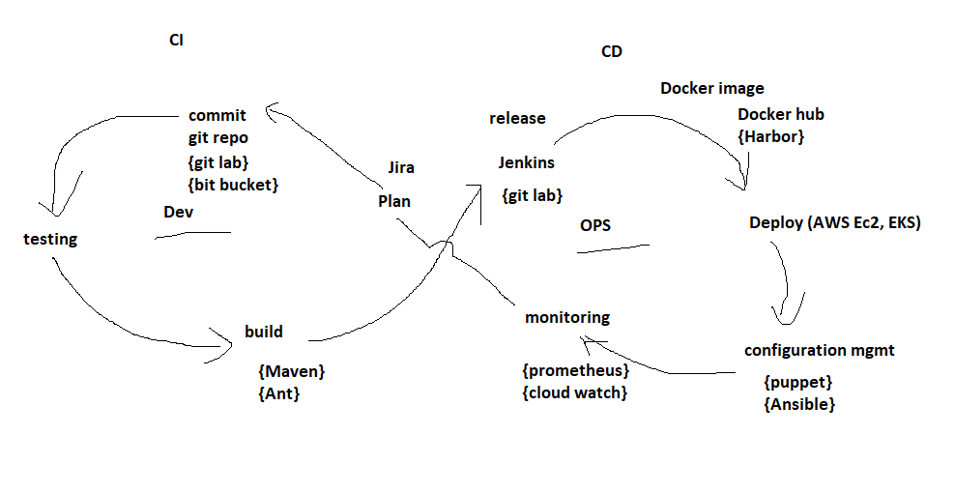

**Testing tool: Sonar qube**

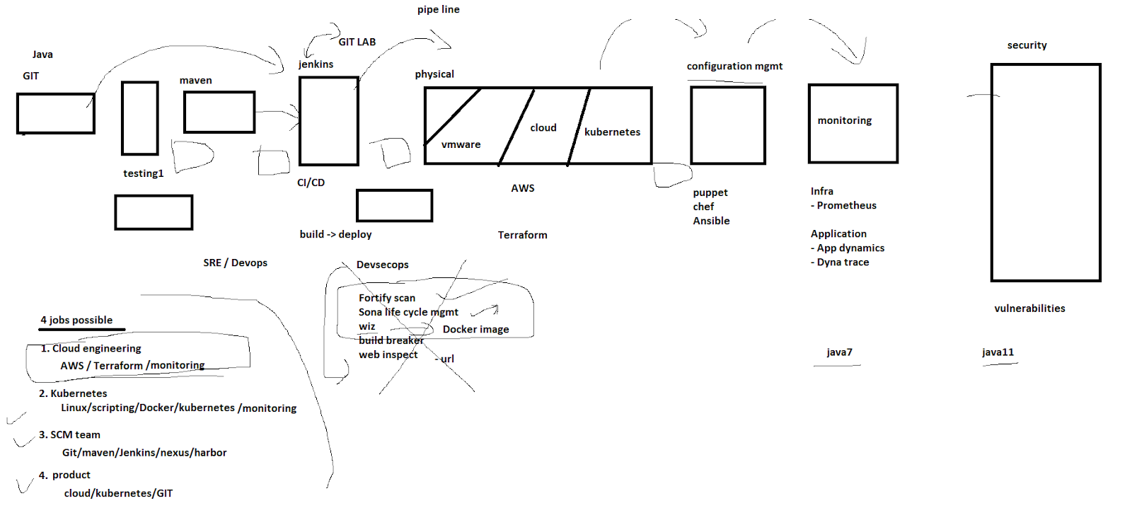

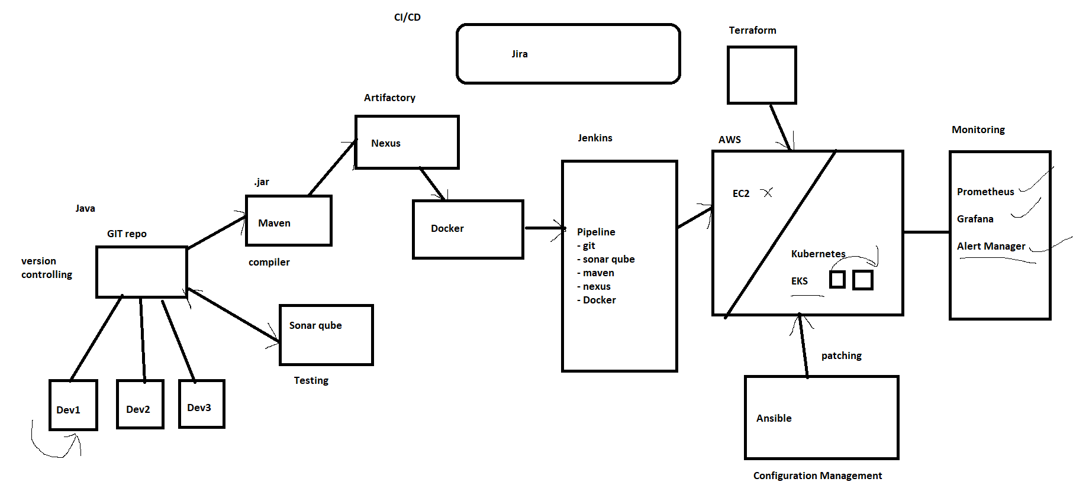

**Devops_setup**

* install intelliJ (IDE to maintain all devops code) - Integrated Development Environment

<https://www.jetbrains.com/idea/download/#section=windows>

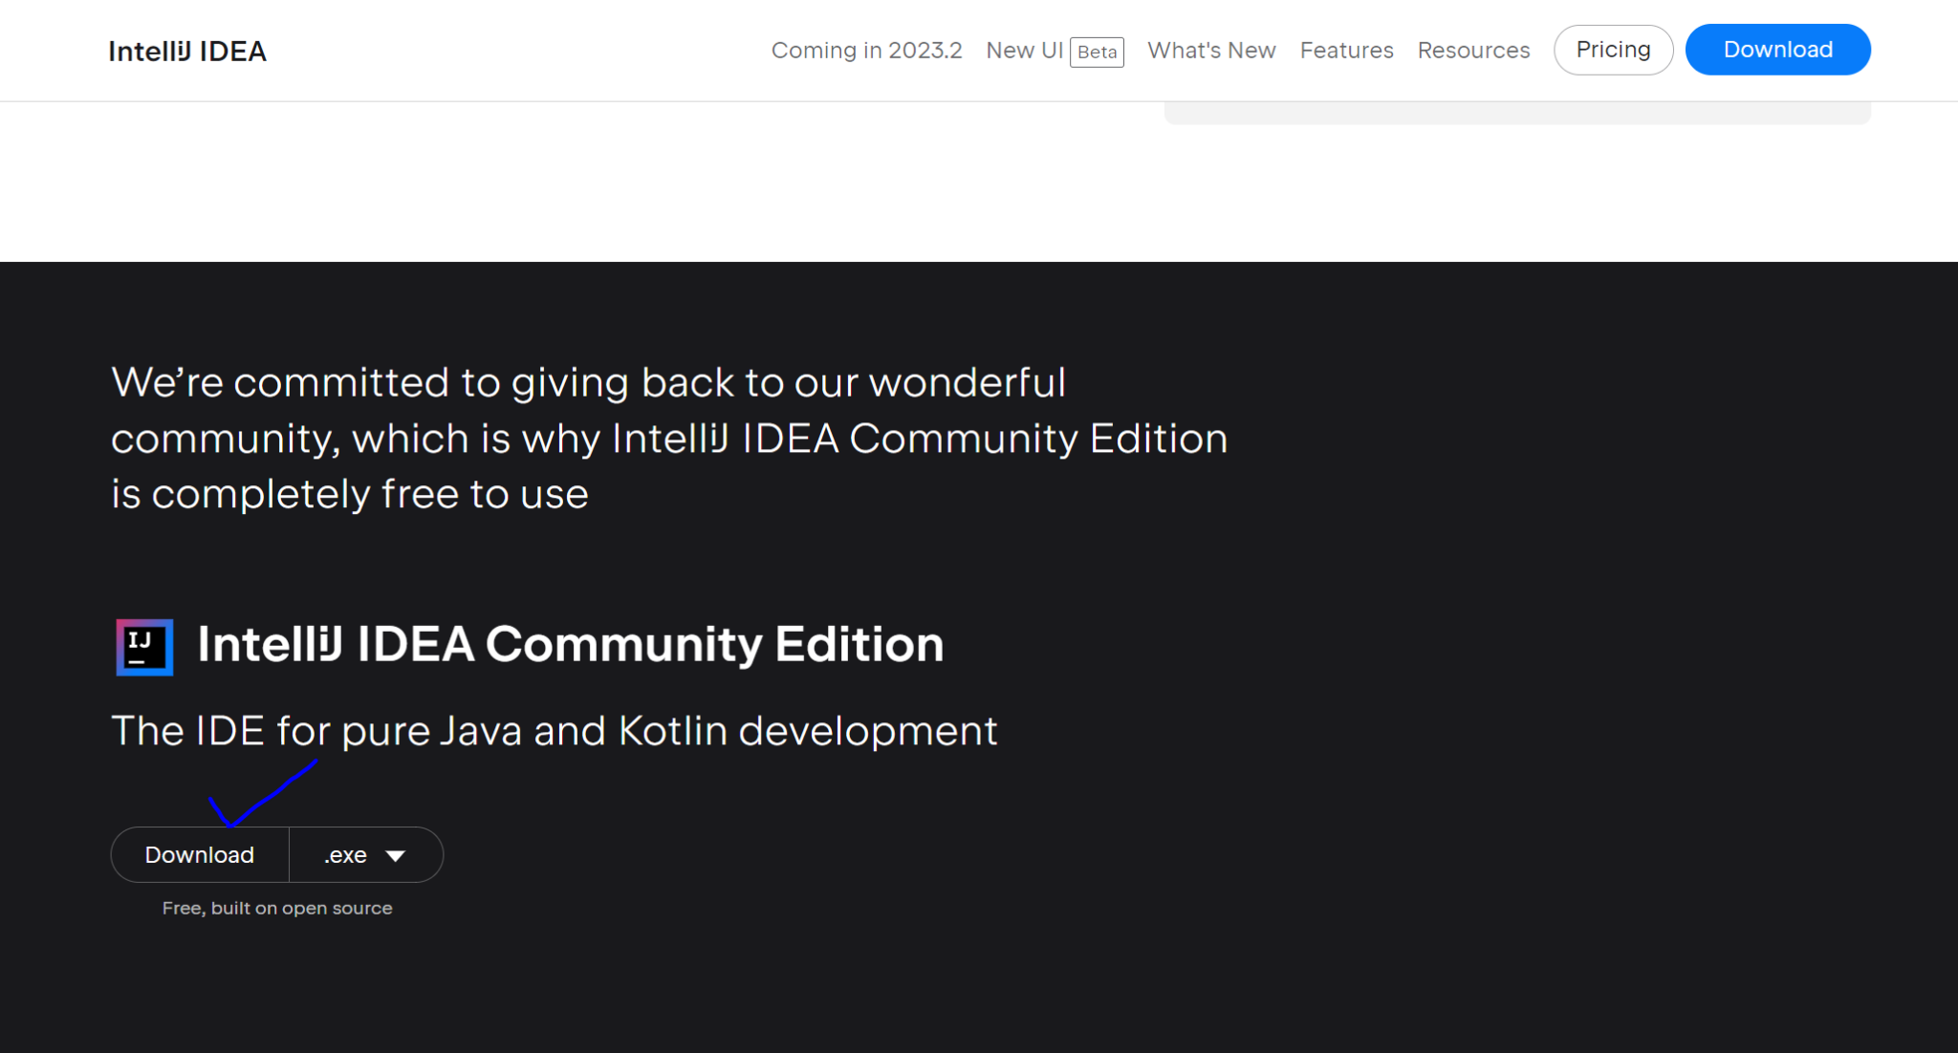

* **git bash for (Linux terminal)**

<https://git-scm.com/download/win>

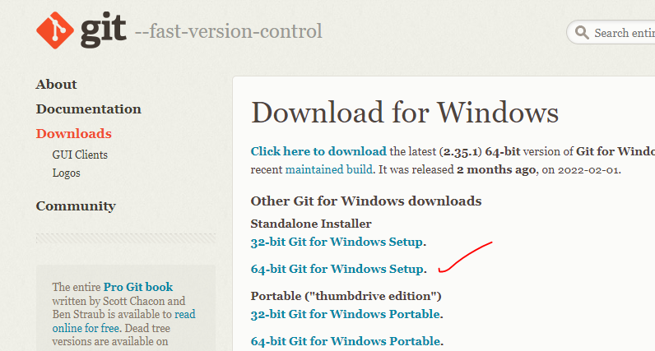

mention the terminal path in Intelij settings

File -> settings -> tools -> Terminal - Git bash path

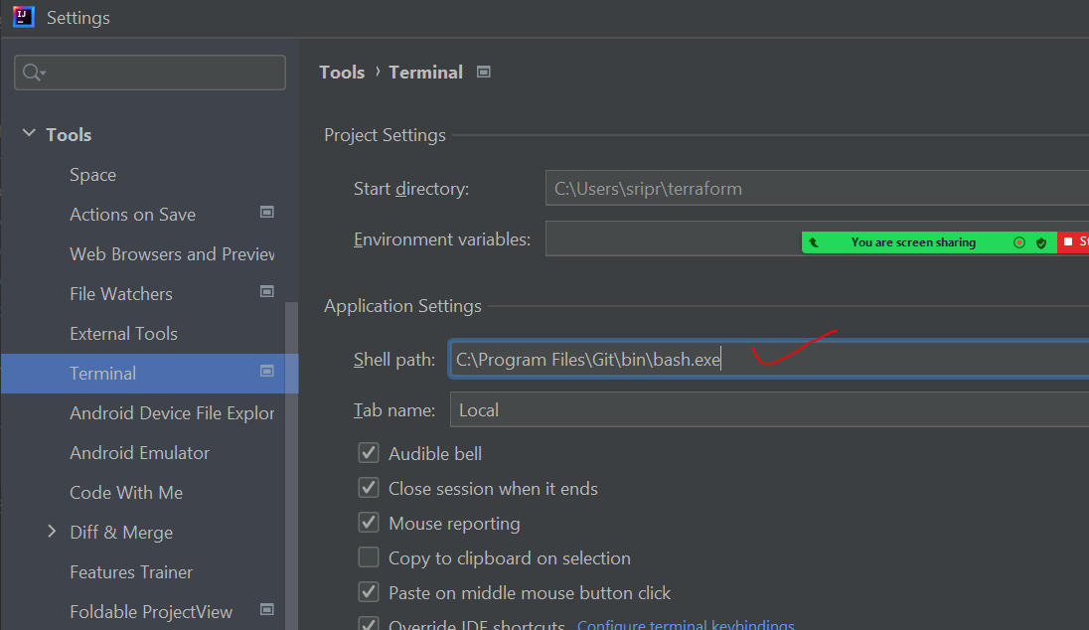

* **Terraform**

<https://www.terraform.io/downloads>

search - environment variable - uservariable - path - edit - then add terraform.exe folder path eg: “C:\Users\sripr”

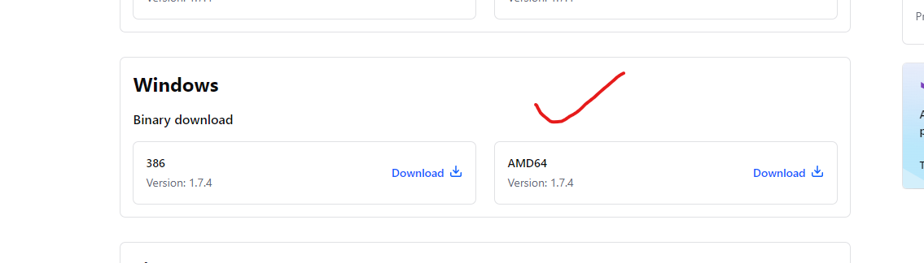

extract the terraform zip file and paste it under c:/User/<your_user>/terraformfolder

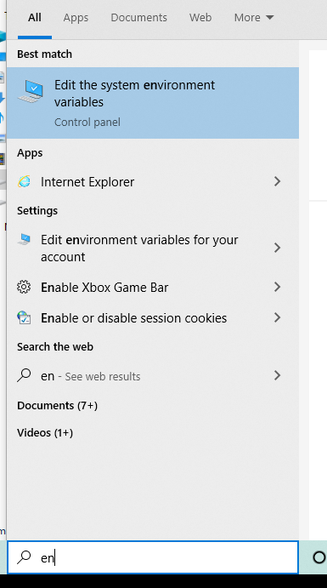

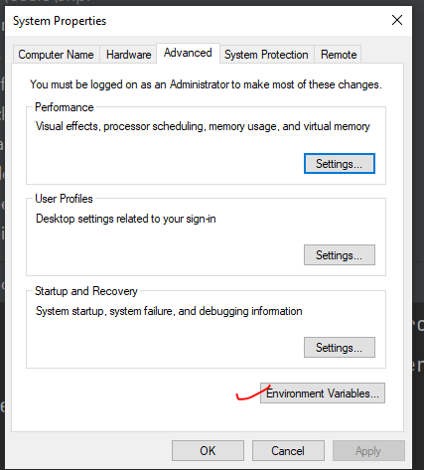

Edit Path and set the below path !

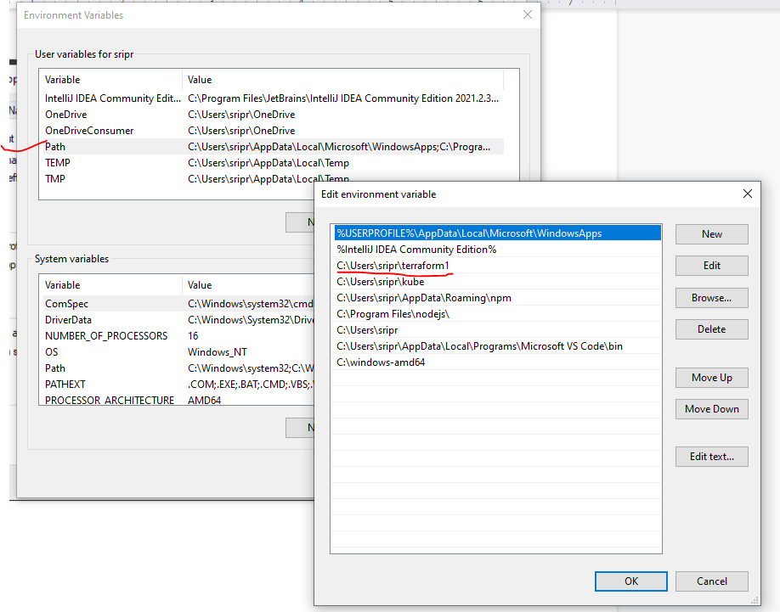

After this restart IntelliJ

4. Install AWS CLI directly from this link

<https://docs.aws.amazon.com/cli/latest/userguide/getting-started-install.html>

download and install this aws-cli

xxxxxxxxxxxxxxxxxxxxxxxxxxxxxxxxxxxxxxxxxxxxxxxxxxxxxxx

5. **Git Hub setup:**

<https://github.com/>

in the terminal generate ssh key with below commands.

cd

ssh-keygen

press “enter” default for all

cd

cd .ssh

cat id_rsa.pub

copy the content and paste in github profile -> setting -> sshandgpg keys add newsshkey

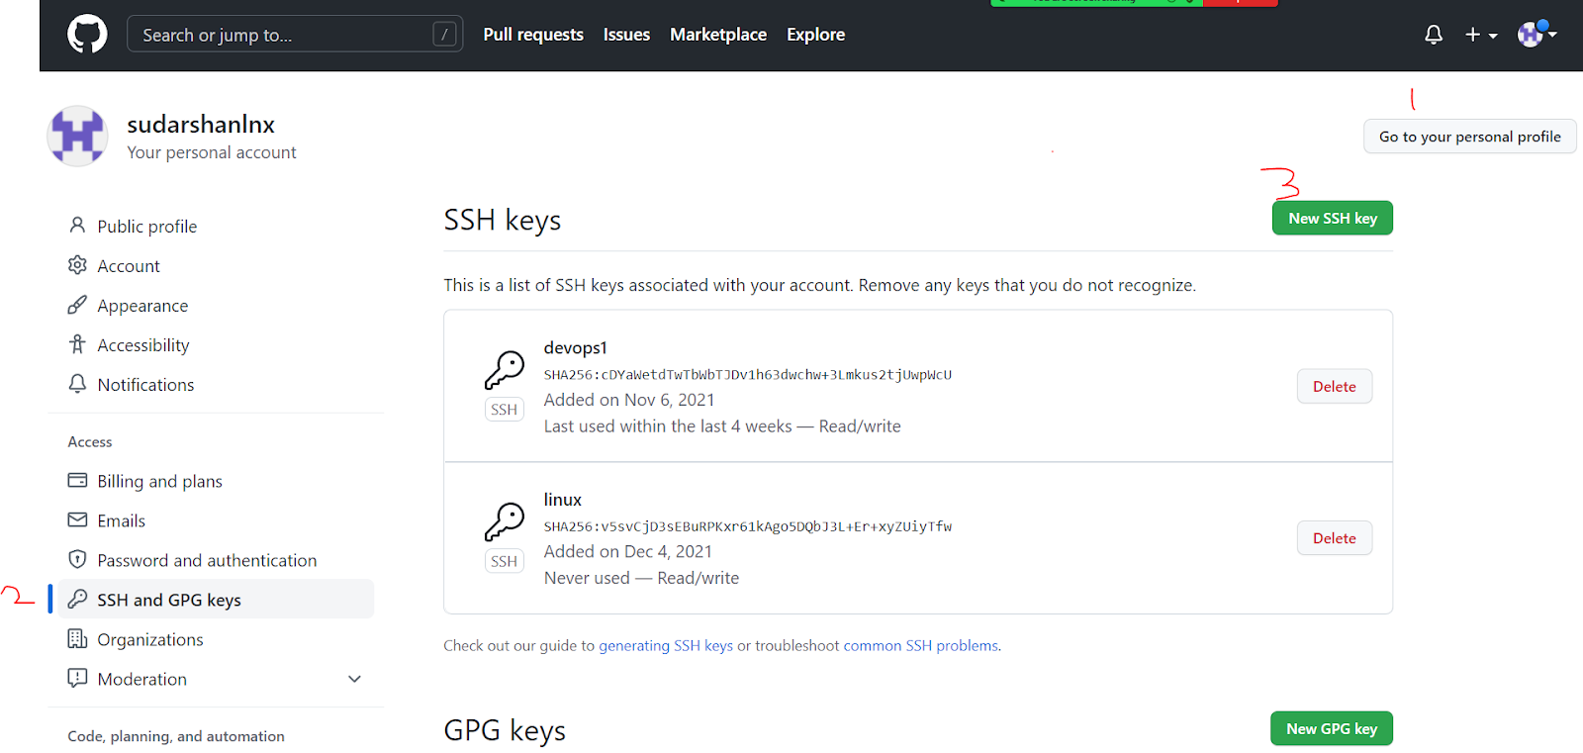

**go to terminal:**

git config --global user.email "sudarshanlnx@gmail.com"

git config --global user.name "sudarshan"

now go to github console and create a private repository and try to clone it

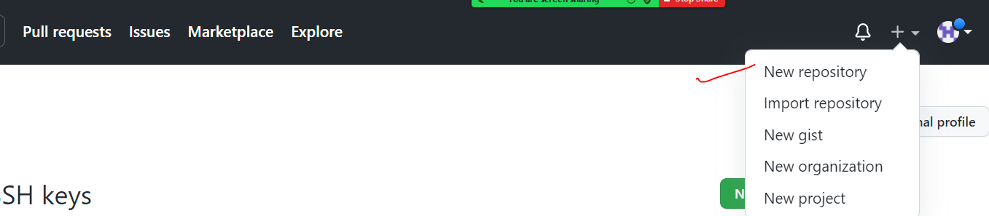

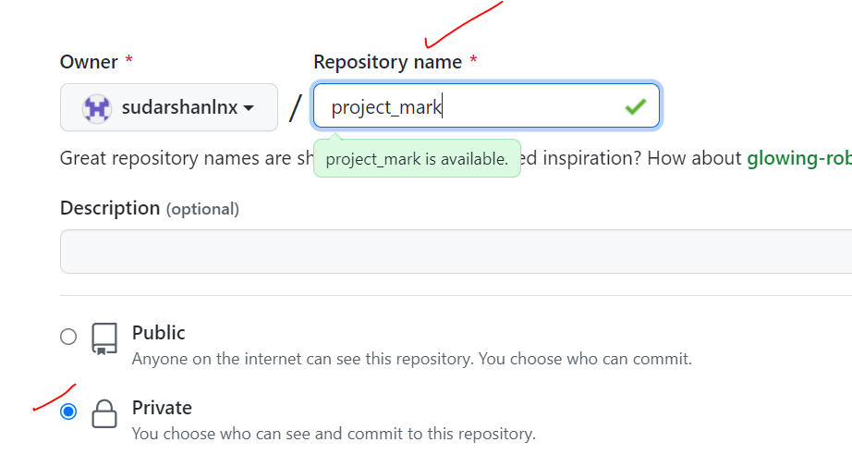

cd

git clone [git@github.com](mailto:git@github.com):sudarshanlnx/7am-devops.git

Uploading new changes to your repository:

1. Right click the git folder name and Create a new file
2. git add .
3. git commit -m “new change”
4. git push