Project name: surveil
Detect customers, selected products through laptop camera
Track customer/session IDs across frames.
Detect pickup, return and basket events.
Store events in the Product Interaction Ledger.

Core state model: ON_SHELF → PICKED_UP → RETURNED/ON_SHELF, or ON_SHELF → PICKED_UP → IN_BASKET → CHECKED_OUT OR LOST

Workflow:
• Detect products in the camera frame using YOLO.
• Track each detected product across frames using ByteTrack, giving every product a persistent track_id.
• Learn the product's initial shelf position (shelf anchor).
• Detect when the product has moved sufficiently away from that anchor.
• Use those signals over multiple consecutive frames to infer:
- PICKED_UP
- PUT_BACK
- PLACED_IN_BASKET
• Store the resulting events in a structured event log/CSV.

We use yolo26 right now.
How is hand detection working right now?
Hand detection model: https://github.com/victordibia/handtracking.git

Clone using:
git clone https://github.com/victordibia/handtracking.git

Hand detection model:
Real-time Hand-Detection using Neural Networks (SSD) on Tensorflow.
This repo documents steps and scripts used to train a hand detector using Tensorflow (Object Detection API). As with any DNN based task, the most expensive (and riskiest) part of the process has to do with finding or creating the right (annotated) dataset. I was interested mainly in detecting hands on a table (egocentric view point). I experimented first with the Oxford Hands Dataset (the results were not good). I then tried the Egohands Dataset which was a much better fit to my requirements.
The goal of this repo/post is to demonstrate how neural networks can be applied to the (hard) problem of tracking hands (egocentric and other views). Better still, provide code that can be adapted to other uses cases.
If you use this tutorial or models in your research or project, please cite this.
Here is the detector in action.
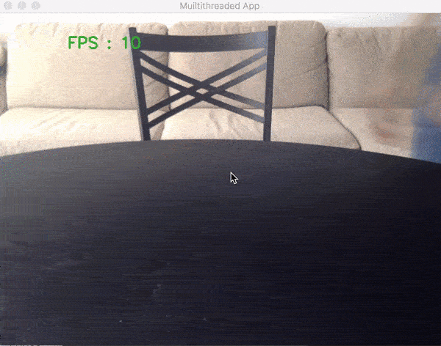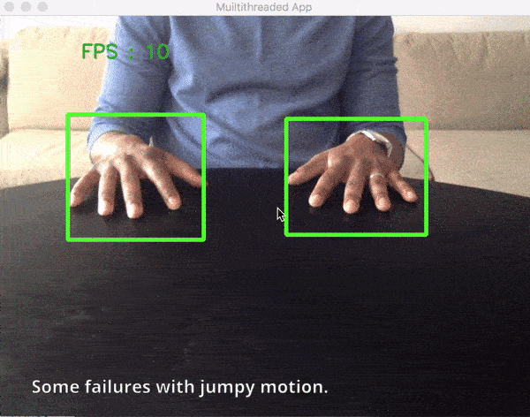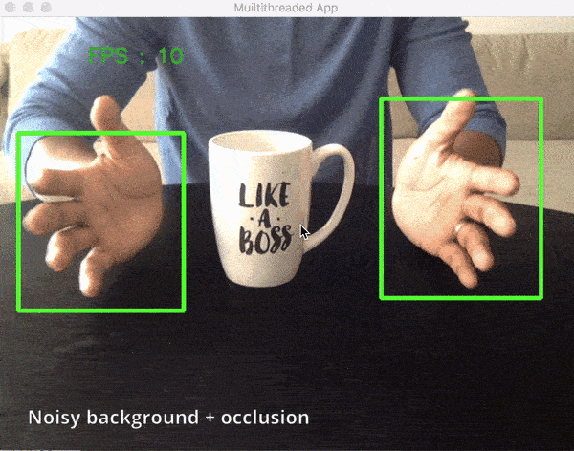Realtime detection on video stream from a webcam .
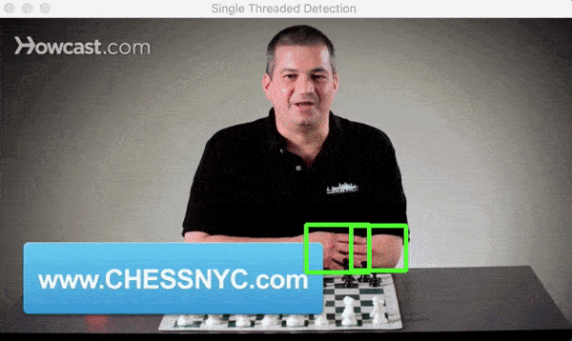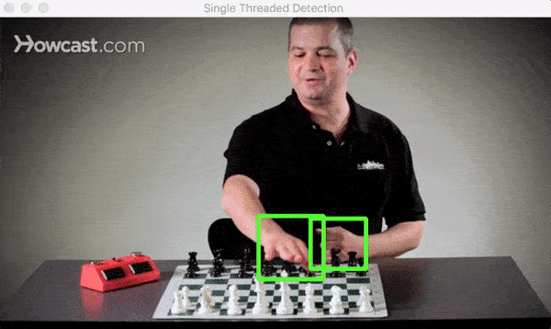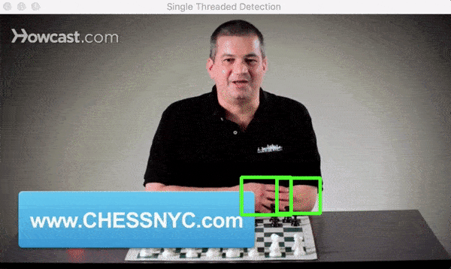Detection on a Youtube video.
Both examples above were run on a macbook pro CPU (i7, 2.5GHz, 16GB). Some fps numbers are:
FPS | Image Size | Device | Comments
21 | 320 * 240 | Macbook pro (i7, 2.5GHz, 16GB) | Run without visualizing results
16 | 320 * 240 | Macbook pro (i7, 2.5GHz, 16GB) | Run while visualizing results (image above)
11 | 640 * 480 | Macbook pro (i7, 2.5GHz, 16GB) | Run while visualizing results (image above)
Note: The code in this repo is written and tested with Tensorflow 1.4.0-rc0. Using a different version may result in some errors. You may need to generate your own frozen model graph using the model checkpoints in the repo to fit your TF version.
The tensorflow object detection repo has a python file for exporting a checkpoint to frozen graph here. You can copy it to the current directory and use it as follows
python3 export_inference_graph.py \
--input_type image_tensor \
--model-checkpoint/ssd_mobilenet_v1_pets.config \
--model-checkpoint/model.ckpt-200002 \
--output_directory hand_inference_graph
Content of this document
- Motivation - Why Track/Detect hands with Neural Networks
- Data preparation and network training in Tensorflow (Dataset, Import, Training)
- Training the hand detection Model
- Using the Detector to Detect/Track hands
- Thoughts on Optimizations.
P.S if you are using or have used the models provided here, feel free to reach out on twitter (@vykthur) and share your work!
Update 3/5/19 - You can now use the model in the Browser using Handtrack.js
I exported the model using the Tensorflow.js converter and have it wrapped into an easy to use javascript library - Handtrack.js. You can do hand tracking in 3 lines of code, no installation, no model training, all in the browser.
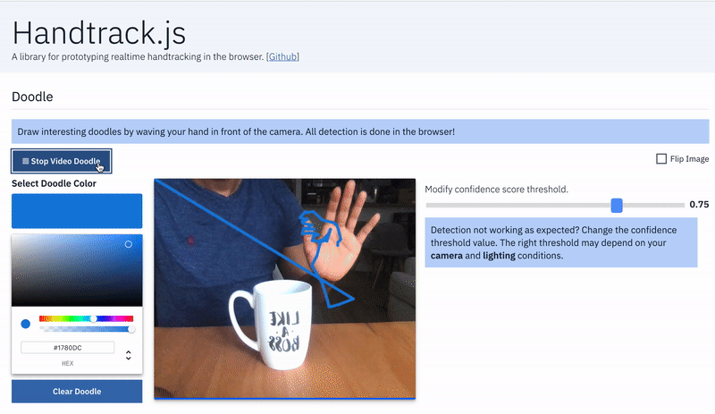
Learn more below
- Blog Post: Hand Tracking Interactions in the Browser using Tensorflow.js and 3 lines of code.
- Github: Handtrack.js Github Repo
- Live Demo : Handtrack.js Examples in the Browser
Update 15/09/2021 - Android example using a TFLite model
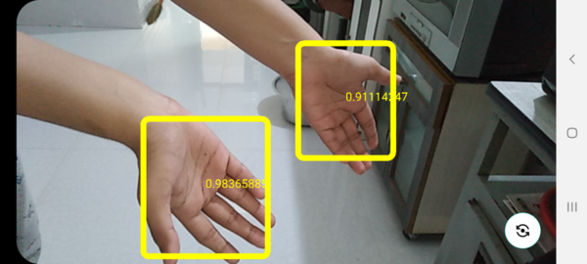
The trained model checkpoints are converted to the TensorFlow Lite format so that they can used in both Android and iOS apps.
The Android app which uses the hand tracking model from this repo is available here -> shubham0204/Hand_Detection_TFLite_Android
Also, a step-by-step guide on how to convert the model checkpoints to a TFLite model ( .tflite ) is available as a IPYNB notebook ( open it in Google Colab ) -> shubham0204/Google_Colab_Notebooks/Hand_Tracking_Model_TFLite_Conversion.ipynb
Motivation - Why Track/Detect hands with Neural Networks?
There are several existing approaches to tracking hands in the computer vision domain. Incidentally, many of these approaches are rule based (e.g extracting background based on texture and boundary features, distinguishing between hands and background using color histograms and HOG classifiers,) making them not very robust. For example, these algorithms might get confused if the background is unusual or in situations where sharp changes in lighting conditions cause sharp changes in skin color or the tracked object becomes occluded.(see here for a review paper on hand pose estimation from the HCI perspective)
With sufficiently large datasets, neural networks provide opportunity to train models that perform well and address challenges of existing object tracking/detection algorithms - varied/poor lighting, noisy environments, diverse viewpoints and even occlusion. The main drawbacks to usage for real-time tracking/detection is that they can be complex, are relatively slow compared to tracking-only algorithms and it can be quite expensive to assemble a good dataset. But things are changing with advances in fast neural networks.
Furthermore, this entire area of work has been made more approachable by deep learning frameworks (such as the tensorflow object detection api) that simplify the process of training a model for custom object detection. More importantly, the advent of fast neural network models like ssd, faster r-cnn, rfcn (see here ) etc make neural networks an attractive candidate for real-time detection (and tracking) applications. Hopefully, this repo demonstrates this.
If you are not interested in the process of training the detector, you can skip straight to applying the pretrained model I provide in detecting hands.
Training a model is a multi-stage process (assembling dataset, cleaning, splitting into training/test partitions and generating an inference graph). While I lightly touch on the details of these parts, there are a few other tutorials cover training a custom object detector using the tensorflow object detection api in more detail[ see here and here ]. I recommend you walk through those if interested in training a custom object detector from scratch.
Data preparation and network training in Tensorflow (Dataset, Import, Training)
The Egohands Dataset
The hand detector model is built using data from the Egohands Dataset dataset. This dataset works well for several reasons. It contains high quality, pixel level annotations (>15000 ground truth labels) where hands are located across 4800 images. All images are captured from an egocentric view (Google glass) across 48 different environments (indoor, outdoor) and activities (playing cards, chess, jenga, solving puzzles etc).
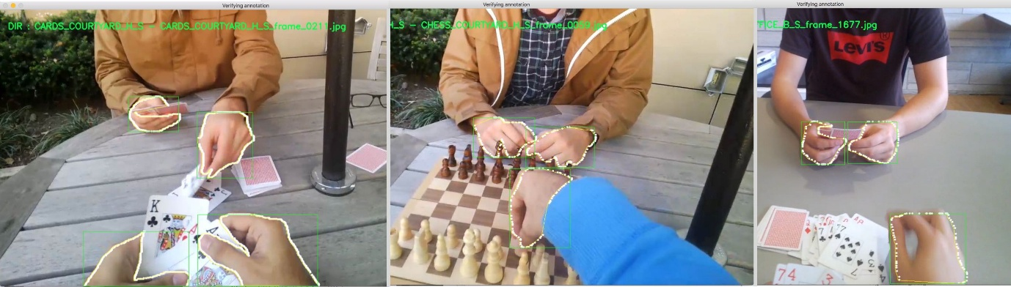
If you will be using the Egohands dataset, you can cite them as follows:
Bambach, Sven, et al. "Lending a hand: Detecting hands and recognizing activities in complex egocentric interactions." Proceedings of the IEEE International Conference on Computer Vision. 2015.
The Egohands dataset (zip file with labelled data) contains 48 folders of locations where video data was collected (100 images per folder).
-- LOCATION_X
-- frame_1.jpg
-- frame_2.jpg
...
-- frame_100.jpg
-- polygons.mat // contains annotations for all 100 images in current folder
-- LOCATION_Y
-- frame_1.jpg
-- frame_2.jpg
...
-- frame_100.jpg
-- polygons.mat // contains annotations for all 100 images in current folder
Converting data to Tensorflow Format
Some initial work needs to be done to the Egohands dataset to transform it into the format (tfrecord) which Tensorflow needs to train a model. This repo contains egohands_dataset_clean.py a script that will help you generate these csv files.
- Downloads the egohands datasets
- Renames all files to include their directory names to ensure each filename is unique
- Splits the dataset into train (80%), test (10%) and eval (10%) folders.
- Reads in polygons.mat for each folder, generates bounding boxes and visualizes them to ensure correctness (see image above).
- Once the script is done running, you should have an images folder containing three folders - train, test and eval. Each of these folders should also contain a csv label document each - train_labels.csv, test_labels.csv that can be used to generate tfrecords
python egohands_dataset_clean.py
Note: While the egohands dataset provides four separate labels for hands (own left, own right, other left, and other right), for my purpose, I am only interested in the general hand class and label all training data as hand. You can modify the data prep script to generate tfrecords that support 4 labels.
Next: convert your dataset + csv files to tfrecords. A helpful guide on this can be found here.For each folder, you should be able to generate train.record, test.record required in the training process.
Training the hand detection Model
Now that the dataset has been assembled (and your tfrecords), the next task is to train a model based on this. With neural networks, it is possible to use a process called transfer learning to shorten the amount of time needed to train the entire model. This means we can take an existing model (that has been trained well on a related domain (here image classification) and retrain its final layer(s) to detect hands for us. Sweet!. Given that neural networks sometimes have thousands or millions of parameters that can take weeks or months to train, transfer learning helps shorten training time to possibly hours. Tensorflow does offer a few models (in the tensorflow model zoo) and I chose to use the ssd_mobilenet_v1_coco model as my start point given it is currently (one of) the fastest models (read the SSD research paper here). The training process can be done locally on your CPU machine which may take a while or better on a (cloud) GPU machine (which is what I did). For reference, training on my macbook pro (tensorflow compiled from source to take advantage of the mac's cpu architecture) the maximum speed I got was 5 seconds per step as opposed to the ~0.5 seconds per step I got with a GPU. For reference it would take about 12 days to run 200k steps on my mac (i7, 2.5GHz, 16GB) compared to ~5hrs on a GPU.
Training on your own images: Please use the guide provided by Harrison from pythonprogramming on how to generate tfrecords given your label csv files and your images. The guide also covers how to start the training process if training locally. [see [here] (https://pythonprogramming.net/training-custom-objects-tensorflow-object-detection-api-tutorial/)]. If training in the cloud using a service like GCP, see the guide here.
As the training process progresses, the expectation is that total loss (errors) gets reduced to its possible minimum (about a value of 1 or thereabout). By observing the tensorboard graphs for total loss(see image below), it should be possible to get an idea of when the training process is complete (total loss does not decrease with further iterations/steps). I ran my training job for 200k steps (took about 5 hours) and stopped at a total Loss (errors) value of 2.575.(In retrospect, I could have stopped the training at about 50k steps and gotten a similar total loss value). With tensorflow, you can also run an evaluation concurrently that assesses your model to see how well it performs on the test data. A commonly used metric for performance is mean average precision (mAP) which is single number used to summarize the area under the precision-recall curve. mAP is a measure of how well the model generates a bounding box that has at least a 50% overlap with the ground truth bounding box in our test dataset. For the hand detector trained here, the mAP value was 0.9686@0.5IOU. mAP values range from 0-1, the higher the better.
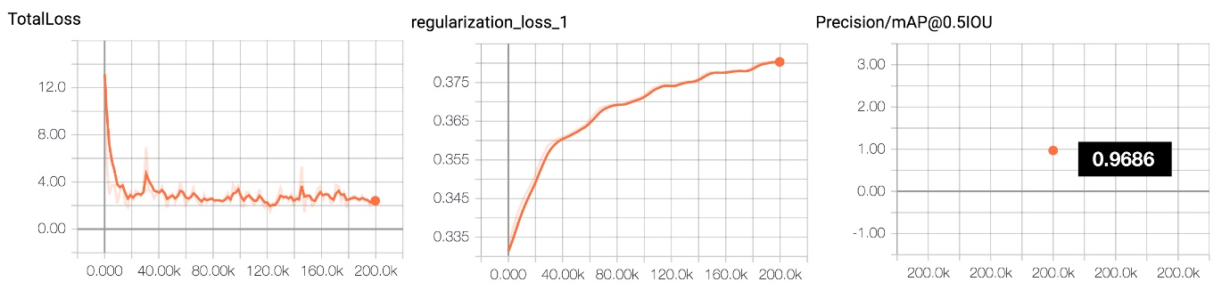
Once training is completed, the trained inference graph (frozen_inference_graph.pb) is then exported (see the earlier referenced guides for how to do this) and saved in the hand_inference_graph folder. Now its time to do some interesting detection.
Using the Detector to Detect/Track hands
If you have not done this yet, please following the guide on installing Tensorflow and the Tensorflow object detection api. This will walk you through setting up the tensorflow framework, cloning the tensorflow github repo and a guide on
- Load the frozen_inference_graph.pb trained on the hands dataset as well as the corresponding label map. In this repo, this is done in the utils/detector_utils.py script by the load_inference_graph method.
- detection_graph = tf.Graph()
- with detection_graph.as_default():
- od_graph_def = tf.GraphDef()
- with tf.gfile.GFile(PATH_TO_CKPT, 'rb') as fid:
- serialized_graph = fid.read()
- od_graph_def.ParseFromString(serialized_graph)
- tf.import_graph_def(od_graph_def, name='')
- sess = tf.Session(graph=detection_graph)
print("> ====== Hand Inference graph loaded.")
- Detect hands. In this repo, this is done in the utils/detector_utils.py script by the detect_objects method.
- (boxes, scores, classes, num) = sess.run(
- [detection_boxes, detection_scores,
- detection_classes, num_detections],
feed_dict={image_tensor: image_np_expanded})
- Visualize detected bounding detection_boxes. In this repo, this is done in the utils/detector_utils.py script by the draw_box_on_image method.
This repo contains two scripts that tie all these steps together.
- detect_multi_threaded.py : A threaded implementation for reading camera video input detection and detecting. Takes a set of command line flags to set parameters such as --display (visualize detections), image parameters --width and --height, videe --source (0 for camera) etc.
- detect_single_threaded.py : Same as above, but single threaded. This script works for video files by setting the video source parameter videe --source (path to a video file).
# load and run detection on video at path "videos/chess.mov"
python detect_single_threaded.py --source videos/chess.mov
Update: If you do have errors loading the frozen inference graph in this repo, feel free to generate a new graph that fits your TF version from the model-checkpoint in this repo. Use the export_inference_graph.py script provided in the tensorflow object detection api repo. More guidance on this here.
Thoughts on Optimization.
A few things that led to noticeable performance increases.
- Threading: Turns out that reading images from a webcam is a heavy I/O event and if run on the main application thread can slow down the program. I implemented some good ideas from Adrian Rosebuck on parrallelizing image capture across multiple worker threads. This mostly led to an FPS increase of about 5 points.
- For those new to Opencv, images from the cv2.read() method return images in BGR format. Ensure you convert to RGB before detection (accuracy will be much reduced if you dont).
cv2.cvtColor(image_np, cv2.COLOR_BGR2RGB)
- Keeping your input image small will increase fps without any significant accuracy drop.(I used about 320 x 240 compared to the 1280 x 720 which my webcam provides).
- Model Quantization. Moving from the current 32 bit to 8 bit can achieve up to 4x reduction in memory required to load and store models. One way to further speed up this model is to explore the use of 8-bit fixed point quantization.
Performance can also be increased by a clever combination of tracking algorithms with the already decent detection and this is something I am still experimenting with. Have ideas for optimizing better, please share!

Note: The detector does reflect some limitations associated with the training set. This includes non-egocentric viewpoints, very noisy backgrounds (e.g in a sea of hands) and sometimes skin tone. There is opportunity to improve these with additional data.

Different States of objects:

1. ON_SHELF — normal/default state
This is the starting state.
Product detected
↓
ON_SHELF
When a product is first detected, its current bounding box is saved as its shelf_anchor.
shelf_anchor = box
state = ON_SHELF
If the product stays relatively still and isn't being touched, the system keeps updating/learning its shelf anchor. It needs about 15 settling frames with very little movement before treating the position as a stable anchor.

2. LIFTING — possible pickup
This is a temporary/uncertain state.
The transition is:
ON_SHELF
↓
hand touching product
+
product displaced from shelf
↓
LIFTING
Two things must happen:
- The hand must be sufficiently close to/touching the product.
- The product must have moved at least the configured shelf displacement — currently 60 pixels from its anchor.
So:
Hand detected
+
Product moved away
↓
LIFTING
At this point we are not yet saying it was definitely picked up. We're waiting to see whether the condition persists.

3. IN_HAND — confirmed pickup
If the product remains:
hand touching
+
displaced from shelf
for 5 consecutive frames, then:
LIFTING
↓
5 valid frames
↓
IN_HAND
At that moment the system generates:
PICKED_UP
event.
So the complete transition is:
ON_SHELF
↓
hand touches + product moves
↓
LIFTING
↓
5 consecutive frames
↓
IN_HAND
↓
PICKED_UP event
The PICKED_UP event contains the product ID, track ID and timestamp.
If the hand stops touching the product or the displacement condition disappears during LIFTING, it is considered a false alarm and goes back to:
LIFTING → ON_SHELF

4. RETURNING — possible put-back
Once a product is confirmed IN_HAND, the system watches what happens next.
If:
hand is no longer touching
+
product is no longer displaced from its shelf anchor
then:
IN_HAND
↓
RETURNING
This means:
"The customer appears to have put the product back, but let's wait before confirming."

5. Back to ON_SHELF — confirmed put-back
If the product stays:
not touching hand
+
not displaced from shelf
for 5 consecutive frames:
RETURNING
↓
5 frames
↓
ON_SHELF
and the system generates:
PUT_BACK
event.
So:
ON_SHELF
↓
LIFTING
↓
IN_HAND
↓
RETURNING
↓
ON_SHELF
This represents:
Customer picked it up → held it → returned it to the shelf.

6. IN_BASKET — product placed in basket
There is another path from IN_HAND.
If:
IN_HAND
↓
product enters basket zone
and at least 50% of the product bounding box overlaps the basket zone for 4 frames, then:
IN_HAND
↓
IN_BASKET
and:
PLACED_IN_BASKET
is generated.
So the purchase journey can look like:
ON_SHELF
↓
LIFTING
↓
IN_HAND
↓
IN_BASKET
This is particularly important for the larger project because the synopsis defines the intended product lifecycle as:
ON_SHELF
↓
PICKED_UP
↓
RETURNED / ON_SHELF
or:
ON_SHELF
↓
PICKED_UP
↓
IN_BASKET
↓
CHECKED_OUT

7. LOST — tracking failure state
There is also a LOST state defined in the code:
LOST
However, in the current state-machine logic it isn't actually transitioned into during the normal update flow.
What currently happens when a product disappears is:
Product track disappears
↓
frames_missed++
↓
wait up to 30 frames
↓
delete track
So LOST exists as an enum/state concept, but the current implementation effectively ages out and removes the track after max_missed_frames = 30.

Complete state diagram
The easiest way to explain it in your viva is:
┌──────────────┐
│ ON_SHELF │
└──────┬───────┘
│
hand touching + displaced
│
▼
┌──────────────┐
│ LIFTING │
└──────┬───────┘
│
5 consecutive frames
│
▼
┌──────────────┐
│ IN_HAND │
└──────┬───────┘
│
┌──────────┴──────────┐
│ │
returns to shelf enters basket
│ │
▼ ▼
┌────────────────┐ ┌──────────────┐
│ RETURNING │ │ IN_BASKET │
└───────┬────────┘ └──────────────┘
│
5 consecutive frames
│
▼
┌──────────────┐
│ ON_SHELF │
└──────────────┘
In very simple terms:
State | What it means | How we get there
ON_SHELF | Product is sitting normally | Initial detection / confirmed put-back
LIFTING | Possible pickup happening | Hand touching + product moved from anchor
IN_HAND | Pickup confirmed | Lifting condition persists for 5 frames
RETURNING | Possible return to shelf | Product comes back near anchor without hand contact
IN_BASKET | Product placed in basket | Product stays sufficiently inside basket zone for 4 frames
LOST | Conceptual tracking-loss state | Defined, but not currently actively entered by the state machine

Next:
Add actual TOUCH detection
This is one thing I'd add before going further.
Currently, your logic basically uses hand contact as an internal signal:
hand touching product
But you don't emit a:
TOUCH
event.
Since the RetailAction dataset you're using has:
TAKE
PUT
TOUCH
you can explicitly represent:
TOUCH
as a short interaction that doesn't result in the product leaving the shelf.

Build the Product Interaction Ledger
This is probably the most important next backend step.
Right now you have:
event_log
↓
CSV
You need to move toward:
CV
↓
Event
↓
FastAPI
↓
Supabase/PostgreSQL
↓
Product Interaction Ledger

The two interfaces can be designed as:
- Live Monitoring — the computer-vision interface that runs the laptop/webcam and shows what the system is detecting in real time.
- Shop Owner Dashboard — the business interface where the owner sees products detected by the system, confirms purchases, and receives alerts for products that appear to have been taken but have not been accounted for.
This fits very well with the synopsis because the core idea is to turn CCTV footage into structured product-interaction events and then reconcile those events with purchases.

TAB 1
LIVE CCTV MONITOR
│
│
Laptop Camera / Webcam
│
▼
┌──────────────────┐
│ YOLO Product │
│ Detection │
└────────┬─────────┘
│
▼
┌──────────────────┐
│ ByteTrack │
│ Object Tracking │
└────────┬─────────┘
│
├───────────────┐
│ │
▼ ▼
Product State Hand Detection
│ │
└───────┬───────┘
▼
Interaction Engine
│
┌──────────┼──────────┐
▼ ▼ ▼
PICKED UP PUT BACK IN BASKET
│ │ │
└──────────┴──────────┘
│
▼
EVENT DATABASE
│
▼
TAB 2
SHOP OWNER DASHBOARD
│
┌───────────┼───────────┐
▼ ▼ ▼
Products Purchased Alerts
Detected by Owner / Lost

The important separation is:
Tab 1 observes.
Tab 2 manages and reconciles.
The CV system should not decide on its own that something is definitely stolen. It should identify an unresolved/lost-product situation and bring it to the owner's attention for review.

You can train/use YOLO to detect the basket directly, instead of defining a fixed basket region manually.
Then:
Product detected
↓
Product picked up
↓
Product moves toward basket
↓
Basket detected
↓
Product enters/overlaps basket
↓
Condition persists for N frames
↓
IN_BASKET
use next.js framework
react js frontend
fast api
py backend
use yolo for general obj detection
MAKE SURE PEOPLE I.E. “PERSON” CLASS IS NOT BOXED AND HIGHLIGHTED, OUR FOCUS IS PRODUCTS

