

**FPT UNIVERSITY**

**Taxi Caller Application on Windows Phone**

**F_Taxi**

**Report #2 – Software Project Management Plan**

|  |  |
| --- | --- |
| F_Taxi | |
| Group Member | SE02705 - Phạm Gia Hữu |
| SE02900 - Tạ Thiên Hưởng |
| SE02268 - Phạm Ngọc Hoàn |
| SE02314 - Nguyễn Văn Lập |
| Supervisor | Nguyễn Văn Sang |
| Project Code | F_Taxi |

HaNoi, 09/2015

Table of Contents

1 INTRODUCTION 3

1.1 Purpose 3

1.2 References 3

2 PROJECT ORGANIZATION 3

2.1 Software Process Model 3

2.2 Roles and Responsibilities 4

3 TOOLS AND INFRASTRUCTURES 4

4 SCHEDULE 5

4.1 Detailed Schedule 5

4.2 Meeting Schedule 5

5 RISK MANAGEMENT 6

6 CODING CONVENTION 8

# INTRODUCTION

## Purpose

The purpose of this chapter is to describe the organization and plan of the project. All team members must use this chapter as a guideline for tracking assigned tasks and deadlines. This chapter also included an overview of this project and team member. This is a document for daily meeting and meeting minute

## References

[3] Information about Iterative and Incremental software process model:

- http://www.ibm.com/developerworks/.../bittner-pdf.pdf

- http://www.ibm.com/developerworks/.../bittner-spence-pdf.pdf

# PROJECT ORGANIZATION

## Software Process Model

To develop the system, we decided to use the Iterative and Incremental Software Process Model [3].

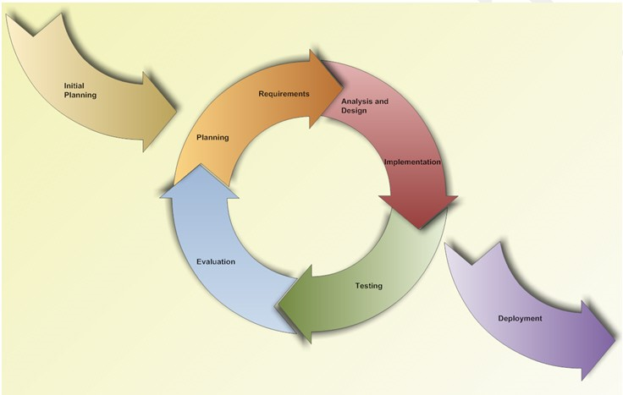

Figure 2.1: Iterative and Incremental Software Process Model

* **Why this model was chosen:**
  + We can learn from time to time during our process, and use anything we learned to improve the product.
  + Through every iteration, we are able to control scope and requirements, flexibly update or even change anything if we think it will help us to have a better product.
  + Customers can respond after each build of the product.
  + It is easy to manage risks by dividing into many pieces and solve it as quick as possible in each iteration.
  + It is also easy to test and debug during a smaller iteration.

## Roles and Responsibilities

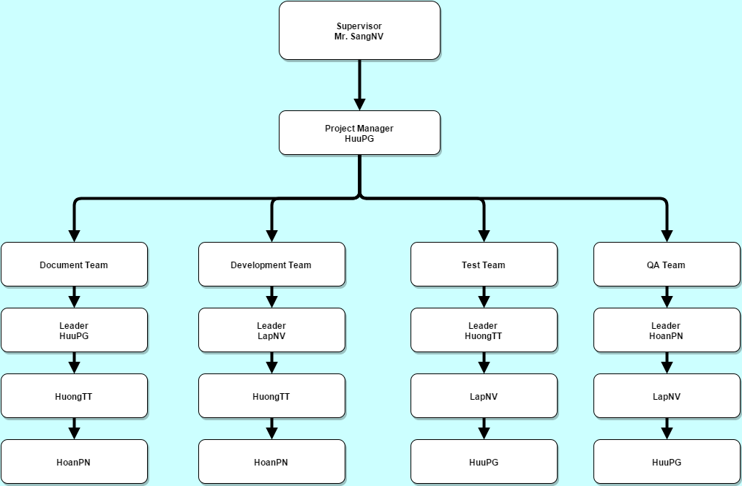

**Figure 2.2 : Project Organization**

|  |  |  |
| --- | --- | --- |
| **Member** | **Roles and Responsibilities** | |
| **Roles** | **Responsibilities** |
| HuuPG | * Project Manager * SRS Analysis Leader * Design Leader * Developer | * Defining project scope, planning and developing schedules * Allocating resources * Being responsible for make team keep focusing on the main goal at all, and the right goal at a time * Analyzing, documenting and communicating requirements, identifying and verifying solutions meets the requirements * Involving to design user interfaces, specifying the design direction |
| LapNV | * Technical Leader * Developer Leader * Designer * Tester | * Being responsible for the underlying architecture of the software program * Leading and coordinating use cases modeling, outlining the system’s functionality * Assigning tasks, training and mentoring other team members about new technologies * Being responsible for developing the product, including create database, develop functions, … |
| HuongTT | * SRS Analysis * Test Leader * Developer | * Involving to create SRS document * Being responsible for testing execution, including setting up and running test, creating test cases, recording test results * Involve to develop the product, analyze the “Matching” module |
| HoanPN | * QA Leader * Developer * Tester | * Ensuring the product meets the certain standards of quality from requirements * Involving to develop and test product. |

# TOOLS AND INFRASTRUCTURES

|  |  |
| --- | --- |
| **Title** | **Details** |
| Operation System | * Microsoft Windows 7 * Microsoft Windows 8 * Microsoft Windows 8.1 * Microsoft Windows 10 |
| Development and Design Software | * Microsoft Visual Studio 2013 * Microsoft SQL Server 2012 |
| Management and Document Software | * Microsoft Office 2013 * Microsoft Project 2013 * Microsoft Visio 2013 |
| Development Framework | * ASP .NET * Window Phone Emulator |
| Subversion Tool | * TortoiseSVN 1.8 or higher |
| Version Controller | * GitHub |
| Contact Software | * Gmail * Skype 7.0 or higher * Facebook |

Table 2.1 : Tools and infrastuctures

# SCHEDULE

## Detailed Schedule

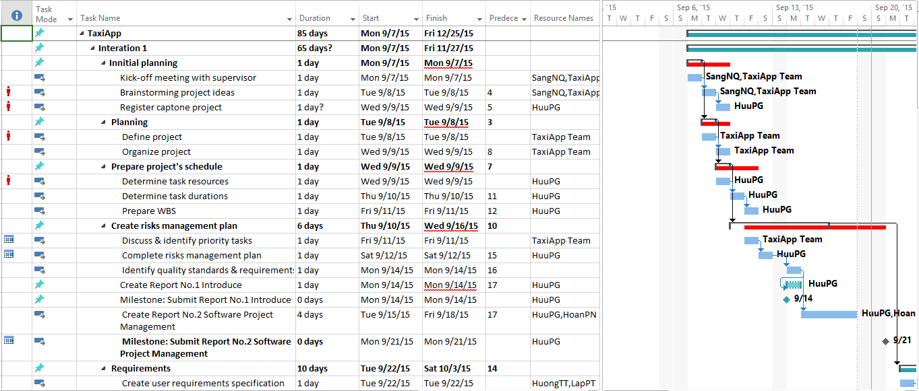

**Figure 2.2: Gantt chart (*Reference file: TaxiApp_Ganttchart.mpp*)**

## Meeting Schedule

|  |  |  |  |
| --- | --- | --- | --- |
| **Subject** | Capstone Project Meeting | **Date** | Every Tuesday |
| **Facilitator** | FPT University | **Time** | 12h00 – 13h00 |
| **Location** | Hoa Lac | **Scribe** | HuuPG |
| **Attendees** | SangNV(Supervisor), HuuPG,LapNV,HuongTT,HoanPN | | |
| **Absent** |  | | |

| **Key Points Discussed** | | |
| --- | --- | --- |
| **No** | **Topic** | **Highlights** |
| 1 | Team member problems | * All the activities, the issues will be discussed and reported with supervisor in last week. * Discuss all issues & problems on the job last week * Discuss the working plan next week |
| 2 | Project introduction | * Instruct the direction for project team to deal with the problems * Support & comments the working ​​plans next week |

# RISK MANAGEMENT

|  |  |  |  |  |
| --- | --- | --- | --- | --- |
| **ID** | **Risk Content** | **Propability** | **Effect** | **Solution** |
| **#** | **People Risks** |  |  |  |
| 1 | Team member may not follow deadlines. | HIGH | SERIOUS | * Find out reasons * Depending on circumstances, may set penalty rule. |
| 2 | Team members are sick, cannot complete task under deadline. | HIGH | SERIOUS | * Increase project team’s working effort in “peace period”. * Allow all team members clear about what others do, so that they can cover the tasks when necessary. |
| 3 | Conflict between team members. | HIGH | SERIOUS | * Setup an open-talk environment in project team. * “*Do not criticize*” is set as a rule. * Organize team-building more often. * In some cases, manager must use his power to make decisions. |
| 4 | New technology is hard to apply for project | HIGH | SERIOUS | * List tasks and check continuously. Evaluate quality and progress weekly. * Send email to other member or supervisor to ask for help. |
| 5 | Problems in communication breakdown makes changing time, work and delay plan | HIGH | SERIOUS | * We need using words more clearly, improve our communication skills * Using note and email to confirm information. |
| **#** | **Technical Risk** |  |  |  |
| 6 | Team member need to be trained about new technology. This can causes the project to be delayed | HIGH | SERIOUS | * Divided knowledge into many technology research groups, each member just need to learn about things that are necessary to complete their own tasks. * Send technical issues to supervisor who has experience to get support. |
| **#** | **Process Risk** |  |  |  |
| 7 | Underestimate the scope of project, difficulty level of tasks and effectiveness of risks. | HIGH | SERIOUS | * Estimate project scope with supervisor and experience people. * Assign task weight value to make task evaluation easier. * Involve all team members into risk management process, ask supervisor for his opinion. |
| # | **Requirement Risk** |  |  |  |
| 8 | Misunderstand system process, so we can have mistaken in describing the essential functions | HIGH | SERIOUS | * Receive advice from experts * Develop prototypes and review prototypes with experts and supervisor |
| # | **Management Risk** |  |  |  |
| 9 | Poor experience of management so that team makes plan unrealistically | HIGH | SERIOUS | * Team leader will tightly co-operate with team members during planning phase. * Get advice and review from supervisor about the plan. |

**Table 2.4 : Risk Manager**

# CODING CONVENTION

* The project team will follow this coding conventions:
  + [http://se.inf.ethz.ch/old/teaching/.../CSharpCodingStandards.pdf](http://se.inf.ethz.ch/old/teaching/ss2007/251-0290-00/project/CSharpCodingStandards.pdf)
* Role of coding conventions in software development:
  + Recommends programming style, practices and methods for each aspect of a piece program.
  + Improve the readability of source code, allow engineers to understand new code more quickly and thoroughly.
  + Following a coding convention can help reducing the cost of software maintenance and make it easier.