Web Services and Microsoft .NET

Name: Mark Angrish (mangr)
Student Number: 74592

Abstract

Web services are the building blocks for constructing distributed Web-based applications in a platform independent, object model, and multi language manner. Web Services are based on open Internet standards, such as HTTP and XML, and form the basis of Microsoft's vision of the programmable Web.

This paper defines Web Services and the key enabling technologies that ensure services can be aggregated into applications. It describes Microsoft's new .NET Framework and its support for creating and consuming Web Services. It then compares .NET to its chief rival, Sun's J2EE Framework. It also describes .NET Web Service implementations in grid and cluster computing, as well as an outline of the future of .NET web Services.

Key words: Web Services, Microsoft .NET, grid computing, cluster computing, J2EE
1.Introduction

1.1 Overview

The next generation of distributed computing has arrived. Over the past few years, XML has enabled heterogeneous computing environments to share information over the World-Wide Web. It now offers a simplified means by which to share process as well. From a technical perspective, the advent of web services is not a revolution in distributed computing. It is instead a natural evolution of XML application from structured representation of information to structured representation of inter-application messaging. The revolution is in the opportunities this evolution affords.

Web Services can take different applications running on different operating systems built with different object models using different programming languages and seamlessly integrating them into easy to use web-based applications. Microsoft's vision of Web Services and its recent development, the .NET framework, attempts to address this Web Services challenge. The promise of web services gives rise to developing massively scalable applications in cluster and grid environments. Recent projects have looked to utilize .NET XML Web Services in these scenarios to realise the various large scale data problems in fields such as physics and bio-informatics.

1.2 Web Services in context

To identify the need for Web Services, we must first understand where they fit in the evolution of computing. The Internet as we know it today began with the advent of telecommunications involving computers. This began with the American Governments Defense Advanced Research Projects Agency (ARPA) conceiving of a project to allow packet transfer across computer networks. The idea was then expanded upon by various universities as an efficient method of data sharing. At this early stage of the Internet, the killer application was email.

It was then in 1991, that Tim Berners-Lee came up with a way for scientists to post scientific papers on this Internet, which lead to the idea that has become known today as the World Wide Web. The world wide web was a static medium until a new technology, the Common Gateway Interface (CGI) gave rise to allowing developers to create programs that could dynamically interact with people. This also gained heavy financial backing, and allowed businesses to sell products over the "net". This human to software interaction formed the second major grounds for Internet killer applications.

It seems at this stage in time, that the next killer Internet application will be software application communications and interoperability, that being Web Services,.

During the 1990’s and beyond, the power of computers has been increasing geometrically, with power doubling every 18 months on average. These facts combined have led to a massive increase in the use of the Internet and the use of commodity computers for cluster and grid computing and potential for massively scalable Web Services.
2. Web Services

2.1 What are Web Services?

XML Web services are the fundamental building blocks in the move to distributed computing on the Internet and represent black box functionality. They can be called independently or combined together with no necessary prior knowledge of how any of the services have been implemented. Web Services can be used, or consumed, externally because they have predefined interfaces which are called contracts. As long as the Service reflects its contract, it can reasonably be expected to be used without producing errors. Open standards and the focus on communication and collaboration among people and applications have created an environment where XML Web services are becoming the platform for application integration. Applications are constructed using multiple XML Web services from various sources that work together regardless of where they reside or how they were implemented.

There are probably as many definitions of XML Web Service as there are companies building them, but almost all definitions have these things in common:

- XML Web Services expose useful functionality to Web users through a standard Web protocol. In most cases, the protocol used is SOAP.
- XML Web services provide a way to describe their interfaces in enough detail to allow a user to build a client application to talk to them. This description is usually provided in an XML document called a Web Services Description Language (WSDL) document.
- XML Web services are registered so that potential users can find them easily. This is done with Universal Discovery Description and Integration (UDDI).

One of the primary advantages of the XML Web services architecture is that it allows programs written in different languages on different platforms to communicate with each other in a standards-based way.

Web Services use the basic Web Model for their design, but extend it to be usable for applications that are not browser based. Web Services are not designed to be a service directly to the user, they are not meant to be displayed in a browser or directly interacted with. Web Services are rather an application delivered as a service that can be integrated with other Web Services using Internet Standards. Web Services are URL-addressable resources that programmaticly return information to Clients who want to use it.

The Web model has been more rapidly and widely adopted than any other approach to building distributed applications to date. The phenomenal success of the Web model can be attributed to one core characteristic: it is more loosely coupled than traditional distributed programming models like RPC, DCOM and CORBA. The interactions between Web clients and servers are simple: they exchange messages that carry MIME-typed data, and the semantics of a message can be modified using headers. The destination of a message is specified indirectly using a URL, and this level of indirection can be leveraged to implement load balancing, session tracking and other features.

Web Services differ from current component based technologies in one important area, Web Services so not use object model-specific protocols. This means that unlike current technologies such as DCOM and RMI, Web Services do not need specific homogeneous infrastructure on both the Client and the Server side of the application. Web Services take the approach of using universally standard protocols and data formats such as HTTP and XML to communicate, thus any system that can support these standards can utilize Web Services. Web Services can be independent of operating system, application language, object model and platform. This is the Key of Web Service operation, having a standard that both the Web Service supplier and Consumer agree upon.

The basic idea behind Web services is to adapt the loosely coupled Web programming model for use in applications that are not browser-based. The goal is to provide a platform for building distributed applications using software running on different operating systems and devices, written using different programming languages and tools from multiple vendors, all potentially developed and deployed independently.

Web Service Contracts focus solely on the services provided in terms of the messages that the Web Service Accepts and Returns. There is no mention of how the service was implemented. The Contract information is kept purposely low so as to maintain the maximum independence while allowing for both the application and the Web Service to be extended or modified.

Put simply, Web Services provide a structure for building distributed applications using software running on different operating systems and computer types. These can be written using different programming languages and tools from multiple vendors, all potentially developed and deployed independently. Web services enable new applications to be built, they do not constitute these programs, nor implement these applications.

There are a few key specifications and technologies you are likely to encounter when building or consuming Web services. These specifications and technologies address five requirements for service-based development:
- A standard way to represent data
- A common, extensible, message format
- A common, extensible, service description language
- A way to discover services located on a particular Web site
- A way to discover service providers
Web services are still a work in progress. Some of the standards are still new and not fully tested, and many of the potential business uses are still getting started. But companies should start planning for Web services, and asking vendors for their plans to support Web services.

2.2 Web Services in Context

Userland Software, IBM and DevelopMentor joined Microsoft in defining the SOAP 1.0 specification. Their contributions resulted in an open specification aimed at the broader development and integration community. Working together with Microsoft, they then refined the standard into SOAP 1.1. In April 2000, the team released the new spec. In September 2000, the W3C (World Wide Web Consortium) adopted it, and so did just about everybody else.

While HP did not define the SOAP specification, they laid much of the intellectual foundation behind Web services through their Web services product, in May 1999, e-Speak. Among the components included in the e-Speak suite was e-Services Village, a Web services registry that was a forerunner to the Universal Discovery Description and Integration (UDDI) specification.

Over the past few years, XML has enabled heterogeneous computing environments to share information over the World-Wide Web. It now offers a simplified means by which to share process as well. From a technical perspective, the advent of web services is not a revolution in distributed computing. It is instead a natural evolution of XML application from structured representation of information to structured representation of inter-application messaging. The revolution is in the opportunities this evolution affords.
The vision for web services predicts that services will register themselves in public or private business registries. Those web services will fully describe themselves, including interface structure, business requirements, business processes, and terms and conditions for use. Consumers of those services read these descriptions to understand the abilities of those web services. Web services will be smart, in that once a service has been invoked, it will spontaneously invoke other services to accomplish the task and to give users a completely personal, customized experience. In order for these services to dynamically interact, they need to share information about the user's identity, or context information. That context information should only need to be typed in once, and then made available at the user's discretion to selected web services.

2.3 Why the need for Web Services?
E-business has been a growth industry over the last few years, with almost all businesses having their own web-sites. The e-business phenomenon has led to businesses needing specific repetitive services such as user passwords, or a booking system with a database. Currently these services have been designed individually, with each system having a tightly coupled individual design. This means that any new business had to make a large initial investment to set up the same type of services that many other sights offered. The services were designed to be used by users directly, using a browser. This promotion of highly coupled computing makes interoperability extremely difficult to achieve. This is the scenario that brought out the use of Web Services.

Besides addressing e-business concerns and tight coupling, Web Services offer more benefits:
Software as a Service: As opposed to packaged products, Web Services can be delivered and paid for as streams of services and allow standardized access from any platform.
Encapsulation: Web services allow for encapsulation, components can be isolated such that only the business-level services are exposed. This results in decoupling between components and produces more stable and flexible systems.
Dynamic Business Interoperability: New business partnerships can be constructed dynamically and automatically since Web Services ensure complete interoperability between systems.
Accessibility: Business services can be completely decentralized and distributed over the Internet and accessed by a wide variety of communications devices.
Software Development Efficiencies: The burden of complex, slow and expensive software development can be reduced, with focus instead being placed upon value adding and mission critical tasks. This is achieved by using Incremental development, which is easy, since Web Services are declared and implemented in a human readable format. This also leads to easier bug tracking and fixing. The overall result is risk reduction and more efficient system deployment.

Software Externalization: Web Services constructed from applications meant for internal use can be easily ported for external use without changing the applications code.
Universally Agreed Specifications: Web Services are based on standard specifications for structured data exchange, messaging, discovery of services, interface description, and business process orchestration. This ensures that all Web Services can be completely inter-operable.
Legacy Integration: Greater agility and flexibility from increased integration between legacy systems.

2.4 What are the key components of Web Services?

The key components of Web Services are built on international standards developed by leading world technology companies. At the heart of Web Services are:

The Common Internet Protocols - TCP/IP, the backbone of networking, and http, the connection protocol used by web servers and browsers belongs here (however STMP has also been implemented).

XML - XML is the format that defines the contents Web services deliver.

SOAP - SOAP stands for Simple Object Access Protocol. Soap is the communications protocol for XML Web services. SOAP is a specification that defines the XML format for messages—and that's about it for the required parts of the spec. The HTTP binding is optional, but almost all SOAP implementations support it because it's the only standardized protocol for SOAP. For this reason, there's a common misconception that SOAP requires HTTP. The ubiquity of HTTP and the simplicity of SOAP make them an ideal basis for implementing XML Web services that can be called from almost any environment.

WSDL - WSDL (often pronounced whiz-dull) stands for Web Services Description Language. For our purposes, we can say that a WSDL file is an XML document that describes a set of SOAP messages and how the messages are exchanged. In other words, WSDL is to SOAP what IDL is to CORBA or COM. Since WSDL is XML, it is readable and editable but in most cases, it is generated and consumed by software.

WSDL defines services as collections of network endpoints or ports. In WSDL the abstract definition of endpoints and messages is separated from their concrete network deployment or data format bindings. This allows the reuse of abstract definitions of messages, which are abstract descriptions of the data being exchanged, and port types, which are abstract collections of operations. The concrete protocol and data format specifications for a particular port type constitute a reusable binding. A port is defined by associating a network address with a reusable binding; a collection of ports define a service. And, thus, a WSDL document uses the following elements in the definition of network services:

- Types -- a container for data type definitions using some type system (such as XSD).
- Message -- an abstract, typed definition of the data being communicated.
- Operation -- an abstract description of an action supported by the service.
- Port Type -- an abstract set of operations supported by one or more endpoints.
- Binding -- a concrete protocol and data format specification for a particular port type.
- Port -- a single endpoint defined as a combination of a binding and a network address.
- Service -- a collection of related endpoints.

So, in plain English, WSDL is a template for how services should be described and bound by clients.

UDDI - Universal Discovery Description and Integration is the yellow pages of Web services. As with traditional yellow pages, you can search for a company that offers the services you need, read about the service offered and contact someone for more information. You can, of course, offer a Web service without registering it in UDDI, just as you can open a business in your basement and rely on word-of-mouth advertising but if you want to reach a significant market, you need UDDI so your customers can find you.

A UDDI directory entry is an XML file that describes a business and the services it offers. There are three parts to an entry in the UDDI directory. The "white pages" describe the company offering the service: name, address, contacts, etc. The "yellow pages" include industrial categories based on standard taxonomies such as the North American Industry Classification System and the Standard Industrial Classification. The "green pages" describe the interface to the service in enough detail for someone to write an application to use the Web service. The way services are defined is through a UDDI document called a Type Model or tModel. In many cases, the tModel contains a WSDL file that describes a SOAP interface to an XML Web service, but the tModel is flexible enough to describe almost any kind of service.

The UDDI directory also includes several ways to search for the services you need to build your applications. For example, you can search for providers of a service in a specified geographic location or for business of a specified type. The UDDI directory will then supply information, contacts, links, and technical data to allow you to evaluate which services meet your requirements.

Other specifications being developed, proposed or pushed are:

WSFL - WSFL stands for Web Services Flow Language. One of the newest additions to the Web services stack, WSFL is an attempt to help web services implementers express the business logic needed to make multiple services work.

ebXML - The eb stands for Electronic Business and efforts to establish a standard XML format for exchanging ecommerce-related information. It got its start before Web services and is sometimes viewed as a competitor to Web services, though its focus is reportedly on advancing the Electronic Data Interchange (EDI) format for transmitting business documents or forms between trading partners.
Developed by the Organization for the Advancement of Structured Information Standards (OASIS), ebXML is now the province of ebXML.org, a joint initiative of OASIS and the United Nations Centre for Trade Facilitation and Electronic Business (UN/CEFACT). UN/CEFACT adopted ebXML as a standard in May 2001. It recently added SOAP support.

XAML - XAML stands for Transactional Authority Markup Language. XAML will attempt to define a group of XML interfaces that allow Web service providers to conduct business transactions spanning the Web services of multiple parties.

3. Web Services and .NET

  - What is .NET?

Microsoft.NET is product suite that enables organizations to build enterprise-class web services. As you will see in section 4, there is an important difference to Sun's J2EE: .NET is a product strategy, whereas J2EE is a standard to which products are written.
Microsoft.NET is largely a rewrite of Windows DNA, which was Microsoft's previous platform for developing enterprise applications. Windows DNA includes many proven technologies that are in production today, including Microsoft Transaction Server (MTS) and COM+, Microsoft Message Queue (MSMQ), and the Microsoft SQL Server database. The new .NET Framework replaces these technologies, and includes a web services layer as well as improved language support.

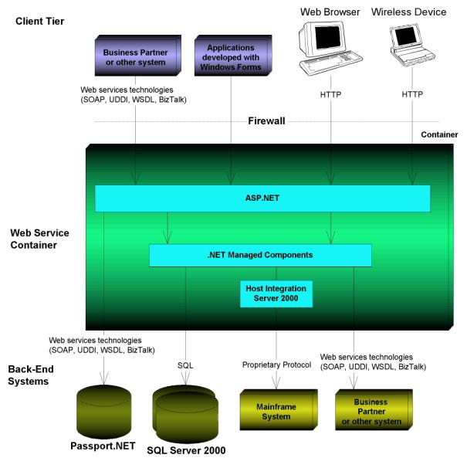
Figure 1.

The developer model for building web services with Microsoft.NET is shown in Figure 1.

  - How does .NET work?

Overview of the .NET Framework

The .NET Framework has two main components: the common language runtime and the .NET Framework class library. The common language runtime is the foundation of the .NET Framework. You can think of the runtime as an agent that manages code at execution time, providing core services such as memory management, thread management, and remoting, while also enforcing strict type safety and other forms of code accuracy that ensure security and robustness. In fact, the concept of code management is a fundamental principle of the runtime. Code that targets the runtime is known as managed code, while code that does not target the runtime is known as unmanaged code. The class library, the other main component of the .NET Framework, is a comprehensive, object-oriented collection of reusable types that you can use to develop applications ranging from traditional command-line or graphical user interface (GUI) applications to applications based on the latest innovations provided by ASP.NET, such as Web Forms and XML Web services.

The .NET Framework can be hosted by unmanaged components that load the common language runtime into their processes and initiate the execution of managed code, thereby creating a software environment that can exploit both managed and unmanaged features. The .NET Framework not only provides several runtime hosts, but also supports the development of third-party runtime hosts.

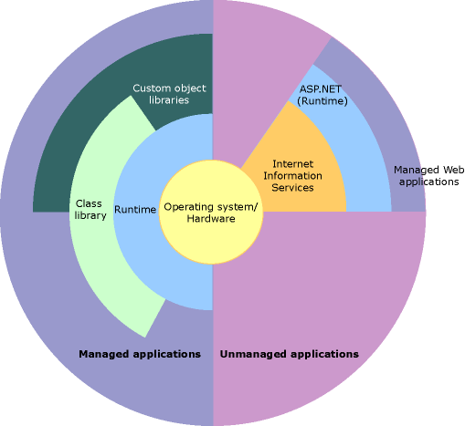

For example, ASP.NET hosts the runtime to provide a scalable, server-side environment for managed code. ASP.NET works directly with the runtime to enable XML Web services.

The following illustration shows the relationship of the common language runtime and the class library to your applications and to the overall system. The illustration also shows how managed code operates within a larger architecture.

The runtime also enforces code robustness by implementing a strict type- and code-verification infrastructure called the common type system (CTS). The CTS ensures that all managed code is self-describing. The various Microsoft and third-party language compilers generate managed code that conforms to the CTS. This means that managed code can consume other managed types and instances, while strictly enforcing type fidelity and type safety.
Features of the Common Language Runtime

The common language runtime manages memory, thread execution, code execution, code safety verification, compilation, and other system services. These features are intrinsic to the managed code that runs on the common language runtime.

The runtime also enforces code robustness by implementing a strict type- and code-verification infrastructure called the common type system (CTS). The CTS ensures that all managed code is self-describing. The various Microsoft and third-party language compilers generate managed code that conforms to the CTS. This means that managed code can consume other managed types and instances, while strictly enforcing type fidelity and type safety.

The runtime is designed to enhance performance. Although the common language runtime provides many standard runtime services, managed code is never interpreted. A feature called just-in-time (JIT) compiling enables all managed code to run in the native machine language of the system on which it is executing. Meanwhile, the memory manager removes the possibilities of fragmented memory and increases memory locality-of-reference to further increase performance.

.NET Framework Class Library

The .NET Framework class library is a collection of reusable types that tightly integrate with the common language runtime. The class library is object oriented, providing types from which your own managed code can derive functionality.

For example, the .NET Framework collection classes implement a set of interfaces that you can use to develop your own collection classes. Your collection classes will blend seamlessly with the classes in the .NET Framework.

As you would expect from an object-oriented class library, the .NET Framework types enable you to accomplish a range of common programming tasks, including tasks such as string management, data collection, database connectivity, and file access. In addition to these common tasks, the class library includes types that support a variety of specialized development scenarios. For example, you can use the .NET Framework to develop the following types of applications and services:

- Console applications.
- Scripted or hosted applications.
- Windows GUI applications (Windows Forms).
- ASP.NET applications.
- XML Web services.
- Windows services.

Client Application Development

Client applications are the closest to a traditional style of application in Windows-based programming. These are the types of applications that display windows or forms on the desktop, enabling a user to perform a task. This area is not the focus of this paper and more information about this can be found in the references.

Server Application Development

ASP.NET is the hosting environment that enables developers to use the .NET Framework to target Web-based applications. However, ASP.NET is more than just a runtime host; it is a complete architecture for developing Web sites and Internet-distributed objects using managed code. Both Web Forms and XML Web services use IIS and ASP.NET as the publishing mechanism for applications, and both have a collection of supporting classes in the .NET Framework.

XML Web services, an important evolution in Web-based technology, are distributed, server-side application components similar to common Web sites. However, unlike Web-based applications, XML Web services components have no UI and are not targeted for browsers such as Internet Explorer and Netscape Navigator. Instead, XML Web services consist of reusable software components designed to be consumed by other applications, such as traditional client applications, Web-based applications, or even other XML Web services. As a result, XML Web services technology is rapidly moving application development and deployment into the highly distributed environment of the Internet.

The .NET Framework also provides a collection of classes and tools to aid in development and consumption of XML Web services applications. XML Web services are built on standards such as SOAP (a remote procedure-call protocol), XML (an extensible data format), and WSDL ( the Web Services Description Language). The .NET Framework is built on these standards to promote interoperability with non-Microsoft solutions.

For example, the Web Services Description Language tool included with the .NET Framework SDK can query an XML Web service published on the Web, parse its WSDL description, and produce C# or Visual Basic source code that your application can use to become a client of the XML Web service. The source code can create classes derived from classes in the class library that handle all the underlying communication using SOAP and XML parsing. Although you can use the class library to consume XML Web services directly, the Web Services Description Language tool and the other tools contained in the SDK facilitate your development efforts with the .NET Framework.

If you develop and publish your own XML Web service, the .NET Framework provides a set of classes that conform to all the underlying communication standards, such as those described in Section 2. Using those classes enables you to focus on the logic of your service, without concerning yourself with the communications infrastructure required by distributed software development.
4. Analysis of .NET

  - Comparision of .NET and J2EE

A significant difference between Microsoft's .Net platform and the J2EE specification is that J2EE involves many different companies. J2EE is not a product in itself, but is more a set of standards that developers need to adhere to.
J2EE and the Microsoft .NET frameworks both hold the promise of being the predominant Web Services framework. Here, we compare and contrast between the two frameworks, ignoring the hype associated with their marketing campaigns.
CRITERIA | J2EE FRAMEWORK | .NET FRAMEWORK
Fundamental Design and Support for Web Services | Support for Web Services is through a pack of APIs such as Java API for XML Messaging (JAXM), Java API for XML Processing (JAXP), Java API for XML Registries (JAXR), and Java API for XML-based RPC (JAX-RPC). | Web Services are built right into the platform and Microsoft .NET framework provides ready support for Web Services standards such as SOAP, WSDL, and UDDI.
Implementation | The implementation of Web Services in J2EE will typically be done through Enterprise JavaBeans (EJBs). You can, however, also have standalone Java applications providing Web Services implementation. It all depends on how the business processing and data logic layer of an application is designed and built. | The implementation of Web Services in .NET framework will typically be done in .NET managed components, including managed classes and COM/COM+ components.
Tools and Servers | There are multiple companies that have built IDEs and application servers based on J2EE. A majority of these companies have already started supporting Web Services creation, deployment and execution within their products.  The level of sophistication and support for Web Services standards differs from product to product. | Microsoft's cornerstone development tool (IDE – Integrated Development Environment) for Web Services is Visual Studio .NET, sure to be as popular as their robust and easy to use Visual Studio.  Web Services enabled servers from Microsoft include BizTalk 2002 and SQL Server 2000.
Maturity of Platform | J2EE has proven to be a robust, scalable and a mature platform over the last four years. Addition of support for Web Services is just another feature for this platform. | Although .NET inherits a lot of features from Windows DNA architecture, it is still relatively new and has to prove itself to be able to offer an enterprise-wide framework.

Table 1:

  - What are the advantages and disadvantages of .NET?

Arguments supporting both platforms:
- You can build web services today using both platforms
- Both platforms offer a low system cost, such as jBoss/Linux/Cobalt for J2EE, or Windows/Win32 hardware for .NET.
- Both platforms offer a single-vendor solution.
- The scalability of both solutions are theoretically unlimited.

Arguments for .NET and against J2EE
- .NET has Microsoft's A-team marketing it
- .NET released their web services story before J2EE did, and thus has some mind-share
- .NET has a better story for shared context today than J2EE
- .NET has an awesome tool story with Visual Studio.NET
- .NET has a simpler programming model, enabling rank-and-file developers to be productive without shooting themselves in the foot
- .NET gives you language neutrality when developing new eBusiness applications, whereas J2EE makes you treat other languages as separate applications
- .NET benefits from being strongly interweaved with the underlying operating system
Arguments for J2EE and against .NET
- J2EE is being marketed by an entire industry
- J2EE is a proven platform, with a few new web services APIs. .NET is a rewrite and introduces risk as with any first-generation technology
- Only J2EE lets you deploy web services today
- Existing J2EE code will translate into a J2EE web services system without major rewrites. Not true for Windows DNA code ported to .NET.
- .NET web services are not interoperable with current industry standards. Their BizTalk framework has proprietary SOAP extensions and does not support ebXML.
- J2EE is a more advanced programming model, appropriate for well-trained developers who want to build more advanced object models and take advantage of performance features
- J2EE lets you take advantage of existing hardware you may have
- J2EE gives you platform neutrality, including Windows. You also get good (but not free) portability. This isolates you from heterogeneous deployment environments.
- J2EE has a better legacy integration story through the Java Connector Architecture (JCA)
- J2EE lets you use any operating system you prefer, such as Windows, UNIX, or mainframe. Developers can use the environment they are most productive in.
- J2EE lets you use Java, which is better than C# due to market-share and maturity. According to Gartner, there are 2.5 million Java developers. IDC predicts this will grow to 4 million by 2003. 78% universities teach Java, and 50% of universities require Java.
- We would not want to use any language other than C# or Java for development of new mission-critical solutions, such as a hacked object-oriented version of C, VB, or COBOL.
5. The future of Web Services and .NET

5.1 .NET Web Services and Grid/Cluster Computing

International interest in supercomputer and high performance computing has seen the creation of Microsoft .NETs’ first true Grid usage. A student group headed by a professor in the Philippines have come up with BayanihanComputing.NET. It is meant to be a medium which brings something that no one has offered before: supercomputing power that you can access anytime, anywhere, and on any device.

As shown in the figure below BayanihanComputing.NET provides a PoolService web service that harnesses the power of the volunteer worker machines. Aa programmer then just needs to to create a Foreman application that divides the computation into separate work packets that the PoolService can distribute to the workers (ie. Economic Scheduling and load balancing etc). The parts of the system are summarized in the table below.

Components
Pool Service | Web service that manages tasks and results from different volunteers
Volunteer | Contributes processing power
Foreman | Creates tasks and asynchronously displays results
Computation Service | Web service that provides a simple interface to a complex, Bayanihan-backed computation
Computation Client | Synchronously invokes computation service

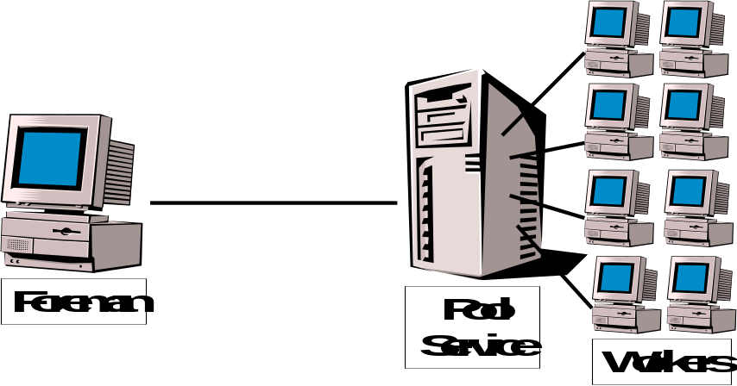

5.2 Current Shortcomings of Web Services and The Future

While the W3 currently is responsible for handing the SOAP ans WSDL specifications a separate organization is focusing more attention on interoperability. The Web Services Interoperability Organization (WS-I) is focused on defining best practices for ensuring Web service interoperability. The WS-I Basic Profile Working Group is currently developing a set of recommendations for how to use the core Web service protocols like SOAP 1.1 and WSDL 1.1 to maximize interoperability.

Besides the ongoing refinement of the current Web Service standards, higher-level services will be added in the coming future. Everyone agrees there needs to be a standard way to secure Web services, route messages to them, ensure reliable message delivery, define transactional semantics, and more. These general-purpose features cut across problem domains and there is no reason each Web service developer should have to implement them individually. Microsoft, IBM and others are doing a lot of work in these areas. The Global XML Web Service Architecture (GXA) by Microsoft is an initiative that defines specifications for how these infrastructure services can be implemented in terms of SOAP messages (i.e. in a transport protocol-neutral way).
6. Conclusion

Are Web Services a flash in the pan? Marketing Hype? It seems Web Services are here to stay.
Many of the major software vendors have entered or will enter the Web services fray, including Microsoft, IBM, HP, Sun, Oracle and SAP to name a few.
With the advent of supercomputing and grid computing, it seems likely that .NET will try to muscle its way in as the number one provider of grid solutions.
References

Refs - http://www.walthowe.com/navnet/history.html
- http://www.ox.compsoc.net/~swhite/history/
- http://transitionlearning.com/demo/10-20k/sect01/10-20k_1-1_read_race.html

