DX-R Mobile Application Project Initiation Documentation

Date of Creation: 2022-04-07

Table of Contents

​ Create Project 3

​ Prerequisite 3

​ Project Initiation 4

​ Additional Library 4

# Create Project

## Prerequisite

npm install -g @angular/core@11

npm install -g @angular/cli@11

npm install -g [ionic](mailto:ionic@5)@5

npm install -g @ionic/angular-toolkit@11

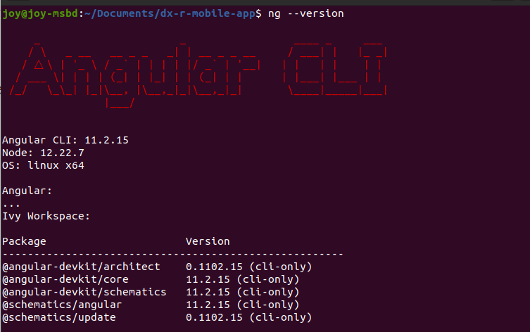

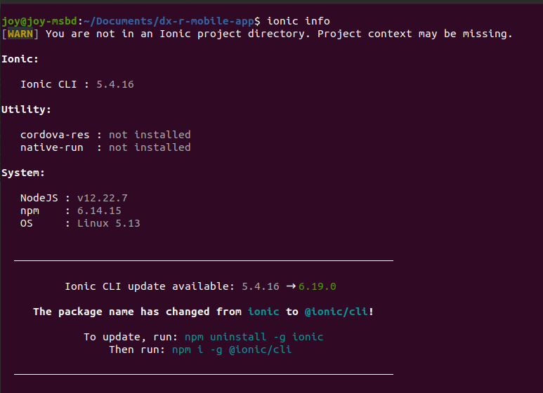

## Project Initiation

1. ionic start
2. Project name: dxr-mobile
3. ? Framework: Angular
4. ? Starter template: tabs

After installing necessary packages project creation will be completed. Then navigate to project directory and run the project using $ ionic serve command.

## Additional Library

1. Integrate Capacitor to project

npm install @capacitor/core

npm install @capacitor/cli -save-dev

npx cap init

**Problem**: capacitor init dxr-mobile io.ionic.starter --npm-client npm exited with exit code 1.

**Solution**: install [ionic@cli](mailto:ionic@cli) instead of ionic

**Reference**: <https://github.com/ionic-team/capacitor/issues/4603>

1. Add Angular PWA to project

$ ng add @angular/pwa

**Reference**: <https://ionicframework.com/docs/angular/pwa>

1. npm install --global http-server
2. ionic build –prod
3. npm i @techiediaries/ngx-qrcode
4. npm i @zxing/ngx-scanner
5. npm i @zxing/library –save
6. npm i @zxing/browser –save

## Trigger PWA Update

# Only two events…

In essence, there are only two events that will automatically trigger a PWA update:

1. A change in the linked manifest.json; e.g. a changed icon file or a changed scope or start_url.
2. A one-character change in the controlling service-worker.js. Hence, if you store the version number in a const in this file and change it, an update of the PWA will be triggered.

Reference:

* 1. <https://stackoverflow.com/questions/49739438/when-and-how-does-a-pwa-update-itself>
  2. https://medium.com/progressive-web-apps/pwa-create-a-new-update-available-notification-using-service-workers-18be9168d717

## 