Eclipse, Spring Tool Suite, (Red Hat) JBoss Developer Studio, MyEclipse

The [Eclipse](https://eclipse.org/) editor is compatible with lombok. Eclipse offshoots are also compatible with lombok, specifically:

* [MyEclipse](https://www.genuitec.com/products/myeclipse/)
* [Red Hat JBoss Developer Studio](https://developers.redhat.com/products/devstudio/overview/)
* [JBoss Developer Studio (JBDS)](https://tools.jboss.org/downloads/devstudio/)
* [Spring Tools Suite (STS)](https://spring.io/tools)

Double-click lombok.jar (downloadable from this site, or from your maven repository; it's the same jar). This starts the eclipse installer which will find eclipse (and eclipse variants as listed above), and offers to install lombok into these eclipse installations. The same tool can also uninstall lombok:   
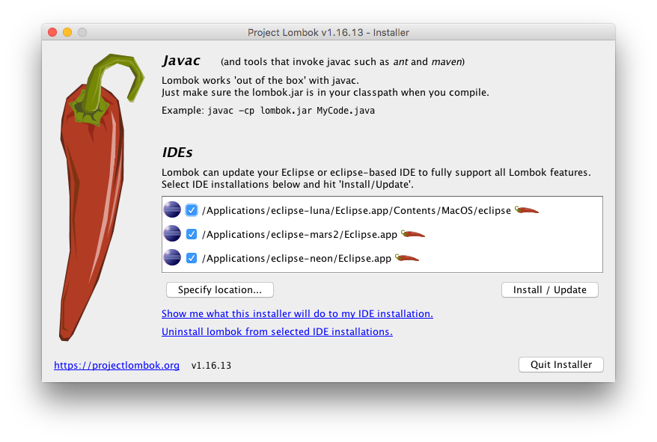

You can check if your eclipse installation is lombok-enabled in eclipse's about dialog. The lombok version will be listed at the end of the copyright text:  
  
