|  |  |
| --- | --- |
|  |  |

**eProject Document**

Amazing bridges

|  |  |
| --- | --- |
| **Group 5** | |
| **Members** | Pham Minh Hien - Student1247030(Team leader)  Tran Khanh Duong - Student1247038  Tran Minh Quang - Student1253305  Nguyen Van Kien- Student1253297 |
| **Instructor** | Nguyen Van Luan |
| **Batch** | C1908I1 |
| **Semester** | I |

**Table of Content**

1. **Problem definition**
   1. ***Acknowledgements***
   2. **eProject Synopsis**
2. **Customer Requirement Specification**
   1. ***Customer Requirement***
   2. ***Hardware – Software Requirements***
3. ***DFDs***
4. ***Folowchar***
5. ***Use case***
6. **Some typical interface**
7. **Task Sheet**
8. **Check List of Validation**
9. **Submission Checklist**
10. **Problem Definition**
    1. **Introduction**

This project going to build a website introducing famous bridges all over the world. Website will run on common browsers such as Chrome, IE, Firefox etc. The website is an open library that provides complete information about historical values, pictures , visual location on the map as well as ways to reach the bridges. It also allows users to search for bridges according to their desired taxonomy such as the highest, longest, etc.

* 1. **Existing Scenario**

The main functions of project:

* Display list of bridges with some filter such as “characteristics” (Largest, Longest, Oldest, Tallest)
* Display history and information of the bridges and it’s images on a detail screen.
* Display location of bridge using GeoLocation API on the maps.
* Allow viewer sends feedback about the bridges
* Show the advertise section of bus, flights to reaching the bridges.
* Allow user download the historic reason and bridge’s information as a pdf or doc file.
* When users log in, users have the right to send feedback and feedback that we will receive, improve.

When completing the registration procedure, you will have 1 account and can log in to use the benefit at any time.

1. **Customer Requirement Specification**
   1. **Customer Requirement**
      1. **Users of the system**

* User
  + 1. **System functions**

|  |  |
| --- | --- |
| **User** | **Functions** |
| **All Users** | * Login * Register * Logout * Interact with the web * Feedback |

* 1. **Reagister**

|  |  |
| --- | --- |
| **Register** | |
| Input | Insert to system, user must be enter username ,email, password and repassword |
| Process | Insert information in local storage |
| Output | Return form login |

* 1. **Login**

|  |  |
| --- | --- |
| **Login** | |
| Input | Login to system, user must be enter username and password |
| Process | Access information in local storage |
| Output | Result of login |

* 1. **logout**

|  |  |
| --- | --- |
| **Logout** | |
| Input | Logout to system, the user needs to click logout |
| Process | Log out of the user account |
| Output | Result of logout |

* 1. **Interact with the web**

|  |  |
| --- | --- |
| **Show list bridge** | |
| Input | The user needs to click on any detail |
| Process | take data. |
| Output | Display the result. |

* 1. **feedback**

|  |  |
| --- | --- |
| **Form feedback** | |
| Input | Insert to system, user must be enter name, email and message |
| Process | Send data to mail |
| Output | Display the result. |

* 1. **Hardware – Software requirement**

### Minimum Hardware Requirements

* CPU: Pentium IV 2.00 GHz.
* RAM: 512 MB.
* Hard Disk: 5 GB.
* OS: Window 2000/XP/Server 2003.

### Recommended Hardware Requirements

* CPU: Dou Core 2.00 GHz or higher.
* RAM: 2 Gb or higher.
* Hard Disk: 80 GB or higher.
* OS: Window XP SP3 / Window 7

### Software Requirements

* Environment: Microsoft .NET Framework 2.0 or later
* Database Management System: Microsoft SQL Server 2005 or later
* IDE: Microsoft Visual Studio 2008 or later
* Web Server: Internet Information Services (IIS 7.0) or later

1. ***DFDs***

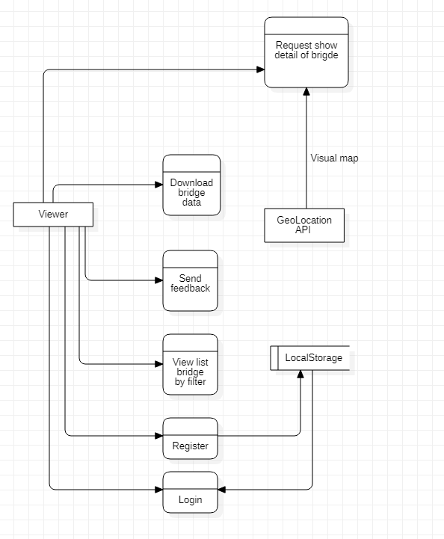

1. **Flow chart**

a. regester

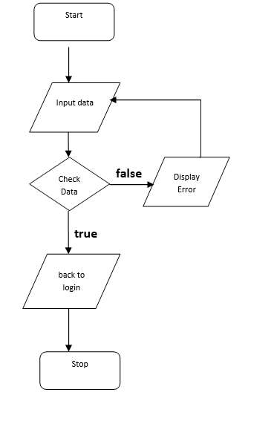

b. login

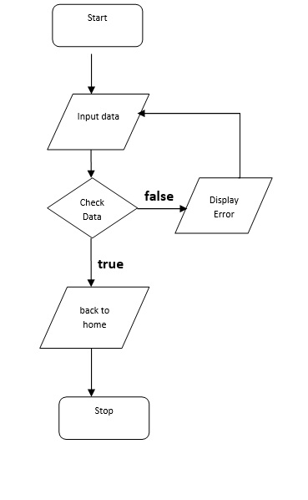

c. logout

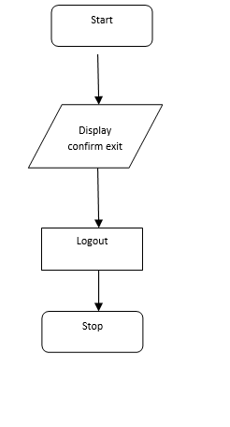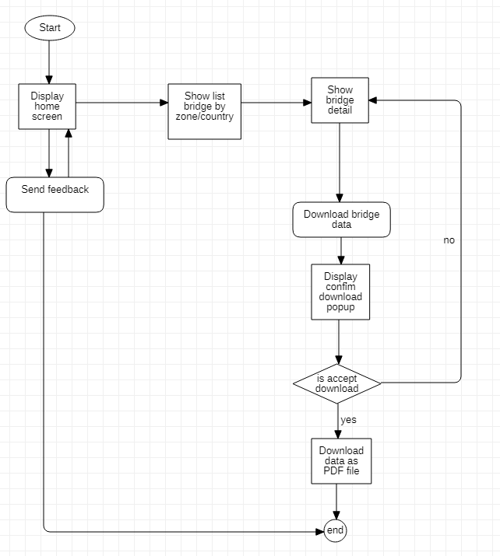

d. Interact with the web and feedback

**5. Use case**

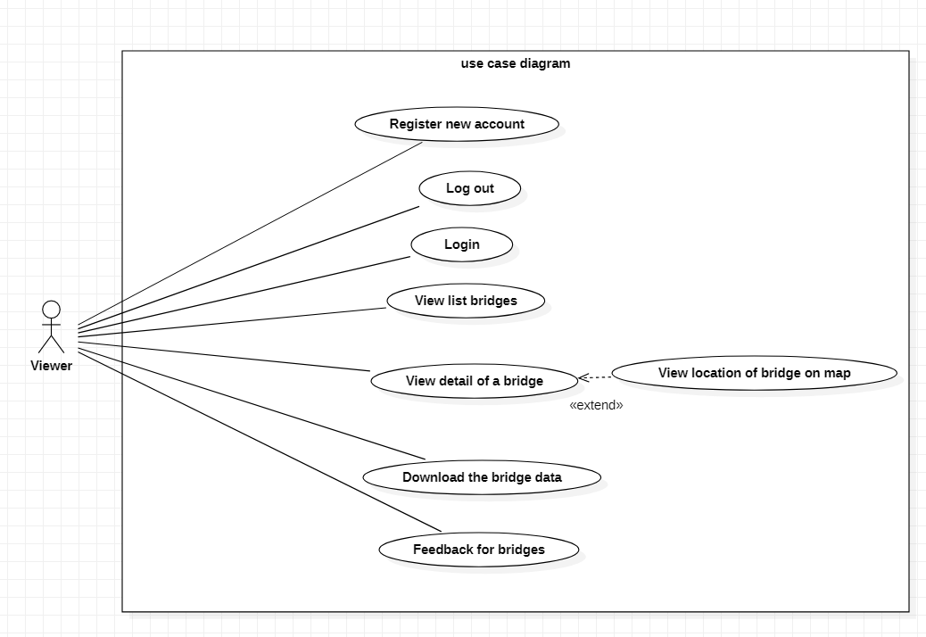

**6. Some typical interface**

## Login Screen

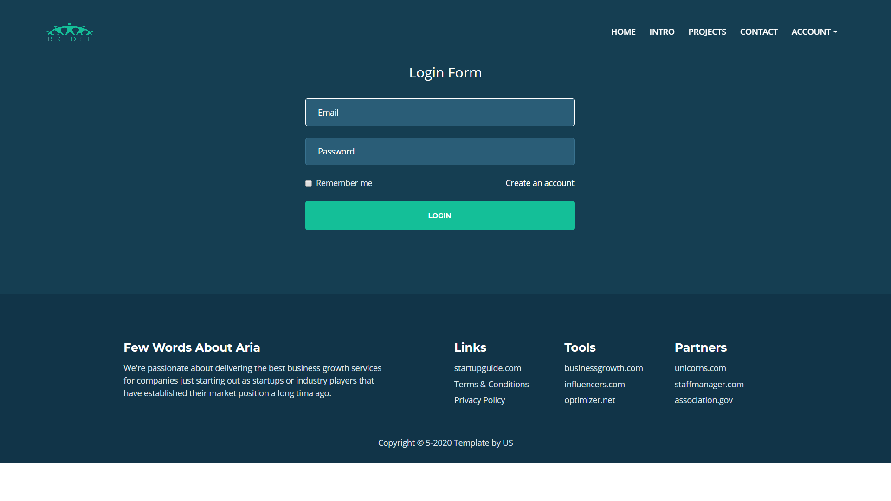

## Register Screen

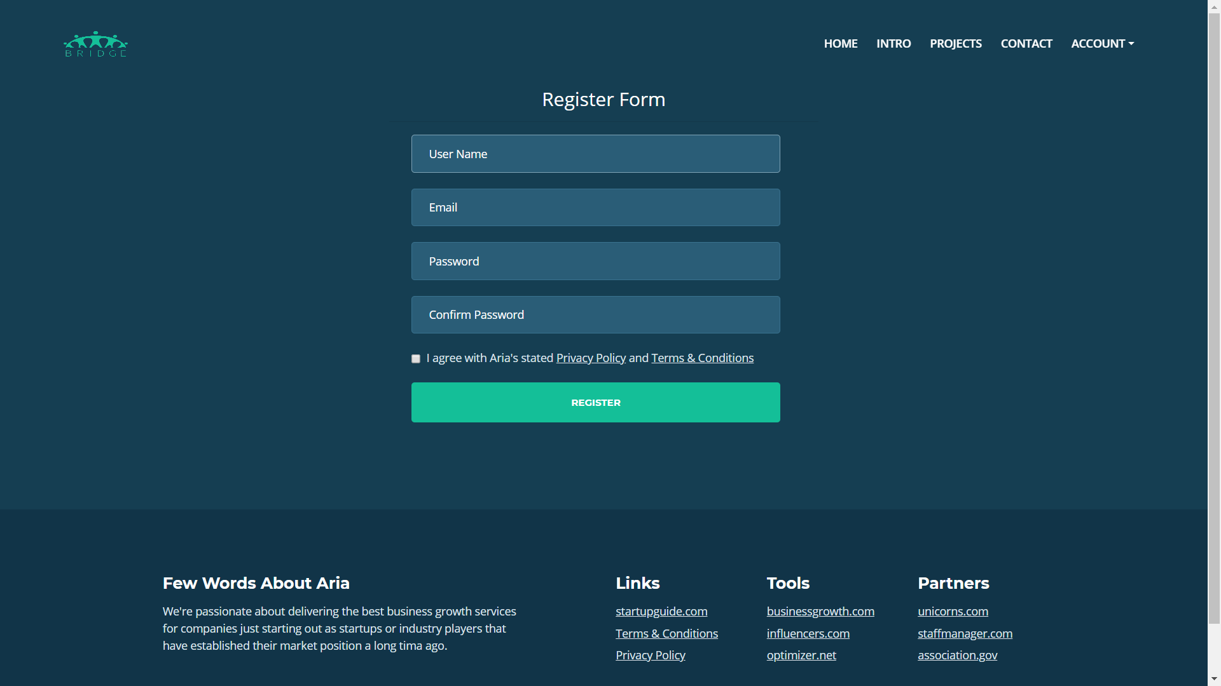

## Home Screen

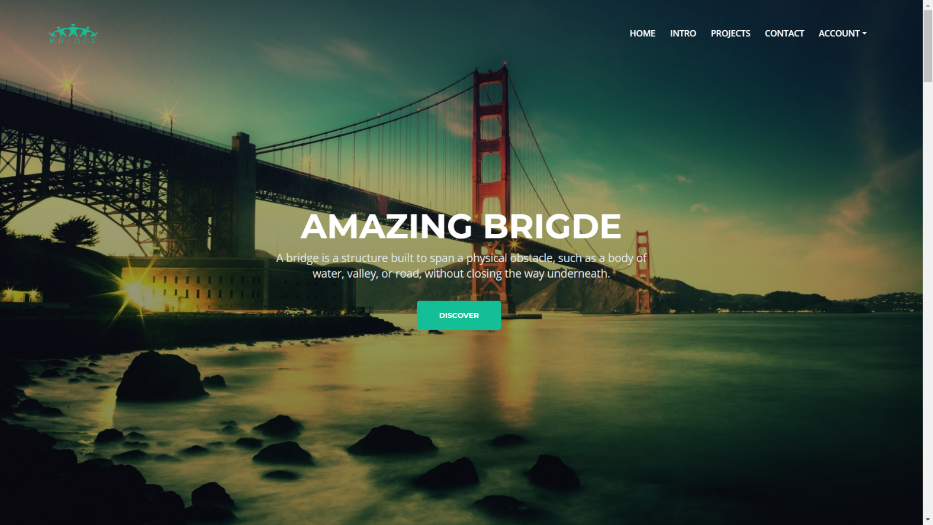

## Fillter Bridges

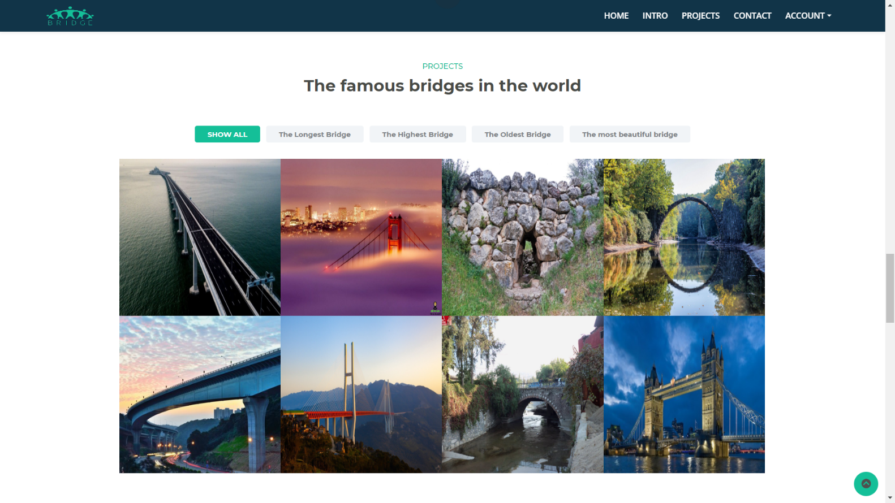

## Feedback

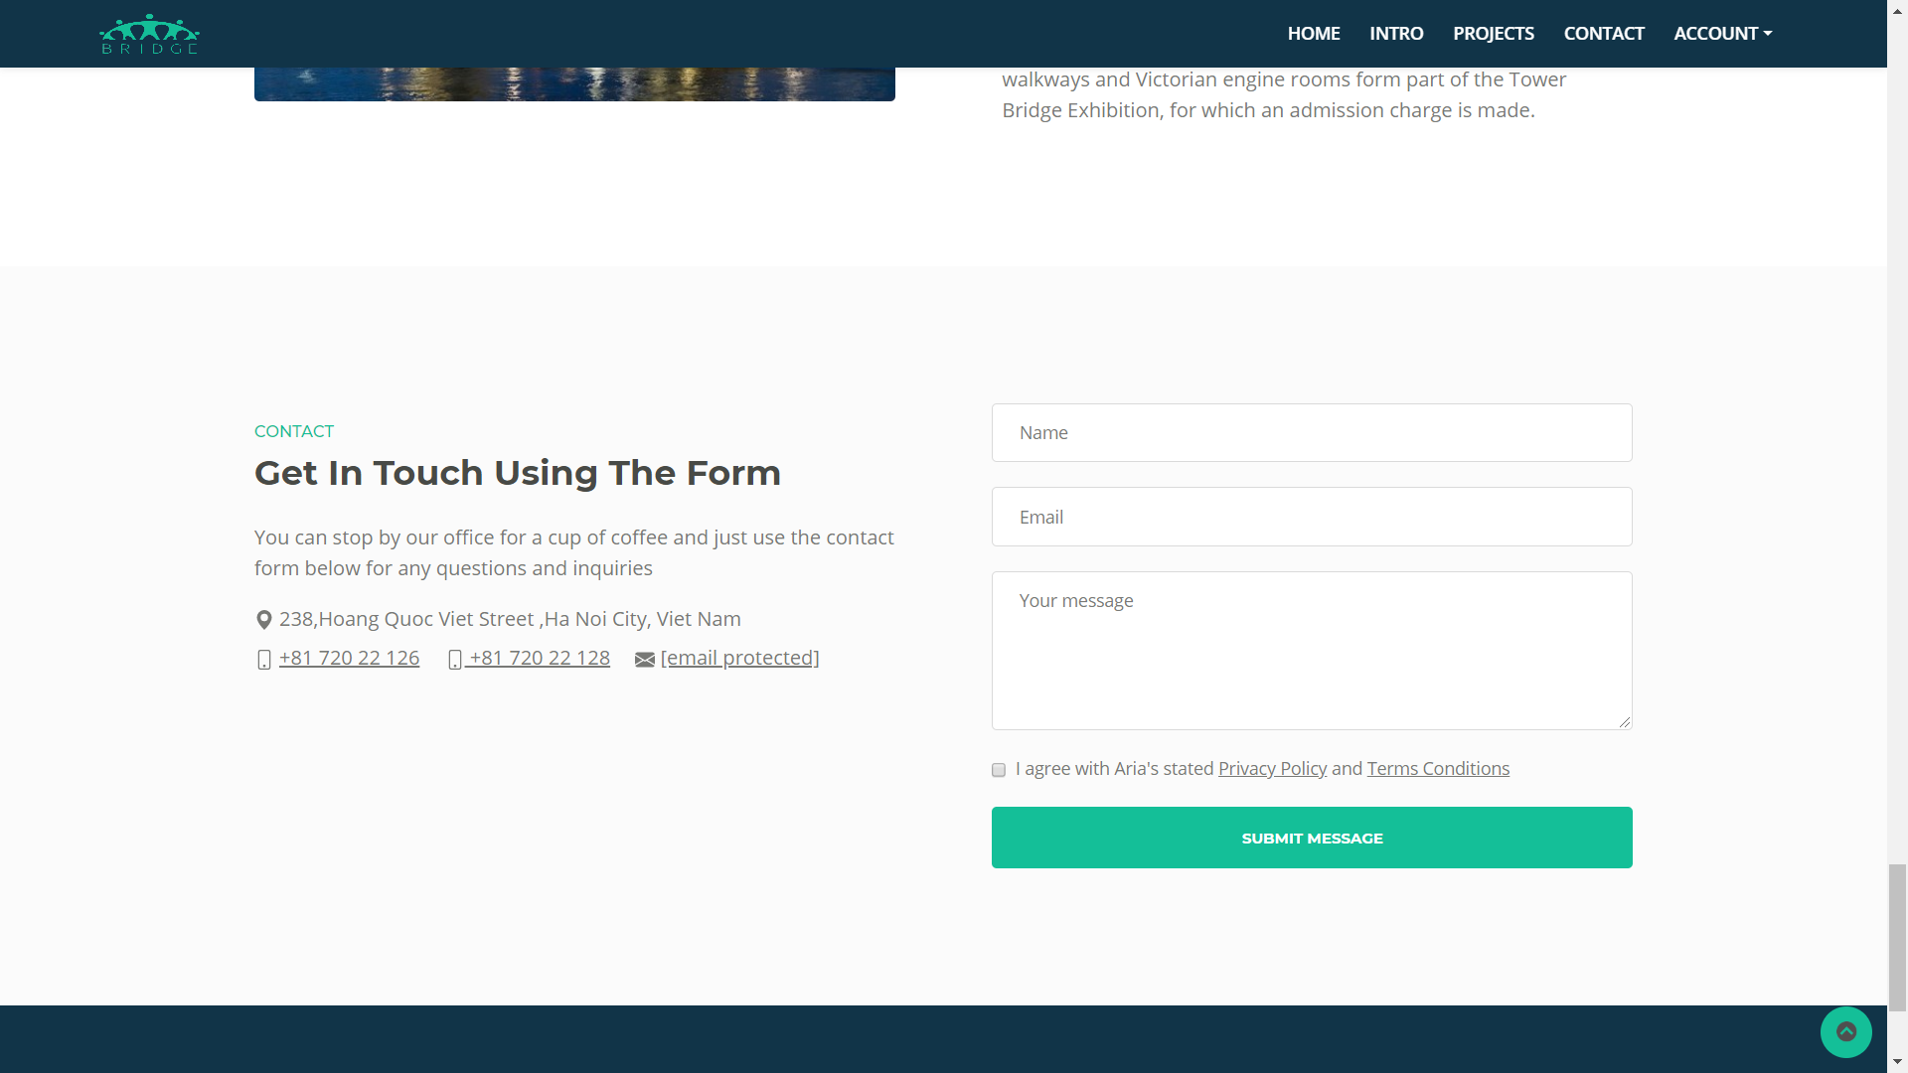

**7. Task Sheet**

|  |  |  |  |  |  |  |
| --- | --- | --- | --- | --- | --- | --- |
| **Project Ref. No: 1** | | Project Title: Amazing Bridges | **Date of Preparation of Activity Plan** | | | |
| **Sr. No.** | **Task** | | **Actual Start Date** | **Actual Days** | **Team Member Names** | **Status** |
| 1 | Ideas | |  | 10 | Pham Minh Hien  Tran Khanh Duong  Nguyen Van Kien  Tran Minh Quang | complete |
| 2 | Document | | Tran Minh Quang  Nguyen Van Kien | complete |
| 3 | Look for Information | | Nguyen Van Kien | complete |
| 5 | Font-end | | Pham Minh Hien | complete |
| 6 | Route | | Tran Khanh Duong | complete |
| 7 | Login Function | | Tran Khanh Duong | complete |
| 8 | Filter and Detail | | Tran Khanh Duong  Pham Minh Hien | complete |
| 9 | Location API | | Pham Minh Hien | complete |
| 10 | Download Function | | Tran Minh Quang | complete |

**8. Check list of validation**

|  |  |
| --- | --- |
| Option | Validate |
| Can a new user who get registered, enter the application after logging in ? | Yes |
| Do all the option present in the application display the correct result | Yes |
| Does the application’s functionality resolve the user problem and satisfy their needs ? | Yes |
| Has the hardware and software been correctly chosen ? | Yes |

**9. Submission checklist**

|  |  |  |  |  |
| --- | --- | --- | --- | --- |
| Sr.No | Particular | Yes | No | Comments |
| 1 | Are the users able to login to application after validations is performed on the on the user name and password ? | Yes |  |  |
| 2 | Are the user able to modify their detail after getting registered |  | No |  |
| 3 | Are all the screen contents devoid spelling mistakes | Yes |  |  |
| 4 | Is the application user-friendly | Yes |  |  |

**THE END**