Slide 5: 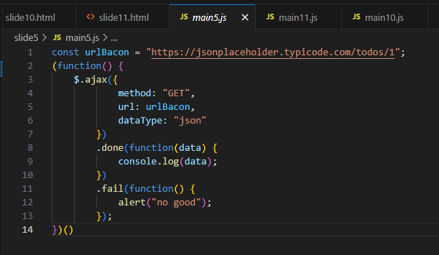

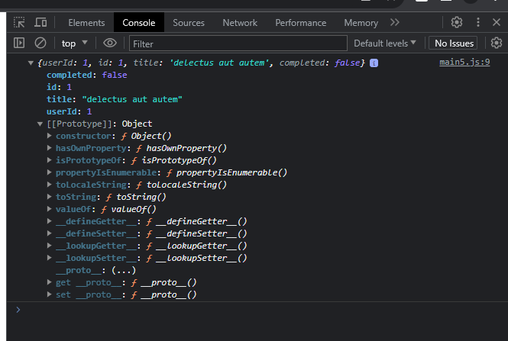

Slide6:

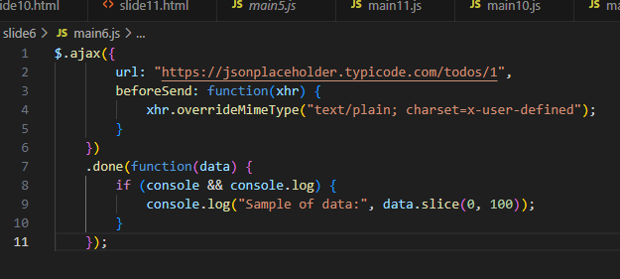

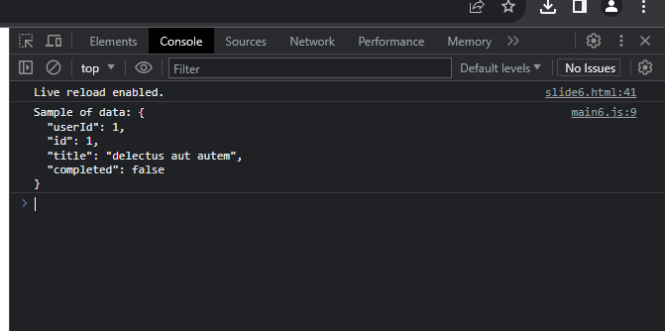

Slide7:

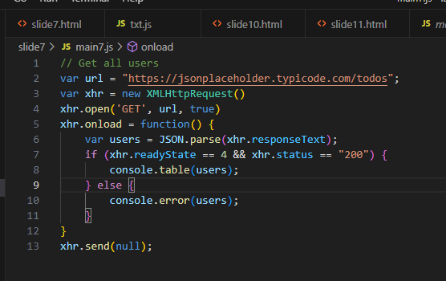

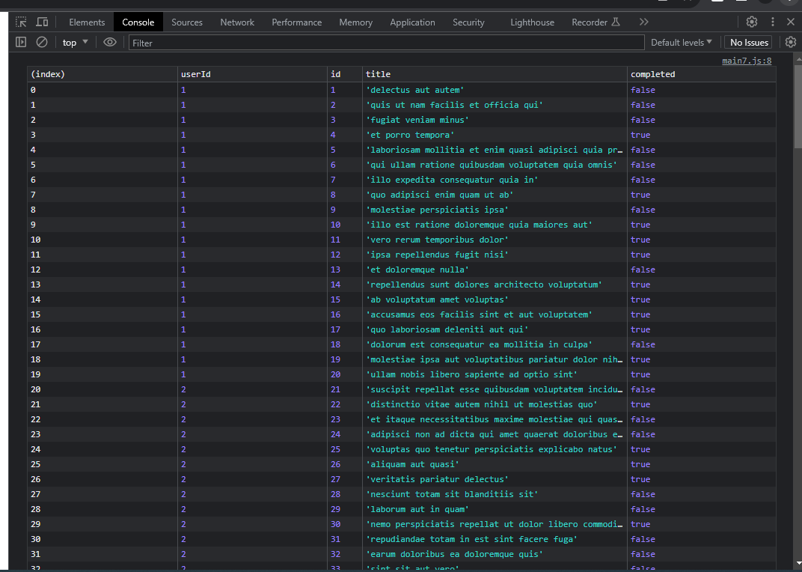

Slide8:

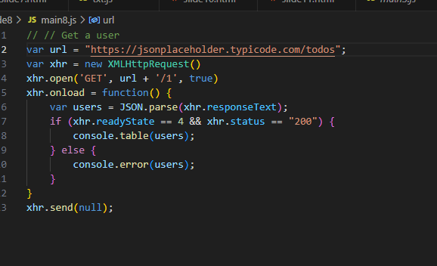

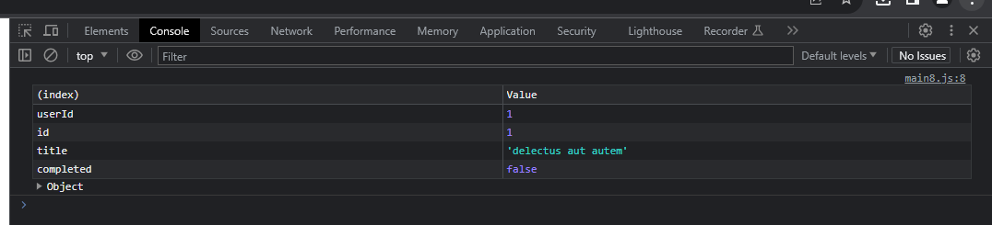

Slide9:

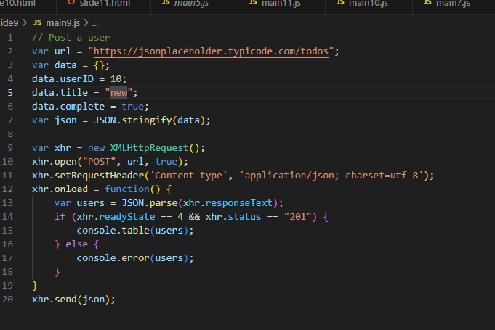

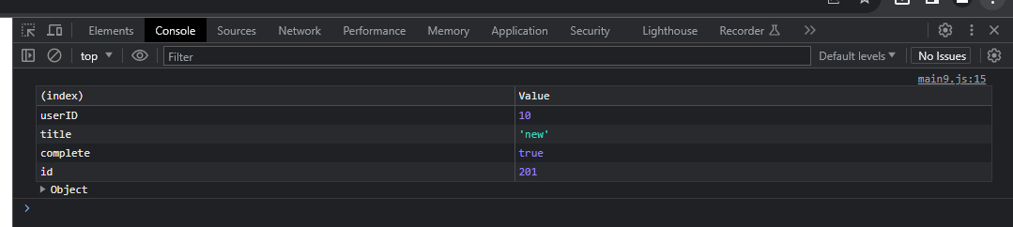

Slide10:

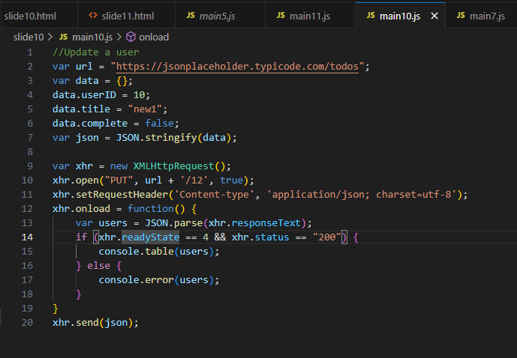

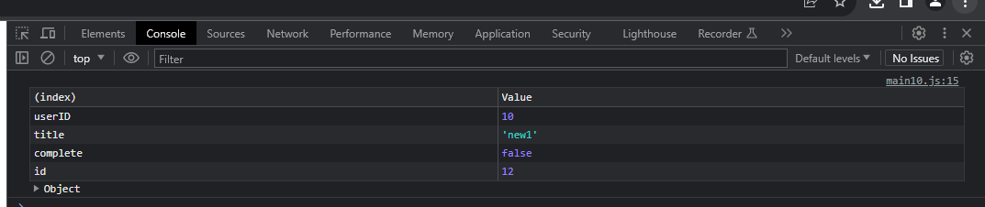

Slide11:

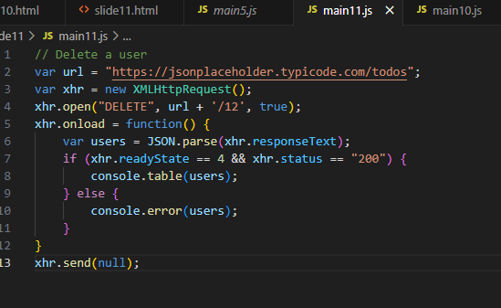

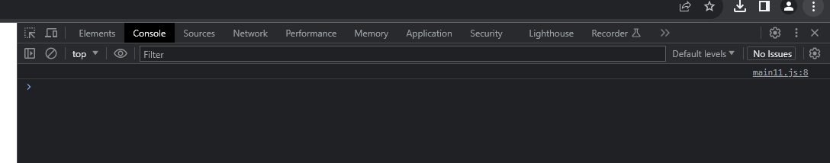

PROMISE CHAIN

RETURN PROMISE

Get Fetch

Creating a resource

Updating a resource

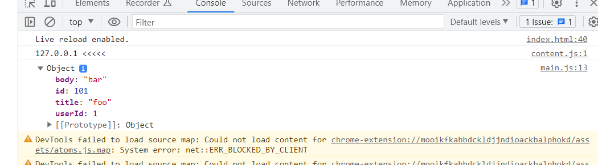

Deleting a resource

Get Axios

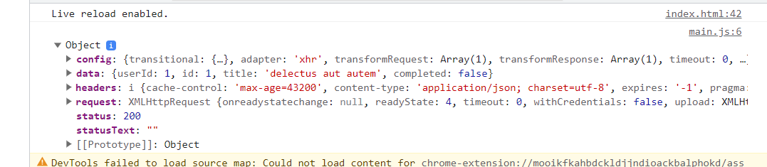

Callback hell

run promise



