ĐẠI HỌC BÁCH KHOA HÀ NỘI  TRƯỜNG ĐIỆN – ĐIỆN TỬ  Đề số: 2 Tổng số trang: 01 |  | ĐỀ THI CUỐI KỲ 2025.1  Học phần: EE3030E – NGUYÊN LÝ TRƯỜNG ĐIỆN TỪ  Ngày thi: 23/01/2026  Thời gian làm bài: 90 phút  (Được sử dụng tài liệu. Nộp lại đề thi cùng bài làm)
Ký duyệt | CBGD phụ trách đề thi: | Trưởng nhóm chuyên môn: | 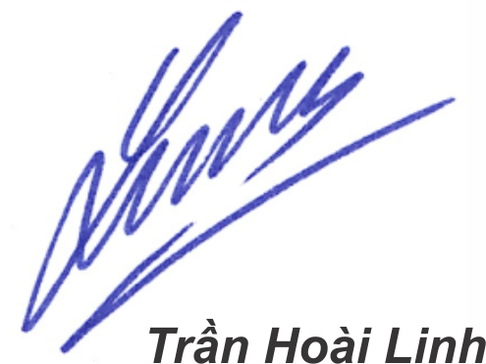

1. Write “Exam code 2” in the first line of the answer sheet, OTHERWISE the final mark is 01.
2. Results must be decimal numbers, e.g., 3.14 or 0.33a_{x}; π or 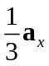 will be considered as WRONG.
3. Result(s)/conclusion(s) must be enclosed, non-enclosed one(s) will be considered as WRONG.
Note: in this question set, the coordinates are given in meters.

Question 1 (4 pts)
Given a potential field V = 5xy + 6y² + z + 10 (V) in free space.
a) Calculate the potential difference between two points A(1, 2, 1) and B(2, 1, 2).
b) Find the electric field intensity (EFI).
c) Consider two regions. The first one whose ε_{r1} = 1 is y > 0, the second one with ε_{r2} = 4 is y < 0. The EFI in the first region is the one found in Question 1b. Determine the EFI in the second region at C(1, 0, 2).

Question 2 (3.5 pts)
The z-axis carries a current of 8 A flowing in the a_{z} direction. An infinite conducting plane having a surface current density of K = –6a_{z} A/m. This plane is parallel to the z-axis and intersects the x- and y-axes at A(4, 0, 0) and B(0, 3, 0), respectively. Find the magnetic field intensity at a point on the y-axis.

Question 3 (2.5 pts)  In a medium whose μ_{r} = 5 there is a magnetic field H = 8a_{x} + 4a_{y} – 7a_{z} (A/m).  a) Find the magnetic flux crossing the circular frame in Fig. 1?  b) The circular frame in Fig. 1 carries a dc current I = 5 mA. If this frame is not deformed, determine the torque acting on this frame. The magnetic field generated by the frame is neglected. | 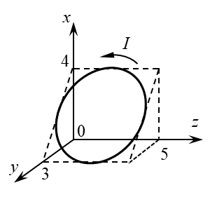
 | Fig. 1

1. Write “Exam code 2” in the first line of the answer sheet, OTHERWISE the final mark is 01.
2. Results must be decimal numbers, e.g., 3.14 or 0.33a_{x}; π or will be considered as WRONG.
3. Result(s)/conclusion(s) must be enclosed, non-enclosed one(s) will be considered as WRONG.

THE END

