

Higher Nationals in Computing

# 1625: MANAGING A SUCCESSFUL PROJECT ASSIGNMENT 1

Student name: TRAN TRONG NGHIA

Student code: GCS210906

Class: GCS0905B

Subject code: 1625

Assessor name: **NGO QUOC ANH**

Assignment due: March 15, 2023Assignment submitted: March 15, 2023

**ASSIGNMENT 1 BRIEF**

|  |  |  |  |
| --- | --- | --- | --- |
| **Qualification** | **BTEC Level 5 HND Diploma in Computing** | | |
| **Unit number and title** | Unit 06: Managing a Successful Project | | |
| **Assignment title** | Plan and conduct a small scale research activity | | |
| **Academic Year** | 2022 - 2023 | | |
| **Unit Tutor** | Do Tien Thanh | | |
| **Issue date** | 03 August 2022 | **Submission date** |  |

|  |
| --- |
| **Submission Format:** |
| *Format:* The submission is in the form of an individual written report that shows how you have manage the project. This should be written in a concise, formal business style using single spacing and font size 12. You are required to make use of headings, paragraphs and subsections as appropriate, and all work must be supported with research and referenced using the Harvard referencing system. Please also provide a bibliography using the Harvard referencing system.  *Submission* Students are compulsory to submit the assignment in due date and in a way requested by the Tutors. The form of submission will be a soft copy in PDF posted on corresponding course of <http://cms.greenwich.edu.vn/>  *Note:* The Assignment *must* be your own work, and not copied by or from another student or from  books etc. If you use ideas, quotes or data (such as diagrams) from books, journals or other sources, you must reference your sources, using the Harvard style. Make sure that you know how to reference properly, and that understand the guidelines on plagiarism. *If you do not, you definitely get fail* |
| **Assignment Brief and Guidance:** |
| **Introduction to theme The environmental impact of digital transformation**  The amount of data created and stored globally is expected to reach 175 Zettabytes by 2025, a six-fold increase from 2018. This will demand additional hardware and power consumption, which; in turn, will increase the environmental impact of the digital sector and there is already increasing attention on the environmental footprint of ICT equipment and services as they become more widespread in all aspects of human life.  It is the responsibility of everyone to take action in addressing the challenges of climate change, as professionals we must also seek ways that the digital sector can play its part. While digital technologies are one of the sectors that has achieved greater efficiency; achieving about 100 times more computation power from the same amount of energy per decade, it remains unsustainable. The sector must continue to seek ways in which it can continue to support and drive innovation, while addressing the global climate emergency for a greener and fairer future.  This unit will enable students to explore the impact of digital endpoint devices and ways to reduce environmental damages, OR the potential of refurbishing, repairing and reusing digital devices rather than replacing  **Tasks**  As a member of Research and Development department, you have been assigned a mini-project to find out the impact of digital endpoint devices and ways to reduce environmental damages, OR the potential of refurbishing, repairing and reusing digital devices rather than replacing.  You need to do primary research (both qualitative and quantitative research) and secondary research to find out that impact and conduct a report for your research. Even it’s a mini-project, you must apply project management (PM) techniques such as project charter with aims, objectives, cost etc. As for time management, you need to produce WBS and Gantt chart with reasonable tasks and time. A project logbook is required to provide evidence of the project development process and ongoing reflection for every week. This logbook will be needed later for your reflection and evaluation in Assignment 2. As part of QA (quality assurance) policy, in the report you also need to critically evaluate the PM process and appropriate research methodologies applied.  Your report must have an introduction stating the project aims and objectives. This must be followed by a copy of your project management plan. Your plan should show the milestones when you will review with your tutor your ongoing progress so far. You will submit your logbook which shows how you have carried out the project. |

|  |  |  |
| --- | --- | --- |
| **Learning Outcomes and Assessment Criteria** | | |
| **Pass** | **Merit** | **Distinction** |
| **LO1** Establish project aims, objectives and timeframes based on the chosen theme | | **LO1 & LO2**  **D1.** Critically evaluate the  project management  process and appropriate  research methodologies  applied. |
| **P1** Devise project aims and objectives for a chosen scenario.  **P2** Produce a project management plan that covers aspects of cost, scope, time, quality, communication, risk and resources.  **P3** Produce a work breakdown structure and a Gantt Chart to provide timeframes and stages for completion. | **M1** Produce a comprehensive project management plan, milestone schedule and project schedule for monitoring and completing the aims and objectives of the project. |
| **LO2** Conduct small-scale research, information gathering and data collection to generate knowledge to support the project | |
| **P4** Carry out small-scale research by applying qualitative and quantitative research methods appropriate for meeting project aims and objectives | **M2** Evaluate the accuracy and reliability of different research methods applied. |

Assignment 1

Table of Contents

Part 1: Project management 5

I. Introduction 5

II. Project initialization (P1) 5

III. Project Management Plan (P2) 5

1. Actions / Activities 5

2. Time 8

3. Communication 10

4. Risks 11

5. Resources 12

6. Cost estimation 12

IV. Planning Chart (P3) 13

1. WBS 13

2. Gantt Chart 14

Part 2: Research (P4) 15

I. Sequential 15

1. Research topic 15

2. Scope 15

3. Methodology 16

4. Data requirement 16

II. Generalized 17

1. E-waste’s definition, cause and effects 17

2. Survey method 17

References 20

# Part 1: Project management

## Introduction

* In this assignment 1, I will be conducting research and planning on the topic of the impact of e-waste on the environment and the reason why Vietnamese people would waste them and the solution to prevent this problem.

## Project initialization (P1)

* **Main aim of the project:** The purpose of this project is to find out the effects of e-waste on the environment then learn how it happened in the first place and the solution to it.
* **List of Objectives to achieve the aim**
  + Objective 1: Gain full understanding and knowledge about the research topic
    - * Have an understanding of what e-waste is
      * The disadvantages and drawbacks of it
  + Objective 2: Knowing the reason why most Vietnamese people do not return or recycle e-waste
  + Objective 3: Having solutions to minimize the problem
* Scope:
  + Do’s:
    - Researching about the correlation between e-waste and the impact it has on the environment as a whole.
    - Knowing the reason why most Vietnamese people do not return or recycle e-waste
    - Give out changes and ways to reduce the effect of e-waste
  + Don’t:
    - This project does not develop a whole software or website, just the act of researching.
    - This project does not do research about the history of e-waste.

## Project Management Plan (P2)

### Actions / Activities

* The first step of project planning is to figure out an action plan. This includes various activities that is needed in the progress of the project. The table below is all of the activities that I think is required to do in the project.

|  |  |  |
| --- | --- | --- |
| Phase | Activity | Description |
| Initiating | Choosing a research topic | This activity is to choose a researching topic. This stage is essential to know what to research and not to go off-topic |
| Investigating the challenge that the project may face when choosing the topics | This is important to know beforehand which issues could occur |
| Finish choosing and present it to the professor | Finalizing the topic of the project |
| Planning | Find out the risks in the project | Knowing risks that can happen during the project can be essential and minimize the impact of those risks |
| Prioritize the risks | Knowing which risks should be handle first can help to effectively remove the risks |
| Calculating the duration of the project | Time plan and scheduling to identify the duration of activities and project |
| Estimating the cost of the project | Calculating all of the cost that tools and other resources can bring |
| Creating goals and action plan for the project | Making goals and actions that is taken in the researching process |
| Creating a WBS and Gantt chart | Making a chart can help to visualize and make it easier to understand the process of the project |
| Executing | Definition of e-waste | Researching about what e-waste is |
| Find the cons of e-waste | Knowing what the disadvantages of e-waste |
| Gathering information on the cause | Collecting data about what cause e-waste to happen |
| Gathering data from survey on how they feel about e-waste | Creating and gathering valuable data from the survey |
| Give suggestion on how e-waste can be reduced | Giving out solutions about how e-waste can be reduced in order to make it effect less impactful |
| Closing | Evaluating the comprehension of the study | Showing what I have learnt throughout the project |

* From the table above, I have made a Work Breakdown Structure Graph.

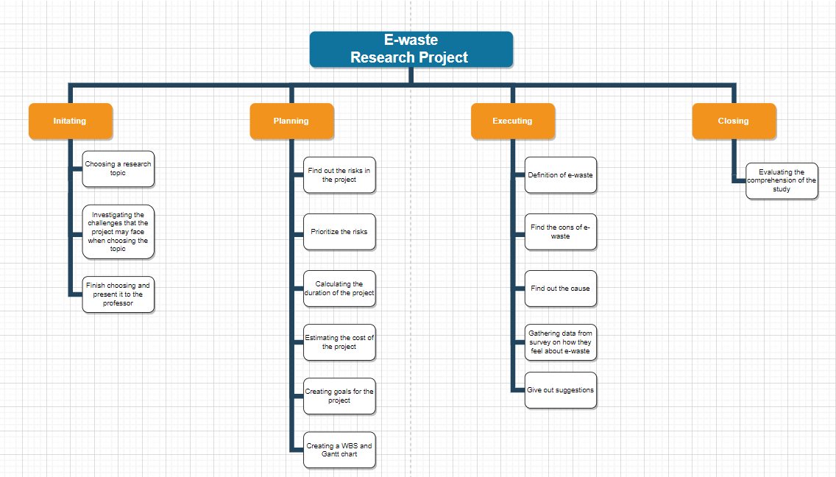

Figure 1: Work Breakdown Structure

* In order to make the project there will be four total phases with its own smaller tasks. Those stages include:
  + **Initiating:** with three tasks
  + **Planning:** with six tasks
  + **Executing:** with five tasks
  + **Closing:** with one task
* I will now begin to explain each stage of the e-authentication research project in-depth:
  + **Initiating**: This is the beginning of the project. In this phase, the idea of the project is explored and elaborated. This phase in the project is consisted of three smaller tasks
    - **Creating a research topic:** this is essential since establishing the main topic of the research reduce the chance of going off topic and focusing on the main topic of the project
    - **Investigating the challenges:** In order to find out whether the topic is comprehensible and suitable for the ability for me, I need to find out the challenges that I may face. Furthermore, it gives me what to expect when tackling the topic.
    - **Finish choosing and present it to the professor:** Finalizing the topic and begin to work on the project.
  + **Planning:** The planning phase is when the project plans are documented, the project deliverables and requirements are defined, and the project schedule is created. It involves creating a set of plans to help guide your team through the implementation and closure phases of the project. This phase in the project is consisted of six smaller tasks
    - **Find out the risks in the project:** Investigating the risks is essential so that I can foreseen the challenges and make up a way to tackle it effectively.
    - **Prioritize the risks:** Examining which risk should be deal with first and which should be given the most attention.
    - **Calculating the duration of the project:** Estimating the time the project would likely take to be completed
    - **Creating goals for the project:** Making milestones for theproject can help to keep track of the progression of the research project.
    - **Creating a WBS and Gantt chart:** A graph can help to simplify and make it easier to understand the actions and time of the project.
  + **Executing:** The execution phase in project management involves carrying out the details of the project charter.
    - **Definition of e-waste:** Finding the meaning and all of the aspects of e-authentication
    - **Find the cons:** Presenting the disadvantages of e-waste
    - **Find out the cause:** Knowing all of the data and hardware/software which is needed for the project.
    - **Gathering data from survey from:** Including creating and taking survey.
    - **Give suggestions on how e-waste can be reduced:** Brainstorm and using all of the data that have been gathered
  + **Closing:** The ending phase of the project
    - **Evaluating the comprehension of the study:** What I learnt from doing the study and research project

### Time

* This project will take a fair amount of time. I estimate that this e-authentication system project will take up almost four weeks to do. This process include:
  + Project planning: about 1 week to plan out and manage the project accordingly
  + Researching: this will likely to take up 1 week to learn and gather information about e-waste
  + Developing e-authentication system: This stage will take up the most amount of time which is 2 weeks to develop.

|  |  |  |
| --- | --- | --- |
| Phase | Description | Time |
| Initiating | Choosing a research topic | 19/02/2023 |
| Investigating the challenge that the project may face when choosing the topics | 19/02/2023 |
| Finish choosing and present it to the professor | 20/02/2023 |
| Planning | Find out the risks in the project | 21/02/2023 |
| Prioritize the risks | 22/02/2023 |
| Calculating the duration of the project | 23/02/2023 |
| Estimating the cost of the project | 24/02/2023 |
| Creating goals for the project | 25/02/2023 |
| Creating a WBS and Gantt chart | 26/02/2023 |
| Executing | Definition of e-waste | 27/02/2023 |
| Find the cons of e-waste | 28/02/2023 |
| Gathering information on the cause | 01/03/2023 |
| Gathering data from survey on how they feel about e-waste | 02/03/2023 |
| Give suggestion on how e-waste can be reduced | 03/03/2023 |
| Closing | Evaluating the comprehension of the study | 04/04/2023 |

* In order to help the project to finish in the earliest finish time. I have organized a table below to helps with the task of creating a critical path method algorithm.

|  |  |  |  |
| --- | --- | --- | --- |
| Task ID | Task Description | Task Predecessors | Task Duration (days) |
| A | Project start |  | 0 |
| B | Initiating the project | A | 3 |
| C | Planning the project | B | 6 |
| D | Doing research about e-waste on the Internet | C | 3 |
| E | Creating a survey to gather data | C | 1 |
| F | Send out the survey and gather data | E | 1 |
| G | Give out suggestion and conclusion | F, D | 1 |
| H | Evaluate the project | G | 1 |

* From the table, I have created a CPM graph

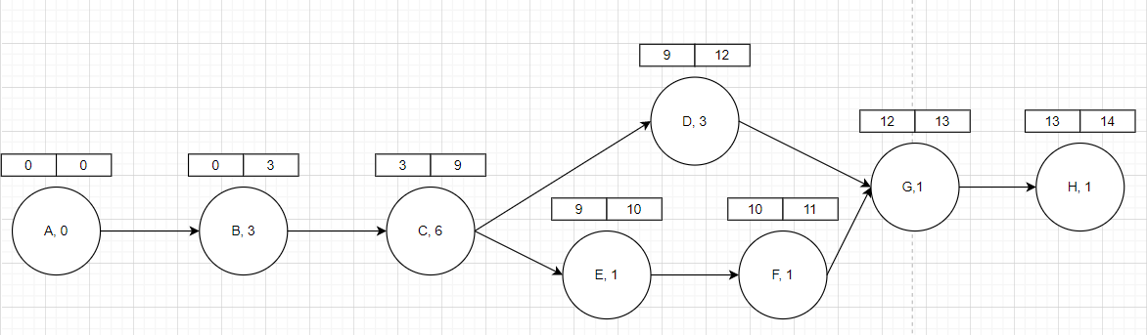

|  |  |  |  |  |  |
| --- | --- | --- | --- | --- | --- |
| **Task ID** | **Duration** | **ES** | **EF** | **LS** | **LF** |
| A | 0 | 0 | 0 | 0 | 0 |
| B | 3 | 0 | 3 | 5 | 8 |
| C | 6 | 3 | 9 | 8 | 13 |
| D | 3 | 9 | 12 | 13 | 16 |
| E | 1 | 9 | 10 | 13 | 14 |
| F | 1 | 10 | 11 | 14 | 15 |
| G | 1 | 12 | 13 | 16 | 17 |
| H | 1 | 13 | 14 | 17 | 18 |

* The two boxes above all of the activities are ES (earliest start) and EF (earliest finish). ES is calculated by the largest EF time of the previous activity and EF is estimated by combining the earliest starting time and the time of the task.
* From the time table above, I have developed a time schedule using Gantt chart for the project with clear tasks and beginning and ending date for each objective
* 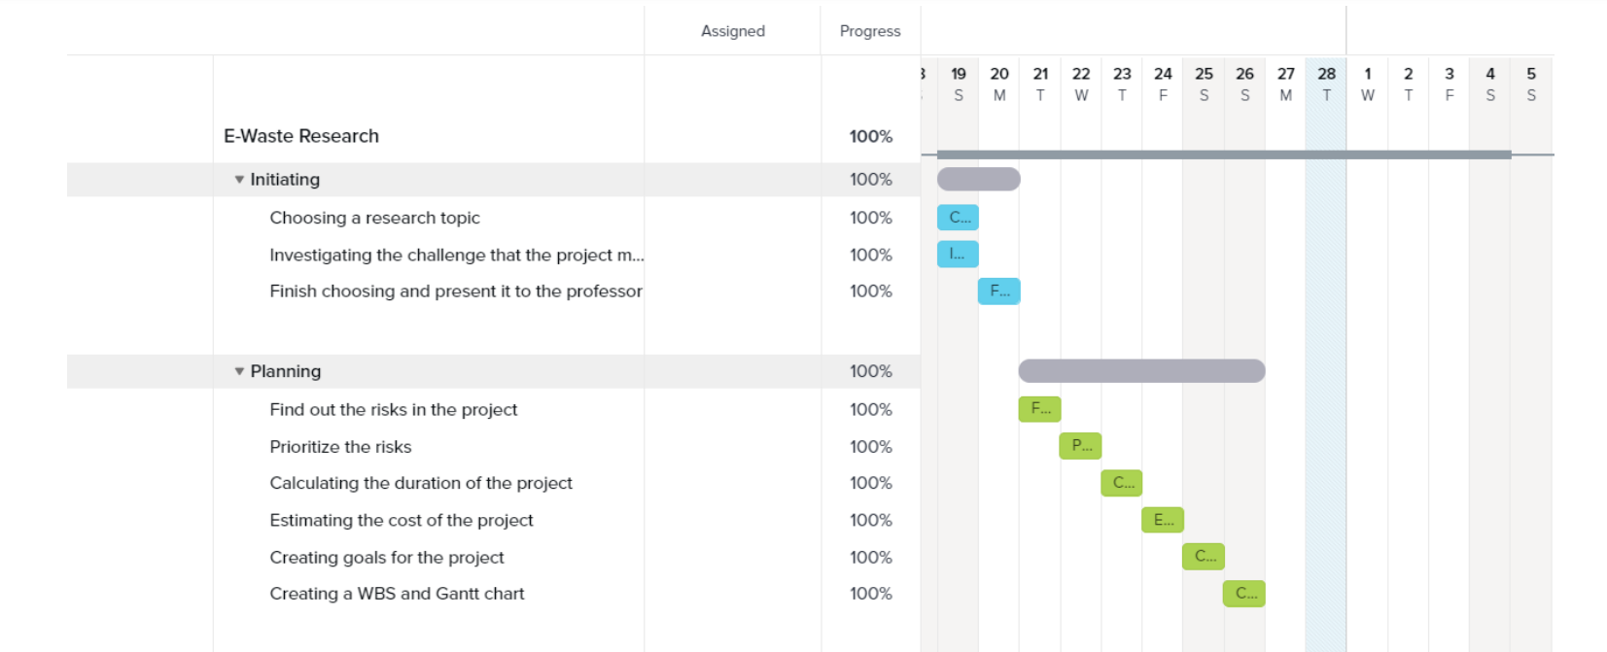
* Figure 2: Gantt Chart #1
* 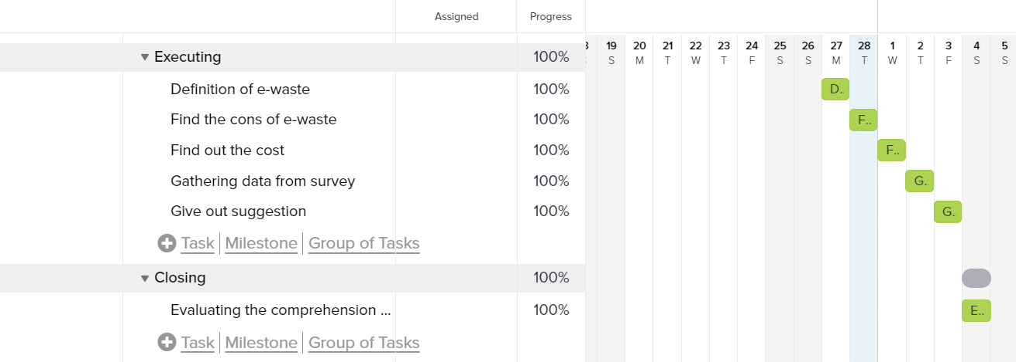
* Figure 3: Gantt Chart #2
* The time plan is divided into four phases: initiating, planning, executing and closing.

### Communication

#### What is communication in project planning?

* Communication in project management refers to the sharing of ideas and opinions between professionals who are working on similar or related tasks. Usually, a priority of a project leader, communication in project management ensures that each professional working on the project is aware of the goals and expectations. This helps professionals work more efficiently and often improves the quality of their work as well.

#### Type of communication that the project will implement

* In this project, I will be using pull communication.
* Pull communication usually allows us to access information whenever we desire. Forms of pull communication include:
* Website and landing pages
* Knowledge base
* Management software and apps
* The reason why I choose this type of communication method is because I will be mainly handle this project by myself. That’s is why the only person that I can communicate is my managers and clients.

### Risks

#### What is risks in project management?

Risks are unforeseen or unplanned happenings, which, when they occur, devastate or at least adversely affect our future plans. A project has these components: budget, time, resources, quality, and technology. If any risk occurs that might affect any of these components, then the project may fail.

#### Risks in project

* The below is all of the risks that may occur in the e-authentication project and also its priority and actions to handle the respective risks:
  + Resource risks: This occurs when the project does not have enough resources to be completed
  + Technology risks: This happens when the project does not have enough technological resources in order to develop
  + Budget risks: The project does not have enough money to
  + Quality risks: The condition of the end product does not meet the requirement of the clients
  + Time risks: The duration to work on the project is not enough or the project takes longer than expected
* From all five of those risks, I will now priorities which risk should be handle first
  + 1. Time I priorities this first because the project will fail regardless if the deadline is overdue.
  + 2. Quality: The quality of the end-product should at-least meet the bar minimum for this project to succeed.
  + 3. Resource: In order to make this project successful, I need to gather as many relevant and useful information and data as possible.
  + 4. Technology & Budget: This should not be priorities much since this project do not require them much.
* Suggestion/Actions:
  + Time: Schedule and manage the timeline of the project accordingly and effectively so that the project can be done within the appropriate time-span. Regularly re-checking the progress of the project to see if it is going accordingly to the plan or schedule.
  + Quality: Researching the requirement of the client and the overall expectation of the security system in order to ensure that it has reached the bar minimum requirement
  + Resource: Collecting various information and data that is require for the e-authentication system firsthand and then collect more if the resource is lacking in the process of development.
  + Technology & Budget: Ensure that the project has all of the technology and budget.
* The below is a risk analysis table from all of the risks above

|  |  |  |  |
| --- | --- | --- | --- |
| Risk Category | Risk | Probability | Impact |
| Time / Schedule | Not enough time for project | Medium | High |
| Resource | Not enough data | High | Medium |
| Resource | Skill is not enough to handle | Medium | Medium |
| Quality | Bad quality of the product solution | Medium | High |
| Project Scope | Expectation and scope creep | Low | Medium |

### Resources

* Firstly, I have to identify the type of resources that is needed:
  + Personnel: Tran Trong Nghia. Since this is a one-person project, there will be only one human resources
  + Tools / Equipment: There are various tools that I needed in order to
* The tools that are require to make this project possible will be divided into two categories hardware and software. Hardware is for parts or machines that is needed for the project while software will be applications.
  + Hardware:
    - Mid-range laptop or desktop
    - Router or Wifi (access to the Internet)
  + Software
    - Microsoft Word
    - A browser of choice
    - TeamGantt
    - Draw.io

### Cost estimation

* Man: one person will handle the project so there may not need to be any resources to mange though the below will prove to be useful
  + **TeamGantt**: A free to use website for scheduling and to make sure that the person know what they have to do in the day
  + **Draw.io**: a useful tool to make chart. I will use this to draw WBS.
* Cost estimation Tools:

|  |  |  |
| --- | --- | --- |
| Cost type | Tool Name | Cost ($) |
| Tools | Microsoft Word | Free |
| TeamGantt |
| Draw.io |
| Total | | 0.00 |

## Planning Chart (P3)

### WBS



Figure 1: Work Breakdown Structure

* In order to make the project there will be four total phases with its own smaller tasks. Those stages include:
  + **Initiating:** with three tasks
  + **Planning:** with six tasks
  + **Executing:** with five tasks
  + **Closing:** with one task
* I will now begin to explain each stage of the e-authentication research project in-depth:
  + **Initiating**: This is the beginning of the project. In this phase, the idea of the project is explored and elaborated. This phase in the project is consisted of three smaller tasks
    - **Creating a research topic:** this is essential since establishing the main topic of the research reduce the chance of going off topic and focusing on the main topic of the project
    - **Investigating the challenges:** In order to find out whether the topic is comprehensible and suitable for the ability for me, I need to find out the challenges that I may face. Furthermore, it gives me what to expect when tackling the topic.
    - **Finish choosing and present it to the professor:** Finalizing the topic and begin to work on the project.
  + **Planning:** The planning phase is when the project plans are documented, the project deliverables and requirements are defined, and the project schedule is created. It involves creating a set of plans to help guide your team through the implementation and closure phases of the project. This phase in the project is consisted of six smaller tasks
    - **Find out the risks in the project:** Investigating the risks is essential so that I can foreseen the challenges and make up a way to tackle it effectively.
    - **Prioritize the risks:** Examining which risk should be deal with first and which should be given the most attention.
    - **Calculating the duration of the project:** Estimating the time the project would likely take to be completed
    - **Creating goals for the project:** Making milestones for theproject can help to keep track of the progression of the research project.
    - **Creating a WBS and Gantt chart:** A graph can help to simplify and make it easier to understand the actions and time of the project.
  + **Executing:** The execution phase in project management involves carrying out the details of the project charter.
    - **Definition of e-waste:** Finding the meaning and all of the aspects of e-authentication
    - **Find the cons:** Presenting the disadvantages of e-waste
    - **Find out the cause:** Knowing all of the data and hardware/software which is needed for the project.
    - **Gathering data from survey from:** Including creating and taking survey.
    - **Give suggestions on how e-waste can be reduced:** Brainstorm and using all of the data that have been gathered
  + **Closing:** The ending phase of the project
    - **Evaluating the comprehension of the study:** What I learnt from doing the study and research project

### Gantt Chart



Figure 2: Gantt Chart #1



Figure 3: Gantt Chart #2

* This Gantt chart is based on all of the activities that is needed to do from the Work Breakdown Structure and then categorize it from all the phases it came from and scheduling it. Most of the works can be done in one day and some of them can be done together.
* The project is taking place from 19th February to 4th March.

# Part 2: Research (P4)

## Sequential

### Research topic

* Firstly, before doing the research, I must identify the topic that the project will be tackling. The topic for this research project is **E-waste**
* Investigate about the effects that e-waste can have on the environment and answer the question: What influence Vietnamese people’s behavior towards e-waste and how can we reduce the impact of e-waste?

### Scope

#### The Do’s

* Researching about the correlation between e-waste and the impact it has on the environment as a whole.
* Knowing the reason why most Vietnamese people do not return or recycle e-waste
* Give out changes and ways to reduce the effect of e-waste

#### The Don’t

* This project does not develop a whole software or website, just the act of researching.
* This project does not do research about the history of e-waste.

### Methodology

* This research mainly discusses about e-waste and its impact on the environment, the cause of it and how it can be minimized.
* Firstly, I need to conduct research on many generalized information on e-waste. Therefore, I will be using “Google” as the main library to search for information and data. By using keywords like “e-waste effect”, “e-waste cause” and so on, a lot of articles can be found which give a hand to the progress of the research project
* Secondly, a method of getting information which this project adopt is the “survey” method to give many perspective data from a great number of individuals. Utilizing “Google Form” as a way to create survey and then send them out to other people for them to take it. Then organize them together and leave out useless data.
* Thirdly, gathering all data that I have gained and then give out some methods that can reduce the amount of e-waste.

### Data requirement

|  |  |  |
| --- | --- | --- |
| Data | Description | Source |
| E-waste | 1. Definition 2. The disadvantages | Great Lakes Electronics Corporation (2020). *What is E-waste? Definition and Why It’s Important*. [online] Great Lakes Electronics. Available at: https://www.ewaste1.com/what-is-e-waste/.  ‌ |
| E-waste data in Vietnam | 1. Number of e-waste | saigoneer.com. (n.d.). *E-Waste: How the Ghosts of iPhones Past Haunt Vietnam’s Low-Income Communities | Saigoneer*. [online] Available at: https://saigoneer.com/saigon-environment/17720-e-waste-how-the-ghosts-of-iphones-past-haunt-vietnam-s-low-income-communities [Accessed 28 Feb. 2023].  ‌ |
| Survey on E-waste | The answer of people from the survey about e-waste | Google Form |

## Generalized

### E-waste’s definition, cause and effects

#### Definition

* E-waste is any electrical or electronic equipment that’s been discarded. This includes working and broken items that are thrown in the garbage or donated to a charity reseller like Goodwill. Often, if the item goes unsold in the store, it will be thrown away. E-waste is particularly dangerous due to toxic chemicals that naturally leach from the metals inside when buried.

#### Cause

* The main cause of electronic waste is the increasing number of electronic products that are being manufactured by companies and bought by consumers. Demand is high.
* Often, when electrical appliances and products break, and it is cheaper to buy a replacement than it is to fix the original.

#### Effects

* While above ground, modern electronics are safe to use and be around. However, most electronics contain some form of toxic materials, including beryllium, cadmium, mercury, and lead, which pose serious environmental risks to our soil, water, air, and wildlife.
* When E-waste gets buried at a landfill, it can dissolve in microscopic traces into the gross sludge that permeates at the landfill. Eventually, these traces of toxic materials pool into the ground below the landfill. This is known as leaching.
* The more E-waste and metals at the landfill, the more of these trace toxic materials show up in the groundwater.
* According to the World Health Organization (WHO), health risks may result from direct contact with toxic materials that leach from e-waste. These include minerals such as lead, cadmium, chromium, brominated flame retardants, or polychlorinated biphenyls (PCBs). Danger can come from inhalation of the toxic fumes, as well as from the accumulation of chemicals in soil, water, and food.
* This puts not just people in danger but land and sea animals as well. In developing countries, the risks are exceptionally high because some developed countries send their e-waste there. Studies have shown this global e-waste has detrimental effects on the people that work with the e-waste but also the people that live around it.

#### Solutions

* **Green electronics:** electronics that seek to be more beneficial and friendly to the environment because of their ecologically friendly materials to build applications (biodegradable). The goal is to produce ecologically and human-friendly technology by combining electronic circuits with biological tissue for biochemical observations, medical examinations, and pharmaceutical help (Forti, et al., 2020).
* **Circular Economy and Recycling:** Electronic trash includes precious, important, and noncritical metals. Reusing them as raw materials is the greatest approach to recycle them. These raw materials were worth USD 57 billion in 2019, and recovering copper, aluminum, and iron from e-waste reduced carbon dioxide emissions by 15 Mt. (Forti, et al., 2020)

### Survey method

* I have created a survey on Google Form that ask some questions about e-waste. The below are some of the research questions.

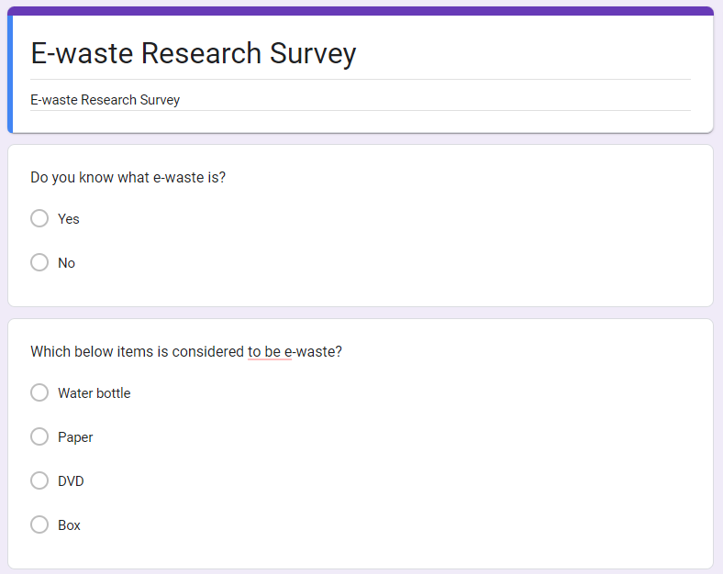

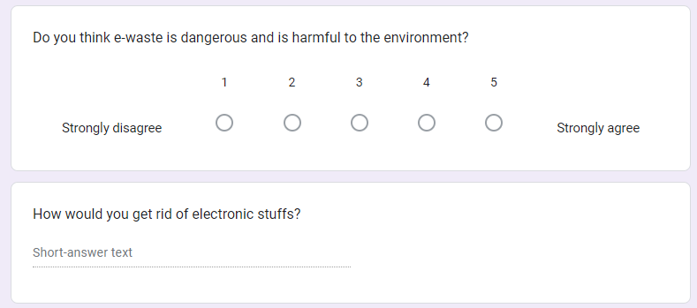

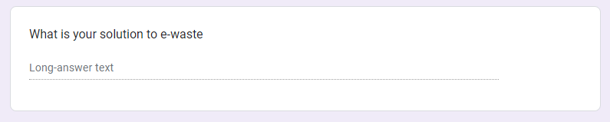

* There are a total of five questions with
  + Two multiple choice questions
  + One quantitative question
  + Two qualitative questions
* The first two multiple choice questions are to test the knowledge of the survey takers about e-waste. This is to take out the survey that is not very useful and one that is helpful to the research. Also these questions help to know how much does the majority of people know about e-waste
* The One quantitative question is to let the survey questioner know about whether the person taking the survey know the danger of e-waste on the environment
* The final two qualitative questions are to help gather data about how would they get rid of their electronic and their own solutions in solving it

# References

1. PM Majik. (2021). *Project Time Risk - What It Is and How to Minimise It? -*. [online] Available at: <https://www.pmmajik.com/project-time-risk-what-it-is-and-how-to-minimise-it/>. [Accessed 28 Feb. 2023].
2. ‌Kashyap, V. (n.d.). *Risk Management in Project Management: 6 Ways to Mitigate Risk*. [online] GoSkills.com. Available at: <https://www.goskills.com/Project-Management/Resources/Risk-management-in-project-management>. [Accessed 28 Feb. 2023].
3. Kissflow (2020). *5 Phases of Project Management Process | Kissflow Projects*. [online] Kissflow. Available at: <https://kissflow.com/project/five-phases-of-project-management/>. [Accessed 28 Feb. 2023].
4. ‌ProjectManager.com. (2021). *How to Sequence Activities in a Project*. [online] Available at: <https://www.projectmanager.com/blog/how-to-sequence-activities>. [Accessed 28 Feb. 2023].
5. Indeed Editorial Team, 2022. The Importance of Communication in Project Management. [Online] Available at: https://www.indeed.com/career-advice/career-development/importance-of-communication-inprojectmanagement#:~:text=Communication%20in%20project%20management%20refers,of%20the%20goals%20and%2 0expectations. [Accessed 28 Feb. 2023].
6. Great Lakes Electronics Corporation (2020). *What is E-waste? Definition and Why It’s Important*. [online] Great Lakes Electronics. Available at: <https://www.ewaste1.com/what-is-e-waste/>. [Accessed 28 Feb. 2023].
7. monre.gov.vn. (n.d.). *Ministry of Natural Resources and Environment - News*. [online] Available at: https://monre.gov.vn/English/Pages/Vietnam-going-on-right-direction-in-handling-with-electronic-waste.aspx [Accessed 28 Feb. 2023].
8. Nikolopoulou, K. (2022). *What Is Generalizability? | Definition & Examples*. [online] Scribbr. Available at: <https://www.scribbr.com/research-bias/generalizability/>. [Accessed 28 Feb. 2023].
9. saigoneer.com. (n.d.). *E-Waste: How the Ghosts of iPhones Past Haunt Vietnam’s Low-Income Communities | Saigoneer*. [online] Available at: https://saigoneer.com/saigon-environment/17720-e-waste-how-the-ghosts-of-iphones-past-haunt-vietnam-s-low-income-communities [Accessed 28 Feb. 2023].
10. Forti, Vanessa, Cornelis P. Balde, Ruediger Kuehr, and Garam Bel, "The Global E-waste Monitor 2020: Quantities, flows, and the circular economy potential," 2020.

Anhnq28@fe.edu.vn